Candidate’s Name: | Random No. |  |  |  |  |  | Personal No.
………………………..……………..………
Signature:……………………………………

(Do not write your School Name anywhere on this booklet)

535/1

PHYSICS

Paper 1

Jul. / Aug. 2020

2¼ hours

SERERE TOWNSHIP SECONDARY SCHOOL

MOCK EXAMINATIONS 2020

Uganda Certificate of Education

PHYSICS

Paper 1

2 hours 15 minutes

INSTRUCTIONS TO CANDIDATES:

Section A contains 40 objective type questions. You are required to write the correct answer A, B, C or D in blue or black ink against each question in the box at the right hand side.

Section B contains 10 structured questions. Answers are to be written in the spaces provided on this question paper.

Mathematical tables and silent non-programmable calculators may be used.

 | Acceleration due to gravity, g |  |  |  |  | = | 10 ms⁻².
 | Specific heat capacity of water |  |  |  |  | = | 4200Jkg⁻¹K⁻¹
 |  |  |  |  |  | For Examiners’ use only
 | Q.41 | Q.42 | Q.43 |  | Q.44 | Q.45 | Q.46 | Q.47 | Q.48 | Q.49 | Q.50 | MCQ | Total

Turn Over

SECTION A (40 MARKS)

- Which of the following is correct about current that flows through resistors connected in series?

  - Current through each of the resistors is the same.

  - Current through each of the resistors is proportional to the resistance.

  - Current increases as it flows through the resistors.

  - Current decreases as it flows through the resistors.

- The amount of heat absorbed by a 3kg mass at constant temperature is called?

A. Specific latent heat. B. Latent heat..

C. Specific heat capacity. D. Heat capacity.

- Which of the following forms Mechanical energy?

A. Nuclear energy and Kinetic energy. B. Potential energy and Kinetic energy. C. Electrical energy and Kinetic energy. D. Potential energy and Nuclear energy.

- Mass, Luminous intensity and Current are;

A. derived quantities. B. units of measurement.

C. fundamental quantities. D. basic quantities.

- The brightness of the spot on a C.R.O screen is controlled by:-

A. Anodes. B. Grid.

C. Cathode. D. X – plates.

- Brownian motion experiment shows that molecules of gases are:

A. in motion in one direction only. B. more closely packed than in liquid. C. in constant random motion D. stationary

- A stone falls freely from rest to the ground. Which one of the following presents the correct order of energy changes which occur when the stone falls to the ground.
A. Kinetic energy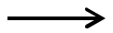Potential energy Sound energy Heat energy
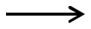

- Sound energyPotential energy kinetic energyHeat energy

- Potential energySound energy Kinetic energyHeat energy

D. Potential energy kinetic energy Heat energy Sound energy

- Which one of the following is true for an object under shearing forces?

  - The object does not change in shape.

  - The object tends to shorten.

  - The layers of the object tend to slide on one another.

  - The object gets twisted.

- When a pin hole camera is moved nearer an object, the size of the image:

A. remains the same. B. becomes larger.

C. becomes diminished. D. becomes smaller.

2

  - In a domestic hot water supply system, hot water in a boiler flows to the taps by convection because:

    - cold water is prevented from mixing with hot water.

    - warm water displaces cold water.

    - hot water is denser than cold water, therefore it sinks.

    - hot water is less dense and therefore rises.

- Which one of the following affects the frequency of a vibrating string?

    - Tension and velocity of sound produced.

    - Mass per length of the string and temperature

    - Tension and length of the string

    - Length and mass of the string

- A liquid of mass 120g and density 4g/cc is mixed with a liquid of 20cc and density 8g/cc. The density of the mixture in g/cc is

A. B. C. D.

- The major reason why helium may be preferred to hydrogen in filling ballons is:

A. Helium is less denser than hydrogen. B. Hydrogen is not flammable.

C. Helium is more denser than hydrogen. D. Helium is not flammable.

- When the North pole of a bar magnet is moved torwards a coil, which of the following ways can be used to increase the size of the induced emf in the coil?

  - Moving the magnet at a higher speed.

  - Reducing the number of turns in the coil.

  - Using a stronger magnet.

A. (i), (ii) and (iii).

B. (ii) and (iii) only

C. (i) and (ii) only

D. (i) and (iii) only

- A man of mass 50kg climbs 40 steps upstairs. If each step is 0.2m high, the potential energy gained is

A. B. C. D.


- In the reaction below, U is likely to be


X 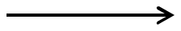 Y U


- a neutron.

- a gamma particle.

- a beta particle.

- an alpha particle.


3 | Turn Over

- When a yellow dress with blue dots is placed in a room lit with pure red light, the dress appears

- yellow with blue dots. C. red with black dots.

B. black with yellow dots.

D. green with red dots.

18. A body moves with a uniform acceleration of |  |  |  |  |  | . If its initial velocity is 40
and it travels for 12s to attain a final velocity of 60 |  |  |  |  |  |  | , find the value of .
A. |  | B. |  | C. |  |  | D.

- Which of the following statements are true about electric wiring?

  - The fuse is connected into the neutral wire leading to a circuit.

  - When a fault develops in the circuit, it is the neutral wire which has to be disconnected.

  - The fuse is always connected into the live wire leading to a circuit.

A. (i), (ii) and (iii). B. (i) and (iii) only

C. (iii) only D. (i) only

- When sound waves pass through a metal bar, the atoms of the metal
A. move along the bar. B. rotate in circles.

C. vibrate about fixed points. D. expand and contract.

- A gas occupies a volume of Find the volume at s.t.p.

at a temperature of 27⁰Cand a pressure of 70cmHg.

A. B.

C. D.

- Figure 1 shows a thermionic diode.

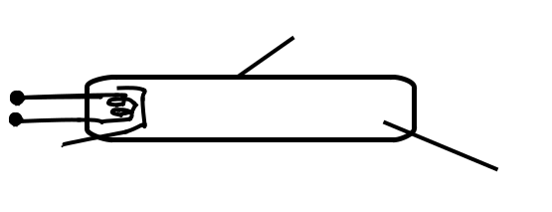
 |  | Fig. 1
Which one of the following are represented by , and .
A. Anode, Glass tube, Cathode. |  | B. Anode, Cathode, Glass tube.
C. Cathode, Anode, Glass tube. |  | D. Cathode, Glass tube, Anode.

- If a load of 1N extends a spring by 5cm, what extension will a load of 0.6N produce?

A. 3.0 cm B. 1.2 cm

C. 30.0 cm D. 8.5 cm

4

24. Figure 2 shows a ray of light incident at an angle of 40⁰ at mirror, |  |  |  | ; which is
inclined with mirror | at 60⁰.
 | 60⁰ | 40⁰
 |  | Fig. 2
Find the angle between the incident ray at |  |  | and reflected ray at | .
A. 50⁰ |  | B. 10⁰
C. 100⁰ |  | D. 60⁰
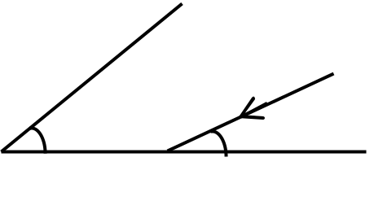

- In a hydraulic press, the area of the piston on which the effort is applied is made smaller in order to

  - transmit a force as large as possible to the load.
  - obtain a pressure as large as possible

  - facilitate the movement of the piston dowards

  - transmit pressure equally throughout the liquid.

- The leaf of a charged electroscope gradually collapses with time due to

  - Leakage to the surroundings

  - similar charges from the sorroundings.

  - surrounding magnetic field.

  - pressure variation in the surroundings

27. A car of mass 1200kg moving with a velocity of |  |  |  |  |  |  | collides head – on with another
car of mass 1000kg at rest and they stick together. Calculate their velocity after collision
A. ( |  |  |  | ) | B. ( |  |  |  |  | )
C. ( |  |  | ) |  | D. ( |  |  |  | )

- Which of the following properties are true about cathode rays?

  - They travel in straight lines.

  - They darken photographic plates.

  - They are deflected by a magnetic field

- (ii) only

- (i) and (iii) only

- (i) and (ii) only

- (ii) and (iii) only

5 Turn Over
- The amount of heat required to raise the temperarure of 0.5kg of iron from 25⁰Cto 50⁰C is (specific heat capacity of Iron is 460 Jkg⁻¹K⁻¹)
A. |  |  | B. ( |  |  |  | )
C. ( |  | ) | D. ( |  |  |  |  | )

- Figure 3 shows a paper tape pulled at a constant speed through a ticker timer vibrating at 50Hz.

 |  |  |  |  |  |  |  | 18cm
Find the speed of the tape. |  |  |  |  |  |  |  | 18cm |  |  |  |  |  | Fig. 3
A. ( |  |  | ) |  |  |  |  | B. ( |  |  |  |  |  |  |  | )
C. ( |  |  |  | ) |  |  |  | D. ( |  |  |  |  |  |  | )
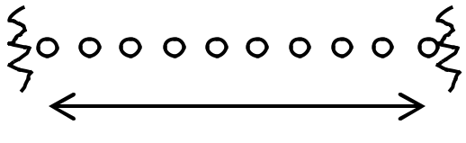

- Which one of the following diagrams represents the correct magnetic field around a straight wire carrying a current?
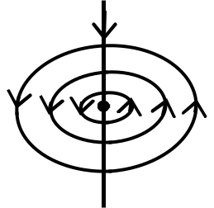
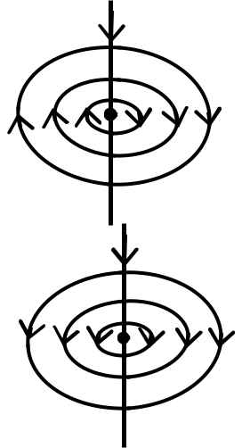

A. | B.
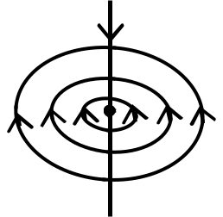

C. | D.

- What occurs when a body is made to vibrate with its natural frequency due to external

vibration?

A. Echo. B. Refraction.

C. Reverberation. D. Resonance.

- The strength of the magnetic field between the poles of an electromagnet remains the same if;
  - the number of turns are halved
  - current in the electromagnetic windings is doubled.
  - direction of the current in the electromagnetic windings are reversed.

- (i), (ii) and (iii)
- (ii) and (iii) only

- (i) and (iii) only
- (iii) only

6

- A load of 500N is placed at 2m from a pivot of a sea saw. At what distance from the pivot should a weight of 250N be placed to balance the sea saw?
A. ( |  |  | ) |  | B. ( |  |  |  | )
C. ( |  |  |  | ) | D. ( |  |  |  |  | )

- Which of the following occurs when a wave passes through a small opening?
    - Interference.

    - Difraction.

    - Refraction.
    - Reflection.

- A voltage of 440V is applied to the primary of a transformer of 2000 turns. If the voltage across the secondary is 11kV, what is the number of turns in the secondary coil?

  - 80,000

  - 50,000

  - 50.

  - 80

- A detergent is used to wash clothes because it
    - increases capillarity in the clothes

    - reduces capillarity in clothes.

    - increases surface tension allowing water to penetrate the dirt.

    - Decreases surface tension allowing water to penetrate the dirt easily.

38. Figure 4 shows a circuit diagram of two resistors of resistances 4 and 2 connected to a

3.0V supply and 2 switches and .
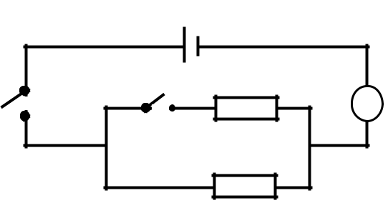

3V

 | 2 | A
 | 4 |  | Fig. 4
What will be the reading of the ammeter if switch, |  |  | is open and | closed?

  - 0.75A

  - 2.25A

  - 9A

  - 8A

- Total internal reflection occurs when
    - light travels from a dense to a less dense medium.

    - the angle of incidence in a dense medium is greater than the critical angle.

    - the angle of incidence is equal to the critical angle.

7 | Turn Over
  - (i), (ii) and (iii)

  - (ii) and (iii) only

  - (i) and (iii) only

  - (i) and (ii) only

- Figure 5 shows a graph of load against extension for a wire.
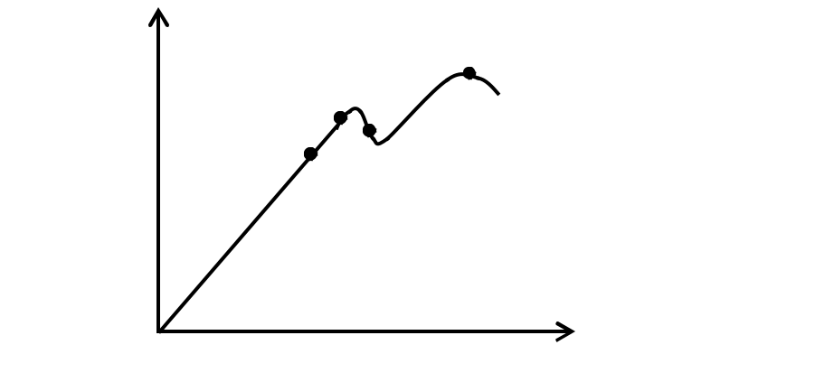

T
R _{S}
Load (N) _{Q}

P

Fig. 5

Extension (m)

Which of the portions of the graph corresponds to a permanently strained wire?

- PQ and QR

- QR and RS

- PQ and RS

- RS and ST

SECTION B (40 MARKS)

Write in the spaces provided

41. (a) What are cathode rays? (01mark)

………………………………………………………………………………………………………

………………………………………………………………………………………………………

- Figure 6 shows cathode rays directed in magnetic field.
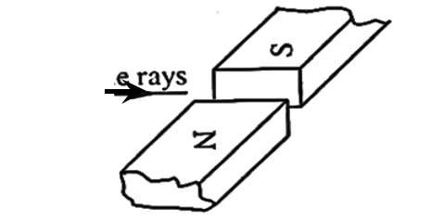

Cathode rays

Fig. 6

Draw to show the direction taken by the rays. (01mark)

- State two advantages of a Cathode Ray Oscilloscope (CRO) as a voltmeter. (02marks)

………………………………………………………………………………………………………

………………………………………………………………………………………………………

8

42. (a) What is meant by a sensitive galvanometer? (01mark)

………………………………………………………………………………………………………

………………………………………………………………………………………………………

- State two factors that determine the sensitivity of a moving coil galvanometer.

(01mark)
………………………………………………………………………………………………………

………………………………………………………………………………………………………

- Describe briefly how a galvanometer can be converted into a voltmeter. (02marks)
………………………………………………………………………………………………………

………………………………………………………………………………………………………

………………………………………………………………………………………………………

43. (a) State Graham’s law of gaseous diffusion. (01mark)

………………………………………………………………………………………………………

………………………………………………………………………………………………………

(b) Give one example of a gas that has high diffusion rate. (01mark)

………………………………………………………………………………………………………

(c) State two factors that affect the rate of diffusion of a gas. (02marks)

………………………………………………………………………………………………………

………………………………………………………………………………………………………

44. (a) State one application of a hydrometer in Agriculture. (01mark)

………………………………………………………………………………………………………

- Explain why a ship is able to float on water inspite of being made of a metal. (02marks)
………………………………………………………………………………………………………

………………………………………………………………………………………………………

………………………………………………………………………………………………………

(c) Calculate the relative density (R.D) of a body whose density is 1420kgm⁻³. (01mark)

………………………………………………………………………………………………………

………………………………………………………………………………………………………

45. (a) Define pitch of a screw. (01mark)

………………………………………………………………………………………………………

………………………………………………………………………………………………………

⁹ Turn Over
(b) Figure 7 shows a simplified Screw Jack of radius 0.42m and velocity ratio 329.7.
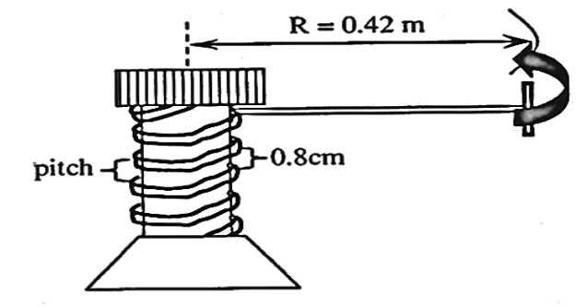

Fig. 7

(i) Find the pitch of the Screw Jack

(01mark)

………………………………………………………………………………………………………

………………………………………………………………………………………………………

(ii) Calculate the effort that would be necessary to raise a load of 500N if the Screw
Jack is 45% efficient. (02marks)
………………………………………………………………………………………………………

………………………………………………………………………………………………………

………………………………………………………………………………………………………

………………………………………………………………………………………………………

46. (a) What are ultrasonic waves? (01mark)

………………………………………………………………………………………………………

………………………………………………………………………………………………………

- In sonar navigation, the emitter sends a pulse of an ultrasonic wave vertically towards the bottom of the sea and its receiver next to the emitter receives its echo after
0.65 seconds. If the velocity of sound in water is 1450ms⁻¹, estimate the sea depth at
the point. (02marks)
………………………………………………………………………………………………………

………………………………………………………………………………………………………

………………………………………………………………………………………………………

………………………………………………………………………………………………………

(c) State one application of ultrasonic waves. (01mark)

………………………………………………………………………………………………………

47. (a) What is a Joule? (01mark)

………………………………………………………………………………………………………

………………………………………………………………………………………………………

10

(b) State how energy from the sun is utilized. (01mark)

………………………………………………………………………………………………………

………………………………………………………………………………………………………

- A ball of mass 800g falls from a height of 20m. If it loses 5% of the energy it strikes

with, find the kinetic energy with which it bounces. (02marks)

………………………………………………………………………………………………………

………………………………………………………………………………………………………

………………………………………………………………………………………………………

48. (a) What is meant by accommodation of the eye? (01mark)

………………………………………………………………………………………………………

………………………………………………………………………………………………………

(b) Explain how a normal eye is able to see near objects. (01mark)

………………………………………………………………………………………………………

………………………………………………………………………………………………………

(c) A man can see far objects clearly. The nearest object he can see well is 0.80m away.

Calculate the focal length of the lens he needs. (02marks)

………………………………………………………………………………………………………

………………………………………………………………………………………………………

………………………………………………………………………………………………………

- (a) “A body accelerates at 4ms⁻²”. What do you understand by this statement? (01mark)

………………………………………………………………………………………………………

………………………………………………………………………………………………………

(b) Explain why a car originally moving at 20ms⁻¹ with its engine off on a straight road
eventually stops. (01mark)

………………………………………………………………………………………………………

………………………………………………………………………………………………………

- A presidential convoy moving at 20ms⁻¹ notices a goat crossing the road at a distance of 100m away and then applies the brakes 3 seconds later. Find out whether the goat
will be knocked if the convoy decelerates at a rate of 4ms⁻². (02marks)

………………………………………………………………………………………………………

………………………………………………………………………………………………………

………………………………………………………………………………………………………

………………………………………………………………………………………………………

11
50. (a) Sketch a graph of current gainst voltage for a semi – conductor diode. (01mark)

(b) A house has one 100W bulb, two 75W bulbs and five 40W bulbs. Find the cost of having all these bulbs switched on for 2 hours every day for 30 days at a UMEME cost
of sh.980 per unit. (03marks)

………………………………………………………………………………………………………

………………………………………………………………………………………………………

………………………………………………………………………………………………………

………………………………………………………………………………………………………

………………………………………………………………………………………………………

………………………………………………………………………………………………………

………………………………………………………………………………………………………

………………………………………………………………………………………………………


END

12

