535/3

PHYSICS

PRACTICAL

Paper 3

Nov./Dec. 2020

2¼ hours

SERERE TOWNSHIP SECONDARY SCHOOL
MOCK EXAMINATIONS 2020

Uganda Certificate of Education

PHYSICS PRACTICAL

Paper 3

2 hours 15minutes

INSTRUCTIONS TO CANDIDATES:

Answer Question 1 and one other question.

Any additional question answered will not be marked

For each question candidates will be required to select suitable apparatus from the equipment provided

You will not be allowed to start working with the apparatus for the first quarter of an hour.

Marks are given mainly for a clear record of the observation actually made, for their suitability and accuracy, and the use made of them.

Candidates are reminded to record their observations as soon as they are made

Where possible, candidates should put their observations and calculations in a suitable table drawn in advance

An account of the method of carrying out the experiment is not required.

Squared paper is provided.

Mathematical tables and silent non-programmable calculator may be used.

Turn Over

1. In this experiment, you will determine the constant, of the spiral spring provided. (30marks)

- Suspend the spring with a pointer fixed at its free end from a clamp.

- Support one end of the metre rule against the wooden block and suspend the other end from the spring using a piece of thread as shown in figure 1
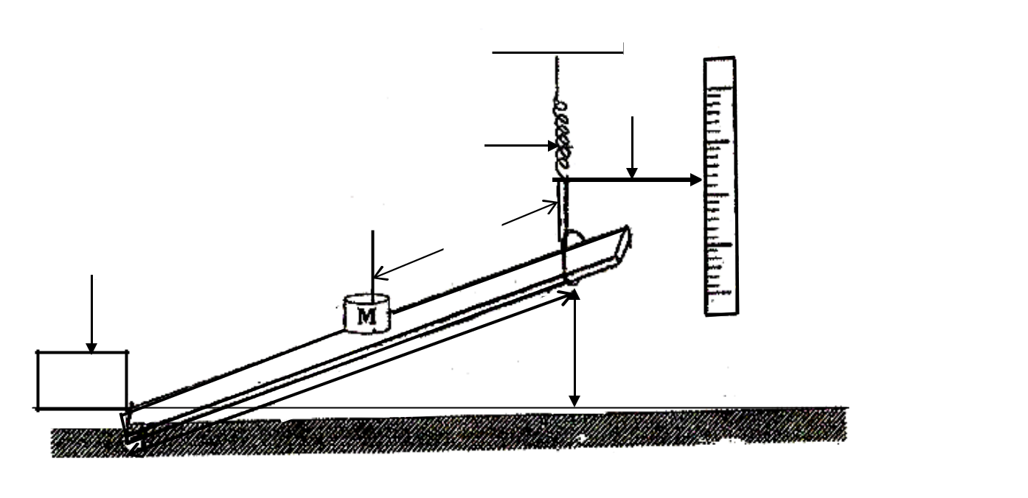

Pointer

Spring

Wooden block

Metre rule
(or half metre rule)

Fig.1

(c) Adjust the height, above the table surface to .

(d) Measure and record the distance, between the end of the rule pressing against the wooden

block and the point of suspension of the meter rule.

- Clamp the half meter rule vertically with its scale against the end of the pointer.

(f) | Read and record the position, | of the pointer.
(g) | Place a mass, M at a distance, |  | from the point of suspension of the metre rule.
(h) | Read and record the new position, of the pointer.
(i) | Find the extension, of the spring.
(j) | Repeat procedures (g) to (i) for values of |  | = | , | , | , | and | .

- Tabulate your results including values of (

(l) | Plot a graph of | against (
(m) | Find the slope, | of the graph.
(n) | Calculate, from:

DISMANTLE THE SET UP OF THE APPARATUS

2

2. In this experiment, you will determine the refractive index, of a glass block provided. (30marks)

- Fix a fresh plain sheet of paper on the soft board using drawing pins.
^{I} P₁
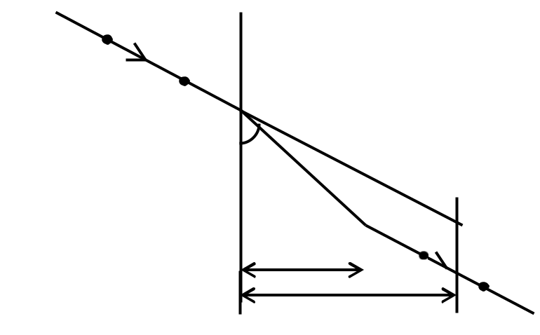

P | P₂ | N |  |  |  |  |  | Q
S |  |  |  | C |  | O |  | R | M
S |  |  |  | P |  |  | P4
 |  |  |  | Type eq33


  - Fig. 2

- Place the glass block on the sheet of paper provided with the largest face top most.

(c) Trace its outline Q .

- Remove the glass.

(e) | Mark point | on | Q such that the distance |  |  |  |  | .
(f) | Draw a normal to |  | Q at | . Extend |  | to | such that the distance
(g) | Mark another | on | such that |  |  |  | .
(h) | Join to and extend to I as shown in figure 2.
(i) | Stick two optical pins |  |  | and | on | . Put the glass block on its outline.
(j) | While looking through the glass block from side |  |  |  |  |  |  | , stick two pins | and | such that they
 | appear to be in line with the images of |  |  |  |  |  | and .

- Remove the glass block and the pins

(l) | Draw a line through |  |  | and |  |  | to meet |  |  |  | at |  | . Join to .
(m) | Measures and record distances |  |  |  |  |  | , | and .
(n) | Repeat procedures (g) to (m) for values of |  |  |  |  |  |  |  |  |  |  |  |  |  | and | .
(o) | Tabulate your results including values of |  |  |  |  |  |  |  |  |  |  |  | and |  | .
(p) | Plot a graph of |  | against |  |  | .
(q) | Determine the slope, |  |  | , of the graph.
(r) | Calculate from the expression: |  |  |  |  |  |  |  | .
N.B | Hand in the tracing papers used in the experiment together with your results.
 | DISMANTLE THE SET UP OF THE APPARATUS
 |  |  |  |  |  |  |  | 3 |  |  |  |  |  |  |  | Turn Over

3. In this experiment, you will determine the potential difference per metre, of the wire provided.

(30marks)

(a) Connect the circuit shown in figure 3.


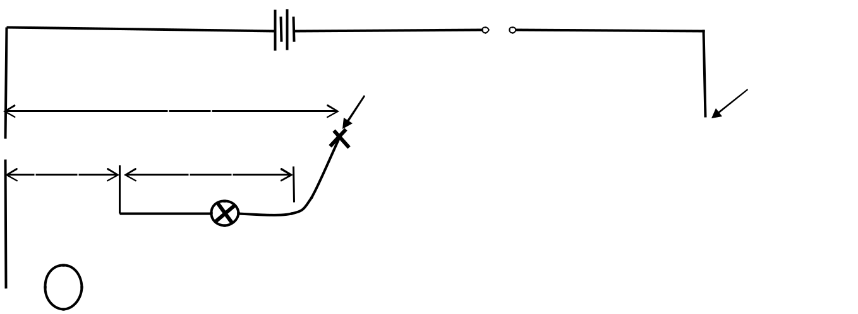

 |  |  |  |  |  |  |  |  |  |  |  |  |  |  | Crocodile Clip |  |  |  |  | Sellotape
 |  |  |  |  |  |  |  |  |  |  |  |  |  |  |  |  | Bare wire,
 |  |  |  |  |  | R |  |  |  |  |  |  |  |  |  | Fig. 3
 |  |  |  |  |  | V |  |  |  |  |  |  |  |  |  | Fig. 3
(b) |  |  |  | Record the value of the resistor |  |  |  |  |  |  |  |  |  |  |  | Provided.
(c) |  |  |  | With |  |  |  |  |  | 0.10m, close the switch, .
(d) |  |  |  | Read and record the voltmeter reading.
(e) |  |  |  | Open switch .
(f) |  |  |  | Disconnect the voltmeter and connect it across the bulb, L.
(g) |  |  |  | Close switch, .
(h) |  |  |  | Read and record the voltmeter reading, .
(i) |  |  |  | Repeat procedures (c) to (h) for values of |  |  |  |  |  |  |  |  |  |  |  |  | 0.20, 0.30, 0.40, 0.50, 0.60, 0.70 and 0.80.
(j) |  |  |  | Tabulate your results in a suitable table.
(k) |  |  |  | Plot a graph of |  |  |  |  |  |  |  |  | against.
(l) |  |  |  | Locate the point, |  |  |  |  |  |  |  |  |  | on the graph for which |  |  | .
(m) Plot a graph of |  |  |  |  |  |  |  |  |  |  |  |  | against .
(n) |  |  |  | From your graph find values of |  |  |  |  |  |  |  |  |  |  |  | for which |  | is .
(o) |  |  |  | Calculate the potential difference per metre |  |  |  |  |  |  |  |  |  |  |  |  | , of the wire, | from the expression:


.


DISCONNECT THE CIRCUIT END 4

