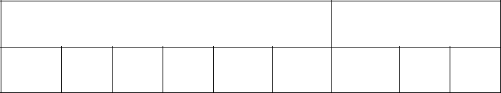
Candidate’s Name: | Random No. | Personal No.

………………………………………………

Signature:………………………………………

(Do not write your School Name anywhere on this booklet)

553/1

BIOLOGY

(Theory)s

Paper 1

Nov./Dec. 2020

2½ hours

SERERE TOWNSHIP SECONDARY SCHOOL
MOCK EXAMINATIONS 2020

Uganda certificate of Education

BIOLOGY

(THEORY)

Paper 1

2hours 30minutes

INSTRUCTIONS TO CANDIDATES:

This paper consists of sections A, B and C.

Answer all questions in section A and B, plus two questions in section C.

Write answers to section A in the boxes provided, answers to section B in the spaces provided, and answers to section C in the answer booklets provided.

 |  | For Examiners’ Use Only
 | Section | Marks Examiner’s signature & No.
 | A
 | No. 31
B | No. 32
 | No. 33
 | No.

- No.

TOTAL

Turn Over

SECTION A (30 MARKS)

Answer all questions in this section. Write the letter representing the most correct answer to each question in the box provided

- A farmer usually retains a bull in bins herd whose ancestors have good qualities. This is an example of:

A. Natural selection B. Artificial selection
C. In breeding D. Out breeding

- Meiosis normally results in:
  - halving the chromosome number.

- maintaining the number of chromosomes.

- producing identical cells

- propagation of new organism

Which of the following is correct?

A. (i) and (iv) B. (ii) and (iv)
C. (ii) and (iii) D. (i) and (iii)

- A student complained of seeing blurred images of nearby objects, what was the eye defect and what is its remedy?

 | A. | short sight, concave lens | B. | short sight, concave lens
 | C. | long sight, convex lens | D. | long sight, concave lens
4. | Which of the following muscles causes the arm to straighten when it contracts?
 | A. | Triceps | B. | Biceps
 | C. | Erector pili | D. | Flexor

- Plants convert glucose to starch after synthesis during photosynthesis because it is:
  - Not as sweet as other sugars formed.
  - source of vitamins as well as energy
  - Better source of energy than other sugars.
  - Insoluble hence can be conveniently stored.

- Figure 1 below shows the structure of a sperm cell.
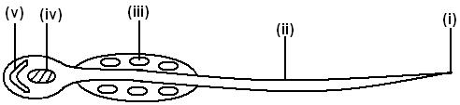

Fig. 1
Which one of the following pairs consists of parts which contain the genetic material and
provide energy for the cell during propulsion respectively?
A. | (iv) and (i) | B. | (v) and (ii)
C. | (iii) and (i) | D. | (iv) and (iii)

- Arachnids can easily be identified by:

A. three pairs of legs B. two body parts.
C. two main body parts D. a pair of antennae.

- The figure 2 below shows a pyramid of numbers for a food chain.

Tertiary consumers
Secondary consumers

 Primary consumers

Producers
Fig. 2

2

Which of the following correctively represents the information in diagram?
  - a herd of antelopes in an African plain
  - a locust swarm in a maize field
  - a plague of caterpillars on a tree
  - round worms in a child’s gut

- What is the possible reason for the fall in the volume of oxygen gas released during photosynthesis after 40°C?

  - there was no more oxygen in the atmosphere.
  - there was no more carbon dioxide in the atmosphere.
  - there was too much light intensity.
  - enzymes were denatured.

- Leguminous plants are characterized by:
  - production of seeds in a capsule pod
  - production of seeds in a follicle pod
  - presence of nodes in shoots
  - presence of nodules in roots

- The following events occur in seeds during germination:

- Seed coat splits
- Hypocotyls grows fast
- Epicotyls grows fast
- Cotyledons appear above the ground
- Cotyledons remain below the ground

Which of the following occur during epigeal germination?

A. (i), (ii), (iii) B. (i), (iii), (iv) C. (i), (ii), (iv) D. (ii) and (iv) only

- The structure in figure 3 shows the side view of a human tooth. Study and identify it.

Fig. 3
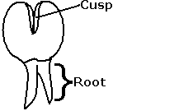

A. Molar B. Premolar C. Canine D. Incisor

- A student performed an experiment to determine the percentage of humus in a soil sample. The following results were obtained.

  - mass of empty dish = 50g
  - mass of dish + soil = 200g
  - mass of dish + soil after heating to constant mass = 170g

What is the percentage of humus in the soil?
A.15% | B.30% | C.20% | D.90%

- Mostly an enzyme is a ………………………. in nature.

A. protein B. carbohydrate C. lipid D. vitamin

- Blood rich in the products of digestion enters the liver through:

A. | hepatic vein | B. | hepatic artery
C. | hepatic portal vein | D. | renal portal vein
 |  |  | 3
 |  |  | 3 | Turn Over

- Birds pass out nitrogenous waste in the form of:

A. Uric acid B. urea
C. Ammonia D. trimethylamine oxide

- Which of the following represents the correct order of taxonomic ranks starting with the largest?

  - kingdom, phylum, class, order, family, genus and species
  - kingdom, phylum, class, family, order, genus and species
  - species, genus, family, order, class, phylum, kingdom
  - species, genus, order, family, class, phylum, kingdom

- The basic unit of chlorophyll is?

A. Nitrogen
C. iron

B. Magnesium
D. potassium

- Biological control is preferred to use instead of insecticides in pest control management. This is because insecticides:

A. are quite expensive B. are indiscriminative in their action
C. require skill to use D. make the soil infertile

- Which one of the following fruits represents a capsule?

A. Bean pod B. cassia C. Dutch man’s fruit D. coconut

- Which of the following root systems of plants is specialized for gaseous exchange?
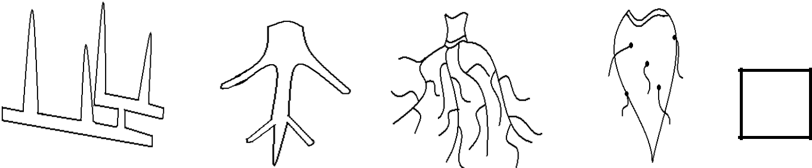

A B C D

- The rate of flow of blood through the renal artery was found to be 1200cm³/min; the urea concentration in the renal artery was 32mg/100cm³ and in the renal vein 24mg/100cm³.

If the flow rate of the blood remained constant, determine the quantity of urea removed from the kidney in one hour.

  - 480mg
  - 96mg
  - 11520mg
  - 5760mg

- Which one of the following insects undergoes complete metamorphosis?
  - locust
  - bee
  - grass hopper
  - cockroach

4

- A seedling was grown on a horizontal board and the shoot grew towards light while the root grew downwards as shown in the diagram.
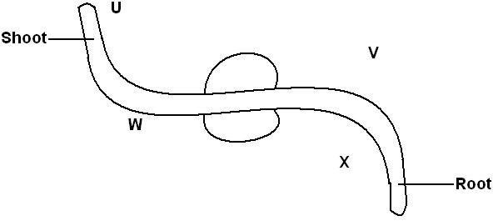

This was due to:
- more auxin on side U and less auxin on side V
- less auxin on side W and more auxin on side V
- less auxin on side W and more auxin on side X
- more auxin on side W and less auxin on side V

- By which process does oxygen move from the leaf cells to the air spaces.

A. diffusion B. osmosis C. active transport D. capillarity

- Below are some of the characteristics of vertebrae: Vertebraterial canals, short neural spine, cervical ribs.

Which vertebra do these characteristics represent?

A. lumbar B. cervical C. thoracic D. caudal

- A couple produced four children who are of different blood groups with the following
genotypes, AO, BO, AB and OO. Identify the genotypes of the blood groups of the couple.

A. AA and BO B. AO and BO C. BB and BO D. AB and OO

- Study the dichotomous key below.

1(a) Has 8 legs -----------------------------------------P
(b) Has 6 legs -----------------------------------------2

2(a) Has long antenna ----------------------------------Q
(b) Has short antenna ----------------------------------3

3(a) Has proboscis -------------------------------------R
(b) Has mandibles ------------------------------------S

Which of the organisms is a housefly?

A. P B. Q
C. R D. S

- Which one of the following organisms reproduce by budding?

A. mushroom B. amoeba
C. spirogyra D. hydra

- Which one of the following parts is most important in promoting insect pollination?
A. | calyx | B. | stamens
C. | corolla | D. | pistil
 |  |  | 5
 |  |  | 5 | Turn Over

SECTION: B (40 MARKS)

Attempt all questions in this section in the spaces provided

- Under normal health conditions, the amount of waste products released by NTUBIIRU were

observed and recorded over time as the temperature of his surroundings were altered. The results obtained were recorded in the table below;

Temperature (ºC) |  | 0 | 5 | 10 | 15 | 20 | 25 | 30 | 35 | 40 | 45
Volume | Urine | 87.6 | 72 | 63 | 55.1 | 47 | 32.5 | 25 | 20.4 | 16 | 8.2
of wastes
of wastes | Sweat | 0 | 6 | 11 | 13.9 | 18.3 | 30 | 52 | 64.8 | 75 | 88.7
(cm³)
- Represent the above information on a suitable graph using the graph paper provided on

page 6 (12marks)

(b) Explain the shape(s) of your graph(s).

(04marks)

…………………………………………………………………………………………………………

…………………………………………………………………………………………………………


…………………………………………………………………………………………………………

…………………………………………………………………………………………………………

(c) Explain the relevance of excreting urine from the body. (02marks)

…………………………………………………………………………………………………………

…………………………………………………………………………………………………………

6

- Estimate from your graph, the amount of urine that would be produced by NTUBIIRU
at 43ºC (02marks)

…………………………………………………………………………………………………………

…………………………………………………………………………………………………………

32. (a) State the significance of the following hormones in reproduction: (03marks)

- LH

…………………………………………………………………………………………………………

…………………………………………………………………………………………………………

- Oestrogen

…………………………………………………………………………………………………………

…………………………………………………………………………………………………………

- Prolactin

…………………………………………………………………………………………………………

…………………………………………………………………………………………………………

(b) What do you understand by the following terms?

(i) Implantation

(03marks)

…………………………………………………………………………………………………………

…………………………………………………………………………………………………………

(ii) Parturition

…………………………………………………………………………………………………………

…………………………………………………………………………………………………………

(iii) Spermatogenesis

…………………………………………………………………………………………………………

…………………………………………………………………………………………………………

(c) Describe any four roles of the placenta to the fetus (04marks)

…………………………………………………………………………………………………………

…………………………………………………………………………………………………………

…………………………………………………………………………………………………………

…………………………………………………………………………………………………………

…………………………………………………………………………………………………………

…………………………………………………………………………………………………………

…………………………………………………………………………………………………………

…………………………………………………………………………………………………………

7 Turn Over

- The graph below shows the variation of weight of the seed during germination:
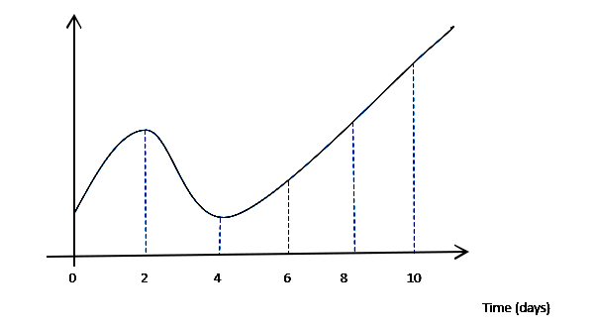

Weight
(mg)

Time (days)

(a) Explain the shape of the graph

(03marks )

…………………………………………………………………………………………………………

…………………………………………………………………………………………………………

…………………………………………………………………………………………………………

…………………………………………………………………………………………………………

…………………………………………………………………………………………………………

…………………………………………………………………………………………………………

(b) Describe any three conditions necessary for germination (03marks )

…………………………………………………………………………………………………………

…………………………………………………………………………………………………………

…………………………………………………………………………………………………………

…………………………………………………………………………………………………………

…………………………………………………………………………………………………………

…………………………………………………………………………………………………………

(c) State any three causes of seed dormancy (03marks)

…………………………………………………………………………………………………………

…………………………………………………………………………………………………………

…………………………………………………………………………………………………………

(d) Define the term ecdysis (01mark )

…………………………………………………………………………………………………………

…………………………………………………………………………………………………………

8

SECTION: C (30 MARKS)

Attempt any 2 questions from this section. Answers to this section must be written on the answer sheets provided

- (a)Stating one example in each case, describe the various types of skeleton in animals

(b)

(09marks)

Describe six adaptations of a duck for locomotion. (06marks)

- (a)With one example in each case, describe the types of genetic variation in organisms. (06marks)

  - In an experiment at a poultry farm, using pure breeds, a short legged cock was crossed with a long legged hen. All off springs in F1 generation had long legs

- using appropriate symbols, show the possible genotypes and phenotypes of F1

and F2 generation. (07marks)

- If there were a total of 80 off springs in F2 generation, calculate the number of

long legged chicks in F2 generation. (02marks)

- (a)Describe how the mammalian eye is able to carry out the following processes:

(i) Visibility. (04marks)

(ii) Adaptation. (05marks)

- Long sightedness is an eye defect.

(i) | What do you understand by the term long sightedness? | (01mark)
(ii) | State the causes of long sightedness | (01mark)
(iii) | With illustrations, describe how long sightedness can be rectified. | (04marks)

- (a)The following results were obtained from an experiment done about soil in a secondary school.
Volume of water………………………………30cm³ Volume of water + soil……………………….70cm³ Volume of water + soil after stirring…………66cm³

From the above results calculate the:

- Volume of soil used

- Volume of air in the soil

- Percentage of air in soil

(06marks)
- In another experiment about soil, the following results were obtained.

Mass of crucible alone …………………………………10g

Mass of crucible + soil before heating …………………30g

Mass of crucible + soil after heating ……………………25g

From the above results, calculate;

- How much water was lost from the soil?

- Mass of the soil used.

- Percentage of water lost from the soil.

(06marks)

9

(c) Explain the role of living organisms in the soil. (03marks)

END

10

