273/1

GEOGRAPHY

Paper 1

Nov./Dec. 2020

2½ hours

SERERE TOWNSHIP SECONDARY SCHOOL

MOCK EXAMINATIONS 2020

Uganda Certificate of Education

GEOGRAPHY

Paper 1

2 hours 30minutes

INSTRUCTIONS TO CANDIDATES:

This paper consists of parts I and II

Part I and section A of part II are compulsory.

Answer only one question from section B of part II

Answers to all questions must be written in the answer booklet provided.

Any additional question (s) answered will not be marked.

Turn Over

PART I

OBJECTIVE – TYPE QUESTIONS (30 MARKS)

There are 30 compulsory questions. Each question carries one mark.

Answers to this part must be written in the answer booklet provided.

- Kenya’s population is unevenly distributed mainly due to the difference in…..

A. soil fertility C. transport network B. sconomic activities D. climatic conditions

- A river regime means

  - a river which has lost ability to carry its total load

  - the whole area drained by a river and its tributeries
  - the seasonal variation of the volume of water in a river
  - Occassional flooding of the river valley

- Which one of the following is the most important contribution of the fishing industry to East Africa

    - development of fish processing industries

    - foreign exchange earnings

    - improved transport network

    - development of ports

- The Campbell stoke recorder in a weather station is used for measuring

A. Sunshine C. temperature

B. Relative humidity D. atmospheric pressure

- The development of electricity power station on river pangai was mainly favoured by the

presence of

A. hard basement rock C. water fall

B. narrow gorge D. a large volume of water

- The second largest national park in Uganda is ……..

A. Murchison falls C. Queen Elizabeth B. Bwindi D. Kidepo

- The major factor influencing the location of industries in East Africa is…….

A. efficient transport C. skilled labour B. power supply D. raw materials

- Which of the following groups of crops need to be grown near urban centres

A. Tomatoes, Pineapples, Cabbage C. Sugarcane, Onions, Carrots B. Tomatoes, Onions, Carrots D. Pineapples, Millet, Cabbage

- Which of the following minerals are found inTororo

A. limestone and beryl C. iron ore and beryl

B. iron ore and phosphate D. phosphate and limestone

2

- Which one of the following commodities is exported through Jomo Kenyatta air port

A. Flowers B Cotton C. Coffee D. Tea

- The following ports are not entre ports except

A. Tanga C. Mombasa B. Mwanza D. Mtwara

- Which one of the following is not a characteristic of tropical rain forest vegetation

A. Trees are ever green B. Very heavy annual rainfall is experienced C. Trees are very tall D. Trees have buttress roots

- Which one of the following fish landing sites is found on lake Kyoga

A. Butiaba C. Katungulu B. Kasenyi D. Kagwara

- Which one of the following game reserves is found in Tanzania

A. Mkomazi C. Katonga B. South kitui D. Losai

- The method used in the mining of oil in the Albertine region of Uganda is

A. Adit C. Open cast B. Drilling D. Shaft

- Kampala has of recent developed into a great industrial centre because of

1. | ready market | 3. | improved infrastructure
2. | raw materials | 4. | cheap hydro electric power
A. 1and 2 |  | C. | 1and 3
B. 3and 4 |  | D. | 1 and 4

- Cashew nuts in East Africa are grown in the

A. highlands C. coastal areas

B. rift valley areas D. lake Victoria shores

- Which of the following commodities does Uganda export to Kenya

A. wheat C. cement B. maize D. shoes

- Which of the following ports in East Africa is an inland port

A. Mombasa C. Malindi B. Mwanza D. Tanga

- The mean annual rainfall for a station that received annual rainfall of 1231 is

A. 102mm | C. | 1243mm
B. 1219mm | D. | 1231mm

- Population distribution in East Africa is mainly influenced by

A. Relief B. Rain fall C. Vegetation cover

D. Temperature

3

Turn Over

- The major factor responsible for the spread of secondary vegetation in East Africa is

A. Altitude C. Latitudes B. Man’s activities D. Topography

- The seven forks dam project in East Africa is located on river

A. Rufigi C. Pangani B. Tana D. Nile

- The term Transhumance means

  - Seasonal movement of animal from place to place

  - Grazing of animals from time to time

  - Movement of animals from place to place

  - Keeping of cattle on large scale

- Which one of the following is a sedimentary rock

A. Sand stone C. Marble B. Granite D. Basalt

- The different size of particles making up soil is refered to as soil

A. Catena C. Profile

B. Texture D. Composition

- Large deforestation is going on in East Africa mainly due to

A. Charcoal burning C. Lumbering B. Agriculture D. Bush burning

- A steep sided feature formed between two adjascent cirques is called

A. A pyramidal peak C. glacial trough B. Hanging valley D. an arete

- The highland areas of East Africa are agriculturally productive because they have

1. | fertile soils | 3. | reliable rainfall
2. | efficient transport | 4. | abundant labour
A. 1 and 2 |  | C. | 1 and 3
B. | 2 and 3 | D. | 3 and 4

- The major purpose for the development of the standard guage railway network in East Africa is to

  - Ease movement of bulky commodities

  - Create political togetherness among countries

  - Widen the revenue collections in the region

  - Attract investments and job creation in the region

4
PART II

MAPWORK, PHOTOGRAPH INTERPRETATION, FEILDWORK AND EAST AFRICA

Answer four questions from part II including questions 1, 2 and 3 which are compulsory

SECTION A

1.

COMPULSORY QUESTION: MAPWORK

(20 MARKS)

Answer all parts of this question.

(a)

Study the 1:50,000 (UGANDA): MASAKA Map extract, part of sheet 79/3 series Y732;

Edition 3- U.S.D and answer the questions that follow:

(i) State the grid reference of the church found at Butale. (01mark)

(ii) Name the mad – made feature found at grid reference 569 589.

(01mark)

(b) (i)

State the direction of Tagga church from Gayaza Ginnery.

(02marks)

- Measure the distance in kilometres of the dry weather road from Buyoga function junction (grid reference 475 714) to Kyanja coffe factory (grid reference 563 632)
(02marks)

- Draw a sketch map of the area along nothing 60 between Easting 46 to 60 and on it mark and name the following features.

  - highlands.

  - Papyrus swamp.

  - areas under plantation farming.

  - all weather roads.

(07marks)

- (i)Name any two economic activities carried out in the area shown on the map. (02marks)

- Giving evidence from the map, explain the factors that influence on economic

activity mentioned in d(i) above. (02marks)

5 | Turn Over

2. COMPULSORY PHOTOGRAPH INTERPRETATION.

Study the photograph provided and answer the questions that follow;
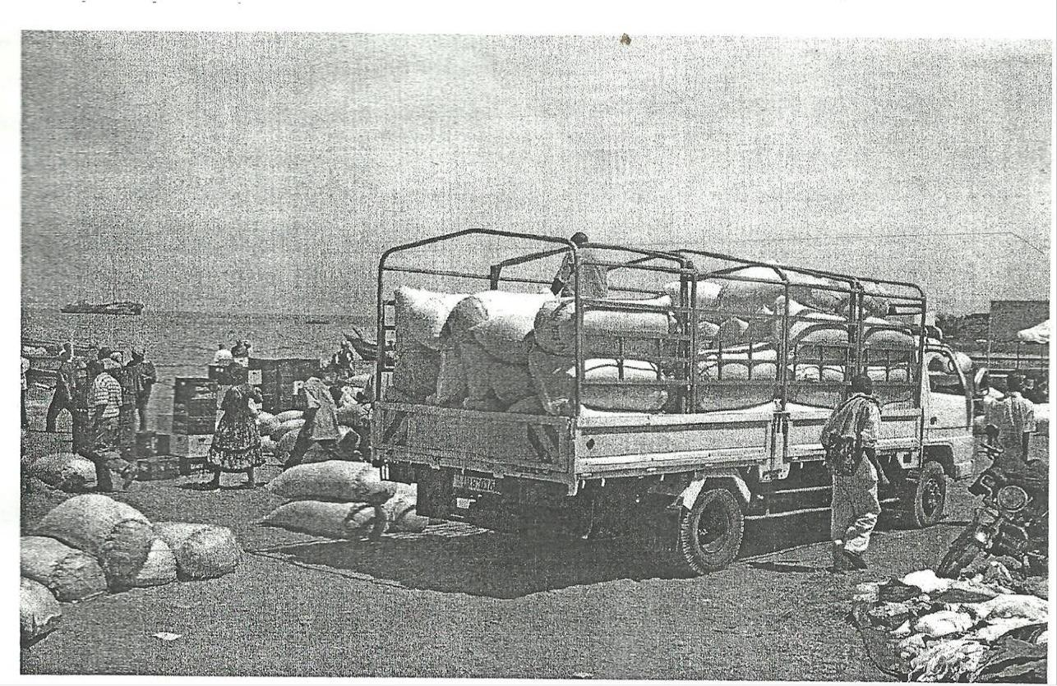
(15 MARKS)

(a) With clear evidence from the photograph:

(i) What type of photograph is shown. (02marks)

  - Identify any two economic activities likely to be taking place in the photograph. (02marks)
- What problems are likely to be faced by the people living in the area shown in the
 | photograph. | (05marks)
(c) | Suggest possible remedies to the problems identified in (b) above. | (04marks)
(d) | Giving reasons for your answer, where could the phograph have been taken. | (02marks)
3. COMPULSORY QUESTION: FIELDWORK (15 MARKS)
For any one fieldwork study you have carried out either an individual or a class:
(a) | State the:
 | (i) Topic of the study. | (02marks)
 | (ii) Objectives of the study. | (03marks)
(b) | Explain the pre field activities carried out. | (02marks)

(c) Draw a sketch map of the area studied and on it mark and name:
- Physical features.
(ii) Man made features. (05marks)

- Explain the relationship between the physical environment and land use in the area studied. (03marks)

6

SECTION B: EAST AFRICA (20 MARKS)

Answer only one question from this section.

- (a) Draw a sketch map of East Africa and on it mark and name:

  - Lakes: Kyoga and Tanganyika.

  - Any one block mountain.

 | (iii) | Rivers: Athi and Rufigi. | (06marks)
(b) | Describe the process that led to the formation of Lake Kyoga. |  | (05marks)
(c) | Explain the importance of lakes to the people of East Africa. |  | (06marks)
(d) | Outline the problems faced by the people living around lakes. |  | (03marks)

- Study the table below showing Uganda’s population between 1982 and 2024 (projected) and answer the questions that follow

 | Year | 1982 | 1992 | 2002 | 2014 | 2024(projected)
 | Population | 9 | 16 | 26 | 34 |  | 46
 | (‘000,000)
 |  | Source: own compilation
(a)Draw a line graph to represent the information in the table above. |  |  |  |  |  |  |  | (07marks)

- Describe the trend of the population shown in the table and the graph above. (02marks)

(c) | Explain the factors that influenced the trend described in (b) above. |  | (06marks)
(d) | Outline the advantages of a large population size. |  | (05marks)
6. (a) | (i) | Name any two types of coral reefs found along the coast of East Africa. | (02marks)
 | (ii) | Describe the characteristics of the coral reefs named in (a) (i) above. | (04marks)
- Describe the factors which have been responsible for the growth of coral reefs on the

East African coast. (05marks)

(c) Explain the value of coral reefs to the people of East Africa. (05marks)

- Outline the problems which have resulted from the presence of coral reefs on the East

African coast. (04marks)

- (a)Draw a sketch map of East Africa and on it mark and name;

  - National parks: Kidepo, Tsavo and Serengeti.

  - Game reserves: Selous and Pian-upe.

  - Towns: Masindi, Dar-es-salam and Kasese.

(02marks)

7 Turn Over
(b) State any two tourist attractions in East Africa other than wildlife. (08marks)

(c) Describe the conditions that favour tourism in East Africa. (05marks)

- Outline the problems faced by tourist industry in any one country in East Africa. (05marks)

END

8

