Candidate’s Name:
Candidate’s Name: | Random No. |  |  |  |  |  | Personal No.
………………………………………………………
Signature:…………………………………….

(Do not write your School Name anywhere on this booklet)

545/3

CHEMISTRY
(PRACTICAL)
Paper 3

Nov./Dec. 2020

2 hours

SERERE TOWNSHIP SECONDARY SCHOOL

MOCK EXAMINATIONS 2020

Uganda Certificate of Education

CHEMISTRY

Paper 3

2 hours

INSTRUCTIONS TO CANDIDATES:

Answer both questions. Answers are to be written in the spaces provided in this booklet. Use blue ink ball pen only. Any work done in pencil will not be marked except drawings
You are not allowed to use any reference books.(i.e. text books, booklets on qualitative analysis etc).

All working must be clearly shown.

Mathematical tables and silent non – programmable calculators may be used.
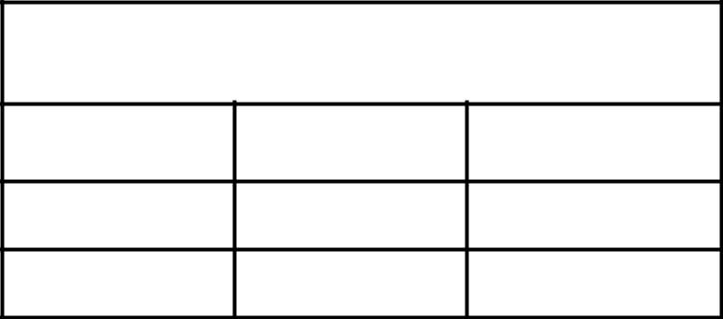

For Examiners’ Use Only

- 1

- 2

Total

Turn Over

- You are provided with the following:

BA1, which is a solution of 0.1M sodium hydroxide.

BA2, which is made by dissolving 6.3g of a hydrated salt ( ) in one litre of distilled water.

You are required to find the value of in the compound.

Procedure

Pipette 20.0 or 25.0cm³ of BA1 into a clean titration flask, add 3 drops of phenolpthalein indicator and titrate with BA2 from the burette. Repeat the titration until you obtain consistent results and record your results in the table below.

Volume of pipette used = ………………………………………….……………..cm³ |  |  |  |  |  |  | (01mark)
 | Burette reading | 1 |  | 2 |  | 3
 | Final Burette reading (cm³)
 | Initial Burette reading (cm³)
 | Volume of BA2 used (cm³)
 |  |  |  |  |  |  | (03marks)
Titre values used for obtaining average volume……………… , ………..…………cm³ |  |  |  |  |  |  | (02marks)
Average volume of BA2 used = …………………………………………………….. |  |  |  |  |  |  | (02marks)
(a)Write the equation for the reaction between BA1 and BA2. |  |  |  |  |  |  | (03marks)

………………………………………………………………………………………..…………………

………………………………………………………………………………………..…………………

- Calculate the:

(i) number of moles of BA1 that reacted with BA2. (03marks)

………………………………………………………………………………………..…………………

………………………………………………………………………………………..…………………

………………………………………………………………………………………..…………………

………………………………………………………………………………………..…………………

………………………………………………………………………………………..…………………

………………………………………………………………………………………..…………………

(ii) number of moles of BA2 that reacted with BA1. (03marks)

………………………………………………………………………………………..…………………

………………………………………………………………………………………..…………………

………………………………………………………………………………………..…………………

2
………………………………………………………………………………………..…………………

………………………………………………………………………………………..…………………

………………………………………………………………………………………..…………………

………………………………………………………………………………………..…………………

- Determine the:

(i) molarity of BA2. (03marks)

………………………………………………………………………………………..…………………

………………………………………………………………………………………..…………………

………………………………………………………………………………………..…………………

………………………………………………………………………………………..…………………

………………………………………………………………………………………..…………………

………………………………………………………………………………………..…………………

(ii) relative molecular mass of (03marks)

………………………………………………………………………………………..…………………

………………………………………………………………………………………..…………………

………………………………………………………………………………………..…………………

………………………………………………………………………………………..…………………

(iii) value of . (02marks)

………………………………………………………………………………………..…………………

………………………………………………………………………………………..…………………

………………………………………………………………………………………..…………………

………………………………………………………………………………………..…………………

- You are provided with substance W, which contains two cations and one anion.

Carry out the following tests on W to identify the anion and cation present in W.
Identify any gas(es) that may be evolved.
Record your observations and deductions in the table on page 4.

(25marks)

3 Turn Over

 | TESTS | OBSERVATIONS | DEDUCTIONS
(a) | Dissolve a spatula end – ful of W in
 | about 5cm³ of water. Shake well and
 | filter.
(b) | Divide the filtrate into 4 portions
(i) | To the first portion add dilute sodium
 | hydroxide drop wise until in excess
(ii) | To the second portion, add aqueous
 | ammonia drop wise until in excess.
(iii) | To the third portion, add 2drops of
 | potassium iodide solution.
(iv) | To the fourth portion, add Barium
 | nitrate solution followed by drops of
 | dilute nitric acid.
(c) | Wash the residue in distilled water and
 | dissolve it in minimum amount of
 | dilute nitric acid and divide the
(i) | resultant solution into two parts.
 | To the first part of the solution; add
 | aqueous ammonia dropwise until in
 | excess.
(ii) | Use the second part of the solution to
 | carry out a test of your own to confirm
 | the second anion in W.
 | TEST:
- (i) The cations in W are ………………………………; ……….………………..………..

  - The anion in W is …………………………………………………………………..………..

END

4

