535/2

PHYSICS

Paper 2

Nov./Dec. 2020

2¼ hours

SERERE TOWNSHIP SECONDARY SCHOOL

MOCK EXAMINATIONS 2020

Uganda Certificate of Education

PHYSICS

Paper 2

2 hours 15 minutes

INSTRUCTIONS TO CANDIDATES:

Answer five questions

Any additional question(s) answered will not be marked.

Mathematical tables and silent non programmable calculators may be used.

These values of physical quantities may be useful to you:

Acceleration due to gravity | = 10
Specific heat capacity of water | = 4,200
Specific heat capacity of copper | = 400
Specific latent heat of fusion of water | = | 340,000
Speed of sound in air | = | 330
Density of water | = | 1,000

Turn Over

1. (a) (i) What is meant by acceleration due to gravity? (01mark)

- Describe an experiment to determine acceleration due to gravity using
a pendulum bob. (06marks)

- Explain briefly why a person feels heavier than usual at the instant an elevator

starts accelerating upwards. (02marks)

- A bomb is released vertically down wards from a fighter jet moving at a horizontal velocity of 100ms⁻¹ and 2km high as shown in figure 1
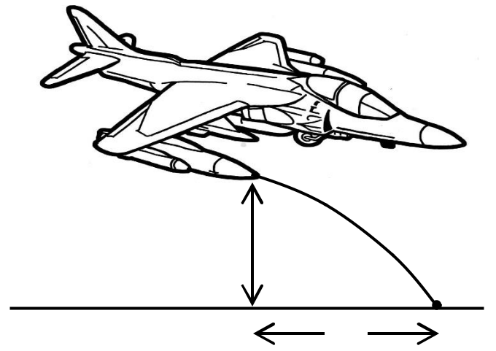

2km

Fig. 1

x
 | Find the;
 | (i) | distance x moved by the bomb. | (03marks)
 | (ii) | velocity with which the bomb is moving on striking the ground. | (04marks)
2. | (a) (i) | State Pascal’s principle of transmission of pressure. | (01mark)

- Describe an experiment to verify Pascal’s principle of transmission of

pressure

(03marks)

(b)

(i)

(ii)

Explain why it is difficult to take a drink using a straw with a hole.

State two uses of pressure measurement.

(02marks)

(02marks)

- A U – tube of cross – sectional area 0.5cm² has some mercury first poured in, then 7cm³ of liquid X is poured through one limb and 4.5cm³ of liquid Y is poured through the other limb. If liquid X has a density of 1000kgm⁻³ and liquid Y has a density of 800kgm⁻³, calculate the;
 |  | (i) | difference in levels between the mercury surfaces. | (05marks)
 |  | (iii) | difference in levels between the surfaces of liquid X and Y. | (01mark)
3. | (a) | (i) | What is diffusion? | (01mark)

  - Describe an experiment to demonstrate the diffusion of a solute in a solvent. (04marks)
- Explain what happens to the molecules of a heated solid as more and more

heat is added.

(03marks)

(c)

(i) Define a spring constant. (01mark)

- A 5.0 cm long spring was used in an experiment. When a 200g mass was suspended using a mass hanger on the spring its new length became 6.5 cm. When the mass on the hanger was changed to 410g, the length of the spring
changed to 8.0cm. Calculate the constant, K, of the spring. (04marks)

2

 | (d) | State two ways how concrete may be made to withstand tensional forces. | (02marks)
4. | (a) | Define resonance as applied to sound waves. | (01mark)
 | (b) | Describe an experiment to demonstrate resonance in an air tube. | (04marks)

- Figure 2 shows a cross section of a ripple tank in which A is a straight dipper attached to a vibrator and B is a barrier with two gaps.

A |  | B

Fig. 2

- Sketch the diagram showing the waves produced when A vibrates

perpendicular to the water surface.

(ii) State two properties of waves shown in your diagram.

(02marks)

(02marks)

- Sound of frequency 264 Hz has a velocity of 320ms⁻¹. At a later time, the temperature changed and the velocity increased to 330ms⁻¹.
 |  | Calculate the change in wave length and explain why increase in temperature
 |  | increases velocity of sound. | (05marks)
 | (e) | State two applications of beats. | (02marks)
5. | (a) | State the conditions for total internal reflection to occur. | (02marks)

- Figure 3 shows light incident on a glass prism and refracted.
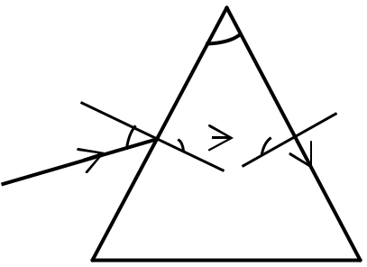

60⁰

 | 40⁰
 |  | Fig. 3
Find the size of angle .
(c) Using a ray diagram show how a converging lens is used as a magnifying glass. |  |  | (03marks)
(d) Distinguish between secondary and primary colours. |  |  | (02marks)

- Explain why an object illuminated by white light appears

 | (i) | black |  | (02marks)
 | (ii) | coloured |  | (02marks)
6. | (a) | (i) | Define specific latent heat of fusion of a solid. | (01mark)
 |  | (ii) | Describe a simple experiment to determine the specific latent heat of
 |  |  | fusion of ice using an electric current. | (06marks)

- 1.8kg of water is put in an ice making machine. If the water is at 40⁰C and the machine removes heat at a rate of 200J/s, how long would it take to convert it into
ice at 15⁰ C ? (specific latent heat capacity of ice = 336,000Jkg⁻¹¹
specific heat capacity of ice = 2,100Jkg⁻¹K⁻¹) | (04marks)
3 | Turn Over

(c) State what happens when salt is added to ice. (01mark)

- Explain how a green house is able to maintain higher temperatures than the

sorroundings.

(03marks)

(e) State one use of forests in the reduction of the green house effect.

(01mark)

7. (a) Define

- Self induced emf.

(ii) Mutual induction

(02marks)

(b) With the aid of a diagram, describe the action of a step up transformer. (05marks)

- Explain briefly how power is transported from Owen falls dam to your home. (03marks)

(e) A cell of Emf, and internal resistance, is connected to resistors of |  |  |  |  |  |  |  |  |  |  |  |  | ,
and | as shown in figure 4.

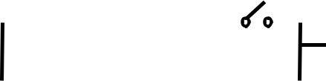
 |  |  |  |  | Fig. 4
When switch is open, the ammeter reads 2.00A and when |  |  |  |  |  | is closed, ammeter reads
2.64A. Calcuate:
(i) | internal resistance, of the battery. |  |  |  |  | (04marks)

- energy lost per second in driving current through the cell when the switch,

is open. (02marks)

- (a) What is meant by;

 | (i) | Photo electric emission |  |  |  |  | (01mark)
 | (ii) | Thermionic emission |  |  |  |  | (01mark)
(b) | List two applications of photo cells. |  |  |  |  |  | (02marks)
(c) | State the energy changes that take place in an |  |  |  | ray tube. |  | (02marks)
(d) | (i) | Explain how intensity and penetrating power of |  |  |  | rays produced in
 |  | an | ray tube may be varied. |  |  |  | (03marks)
 | (ii) | Briefly describe how |  | rays may be used to locate the broken part of
 |  | a bone. |  |  |  |  | (03marks)
(e) | Uranium |  | decays according to the nuclear equation below.


Find the values of and . (03marks)

(f) Give one advantage of a Cathode Ray Oscilloscope (C.R.O) as a voltmeter. (01mark)

END

4

