456/2

MATHEMATICS

Paper 2

Nov./Dec. 2020

2½ hours

SERERE TOWNSHIP SECONDARY SCHOOL

MOCK EXAMINATIONS 2020

Uganda Certificate of Education

MATHEMATICS

Paper 2

2 hours 30 minutes

INSTRUCTIONS TO CANDIDATES:

Answer all questions in section A and any five questions from section B.

Any additional question(s) answered will not be marked.

All necessary calculations must be done in the answer booklet provided; therefore, no paper should be given for rough work.

Squared paper is provided.

Silent, non – programmable scientific calculators and mathematical tables with a list of formulae may be used.

Neat work is a must!!

Turn Over

SECTION A: (40 MARKS)

Answer all questions in this section.

- Without using mathematical tables or calculators, simplify
 | ( |  | ₎ ⁄ | ( |  | ) ⁄ | (04 marks)
2. | Find the equation of the line which passes through the point ( |  |  |  |  |  | ) and is parallel to the line
 | whose equation is |  |  | . |  |  | (04 marks)

- The marked price of a gas cooker is sh. 450,000. A dealer charges 20% more under hire purchase. If the deposit is sh. 40,000, calculate the amount of monthly installments if there are

 | 10 equal installments. |  |  |  |  |  |  |  |  | (04 marks)
4. | Three points , | and C have position vectors ( |  |  |  |  | ) , ( )and ( |  |  | ) respectively.
 | Given that |  |  | ; find the values of |  |  | and . |  |  | (04 marks)
5. | Given that | √ |  | ; find the value of ( |  |  |  | ) |  | (04 marks)
6. | If ( ) |  |  | , show that | ( | ) | ( |  | ). | (04 marks)
7. | In a class of 30 girls, 18 play Netball ( |  |  |  | ) and 14 play Hockey ( |  |  |  |  | ) while 5 play neither.
 | Find the number who play both Netball and Hockey. |  |  |  |  |  |  |  |  | (04 marks)

- A birthday cake is in the shape of a cuboid 10cm long, 6cm wide and 4cm high.

The cake is packed in a similar box 24cm wide. Calculate the surface area of the box.

(04 marks)
9. is a rhombus with ( ), ( ) and ( ). Find the coordinates of vertex .

(04 marks)

- The net of a triangular prism is shown in the figure below.
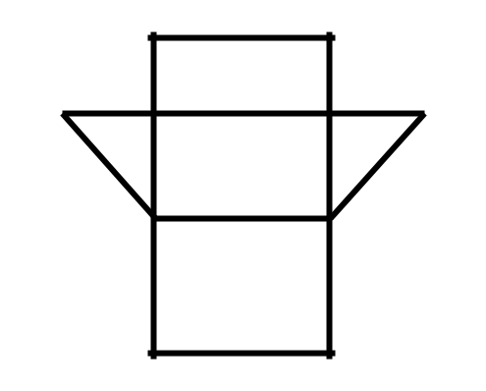

′

′

′
′

(a) Copy and complete the prism (01 mark)

(b) Calculate the total surface area of the prism. (03 marks)

2

SECTION B: (60 MARKS)
Answer any five questions from this section. All questions carry equal marks

- (a)If 45% of the population of Covid -19 Quarantine centre are males and 30% of the males and 40% of the females are under 18 years of age; what percentage are adults? (04 marks)
(b) Without using tables, find the value of ( ) ( ) ( ) (04 marks)

- A cattle farm is located on a rectangular piece of land measuring 7.5km by 6.0km.
On a certain map, its area is 7.2cm². Find the scale of the map. |  |  |  |  |  |  | (04 marks)
12. The functions ( | ), | ( ) and ( ) are defined as |  |  | ( ) | , ( ) | and ( )
(a)Find: (i) |  | ( )
(ii) | √ | ( | )
(iii) |  | ( | ) |  |  |  | (08 marks)
(b)Determine the value of |  |  |  | for which( ) | ( | ) | (04 marks)

- In a survey carried out by the Ministry of Health at Entebbe International Airport on 150 travelers, it was discovered that 40 had visited Dubai (D), 35 had visited Wuhan (W) and 60 had visited New York (N). 7 had visited D and W, 10 had visited W and N and 4 had visited D and N while 34 had visited other cities other than the above three.

(a) Represent the given information on a Venn diagram. (06 marks)

- Determine the number of travelers who had visited:
  - all the three cities

  - only one city

(iii) Dubai and Wuhan only. (04 marks)

- If a traveler is selected at random from the Airport, find the probability that the traveler
had visited two cities only. (02 marks)

- An ambulance travels from Mulago to Hoima, a distance of 156km at a certain average speed of V km/hr. On the return journey, it increased the average speed by 4 and takes 15 minutes less.

(a) Find the average speed, V from Mulago to Hoima. (06marks)

- Calculate the time taken by the ambulance to travel from Mulago to Hoima. (02marks)

- If the Ambulance left Mulago at exactly 7:30am and rested for 15 minutes at Hoima

before travelling back, at what time did it reach Mulago? (04marks)

- The table below shows the income tax rates of government employees. This is applied after the allowances have been already deducted.

Taxable Monthly Income (Shs) |  |  | Tax rate (%)
0 | 100,000 |  | 0
100,001 |  | 200,000 | 5
200,001 |  | 300,000 | 10
300,001 |  | 450,000 | 20
450,001 |  | 550,000 | 30
550,001 and above |  |  | 50

³ Turn Over


An employee has a gross monthly income of sh. 600,000 and is entitled to the following allowances.

- | Marriage allowances | : | Sh. 120,000 per annum.
- | Housing and transport | : | 10% of the gross monthly income
- | Medical care | : | sh. 240,000 per annum

Calculate the:
(a) | amount an employee pays as monthly income tax |  |  |  |  |  |  |  |  |  | (10 marks)
(b) | net monthly income |  |  |  |  |  |  |  |  |  | (02marks)
16. In a parallelogram |  |  |  | , | is the mid-point of |  |  | . | is a point on diagonal |  | such that
 |  |  | and | is a point on |  | such that |  |  | . is also the point of intersection of
AC and MY. |  |  |  |  | , |  | and | .
(a)Express in terms of |  |  |  |  | and | the vectors
 | (i) |  |  |  |  | (ii) |  |  | (iii) |  | (05marks)
(b)Find the values of |  |  |  |  | and | hence show that the ratio |  |  |  | . | (07marks)
17. In the figure below, |  |  |  |  | is a lamp shed bounded by circles of radii |  |  |  |  | and | .
The lamp shed was cut from a cone |  |  |  |  |  |  | .

25cm

If , Calculate the;

- (i) length

  - angle formed by producing

- volume of the lamp shed.

15cm
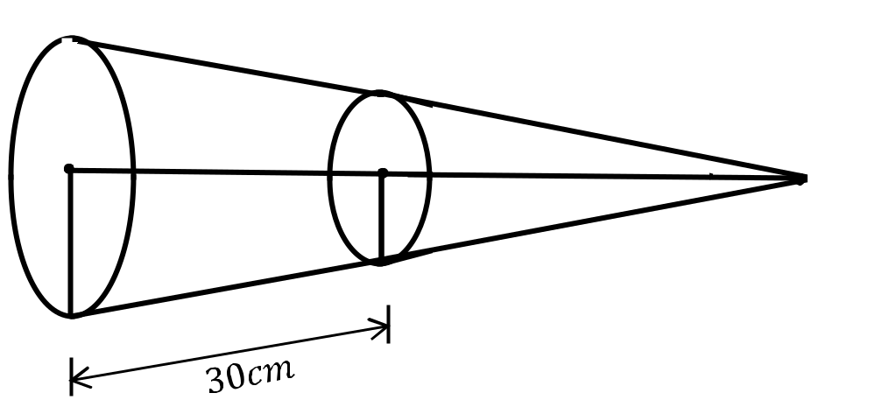

and to . (07marks)

(05marks)

4

