273/2

GEOGRAPHY

Paper 2

Nov./Dec. 2020

2½ hours

SERERE TOWNSHIP SECONDARY SCHOOL

MOCK EXAMINATIONS 2020

Uganda Certificate of Education

GEOGRAPHY

Paper 2

2 hours 30minutes

INSTRUCTIONS TO CANDIDATES:

Answer four questions only.

Choose two questions from Part I and two from part II

In part II, only one question should be chosen from any one region.

Any additional question (s) answered will not be marked.

Turn Over

PART I: THE REST OF AFRICA
Answer two questions in this part.

- (a)Draw a sketch map of Africa and on it mark and name:

  - Highlands: Drankensburg and Futa Jalon.

  - Basin: Victoria and ElDjouf.

(iii) Prevailing winds: North east trades and south east trades. (08marks)

- Describe the process responsible for the formation of any one highland marked in (a)(i)

 | Above. | (05marks)
(c) | Explain the value of the highland in (b) above to the people of Africa. | (07marks)
(d) | Outline the problems faced by people living in highland areas of Africa. | (05marks)

- (a)Draw a sketch map of Egypt and on it mark and name:

  - water bodies: Red sea and lake Nasser.

  - the Nile delta.

  - industrial centres: Aswan, Cairo and port Alexandria.

(i) Aswan high dam. (08marks)

- Describe the factors that have influenced the location of industrial centres in Egypt. (08marks)

(c) Explain the contribution of industries to the development of Egypt.

(06marks)

(d) Outline the effects of industrialization on the environment in Egypt.

(03marks)

- Study the sketch map of Gabon provided below and answer the questions that follow:
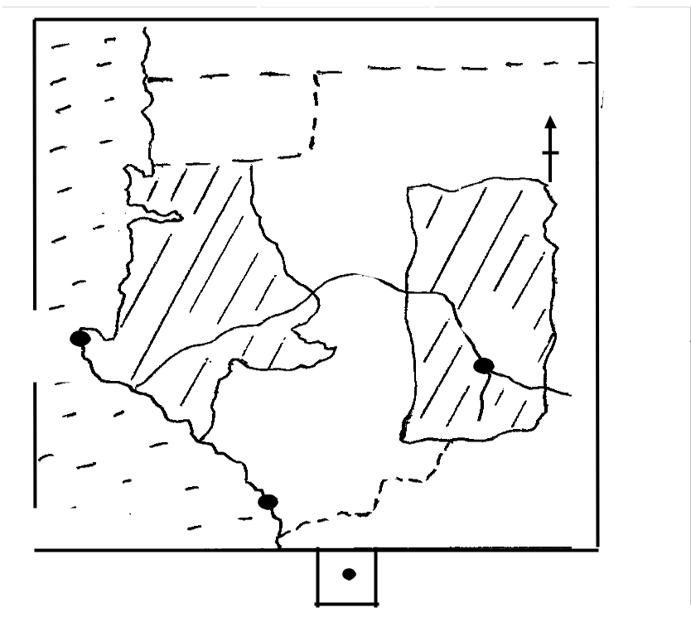
Cameroon

1 | N

 | 6
3 | 4
Mayumba
5 | 2
KEY
Forested areas | Towns

- Name the:

  - Countries marked 1 and 2.

  - Towns marked 3 and 4.

(iii) Water bodies marked 5 and 6. (06marks)

2

(b) | Describe the physical factors that favour forestry in Gabon. | (08marks)
(c) | Explain the problems faced by forestry industry in Gabon. | (06marks)
(d) | Outline the measures taken to solve the problems in (c) above. | (03marks)

- State other two countries in Africa where forestry is a major economic activity. (02marks)

4. | Study the table below showing percentage of total copper exports in Zambia (1990 1994).
 |  | Year | Percentage of total exports
 |  | 1990 | 82
 |  | 1991 | 48
 |  | 1992 | 70
 |  | 1993 | 79
 |  | 1994 | 94

(a) Draw a bar graph to show the information given in the table.

(08marks)

(b) Identify the year with the:

(i) least.
(ii) most.

percentage of total copper exports.

(c) Describe the conditions that favour mining in Zambia.

(d) Explain the problems facing copper mining in Zambia.

(e) Outline any two uses of copper.

(02marks)

(08marks)

(02marks)

(02marks)

PART II: STUDIES IN DEVELOPMENT

Answer two questions from this part

REGION I: NORTH AMERICA

- (a) Draw a sketch map of the area covered by the Tennesse Valley Authority (T.V.A) and on it mark and name:-

  - States: Alabama and Tennessee.
  - Towns: NashVille and Knoxville.

(b)

(c)
(iii) Rivers: Tenessee, Ohio and Mississippi. (08marks)

Explain the reasons for the establishment of the T.V.A. (08marks)

Explain the contribution of the T.V.A to the modernistion of the region. (06marks)

- Name the three areas in East Africa where a river development project has been

Established. (03marks)

³ Turn Over

- Study the sketching of St. Lawrence Sea way provide below and answer the questions that follow:-
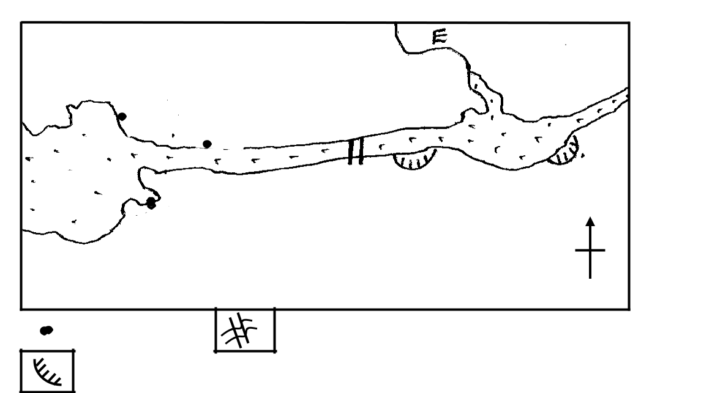

 E

A _{F}
B

G |  | D
G |  | C
 | Water town | N
KEY
Towns |  | Dam
Canals

- Name the:
  - Towns marked A and B
  - Canals marked C and D
  - River marked E
  - Dam marked F
(v) Lake marked G (07marks)

  - Explain the aims and objectives of constructing the St. Lawrence Sea way. (06marks)

  - Describe the conditions that existed along St. Lawrence Sea way before its construction. (06marks)
  - Outline the importance of St. Lawrence Sea way to both Canada and U.S.A. (06marks)

- Study the sketch map of the Canadian Prairies provided below and answer the questions that Follow:-
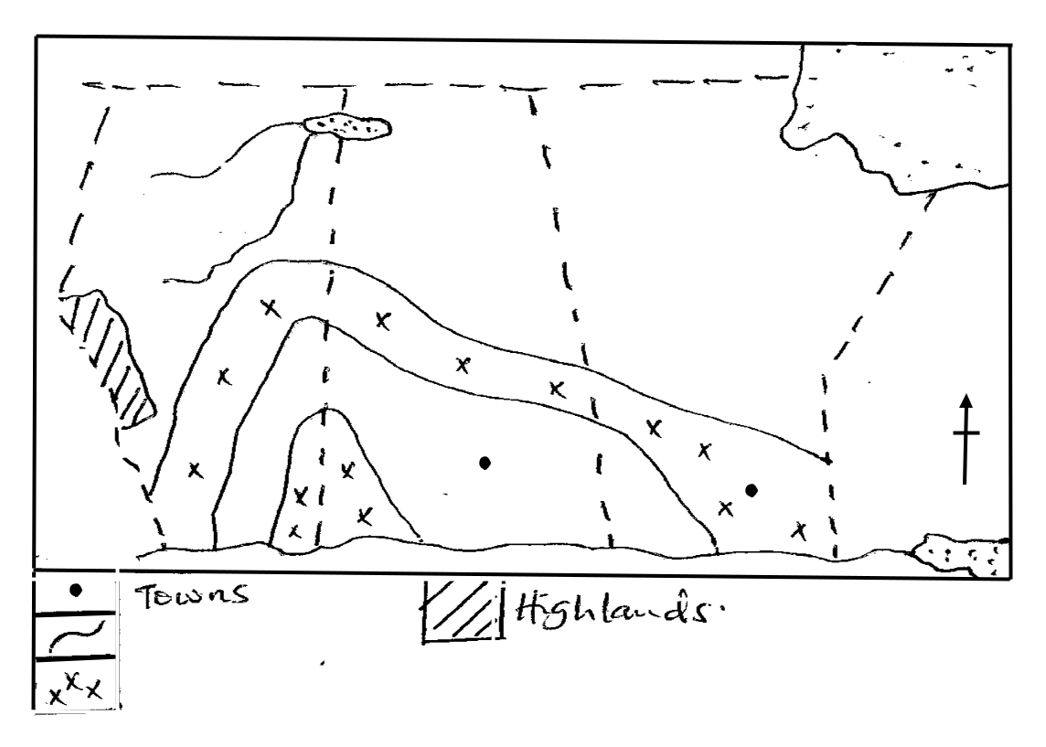

2

5

Hudson Bay

6

 | ONTARIo
7 | N
 | 3
 | 4
 | 1

 |  |  |  | Towns
 |  |  |  | Towns |  |  |  | Highlands
 |  |  |  | Rivers
 |  |  |  | Mixed farming

4

- Name the:

  - Water bodies marked 1 and 2

  - Towns marked 3 and 4

  - Wheat growing provinces marked 5 and 6

(iv) Highlands marked 7 (07marks)

- Describe the physical conditions that favour wheat production in the Canadian Prairies

(08marks)

(c) Explain the problems facing wheat farmers in the Canadian Prairies. (06marks)

(d) Outline the steps being taken to solve the problems in (c) above. (04marks)

REGION II: RHINELANDS

8. (a) Draw a sketch map of Switzerland and on it mark and name

(i) rivers Rhine and Rhone

(ii) lake Geneva

(iii) tourism centres: Davos, Laussane and Zurich (07marks)

(b) Name any two tourist activities in Switzerland during.

(i) Summer

(ii) Winter (04marks)

  - Explain the contribution of the tourism industry to the development of switzerand. (08marks)

  - Outline the problems facing the tourism industry in any one country of the Rhinelands. (06marks)

- Study the sketch map of the Zuiderzee reclamation scheme in the Netherlands and answer the questions that follow:-
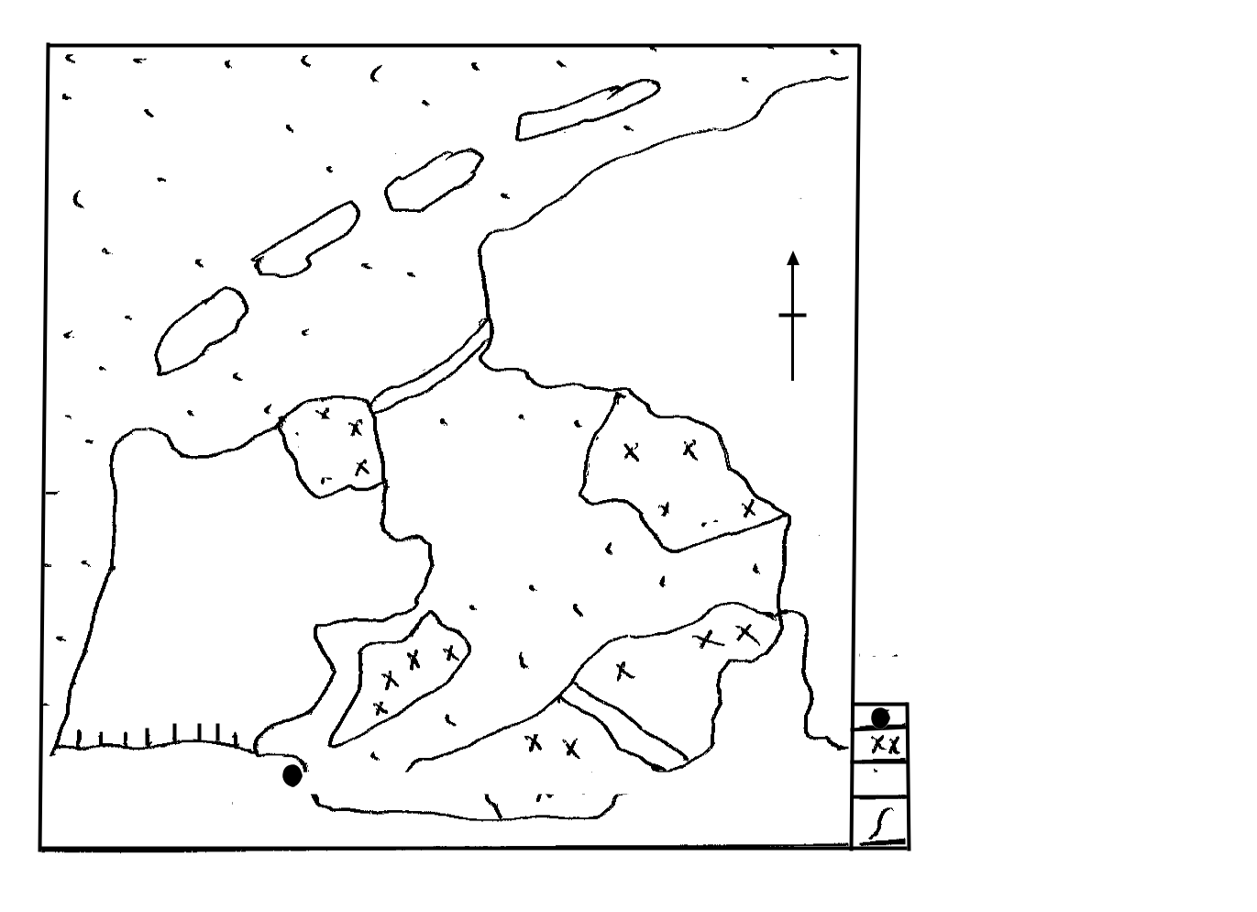

B

N

Barrier dam

CC
Lake | D
Yssel | D

F | G | A | KEY
F | G | A | Town
 |  |  | Polders
E |  |  | Canal
 | 5 |  | River
 | 5 |  | Turn Over
 | 5 |  | Turn Over

- Name the:
  - Water bodies marked A and B
  - Polders marked C, D and G
  - Town narked E
 | (v) | Canal marked F | (07marks)
(b) | Describe the factors that favoured land reclamation in the Netherlands. |  | (08marks)
(c) | Explain the benefits of the Zuiderzee project to the Netherlands. |  | (06marks)
(d) | Outline the problems faced in utilizing polders in the Netherlands. |  | (04marks)
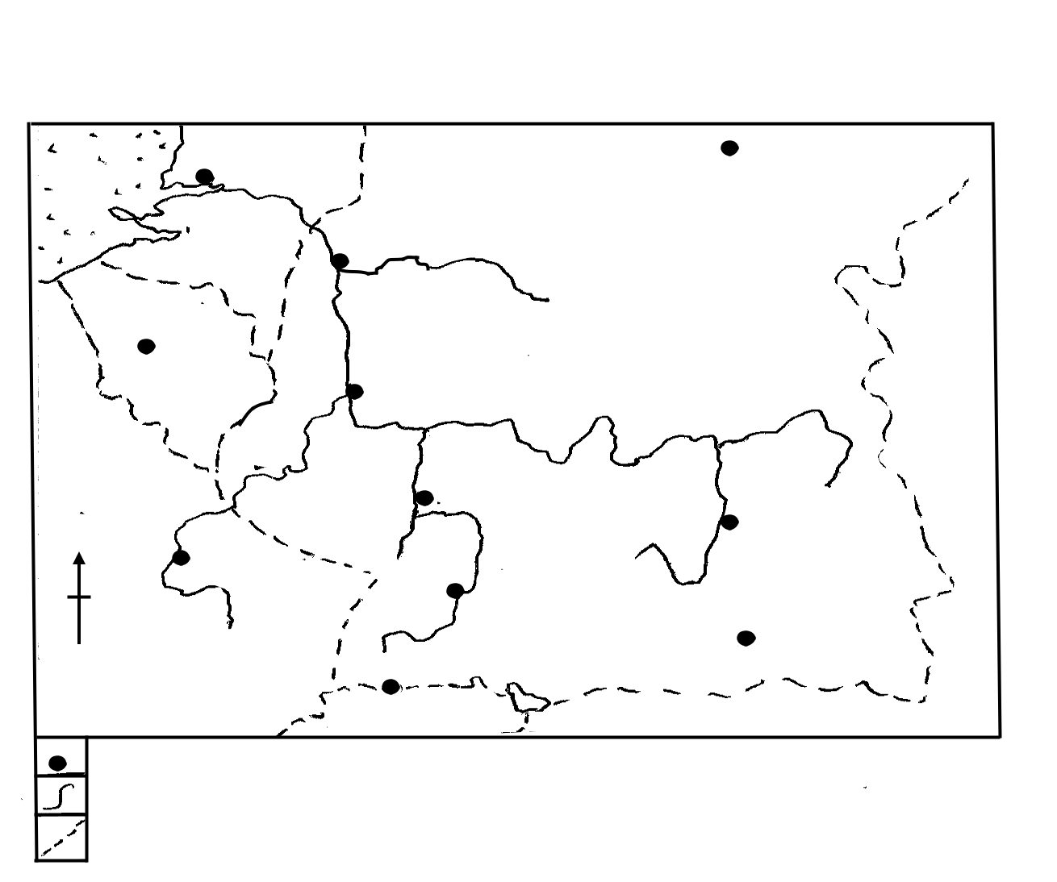

- Study the sketch map of the Rhine water way and answer the questions that follow

C | A | Hannover
G

 |  | Duisbug
 |  |  | B
Brussels
 |  | Koblenz | Polland
France | E
 |  | Manheim | Nurnberg
N |  | F | Nurnberg
N | Nancy | F
 | Nancy | Stuttgart
 |  | D | Munchen
KEY |  | Switzerland
Towns
Rivers
International Boundary

- Name the:

  - River Tributaries marked E and F

  - Ports marked C and D

  - Countries marked A and B

(iv) Sea marked G (07marks)

- Describe the factors which have led to the development of the Rhine into an

international water way. (08marks)

- Explain the importance of the Rhine water way to the development of the Rhine lands. (05marks)
- Outline the:-

(i) challenges faced by using the Rhine water way.

(ii) steps being taken to improve navigation on the Rhine water way.

(03marks)

(02marks)

6

REGION III: CHINA

- (a)Name any three areas of:

  - low population

(ii) High population in China (06marks)

- Describe the factors that influenced population distribution in the areas named in either

(a)(i) or (a)(ii) above. (10marks)
- Explain the problems faced by the people living in highly populated areas named in

(a)(ii) above. (05marks)

(d) Outline the steps being taken to solve the problems in (c) above.

(04marks)

- Study the table below showing the climate of station B in China and answer the questions that follow.

Months | J | F | M | A | M | J | J | A | S | O | N | D
Temperature(⁰C) | 11 | 16 | 9 | 14 | 20 | 29 | 25 | 20 | 8 | 3 | 8 | 14
Precipitation(mm) | 48 | 48 | 96 | 150 | 165 | 245 | 180 | 96 | 70 | 81 | 48 | 26
(a)Draw a suitable graph to represent the information contained in the table. |  |  |  |  |  |  |  |  |  |  | (06marks)

- Calculate the:

  - mean annual temperature

  - mean annual rainfall

 | (iii) annual range of temperature | (04marks)
(c) | Describe the characteristics of the climate of the station. | (08marks)
(d) | Explain the influence of climate on human activities at station B. | (06marks)

- (a)Name any two:

  - winter

  - summer

 | crops in the Yunnan Kweichow region of china. | (04marks)
(b) | Describe the factors that have favoured agriculture in the Yunnan Kweichow region.
 | of china. | (06marks)
(c) | What factors have limited commercial farming in the Yunnan region. | (05marks)
(d) | Explain the steps being taken to develop the Yunnan region. | (10marks)

END

7

8

