456/1

MATHEMATICS

Paper 1

Nov./Dec. 2020

2½ hours

SERERE TOWNSHIP SECODARY SCHOOL

MOCK EXAMINATIONS 2020

Uganda Certificate of Education

MATHEMATICS

Paper 1

2 hours 30minutes

INSTRUCTIONS TO CANDIDATES:

Answer all questions in section A and any five questions from section B.

Any additional question(s) answered will not be marked.

All necessary calculations must be done in the answer booklet provided; therefore, no paper should be given for rough work.

Squared paper is provided.

Silent, non – programmable scientific calculators and mathematical tables with a list of formulae may be used.

Neat work is a must!!

Turn Over

SECTION A: (40 MARKS)

Answer all questions in this section.

1. | Factorize |  | completely. |  |  |  |  | (04 marks)
2. | Solve for in the equation |  |  |  |  |  |  | (04 marks)
2. |  |  | ). Find the inverse of |  |  |  | . | (04 marks)
3. | Given that matrix | ( |  |  |  |  | . | (04 marks)

- The table below shows the ages of army recruits.

Age (years)

Number of recruits

 | Given that the mode is 27.5 and modal class is |  |  |  |  |  |  |  |  |  |  | ; find the value of |  | . (04 marks)
5. | Make the subject of the formula.
 |  |  |  |  | √ |  | ( |  | ) |  |  |  |  | (04 marks)
6. | Given that | ( | ) | ( | ). Find the value of ( |  |  |  |  |  |  |  | ) | (04 marks)
7. | The figure below shows points |  |  | Q | on a circle centre |  |  |  |  |  |  | . Q | is produced to .
 | Angle | and angle |  |  | .
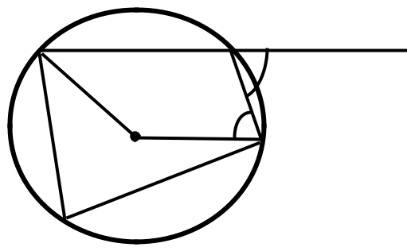

Q

Find the size of angle Q . (04 marks)

- The area of an image is four times the area of the object under a transformation whose
 | matrix is ( | ). Find the value of . | (04 marks)
9. | Catherine is ( | ) years old now; her sister Grace | is 5 years younger but her bother John
 | is twice as old as Catherine. The sum of the two girls is 29. Find John’s age. (04 marks)

10. A metallic pipe 12m long is leaning against a vertical wall, with its foot 3m from the wall. Calculate the;

(a) height of the wall where the pipe reaches.

(b) angle of declination of the pipe to the wall.

(02 marks)

(02 marks)

2

SECTION B: (60 MARKS)

Answer any five questions from this section. All questions carry equal marks.

- (a)The table below shows the number of children in 40 randomly chosen families.

Number of children(x) |  |  | 0 | 1 | 2 | 3 |  | 4 | 5 |  | Over 5 |  | Total
Number of families(f) |  |  | 6 | 8 | 12 | 5 |  | 3 | 6 |  | 0 |  | 40
State the probability that a family chosen at random has;
(i) | more than 2 children |  |  |  | (ii) |  | ( |  |  | ) |  | (05 marks)

- Two tetrahedral dice, with faces labelled 1, 2, 3 and 4, are thrown and the number on which each lands is noted. The ‘score’ is the sum of these two numbers. Find the

probability that:

 | (i) | atleast one die lands on a 3. |  |  |  |  | (ii) |  | the score is even. |  |  |  |  | (07 marks)
12. (a) | Simplify as far as possible. |  |  |  |  |  |  |  |  |  |  |  |  | (04 marks)
(b) | In the figure below, |  |  | is a rectangle with |  |  |  |  |  |  |  |  | and | .
 |  |  |  | . The area of the shaded part is 54 |  |  |  |  |  |  |  |  | .
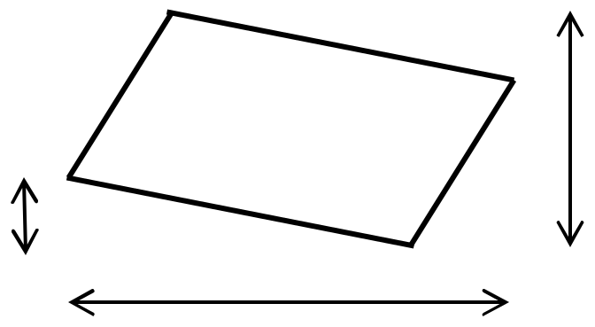

(i) Show that the area of the unshaded part is
(
)

.

(ii) Find the possible values of .

(08 marks)

- A business man who deals in an agricultural produce business visited four markets in a certain week. He bought 3 bags of beans, 5 bags of maize, 10 bags of potatoes and 3 bags of millet from Nakasero market, then 1 bag of beans, 4 bags of potatoes and 2 bags of

millet from Nakawa market while 5 bags of beans and 1 bag of maize from Kalerwe market and lastly 4 bags of beans, 3 bags of maize, 6 bags of potatoes and 1 bag of millet from Busega market. He bought each bag of beans at sh. 45,000, a bag of maize at sh. 30,000, a bag of potatoes at sh. 15,000 and a bag of millet at sh. 50,000.

He later sold all the produce he had bought at sh. 50,000 per bag of beans, sh. 35,000 per bag of maize, sh. 18,000 per bag of potatoes sh. 55,000 per bag of millet.

(a) Write down a:

(i)

(ii)

matrix for the quantity of items bought.

matrix for the price of the produce (02 marks)

- By matrix multiplication, calculate the total amount of money spent on the produce in

all the markets. (04 marks)

- Find the profit made by the business man after the sale of the produce. (06 marks)
³ Turn Over

14. | (a) | Draw a graph of | ( | )( | ) for | . Use a scale of | on
 |  | both axes. |  |  |  |  | (07 marks)
 | (b) | Use your graph to solve the equations
 |  | (i) |  |  | (ii) |  | (05 marks)
15. | In the figure below, |  | and | are tangents from |  | to the circle with centre, | and radius
 | 5cm.
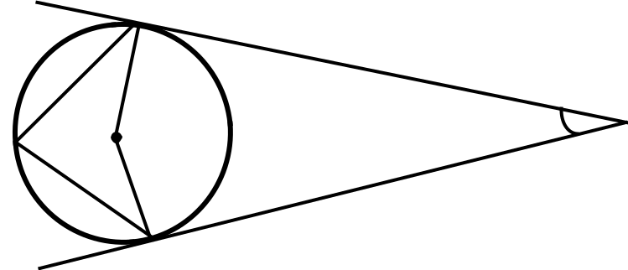

Calculate:
(a) | (i) |  | angle |  | (ii) | length |  |  | (06 marks)
(b) | the area of the shaded part, correct to 2sf. |  |  |  |  |  |  |  | (03 marks)
(c) | the area of the quadrilateral |  |  |  | to the nearest cm². |  |  |  | (03 marks)
16. A triangle |  |  | with vertices ( |  | ), ( | ) and ( | ) is mapped onto triangle
by an enlargement with centre ( |  |  |  |  | ) and scale factor |  | . When | is enlarged by scale
factor |  | , centre ( |  | ), it is mapped onto triangle |  |  | .
(a) | Use a scale of 1cm to represent 1unit on both axes to plot triangle |  |  |  |  |  |  |  | and its images
 | on the same axes. |  |  |  |  |  |  |  | (10 marks)
(b) | Determine the coordinates of the vertices:
 | (i) |  | and |  | (ii) |  | and |  | (02 marks)

- According to the Ministry of Disaster Preparedness, a depot for vulnerable poor relief should have at most 20 bags of beans and 35 bags of flour. The mass, volume and number of meal ratios per bag are as shown in the table below.

Bag of: | Mass (kg) | Volume (m³) | Number of meals
Beans | 25 | 0.05 | 800
Flour | 10 | 0.05 | 160

A delivery van is to carry the largest possible number of bags. It can carry a mass of up to 600kg occupying 2m³.

(a) If a load is made up of bags of beans and inequalities for the given information.

bags of flour, write down six

(05 marks)

- Represent the inequalities on a graph paper by shading the unwanted regions.
(Use a scale of 2cm to represent 5 units on both axes) (04 marks)

- Determine the number of bags of beans and flour that should be delivered to

make the total number of meal ratios the largest. (03 marks)

END

4

