GEOGRAPHY OF UGANDA
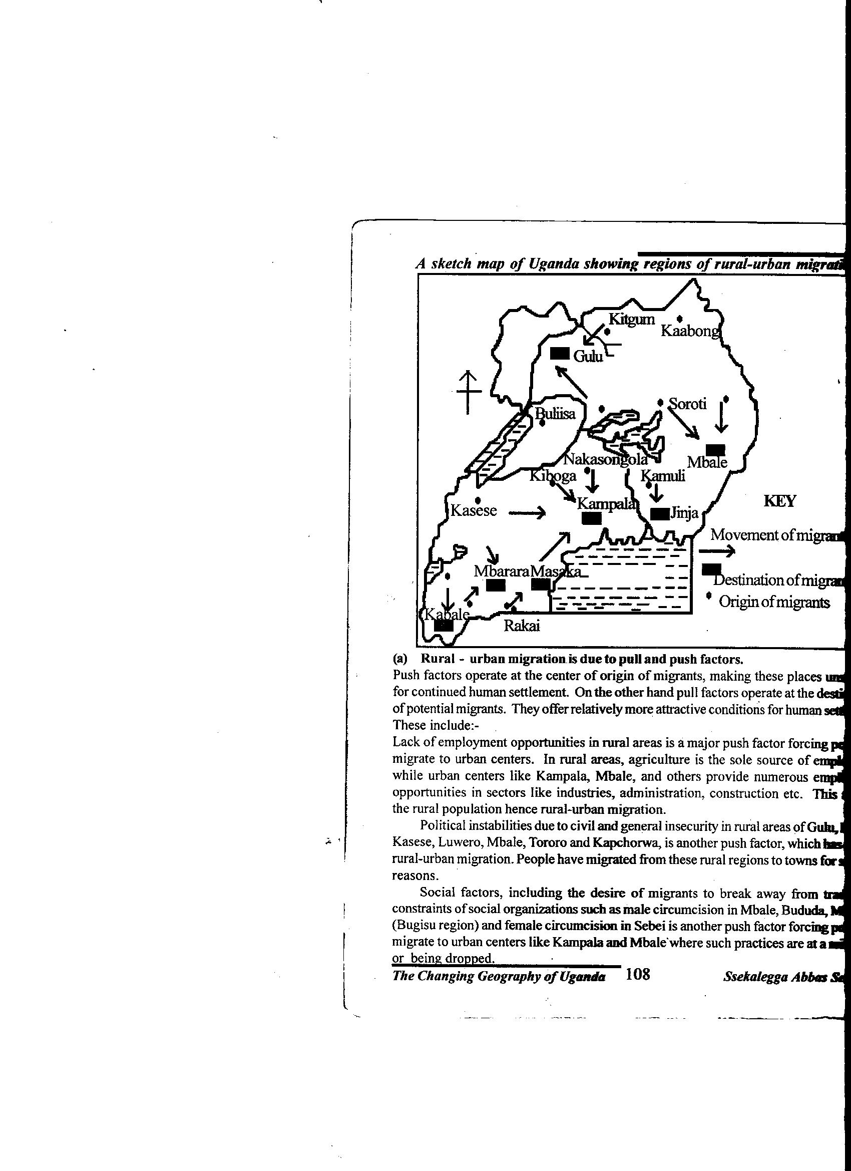
NOTES

Sserugo Thomas
2020 Edition

Acknowledgement
I would like to thank all the geography department members of St. John’s comprehensive SS for the efforts rendered during the compilation of these notes.
Special thanks go to my mum. Nantaba Grace who toiled to make me a geographier using the meager resources she had, you will always keep in my heart mummy.

Dedication
I dedicate this notes book to my children Melvin and Kelvin, and my rib-Beatrice. Thank you for giving me ample time for my research.

Table of content
Content page
- Introduction to Uganda 5
- Relief and land forms of Uganda 8
- Uganda’s drainage 42
- The climate of Uganda 62
- Vegetation and forestry in Uganda 70
- The population of Uganda 91
- Agriculture in Uganda 104
- Water resource of Uganda 138
- Tourism and wildlife resource of Uganda 152
- Mining in Uganda 163
- Industrialization in Uganda 170
- Transport and communication in Uganda 182
- Urbanization in Uganda 193
- Energy resource of Uganda 202
- Desertification in Uganda 206
- Fieldwork study. 210

GEOGRAPHY OF UGANDA P250/3

This paper consists of two sections i.e.
Section A.
This comprises of two fieldwork study questions
A student is supposed to answer one question (25 marks)
Section B.
This comprises of essay type questions and a statistical question.
A student is supposed to answer three questions each carrying 25 marks totaling to 75 marks.

Course Outline
- Introduction to Uganda
- Relief and land forms of Uganda
- Uganda’s drainage
- The climate of Uganda
- Vegetation and forestry in Uganda
- The population of Uganda
- Agriculture in Uganda
- Water resource of Uganda
- Tourism and wildlife resource of Uganda
- Mining in Uganda
- Urbanization in Uganda
- Energy resource of Uganda
- Industrialization in Uganda
- Transport and communication in Uganda
- Desertification in Uganda
- Uganda’s external and internal trade
- Fieldwork study.
Introduction to Uganda
- Uganda is a country that lies in East Africa in the interior of the continent of Africa. It is located astride the equator (0⁰) and extends approximately 4⁰ N to 1⁰S and 30⁰E to 35⁰E.
- Uganda covers a total area of 241,038KM² and it is the smallest with in East African countries of Kenya and Tanzania.
- It is boarded by South Sudan in the north, Democratic Republic of Congo in the west, Rwanda in south west, Tanzania in the south and Kenya in the east. This makes Uganda landlocked.
- Uganda’s population is 34.8m people according to 2015 population census, with the population growth rate of 3.5% per annum and 2.9% death rate.
- It has a population density of 120 persons per square Kilometer and 51% of Uganda’s population consists of children with females greater than males.
- The country depends on a few exports dominated by agricultural products. It is a member of UN, A.U, Common Wealth, P.T.A, COMESA, KBO, EAC, etc.

Location of Uganda with its latitudes and longitudes
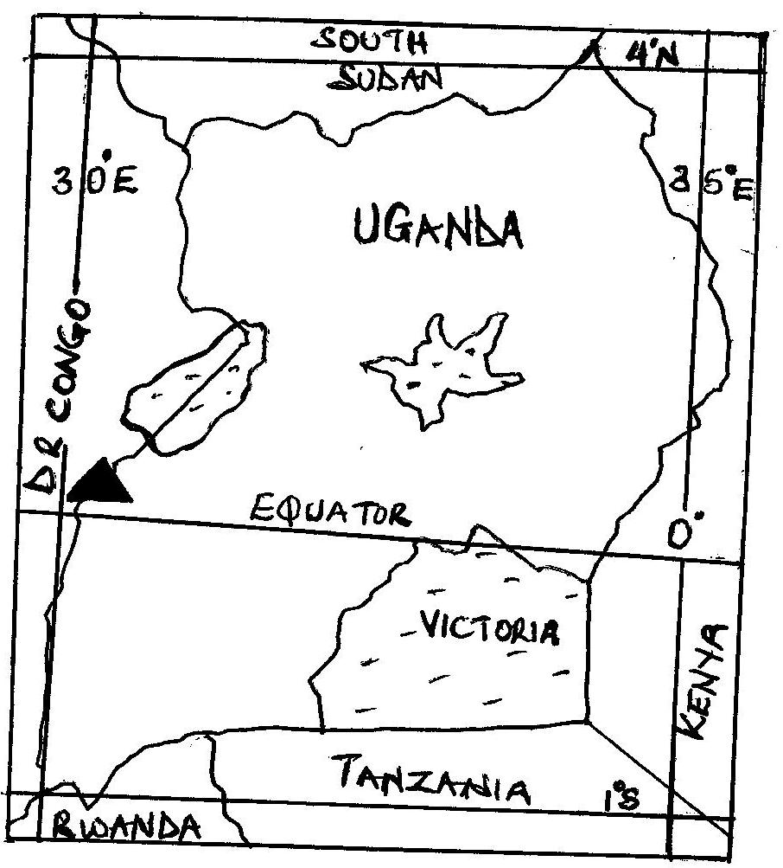

The Evolution of Uganda’s boundaries
The size of Uganda mentioned above was acquired as a result of physical and human manipulations.
- In 1884, there was the Berlin conference were by Africa was partitioned. The present area of Uganda and Kenya was put under IBEACO.
- By 1900, Uganda’s boundaries extended as far as Naivasha, Baringo, Natron, and L. Turkana. And by 1902 the foreigners transferred Kisumu to Kenya. It was decided that Uganda takes part of Mt. Elgon as well as Kenya.
- In 1910, Uganda’s boundaries were extended to cover some part of Zaire to share on Mt. Rwenzori in return Zaire was compensated by getting part of L. Albert and R. Semulik.

- West Nile was part of Sudan by 1914; it was incorporated into Uganda in exchange with a large area north as far as Gondokolo to Sudan. And the reason was to re-unite the small tribe called Tereterenia.

QN. Account for the evolution of Uganda’s boundaries
Approach
- Introduce Uganda by stating her size, location, neighbors and population.
- Draw a map of Uganda locating the above
- Explain the reasons for the shape and size of Uganda giving examples in each.

Factors for the evolution of Uganda’s boundaries
Physical factors
- Mountains such as Muhavura highlands were considered in the south west separating Uganda from Rwanda, Mt. Rwenzori in the west sperating Uganda from DR Congo, Mt. Elgon and Mt. Moroto in the eastern part of Uganda from Kenya, were all considered.
- The western rift valley played a greater role in the west to separate Uganda from Zaire (DR Congo).
- Lakes such as Victoria in the south east separating Uganda from Kenya and Tanzania and L. Albert in the western part of Uganda from DR Congo were considered in the evolution of such boundaries.
- Rivers such as Semulik played a major role in the separation of Uganda from Zaire, and R. Kagera separated Uganda from Tanzania and Rwanda in the south.
- The latitude and longitudes like the Equator (0⁰), 4⁰N, 1⁰S, 30⁰E and 35⁰E all were considered separating Uganda from Kenya, South Sudan, Tanzania, etc.
Human factors
- The tribe groups such as Tereterenia tribe of Sudan separating Uganda from South Sudan, the Bafumbira in south western Uganda from Rwanda, the Banyanya in eastern Uganda from Kenya, all played a major role.
- Politically the colonial rulers wanted to have some shares of the natural resources in the region like it was decided that Uganda and Kenya share on Mt. Elgon and L. Victoria by IBEACO.
- Economically Kigezi area was identified to be with reliable rain fall, mineral potentials and fertile volcanic soils thus separating Uganda from Rwanda.

Relief and landform development in Uganda
- Uganda lies on the African plateau at an average altitude of 1200m above sea level. In Uganda, the lowest altitude is found along L. Albert i.e. 620m above sea level and the elevated areas are found in Rwenzori Mountains i.e. 5000m above sea level.
- Other elevated relief areas are Elgon, Muhavura, and Moroto and much of the western Uganda i.e. Kigezi highlands of between 900m -1500m above sea level.
Uganda’s relief is divided into related divisions i.e.
- Relief below 900m above sea level which constitutes 9% of the total land area of Uganda mainly found around L. Albert in the western rift valley arm.
- Relief between 900m-1500m above sea level which constitutes 84% of the total land area of Uganda majorly found in central, north and north east of Uganda.
- Relief between 1500m-2000m above sea level which constitutes 5% of the total land area of Uganda mainly found in the foot hills of Mt. Elgon and the Kigezi and western Uganda hills.
- Relief above 2000m above sea level which constitutes 2% of the total land area of Uganda majorly found at the peak of Mt. Rwenzori, Elgon Muhavura and Moroto.

Land forms
These were formed mainly due to Tectonism and Denudation processes.
Tectonism
Tectonism/ earth movement refers to all the disturbances of the endogenic origin. The endogenic processes which form what is referred to as tectonism include; Faulting, Vulcanicity, Crustal warping (down warping and uplift), Folding and Earth quakes.
Faulting
- It refers to the process through which the rocks within the earth’s crust are fractured, broken and displaced along the fault lines.
- This form fault land forms such as; The rift valley, Grabens , Rift valley lakes, Block Mountains, Fault scarps, Tilt blocks, Fault guided valley, etc.
- Indirectly, faulting lead to crustal warping, vulcanicity, earth quakes and glaciations.
- Faulting occur due to increased internal pressure and stress within the crust which is brought about by tension and compression forces.
- These forces cause the rock strata to fracture and break into large cracks or joints known as fault lines. There are mainly three types of faults produced i.e.
- Normal fault which is produced by tension forces
- Reversed faults which is produced by compression forces
- Tear faults/strike/wrench which is produced by lateral forces i.e. forces which acted past one another.
It should be noted that tear faulting led to formation of R. Aswa which is a fault guided valley.

Distribution of landforms of faulting in Uganda
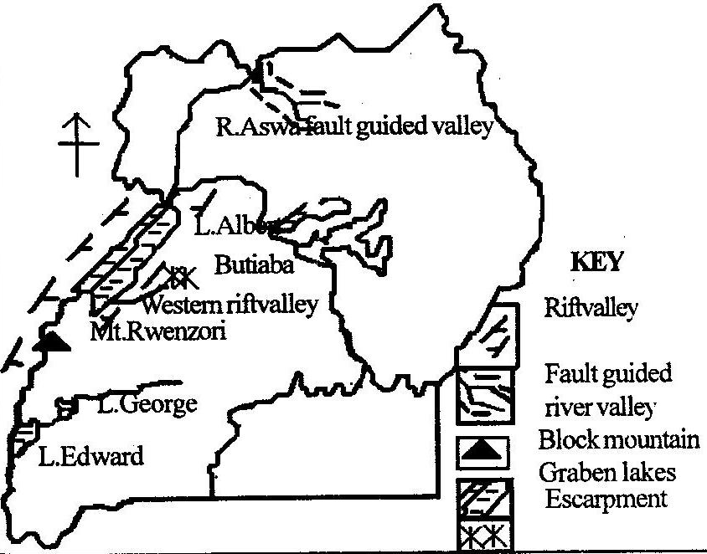
The rift valley and its formation
This is an elongated trough or depression which is boarded by in facing fault scarps on either side.
The western rift valley branch in Uganda covering Kanungu, Rukungiri, Bushenyi, Kasese, Nabbi, Masindi, etc was formed by faulting process.
The formation of the western rift valley
There are different theories put forward to explain the formation of the rift valley. These include;
- The tension force theory.
- The compression force theory
- The plate tectonism theory
- The differential uplift theory
- The basin and swell theory
The tension force theory
According to this theory, the existence of tension forces within the crust led to stretching/pulling of rocks forming fault lines.
This later led to sinking of the middle block along the fault lines to form a trough or an elongated depression as illustrated.
Before tension forces During faulting
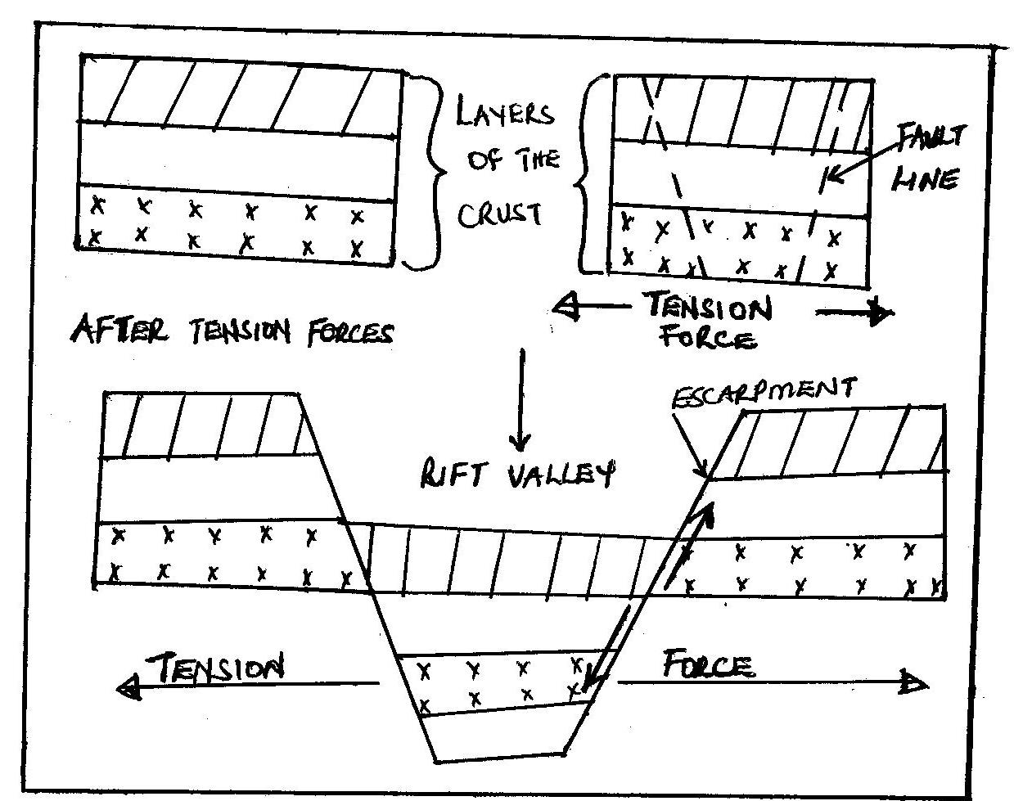

The compression force theory
According to this theory, the existence of compression forces within the crust acted upon/pushed the adjacent blocks forming fault lines.
The central block thrusted against the adjacent blocks forming an elongated depression/rift valley as illustrated.

Before compression forces During faulting
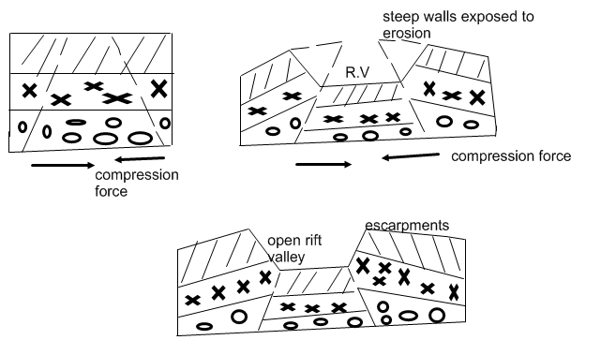

The differential uplift theory
According to this theory, the rift valley was formed due to vertical movement or uplift of various plates/crust along the fault lines.
During the uplift, some plates were slowly uplifted to form a rift valley while other plates were quickly uplifted to form uplands or escarpments as illustrated.
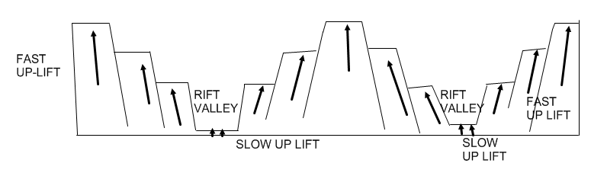

2. The block/horst mountain and its formation.
A horst is formed due to faulting process. It is an upland which is boarded by fault lines on one or more sides and which stands above the general surrounding land.
Mt. Rwenzori in Uganda is an example of a horst and it is sometimes referred to as mountains of the moon due to its high altitude. It has its peak at Margherita i.e. 5110m above sea level.

Formation of a horst
There are several theories put forward to explain the formation of Block Mountains. These include:
- The theory of relative sinking
- The theory of differential uplift
- The theory of topographical inversion.
The theory of relative sinking
This was put forward by Suess and according to him, the earth contracted and some fault blocks settled more slowly than others.
The part of the crust that sunk fast formed depressions while those which sunk slowly formed Block Mountains as illustrated.
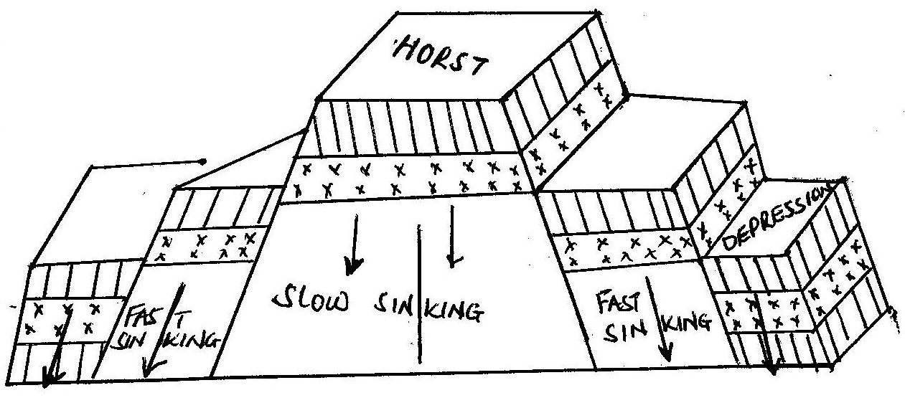

The theory of differential uplift
According to this theory, block faulting occurred extensively which was followed by a general uplift in the faulted region.
The areas which were uplifted very fast formed block mountains while those which were slowly uplifted formed depressions as illustrated
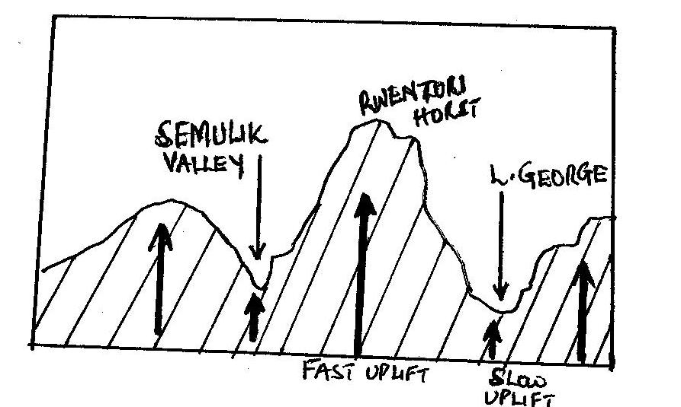
3. Escarpments/fault scarps.
This is a steep slope where the land falls from high to low level. It is a wall of a rift valley.
Examples of escarpments in Uganda include; Kyambura and Bunyaruguru fault scarps in s. western Uganda, Butiaba scarp along and near L. Albert.
Since fault scarps are steep, they are normally destroyed by erosion and weathering agents.
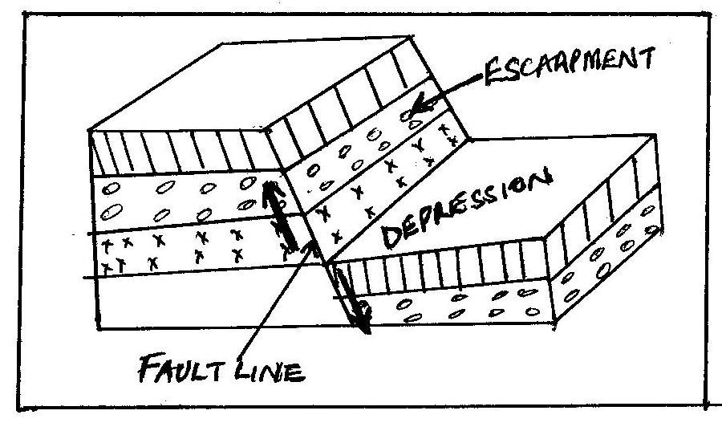

4. Fault guided valley
These are formed due to displacement of rocks along a fault line. The rocks are eroded by the river to create its own valley and channel.
R. Aswa in the north and R. Manafa in the eastern are the best examples of fault guided valleys.

5. Rift valley lakes and grabens.
Grabens are formed due to secondary faulting with in a rift valley. The former rift valley is shaped to become a more defied depression know as a graben.
When grabens are filled with water, they become rift valley lakes. These lakes in Uganda include; L. Albert, L. Edward and L. George.
QN. Examine the influence of faulting on landform development in Uganda.
QN. Give an account of the tectonism process of faulting on relief and landform development in Uganda.
Approach
- Define faulting.
- Mention the three faults, and the features formed by faulting and where they are found.
- Locate the above features on the map of Uganda.
- Explain the formation of all the features mentioned above with aid of diagrams.

Economic importance of faulting in Uganda
The features of rift valley, escarpments, Block Mountain, rift valley lakes, etc formed by faulting have got the following positive and negative contributions to Uganda’s development.

- Development of the tourist industry due to the spectacular sceneries of the western rift valley, Rwenzori horst and fault lakes like Albert. This has helped to develop infrastructure, provision of foreign exchange and jobs to Ugandans.
- The rift valley lakes of Albert, George, and Edward provide great fishing potentials were Ugandans are assured of fish proteins/food, job opportunities and incomes thus high standards of living.
- Rwenzori horst is a source of R. Mubuku, Semulik, and Nyamwamba which provide water for HEP generation like at Mubuku power station, water for irrigation at Mubuku irrigation scheme, industrial water like for Hima Cement factory, etc.
- The rift valley floor has been gazetted into national parks such as Queen Elizabeth, and this has conserved wildlife, boosted tourism for foreign exchange and provided jobs to Ugandans.
- The western rift valley floor provides suitable land for farming, settlement and infrastructural development. For example Mubuku irrigation scheme is well known for crop growing in Kasese thus reduced famine in Uganda.
- The steep slope of Rwenzori horst has favoured the growth of dense forests. Such forests have led to climatic modification i.e. heavy rains for crop growing and development of the forestry industry.
- Rift valley lakes of Albert, Edward and George provide great water transport potential. Foristance L. Albert link Uganda from Butiaba port to Muhanga port in DR Congo. This has led to flourishing trade and international relationship.
- Faulting indirectly influenced the formation of volcanic soils of Kigezi and Mt. Elgon. These soils are very fertile for crop growing like iris growing in kabala and coffee in Mbale. It has also attracted dense settlement in such areas.
- The Rwenzori horst foot hills provide a great potential for mining activities. There was mining of copper in Kilembe-Kasese and now cobalt, this earns Uganda foreign exchange, jobs to Ugandans and infrastructural development.
- Faulting indirectly led to formation of crustal warped lakes of Victoria and Kyoga which are source of fish, navigation and water for industrial use like to Uganda breweries in Luzira, water to Kampala city and for Kajjansi clay crafts.
The short comings of faulting include;
- Faulting increases the rate of earth quakes which leads to loss of property and lives. Foristance Fort Portal and kasese have been fraquently affected by earth quakes.
- Due to high altitude of Rwenzori horst, there is desertification in some parts of Kasese on the lee-ward side of the mountain. This affects crop production in the area.
- The steep escarpments of Rwenzori horst has contributed to the remoteness and inaccessibility of the area around the mountain and this limit trade.
- Faulting leads to formation of deep rift valley lakes such as Albert which restrict fishing activities and navigation. Many people lost their lives while navigating on L. Albert in 2013.
- The steep escarpments like Butiaba scarp of L. Albert and Kicwamba scarp accelerate the rate of erosion which affect crop growing and lead to siltation of water bodies.
- Rift valley soils tend to be poor in terms of crop growing since they are saline. This leads to low agriculture output.
- The rift valley floor is at a low altitude i.e. 900m above sea level like around Albert flats. This cause the area to become dry and with high temperatures.
QN. Assess the contribution of land forms of faulting to the development of Uganda
Approach
- Define faulting and mention the forces of tension and compression.
- Identify the land forms formed by faulting and where they are found.
- Locate the above on the map of Uganda.
- Examine the positive contribution and also the negative.

Crustal warping /Down warping and Up-warping
- The down warping and up-warping of the landscape in Uganda occurred due to an increase in the lateral compression force which affected the earth crust over a wide area.
- Down warping led to the formation of a great basin i.e. Victoria-Kyoga basin and the uplift led to the formation of uplands/plateau.
- Crustal warping also led to a general reversal in the drainage system of Uganda. Rivers such as Katonga, Kagera, Kafu, Mayanja which were originally flowing towards Atlantic Ocean reversed their water due to uplift of western Uganda to over flood the central basin. This led to formation of L. Victoria and Kyoga.
- Other rivers like Ruizi, Nzoia also reversed their flow due to uplift of the eastern Uganda. Other lakes formed include Wamala, Kachera and Kijanabarora.

Illustration of crustal warping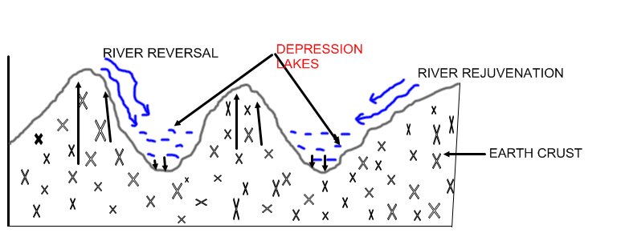

Folding
This is the process through which rocks of the earth’s crust are forced to bend due to lateral compression forces.
Folding process led to formation of anticlines and synclines. It also led to formation of monoclonal folds, asymmetrical folds, and simple folds and over folds.
Folding mainly affected the central, west Nile, Kigezi and Northern Uganda.
Illustration of folding
Before folding During compression forces
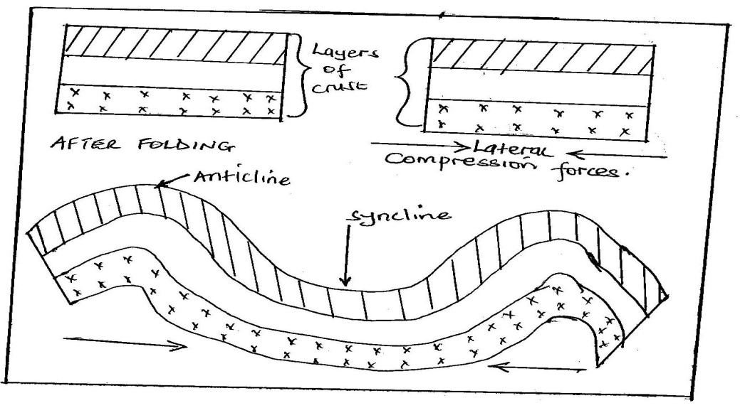
Vulcanicity
It refers to all the total process through which lava and other gaseous materials are either erupted into or onto the earth’s surface to form various relief features.
Vulcanicity leads to formation of two types of relief features i.e. extrusive and intrusive volcanic features.
Distribution of volcanic landforms
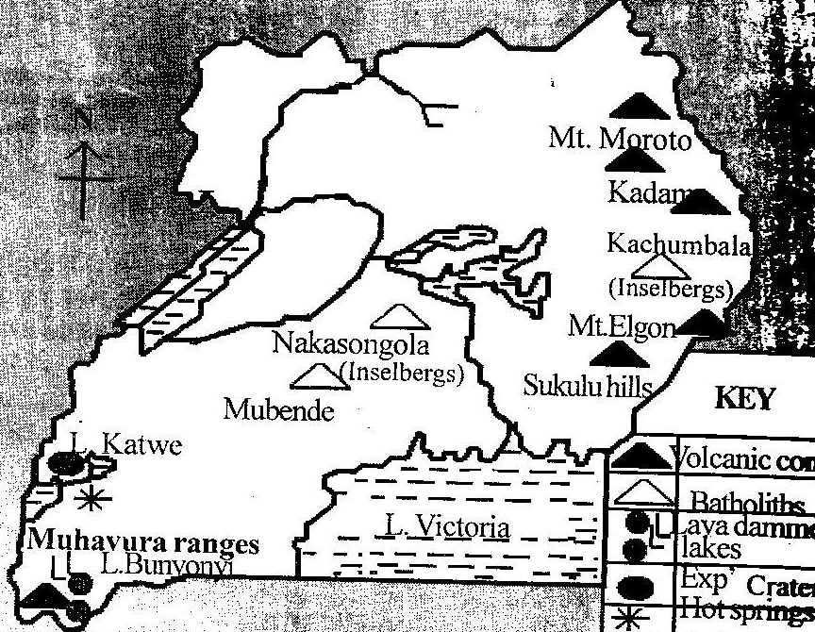

- Extrusive volcanicity
This is the process through which flowing lava and other gaseous materials through a vent are erupted to the earth surface, cools and solidifies to form relief features. Such features include volcanoes, calderas and caldera lakes, explosion craters and crater lakes, volcanic plugs and necks, scoria cones or ash and lava cones, lava dammed lakes and volcanic mud flows, volcanic hot springs, geysers and fumaroles.

- Volcanoes.
This is a hill or mountain which is formed when lava flows through a vent and builds around it into successive layers to form a cone-shaped feature with a crater on top.
Examples of volcanoes include Mt. Elgon, Muhavura and Moroto.
Structure of a volcano
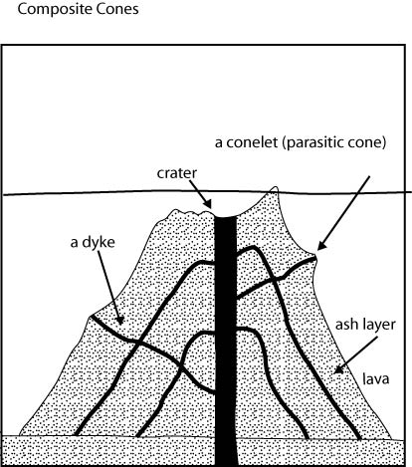s
Volcanoes can be active, dormant, composite, or basalt dome volcanoes. It should be noted that active volcanoes are thought to have erupted recently while dormant volcanoes have not erupted.
Composite volcanoes are made up of alternating layers of ash and lava while basalt domes are large flat topped convex hills formed by basic lava with gently sloping sides like Virunga hills of south western Uganda.
- Caldera and caldera lakes
This is a large rounded depression which is formed when the upper part of a volcano is destroyed by a violent eruption.
When a caldera is filled with water it becomes a caldera lake like Napak caldera in Karamoja. Illustration;
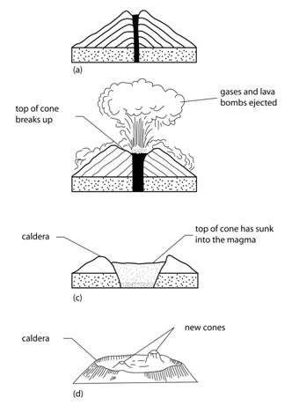
- Explosion crater
It is a shallow flat floored depression which is surrounded by a low rim of pyroclasts (ash and lava) and rock. This is formed as a result of its vent being blown off.
When craters are filled with water it forms crater lakes like L. Katwe, Nyungu, Nyamusingira, Kyamwoga, Nyamunuka, etc in sw Uganda. Illustration;
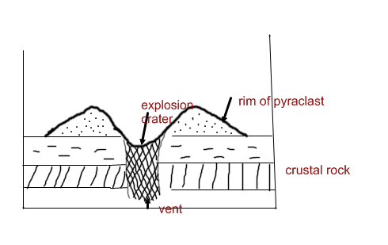
- Volcanic plugs.
This is a cylindrical volcanic feature which is formed by lava which is so vicious and therefore forced to cool and solidify quickly within the vent. Examples include Tororo rock in eastern Uganda, a plug around L. Katwe explosion crater.
When a volcanic plug is destroyed by denudation processes such as erosion, what remains is called a volcanic neck.

- Lava plateau/lava flows.
This is upland with a generally level summit which is made up of successive layers of lava. They are formed due to basic lava
- Lava dammed lakes.
These are formed when flowing lava blocks part of the river valley, forcing it to over flood its valley like L. Bunyonyi in Kabale.
- Volcanic hot spring.
This is formed when water come into contact with heated rocks underground and they result into a spring of hot water on the earth’s surface. Examples include sempaya hot sping in Bundibugyo, Kitagata in Bushenyi, Rubaale hot spring in Ntugamo.illustration;
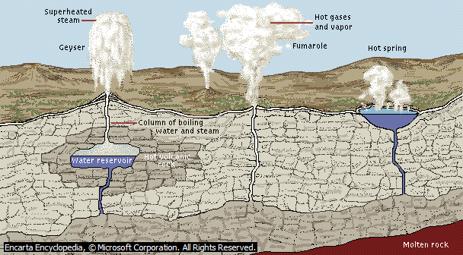
- Geyser.
This is formed when hot water and steam are ejected out of the earth crust periodically in a violent form.
- Intrusive volcanicity.
This is a process by which flowing magma fails to reach the earth’s surface but instead cools and solidifies within the crust to form relief features. Such features include sills, dykes, batholiths, laccolith, ring complex, etc.
- Sill.
It is formed when flowing lava flows along the bedding planes of sedimentary rocks by forcing them apart. Examples include Mubende hills in western Uganda, sukulu hills near Tororo in eastern Uganda. Illustration;
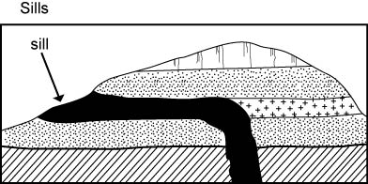
- Dyke.
This is a wall like structure which is vertically inclined rock sheet. Examples are found in Mubende hills and Sukulu hills. Illustration;
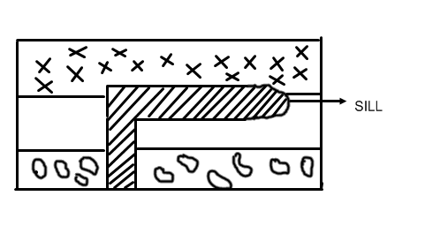
- Batholiths
This is formed when flowing lava cools and solidifies at a great depth within the crust forming a massive volcanic rock.
When batholith rocks are exposed to the surface by denudation forces of weathering and erosion, they form granitic tors or inselbergs.
Examples of batholiths include Mubende hills, Kikandwa and Kawungere batholiths in central Uganda, Singo batholiths, Laabowr ranges and Parabong ranges in Northern Uganda, Nakasongola batholiths, etc. illustration;
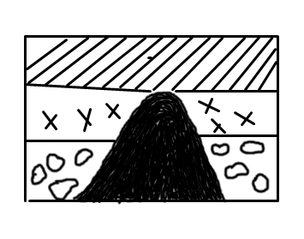
- Laccolith
This is a dome shapped intrusive volcanic feature with a flat topped floor. It is formed when vicious lava fails to spread out and therefore accumulates in a large mass and solidifies very quickly. Illustration;
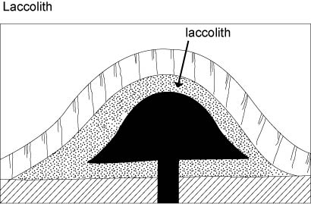
QN To what extent has volcanicity influenced landform development in Uganda?
Approach
- Define volcanicity
- Identify the extrusive volcanic features and where they are found.
- Identify the intrusive volcanic features and where they are found.
- Locate the above on the map of Uganda
- Explain the formation of extrusive volcanic features with aid of diagrams.
- Write that; ‘however there are other processes responsible for landform development in Uganda’
- Then explain the formation of intrusive volcanic features.
- Then explain the formation of features formed by faulting, warping, folding and denudation forces (NB. Here be brief )

The role played by Volccanicity in the Economic development of Uganda.
The features of volcanoes, crater lakes, calderas, hot springs, batholiths etc formed by volcanicity have got the following positive and negative contributions to Uganda’s development.
- Development of the tourist industry due to the spectacular sceneries of the volcanoes like Elgon, Muhavura, hot springs of Sempaya, Kitagata, craters like Nyungu, etc. This has helped to develop infrastructure, provision of foreign exchange and jobs to Ugandans.
- Elgon volcano is a source of R. manafa, masaba, and siti which provide water for domestic use like in mbale and Sironko, water for irrigation at Doho irrigation scheme, industrial water like for Tororo Cement factory, etc.
- The fertile volcanic soils of Kigezi hills, Elgon volcano are suitable for farming, settlement and infrastructural development. For example the slopes of Mt. Elgon are well known for coffee growing thus incomes and forex to Uganda, Kigezi for food crops like vegetables, iris potatoes thus reduced famine in Uganda.
- The slope of Elgon volcano has favoured the growth of dense forests. Such forests have led to climatic modification i.e. heavy rains for crop growing and development of the forestry industry. Also Bwindi impenetrable forests on Muhavura slopes has conserved Mountain golliras and chimpanzees thus development of the tourist industry.
- There is mining of salt in L. Katwe crater, this has earned Uganda foreign exchange, jobs to Ugandans and infrastructural development.
- Hot springs and geysers like sempaya and kitagata are a potential source of geo thermal power.this can be used for home consumption reducing on deforestation for bio mass.
- The wind ward sides of Elgon volcano and kigezi highlands block moist winds for relief rainfall for crop growing. This has ensured constant food production in such areas.

Short comings of volcanism to Uganda’s development
- Volcanic soils lose fertility quickly which affect crop growing since constant cultivation means application of fertilizers which are expensive.
- The lee-ward side of Mt. Elgon in the northern parts of the volcano are dry a disfavor to the development of agriculture.
- Rivers such as Manafa which originate from Elgon volcano do flood during rainy seasons like in 2008 it flooded its banks leading to destruction of people’s property.
- There have been landslides on the slopes of Elgon volcano like in Bududa and Bulambuli killing many people and destroying property.
- Crater lakes water like that of L. Katwe is saline less suitable for domestic use. The water is also dangerous to the people carrying out mining activities especially women.

Distribution of landforms formed as a result of Tectonism
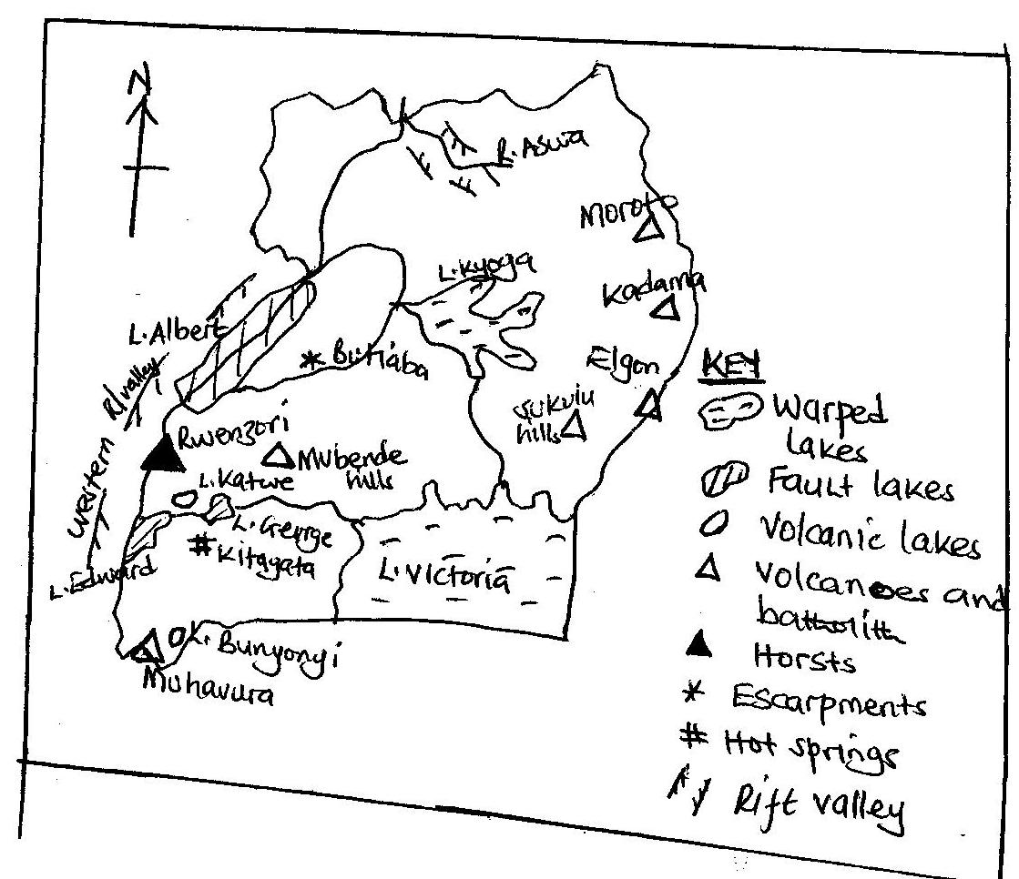
Economic importance of tectonism in Uganda
Tectonism through its processes of faulting, volcanicity, crustal warping, earth quakes, etc, led to formation of different land forms in Uganda such as rift valley, horsts, volcanoes, craters, plateau, basins, grabens, etc.
Such features formed have got both positive and negative contributions to Uganda’s development as discussed below.
- Volcanicity led to formation of very fertile volcanic soils like around M.t Elgon, Kigezi and Muhavura.this has flourished farming especially plantations like tea in Mubende, rice in Kibimba,food crops in Kigezi, etc.
- There is mining of salt in L. Katwe, copper and cobalt on the foot hills of Rwenzori horst, sand and clay mining from L. Victoria shores, limestone in Tororo rock thus jobs, incomes and foreign exchange to Uganda.
- Volcanoes like Mt. Elgon, Rwenzori horst and fault lakes like Albert, crustal lakes of Victoria and Kyoga, hot springs of kitagata, all provide beautiful scenery for tourism attraction. This has earned Uganda foreign exchange, jobs and international relationship for development.
- Crustal warped lakes of Victoria and Kyoga, rift valley lakes like Albert and George are potential source of fish which provide proteins, jobs to fishermen, and develops fishing industry for economy diversification.
- Lakes formed as a result of tectonism like Victoria connect Uganda to Kenya and Tanzania, L. Albert link Uganda to DR Congo, this has promoted trade and led to international relationship.
- The glaciated Rwenzori horst and Elgon volcano are source of rivers such as Mubuku and Manafa respectively. Such rivers are potential source of HEP like Mubuku power station in Kasese and water for irrigation like to Doho by R. Manafa for industrial growth and food respectively.
- The slopes of uplands formed such as Rwenzori, Elgon and Muhavura ranges, facilitates the development of a dense forest which conserve wildlife, wild birds like Mgahinga forests (Mt. golliras) on Muhavura ranges. Forests also provide wood fuel and timber especially to rural people of Kisoro and Kasese.
- The Rwenzori horst, Elgon volcano, etc modify the climate through relief rainfall formation which is heavy and reliable on the wind ward side. This facilitates flourishing farming like on the foot hills of Mt. Elgon.
- The folded highlands provide excellent grounds for population settlement. For example the folded hills of central Uganda like in Kampala have attracted settlement on Ntinda, Mengo, Rubaga and Namirembe hills.
The short comings of tectonism include;
- The uplands formed tend to be steep limiting the construction of transport networks. This tends to lead to remoteness and inaccessibility of some areas in Uganda like some parts of Kasese and in kisoro s.w Uganda.
- Volcanoes such as Elgon are prune to landslides as it was in Bududa eastern Uganda and Sironko district. This leads to property destruction and loss of life.
- The highlands formed such as Rwenzori and Moroto create a negative climatic situation of rain shadow (lee-ward effect). The absence of rain in such areas discourages crop growing and settlement in some parts of Kasese.
- Young soils formed through the volcanic process tend to be porous and easily eroded once produced like in Kisoro. Such soils are infertile limiting crop growing.
- Mountains such as Rwenzori and Elgon are source of rivers like Nyamwamba and Manafa respectively which flood leading to loss of lives and property as it was in Kasese in 2014.
QN. Examine the role played by tectonism in the economic development of Uganda.
Approach
- Define tectonism.
- Mention the processes of tectonism and identify the land forms formed by such processes and where they are found.
- Locate the features identified on a map of Uganda.
- Explain the positive and then the negative contributions of the features.
- Remember to give relevant examples.
QN. Explain the effect of tectonism on the relief and landform development in Uganda.
- Define tectonism.
- Mention the processes of tectonism and identify the land forms formed by such processes and where they are found.
- Locate the features identified on a map of Uganda.
- Explain with aid of diagrams the formation of the above features.

Denudation processes
Denudation refers to all processes through which the surface of the earth is subjected to destruction by various forces. These forces include; Glaciations, Weathering, Mass wasting and Soil erosion.
- Glaciations
This is a denudation process by which glaciers as an agent of erosion and deposition lead to formation of various features in the highland areas of Rwenzori.
A glacier is a mass of ice in motion. Some of the glaciers include valley glaciers/montane glaciers, piedmont glaciers and cirque glaciers which occupy basins on the mountain slopes.
The features formed by glaciers are both erosion and deposition, i.e.
Erosion glacial features
Erosion by glaciers takes place in two processes i.e. plucking and abrasion.
Plucking is the process by which part of the underlying rocks are frozen into the base of the ice and then pulled off.
Abrasion is the grinding process in which stones and other rock debris which are frozen into the base of a glacier are dragged over the rock floor.
Some of the erosion glacial features in Uganda include pyramidal peak or horn, arêtes or ridges, cirque or corrie, glacial trough or u-shaped valley, hanging valley, Roche montane and crag and tail.
A pyramidal peak is a steep sided feature which is surrounded by a series of radiating arêtes. It is formed by head ward erosion of cirques from all sides. In Uganda horns on Mt. Rwenzori include Margherita peak, Albert peak, Speke peak, Alexandria peak and Baker pyramidal peak.
An arête is a narrow steep sided rocky ridge that separate two cirques. It is formed by back wall recession of cirques into the mountain side. Examples on Mt. Rwenzori can be traced in Mugusu and Bujuku valley.
A cirque is a semi-circular steep sided rock basin which is cut into the valley head on mountain side by the flowing glacier. Examples on Mt. Rwenzori are Lac du Speke in Bujuku valley, Lac Catherine and Lac Noir.
A glacial trough is a broad flat bottomed steep sided valley with a roughly u-shaped cross section. It is formed due to over deepening of the original valley by an advancing strong glacier. Examples on Mt. Rwenzori include Mubuku glacial trough, Kamusoso, Bujuku and Lusilube glacial trough.
A hanging valley is an in-facing steep sided feature which is facing the glacial trough. Examples on Mt. Rwenzori are found in Bujuku, Mubuku and Mugusu Glacial troughs.
A Roche montane is a resistance rock mass which rises above the general plain. It is found on the foot hills of Mt. Rwenzori along Mubuku valley.
A crag and tail is an elongated rock mass which is formed when the flowing glaciers meet a resistant rock out crop protecting a soft rock on its lee side. This can be traced in the Rwenzori mountain Bujuku glacial trough.
The structure of some glacial erosion features on Mt. Rwenzori
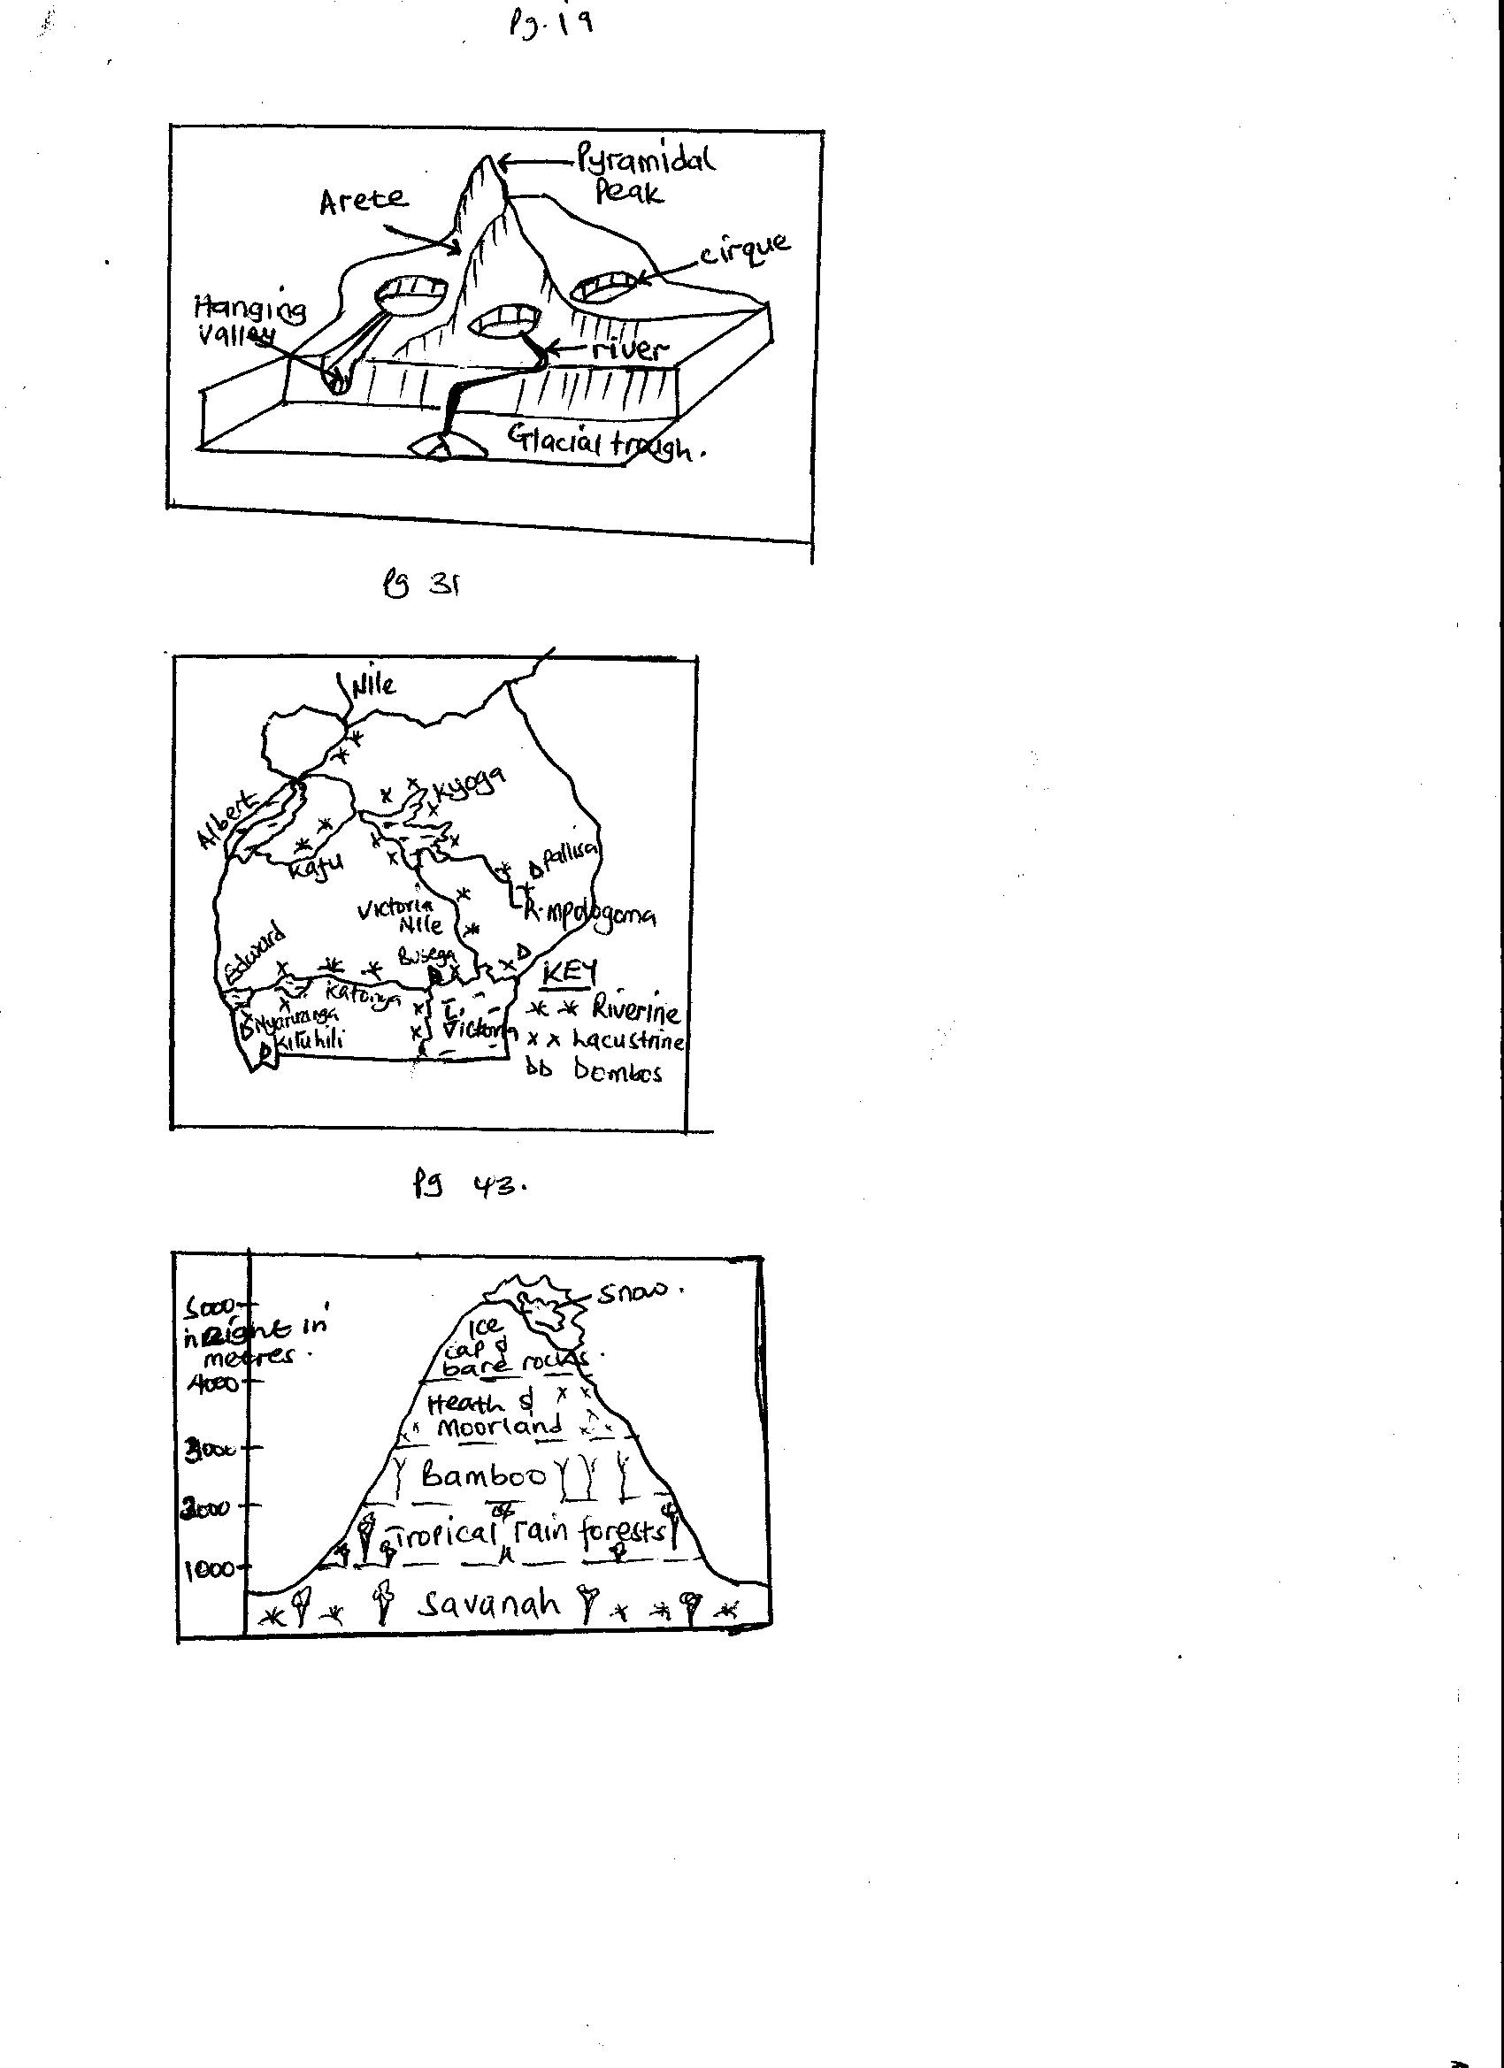

Glacial deposition features.
During glacial erosion, glaciers transport their eroded materials through the following ways;
- Lateral moraine, which is materials which are transported on the sides of the glacier.
- Medial moraine, that is when two adjacent glaciers join together to form a middle moraine on top of the glacier.
- Basal moraine, this is where certain proportion of englacial moraine may reach the bottom bed of the glacier.
- Englacial moraine, this is where materials which fall into crevasses are enclosed within the glacial.
- Terminal moraine, this is materials transported using the snout which it uses to push the debris.
When a glacier transports and deposits the moraine , it leads to formation of glacial deposition features. Such features include till plains, moraines and erratic, out wash plains, eskers, kame and kame terraces and kettle holes.
A till plain is an extensive area of monotonous relief which is formed as a result of constant deposition by the glacier as its retreats.
Moraines refer to all materials carried by the flowing glacier and later deposited.
Erratic are boulders which originally were being transported by the flowing glacier and later deposited all together in a different area.
Economic importance of glaciations in Uganda
- The spectacular scenery of cirques, arêtes, and pyramidal peaks on Mt. Rwenzori attract tourists thus developing the tourist industry for foreign exchange and incomes to Ugandans.
- The glaciers are source of water for rivers such as Mubuku, Nyamwamba and Semilik. These provide water for HEP generation like at Mubuku power station, for irrigation like at Mubuku irrigation scheme, thus industrial development.
- Through the process of evaporation, glaciers modify the climate in the Rwenzori area as it leads to heavy and reliable rainfall. Such rain has helped to support coffee and food crop production in Kasese.
- The deposited moraine and within the glacial troughs of Bujuku and Mubuku on Mt. Rwenzori, there is very fertile soils which has facilitated the development of farming in the area thus food source, incomes to Bakonjo, etc.
- The glacial troughs have got relatively flatlands which have attracted population settlement and easy construction of transport networks of roads. This has made Mubuku and Bujuku areas accessible.
The short comings of glaciations include;
- Glaciers encourage the occurrence of erosion and mass-wasting along the valleys where they are flowing. This may lead to property destruction and loss of lives.
- Such rivers such as Nyamwamba and semulik tend to over flood their valleys destroying property, spreading water borne diseases, blocking roads and loss of lives as it was in Kasese in 2014.
NB. There also coastal landforms formed as a result of erosion and deposition by wave action.
Such include; caves, cliffs, cluffs, arches, stacks, beaches, lagons, sand bars, spits, etc.
Make sure you explain them.
- Weathering
This is a process through which rocks of the crust are increasingly broken down into small portions insitu.
Weathering exists into;
Chemical weathering. This is the breaking down of rocks and their decomposition which change their mineral composition.
Physical weathering. It is a process of weathering where the mineral compositions of the broken rocks do not change.
Biological weathering. This is breaking down of rocks due to the influence of living organisms such as plants and animals.
Weathering has been caused by different factors such as climate, topography, nature of the parent rock, time etc.
Weathering in Uganda has lead to formation of soil and various relief features such as inselbergs, granitic tors and exfoliation domes.
Exfoliation domes are formed as a result of fracturing of the rock surface and eventually peel-off to leave a dome. The fracturing is caused by expansion and contraction of the rock due to changes in temperature. Examples of exfoliation domes can be traced in Mubende, Nakasongola, Kitgum, Karamoja and Soroti.
Granitic tors are formed due to pressure release process. Granite rocks which contain cracks or joints are easily broken down to leave behind a dome known as granitic tor.
Examples in Uganda are found in Mubende, Kachumbala tor in Kumi, Ntungamo granitic tor, etc.
- Mass wasting.
This is the creeping, flowing, falling and sliding of rock debris and other weathered materials down slope under the influence of gravity.
Landslides, is the abrupt falling of rock debris down the slope mainy caused by heavy rains. Landslides are mainly experienced in Elgon slopes in Bududa and in Muhavura ranges.
Factors which influence landslides and mass wasting
- The nature of relief of an area, steep slopes like in Bundibugyo accelerates the rate of landslides and gently sloping areas slows down the rate of mass wasting.
- Deforestation, lumbering and other human activities which clear vegetation on steep slopes accelerates the rate of landslides as it has been in Bududa eastern Uganda.
- Road construction across steep slopes, settlements and farming on steep slopes like in Kisoro s.w Uganda has accelerated the rate of mass wasting.
- The occurrence of tectonism forces of volcanicity, faulting and earth quakes in Fort Portal western Uganda, disturbs the rock structure thus mass wasting.
- Heavy rain fall received in steep sloping areas which deeply saturate the rock debris in the region causing it to fall down wards due to its heavy weight like how it was in Sironko and Bududa in eastern Uganda.
- Highly weathered rocks on steep slopes are easily slided down compared to un-weathered rocks.
- Mining and quarrying which creates steep scarps which later accelerate sliding like in Ntugamo.
Negative effect of landslides
- It leads to loss of lives and property destruction where it has occurred e.g. in Bududa at foot hills of Mt. Elgon.
- It leads to loss of agricultural land since the falling rock debris may cover up the fertile soils.
- There is destruction of important infrastructure such as blocking of roads and railway lines network like in Bundibugyo and Kisoro districts in Uganda.this makes these areas remote and inaccessible.
- Landslides in an area can facilitate flooding in an area which cause water borne diseases such as bilhazia.
Ways of controlling landslides
- Tree planting and reforestating areas on steep slopes damaged by deforestation.
- Educating local people about the dangers of poor practices of farming on steep slopes, deforestation, cultivation and settlement on the steep slopes which cause landslides.
- Introducing and emphasizing the use of better methods of farming like terracing, strip cropping and contour ploughing on steep slopes.
- Filling pits where mining and quarrying have been carried out.
- Strict laws can be formulated to protect steep slopes from being settled, cultivated, etc.
- Soil erosion
This is the process where the top layer of soil is removed by the agents of erosion i.e. running water, wind and animals.
The areas affected by erosion in Uganda include Kigezi highland of south western Uganda, Karamoja region in north eastern Uganda, Elgon slopes in eastern Uganda, Ankole Masaka Corridor and Kasese region in south western Uganda.
Major areas affected by erosion in Uganda
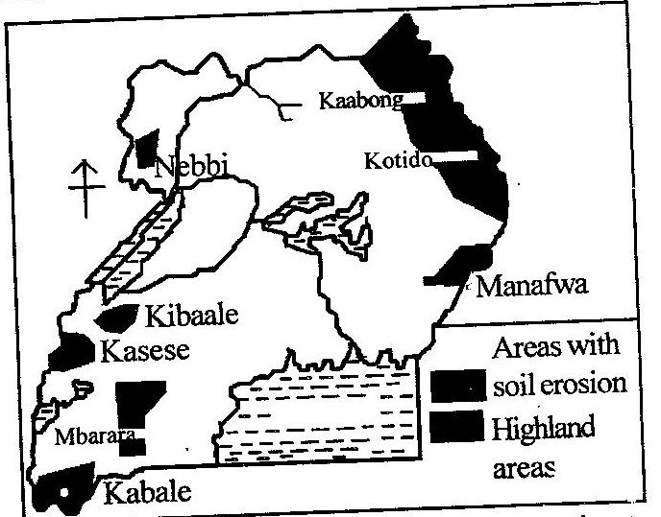
Causes of soil erosion in Uganda
- The nature of climate in an area like Karamoja area in north eastern Uganda which is dry throughout the year. This gives chance to blowing winds to erode the soil.
- When people settle on a steep relief, they clear the vegetation encouraging running water to carry soils down the slope. This is experienced in Kigezi region mainly Kabale and Kisoro.
- Overstocking which results into overgrazing like in Karamoja region. This clears the vegetation leaving bare land which is easily carried by either wind or running water.
- Rapid population growth rate which results in land fragmentation and continuous clearing of vegetation on steep slopes like as in Kigezi south western Uganda. This accelerates running water erosin.
- Use of poor farming methods such as monoculture, communal grazing which leads to overgrazing like in Karamoja and some parts of Ankole Masaka corridor thus accelerating soil erosion.
- Heavy rain fall received in an area especially on steep slopes which have been deforestated, this cause running water to carry down soil like in Elgon slopes eastern Uganda.
- Volcanic soils when repeatedly cultivated like in Kigezi south western Uganda, they lose their fertility and therefore easily carried down slope by running water.
- Ignorance of the local people about the control measures of erosion. Such people continuously deforestate and over cultivate on steep slopes like as in Kasese on foothills of Rwenzori which encourages soil erosion.
- Practices of polygamy and land inheritance have led to increased land fragmentation, deforestation and vegetation deletion as in Kigezi south western Uganda thus automatic soil erosion.
- Burning bush especially by nomads during dry seasons so as to regenerate paratable pasture for their animals. This in turn leads to erosion.
Effects of soil erosion in Uganda
- Soil erosion leads to siltation of river valleys which result into floods like in R. Manafa from Elgon slopes. Floods block roads, cause water borne diseases like bilharzias and destroy property.
- Since the top soil which contains nutrients are eroded, there is loss of fertile soils thereby reducing its productivity.
- The low productivity of soil may lead to famine and food shortage in such areas like Kigezi south western Uganda.
- Due to unproductive soils, crop growing is discouraged and this leads to unemployment and general poverty.
- The effect of soil erosion on agriculture i.e. reduced productivity, affects the export sector of Uganda since the country dominantly exports agricultural products.
- Soil erosion leads to large scale population migration from the affected area that is why KIgezi in south western Uganda has remained the source of population migration to various parts of Uganda.
- Soil erosion increases on the rate of government expenditure to provide social services for the affected groups like in Karamoja.
Ways to control soil erosion.
- Family planning programs should be extended to affected areas so as to control rapid population growth rate which results into land fragmentation.
- The nomads should be encouraged to practice modern and scientific methods of farming such as paddocking and controlled grazing, individual land ownership, afforestation, etc.
- The masses should be taught how to practice better and modern farming methods of terracing, contour ploughing and strip cropping. Monoculture should be discouraged.
- Highly populated areas of Kigezi in south western Uganda should be encouraged to carryout migrations to sparsely populated areas so as to control fragmentation.
- People should be encouraged to practice agro-forestry especially in steep sloping areas of Kasese to check on running water effect.
- Settlement along steep slopes should be discouraged and people in such areas of Mubuku and Bujuku on steep slopes of Rwenzori be encouraged to practice aforestation, re-forestation, and filling up gullies created by erosion.
QN. Account for soil erosion in Uganda
Approach
Define soil erosion
Identify the types of erosion
State the areas affected by erosion in Uganda
Locate the above on a map of Uganda
Explain the physical and human causes of erosion giving examples in each.

The drainage of Uganda
Drainage refers to water logged areas of rivers, lakes and swamps. It is the different water sources in a country.
Uganda has got different drainage systems of lakes such as Victoria, Kyoga, Albert, Bisiina, Wamala, etc rivers such as Nile, Katonga, Kagera, etc. and Swamps like along rivers and lakes, others like Rubigi, Nabajuzi, kirihili, etc.
Distribution of drainage system in Uganda
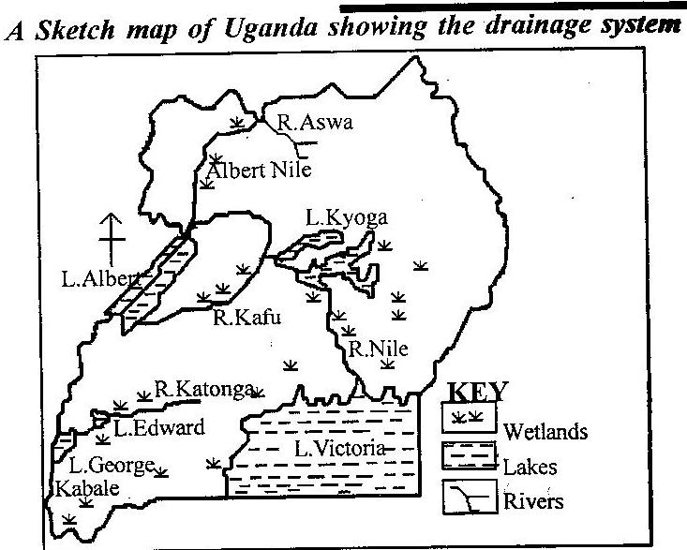

Lakes
A lake is a body of water contained in a hollow with in a basin.
The size, depth and permanence of a lake depend largely on the nature of the basin on which it’s located. In Uganda, there are various lakes like Victoria, which is the largest, Kyoga, Wamala, Albert, George, Edward, Mburo, Bisiina and other volcanic lakes found in south western Uganda.
Lakes can be classified as;
- Depression/crustal warped lakes.
These include L. Victoria, Kyoga, Wamala and Bisiina.They are formed due to crustal warping in down warped basins.Such lakes are generally large and irregular in shape, shallow in depth, surrounded by swamps and their shorelines show influence of drowning inform of numerous inlets.

Formation of Lake Victoria
- Lake Victoria is a crustal warped lake located in a down warped basin in south eastern Uganda.
- Down warping and up-warping of the landscape in Uganda occurred due to an increase in the lateral compression force which affected the earth crust over a wide area.
- Down warping led to the formation of a great basin i.e. Victoria-Kyoga basin and the uplift led to the formation of uplands/plateau.
- Crustal warping also led to a general reversal in the drainage system of Uganda. Rivers such as Katonga, Kagera, Kafu, Mayanja which were originally flowing towards Atlantic Ocean reversed their water due to uplift of western Uganda to over flood the central basin. This led to formation of L. Victoria.
- Other rivers like Ruizi, Nzoia also reversed their flow due to uplift of the eastern Uganda to fill L. Victoria.
Illustration of crustal warping
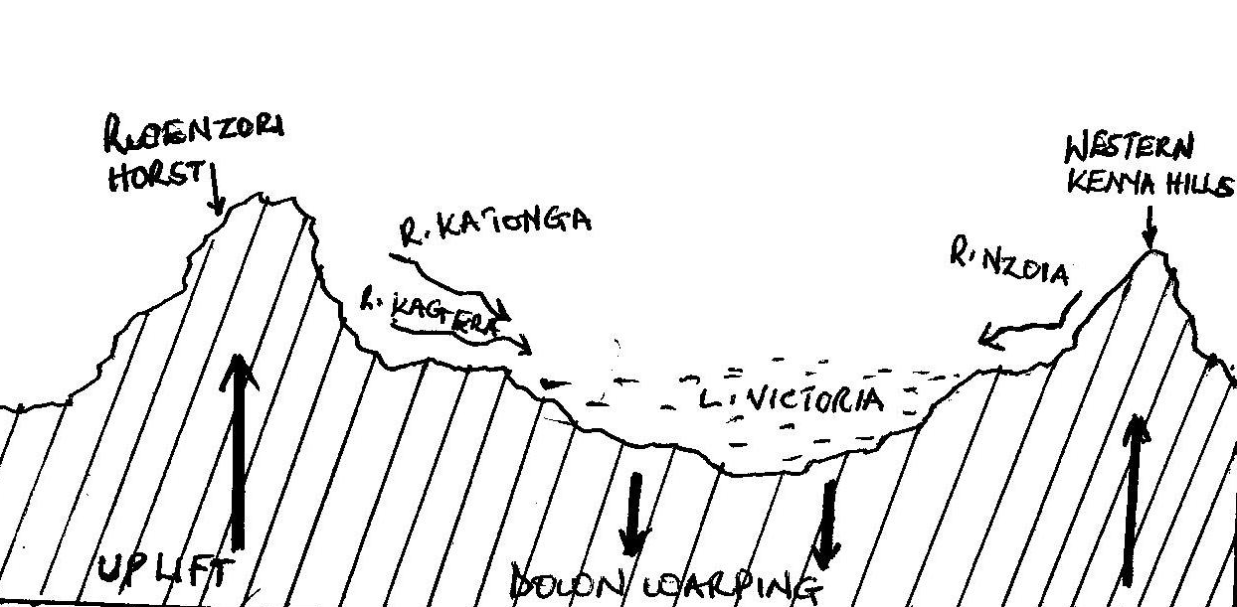
- Tectonic lakes/ fault lakes.
- These are located in the rift valley occupying gradens formed by secondary faulting which was initially caused by tension and compression forces.
- Fault lakes are narrow and elongated in shape, boarded by steep sides or fault scarps, their waters are usually saline and inlets and outlets tend to be confined at their extreme end.
- Such lakes include Albert, George and Edward.
Formation of L. Albert
- L. Albert is a fault lake formed by faulting process due to tension and compression forces in the grabens within the rift valley.
- L. Albert found in western Uganda in the western rift valley is majorly believed to have been formed by compression forces due to its steep Butiaba escarpments.
- According to compression force theory, the existence of compression forces within the crust acted upon/pushed the adjacent blocks forming fault lines.
- The central block thrusted against the adjacent blocks forming an elongated depression/rift valley as illustrated.

Before faulting during faulting
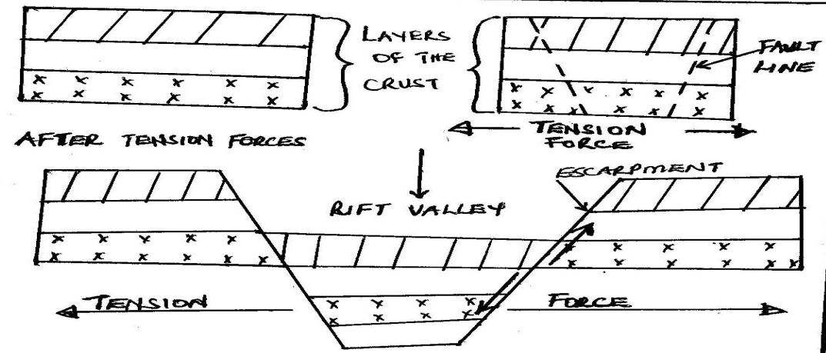

- Later secondary faulting acted upon the rift valley forming a graben/ a more defied depression.
- When the graben was filled with water, it became a rift valley lake known as L. Albert.
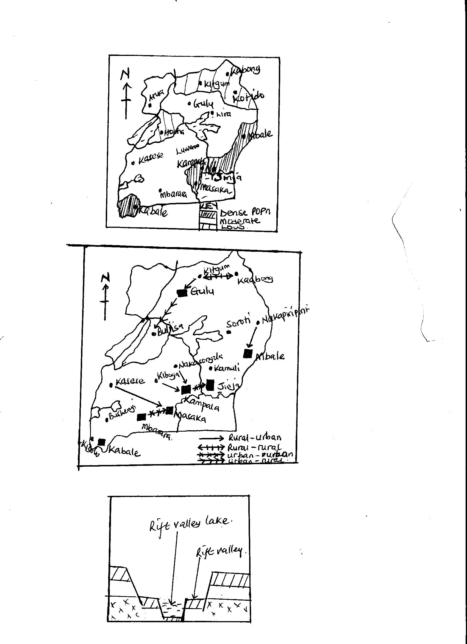

- Volcanic lakes.
These are formed by volcanicity and occupy craters and calderas formed as a result of eruption.
When the created craters or calderas are filled with water they form crater lakes or caldera lakes.
These include Lakes like Katwe, Nyungu, Nyamurangira, Nyamunuka, Kyamwoga, Munyanyange, and Nyamusingira all in south western Uganda.
Lava dammed lakes are formed where lava flow blocks the flowing river and floods a valley to form a lake such as Bunyonyi in Kabale, L. Mutanda, Butera, Muhondo, Mulehe, Ndalaga, all in south western Uganda.
- Glacial lakes.
These occupy cirques on high mountains of Rwenzori formed by glaciations process. The constant erosion caused by glaciers on this snow capped mountain of the moon, shallow steep sided depression are created known as cirques. When these are filled with water, glacial tarns are formed. Examples include Lac du Speke, Lac Catherine, Lac Noir and Lac Vert all on slopes of Mt. Rwenzori in western Uganda.
- Weathered lakes.
Chemical weathering act on some rocks especially limestone and make them break. In such places large pits are created/formed, when the pits are filled with water small lakes known as solution lakes are formed like in Nyakasura south western Uganda.
- Manmade lakes.
These are lakes made where man digs large depressions like Kabaka’s lake in Rubaga-Kampala and L. Kibimba in eastern Uganda.
Other lakes were formed through digging fishing ponds like in Mawogola and Kapchorwa in eastern Uganda. Others were formed as valley dams like in Nyabushozi, Kashari and Isingiro in south western Uganda.
- Deposition lakes or ox-bow lakes.
These are formed as a result of erosion and subsequent deposition along the lower course of a river. Such lakes are usually shallow and small and sometimes temporary. Ox-bow lakes formation is guided by meandering of a river as illustrated;
Meandering river and deposition
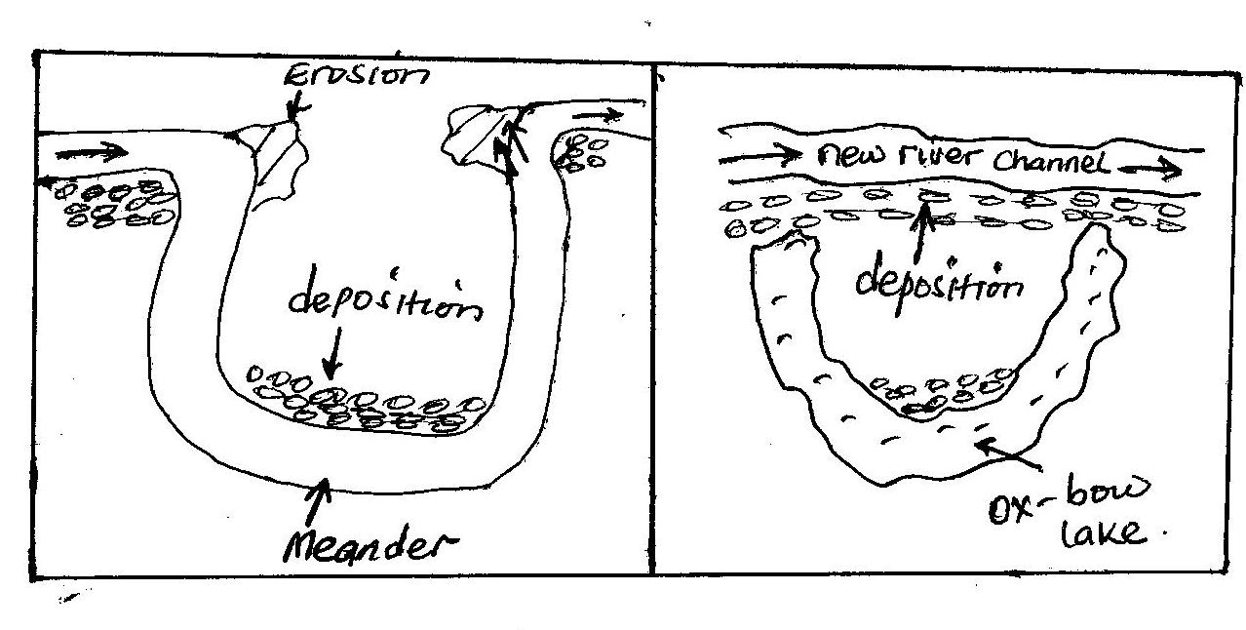
Examples of ox-bow lakes in Uganda have been found on rivers such as Semulik near Rwenzori and on R. Ruizi near Mbarara town.
Economic valsue of lakes in Uganda
- Lakes in Uganda have got both positive and negative values to the economic development of Uganda and these include;
- Lakes such as Victoria modify the climate of the surrounding areas along its shores of Mukono, Buikwe, Jinja, etc. through the process of evaporation and its breezes it forms heavy and reliable convectional rainfall supporting tea growing at Kasaku and sugar at Kakira for foreign exchange.
- Lakes provide water for irrigation at Lugazi sugar estate from L. Victoria, water to cool machines in steel rolling in Mukono and as a raw-material in Uganda breweries at Luzira from L. Victoria. Such industries have been source of consumer goods to Uganda reducing on imports.
- The water provided by lakes like Mburo has been used for animal consumption by the pastoralists in Kiruhura and by Mburo National park animals. This has diversified Uganda’s economy through tourism and livestock farming. Also water from L. Victoria is used by Kampala and Masaka for domestic purpose.
- Lakes provide cheap water transport which has helped to promote trade and international relationship. Forexample L. Albert link Butiaba in Uganda to Muhanga in Congo, L. Victoria connects Jinja and Port bell of Uganda to Mwanza in Tanzania and Kisumu of Kenya.
- Lakes makes it possible for the generation of HEP like L. Victoria act as a reservoir for R. Nile where Owen falls dam and Bujagali dam are built.
HEP in turn has led to industrialization in Jinja and Kampala for jobs and government revenue.
- The papyrus vegetation and other swampy vegetation around lakes Kyoga and Victoria has led to the development of the craft industry were mats, roofing papyrus mats, etc are made. This has availed jobs to locals earning incomes for better living standards.
- The fresh water lakes of Kyoga and Victoria have provided fish such as Tilapia and Nile perch for proteins and development of the fishing industry. This has led to growth of fishing site like Lambu, Kasenyi, Jinja, Luzira, on Victoria and Lwampanga on Kyoga thus infrastructure development.
- Due to reliable rainfall provided by lakes such as L. Victoria, there has grown a dense forest within i.e. Karangara and Ssese islands forests and around the lake like Mabira. This has developed the forestry industry for job provision and economy diversification.
- Sand which is found at the shores of L. Victoria is used for construction purpose and glass making. Salt mining in L. Katwe, oil Prospects in Albert shores, clay mining in Kajjansi for ceramics on L. Victoria shores, all provide jobs to Ugandans, foreign exchange and infrastructure development.
- Lakes provide natural habitats for millions of plants, animals and birds. This promotes eco-system like at L. Mburo and George. The above coupled with the blue waters and beautiful scenery f lakes like Bunyonyi in Kabale, coastal features of beaches like Liddo, Nabugabo, on Victoria attract tourists for foreign exchange.
- Lakes provide great opportunities for research and study purpose in relation to fisheries, forestry, navigation and soils. There is also a meteological department at Entebbe thus weather studies which all help Ugandans understand their environment and make proper planning especially in the farming sector.
The short comings of lakes to Uganda’s development include;
- Lakes are dumping grounds for industrial wastes like Uganda breweries factory at Port Bell in Luzira dump its wastes into Lake Victoria which pollutes its waters becoming un condusive for domestic use and fish existence.
- Navigation on lakes is associated by a number of accidents caused by strong winds like on L. Albert claiming a lot of important labor in form of people who would be productive for development.
- Lakes are barriers to construction of transport networks of roads and railway. Foristance L. Bunyonyi has made some parts of Kabale remote and backward. The low levels of infrastructure in such areas lead to low trade development and low Uganda’s development.
- The swampy vegetation on crescents of lakes like Kyoga are breeding grounds for dangerous pests like mosquitoes and tsetse flies. Such pests transmit human diseases such as malaria and sleeping sickness respectively to people in Lwampanga on Kyoga.
- Sometimes lakes over flood their shorelines and this leads to property destruction and loss of lives. Foristance L. Bisiina flooded in 2007 causing water borne diseases to people in the area.
- Lakes that are shared by different countries like Albert and Edward by Uganda and Congo, Victoria by Uganda, Kenya and Tanzania, cause conflicts especially during usage of the lake in fisheries, transport and mining as it was between Uganda and Kenya over Mijingo island and on Albert with Congo.
- The changes in water levels lead to submergence and emergence of water which leads to destruction of ports as it has been on L. Albert.
- Some lakes like Albert and George fault lakes have got saline water and fault scarps along their shoreline which discourage fishing activities hence low development of the fishing industry.
- Lakes also harbour dangerous wild animals such as snakes, crocodiles and hippos which destroy crops and claim people’s lives like in L. Albert and Edward.
QN. Discuss the formation of Kyoga basin and examine the economic viability of the lake to the region where it is located.
Approach
Define a lake.
Identify where Lake Kyoga is found and some of the landing site on the lake.
Locate the lake differently shaded on the map of Uganda with other lakes. Make sure you indicate its landing sites.
With aid of diagrams explain its formation.
Explain with examples the positive and negative importance of the lake MAJORY to the region where it is located.

Rivers
Uganda is drained by various rivers almost the entire landscape of the country. They are majorly nine rivers which include;
- R. Nile which include Victoria Nile and Albert Nile. It has its source in L. Victoria and its mouth in Mediterranean Sea.
- R. Katonga which flows from L. George to L. Victoria.
- Mpologoma-Manafa River, which originates from Mt. Elgon to L. Kyoga.
- Mayanja-Kato River, which has its source in L. Victoria and its mouth into Kafue.
- Aswa-Moroto River, it originates from north eastern Karamoja areas to R. Nile.
- R. kafue which originates from L. Kyoga to L. Albert.
- R. Kagera, it originates from Rwanda hills to L. Victoria.
- Depeth-Okoth which originates from Karamoja hills to Kyoga.
- R. Semulik and Mubuku.
Other rivers in Uganda include R. Rwizi, R. Sezibwa, R. Okere, Birira River, Nyamwamba, etc.
Major rivers in Uganda
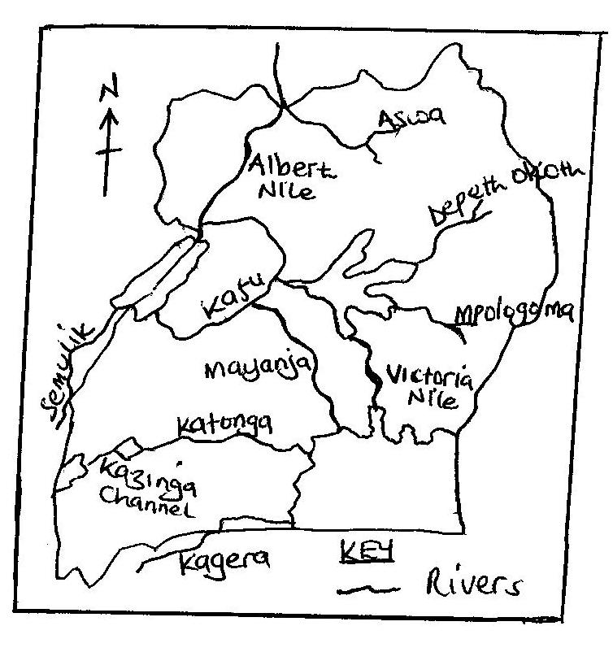
River profile
This refers to the measured slope along the bed or surface of the river from its catchment area to its mouth. A river profile is divided into three sections i.e.
- The youthful stage
- The mature stage
- The senile stage.
During the erosion and deposition of a river there are different features formed i.e.
Waterfalls such as Owen falls, Bujagali falls and Muchison falls on R. Nile, Sezibwa falls on R. Sezibwa, Kisiizi falls, etc are formed by river erosion.
River deposition especially in its lower stage form ox-bow lakes as at R. Rwizi, deltas, etc.
Drainage patterns
A drainage pattern is a lay out plan which is made by a river and its tributaries on the landscape. In Uganda, the different patterns can be identified;
- Dendritic drainage pattern
- Radial
- Trellis
- Centripetal
- Annular
- Barbed
N.B River rejuvenation refers to a renewed river capacity in a river valley. Rejuvenation can be caused by heavy rains and river capture.
River capture or piracy refers to the diversion of part of a river course or whole of it into the system of another adjacent powerful river.
Economic value of rivers in Uganda
- Rivers are source of water for domestic, industrial and recreation purpose. Foristance Mbarara town get water for domestic use from R. Rwizi, Nile breweries use water from R. Nile as raw-material in making beer hence provision of jobs to Ugandans and government revenue.
- The water from rivers like Mubuku and Manafa is used to facilitate irrigation at Mubuku irrigation scheme in Kasese and Doho in eastern Uganda respectively. Such schemes have increased on food production and foreign exchange after rice and vegetable exports.
- Rivers facilitates generation of HEP like Owen falls dam and Bujagali dams on R. Nile, Mubuku power station on R. Mubuku, etc. HEP has lead to industrial development thus infrastructure development and jobs to Ugandans.
- Rivers provide cheap water transport by ferry means like on Victoria Nile. This has developed local trade, provided incomes to transporters hence improved living standards.
- The papyrus swamps which develop along river banks such as on R. Katonga and Mpologoma are potential raw-materials for paper, packing, cardboards, roofing materials and the general development of the craft industry thus employments to Ugandans.
- Rivers are tourist attraction especially waterfalls of Murchison, Bajagali, Sipi and Karuma falls. The meandering nature of R. Rwizi attracts tourists for foreign exchange in terms of invisible export which is used for further development.
- Rivers like Nile provide fishing grounds and fish caught for local consumption and for sale. The swampy areas along R. Katonga provide mud fish, which provide proteins and sold for better incomes to Ugandans.
- The swampy areas and wetlands along river channels are natural habitats for wild animals, birds and other marine life. Shoe bills and crested cranes survive in R. Nile wetlands attracting tourists for foreign exchange.
- There is clay mining along rivers like Katonga and Mpologoma for brick laying thus development of small scale industries for jobs to Ugandans.
- Rivers like Nakivubo channel help to regulate the environmental impurities that would directly enter L. Victoria leading to its pollution. Also rivers modify the climate where they exist like river Manafa form reliable rainfall which supports rice and other crop growing in eastern Uganda.
- River banks like Albert Nile have got fertile soils in West Nile areas supporting tobacco and other crop growing. This also has attracted settlement in the areas of Nebbi, Arua, etc. the grown crops have contributed foreign exchange to Uganda through exportation.
The short comings of rivers include;
- Some rivers tend to over flood their valleys during rainy seasons as it was in 2007 in north eastern Uganda and in 2014 in Kasese by R. Nyamwamba. This cause property destruction, loss of lives and interfere with transport networks since floods wash away bridges.
- Most rivers contain waterfalls and rapids like along Nile at Karuma which make navigation impossible thus resulting into remoteness and inaccessibility of such areas.
- Most rivers like in northern Uganda make the construction of feeder roads hard like at Karuma Bridge which makes such areas remote and inaccessible especially during rainy seasons.
- The swampy vegetation along river channels like along Katonga harbour disease vectors such as mosquitoes and tsetse flies which cause diseases such as malaria and sleeping sickness respectively to human beings.
N.B The economic importance of the drainage system of Uganda includes;
- Values of lakes
- Values of rivers
- Values of swamps

WETLANDS IN UGANDA
- Wetlands develop swampy vegetation in Uganda. Wetlands are water logged areas with plant life adapted to the environment.
- Wetlands are grouped as lacustrine i.e. those along lakes such as along L. Victoria like Lutembe, Nabugabo, Lambu, etc, along L. Kyoga like Galiraya, Kagwara and Lwampanga wetlands. Riverine wetlands i.e. those on river banks such as along R. Nile, Katonga, Kagera, Kafu, Mayanja, Sezibwa, Mpologoma, etc. and Dombos wetlands which exist in open valleys such as Busega in kampala, kiruhili in Kabale, nyaruzinga in Rukungiri, Lubigi in Kampala, etc.
The extent of swamps and wetlands in Uganda

It should be noted that;
Status of wetlands
- There is a reduction of wetlands to 10%.
- Wetland cover 13% of Uganda.
- The dominant type of soil in wetlands is clay and sand.
- Most wetlands have turned into industrial parks such as Namanve, Manafa and Kyambogo.
- NEMA is the body responsible for wetlands in Uganda; however it has done little to save Uganda’s wetlands from destruction.
Economic importance of wetlands
- There is subsistence fishing carried out from swamps i.e. mud fish for consumption. This is majorly done along R. katonga swamps. Such fish provides proteins and is sold for cash thus improved living standards.
- Swamps through the process of evaporation leads to rainfall formation which modify the climate in areas of Lubigi, Nakayiba in Masaka, Lumansi in Bombo etc.this develops crop growing thus constant food supply in such areas.
- Swamps provide water for animal watering and also animal grazing during dry seasons like those along L. Kyoga shores to Baluli of Nakasongola.this has supported livestock thus incomes to farmers.
- Swamps provide grounds for crop growing such as yams in Busega, sugar canes, vegetables in kiruhili in Kabale. This has increased on farmers’ income improving on their standards of living.
- Swamps act as filters to protect lakes and rivers from pollution like Nakivubo swamp which protects L. Victoria from Kampala city sewerage. This ensures conservation of aquatic animals.
- Swamps provide natural habitat for thousands of marine animals and plants. They also protect rare bird species such as crested cranes and shoe bills. This has developed the tourist industry for foreign exchange.
- Wetlands like those around L. Victoria provide raw-materials for the making of crafts, mats and baskets. This has availed Ugandans jobs, earned incomes to the locals and development of the craft industry.
- Swamps are source f clay which has developed the making of tiles, bricks, pottery,etc like in Kajjansi-Wakiso district.
- Swamps provide water for domestic purpose like Nabajjuzi swamp which supply water to Masaka town. Lubigi swamp as well is source of water to Bwaise, kawala, Masanafu locals in Kampala reducing on city cost of living.
- Wetlands like Kasambya provide plants of medicinal value like aloevera which improves peoples’ health.
- Wetlands acts as boundaries for different districts like Kyoga wetland separates Bushenyi from Mbarara.
- Wetlands supports navigation like Lwampanga swamp which promotes trade.
- Wetlands act as hunting grounds for antelopes like along Kalinga
The short comings of wetlands in Uganda include.
- Swamps are breeding grounds of disease vectors of mosquitoes and tsetse flies which cause malaria and sleeping sickness respectively to human beings. This explains why many people in Bwaise, Kawala near Rubigi swamp suffer from malaria fever.
- Swamps like those along R. Katonga and Kazinga channel harbour dangerous animals such as snakes, crocodiles, hippos which claim people’s lives and destroy crops.
- Wetlands are usually over flooded during rainy seasons blocking roads like along R. Mpologoma and Manafa in Eastern Uganda.
- Swamps claim people’s lives as they drown from there. For instance many people have drowned in Rubigi swamp in the out skirts of Kampala.
- Navigable swamps like along Nile and Katonga have led to water accidents.
- Wetlands are affected by siltation and sedimentation which affect fishing and navigation like Lubigi and Lumbuye.
- Wetlands limit land uses such as settlement and agriculture due the floody nature like Nakayiba and Kyogya of Masaka which affect development.
- Many wetlands act as hiding places for anti government elements like robbers in Lwera-Masaka.
- Soils in most wetlands are acidic and un-productive and eaily lose fertility affecting crop growing and incomes like Nabajjuzi swamp in Masaka.
QN. Examine the view that the wetlands areas of Uganda are wasted lands.
Swamp reclamation in Uganda.
This refers to clearing of wetlands for man’s survival. This is happening to many swampy areas in Uganda such as Nabajuzi swamp in Masaka, Mutai swamp in jinja, Doho swamp, Kibimba swamp in eastern uganda, Nalukolongo, Kalerwe-Bwaise wetlands, Lumbuye wetland, Lwampanga wetland along Kyoga, mpologoma wetland along R. Mpologoma, Nakayiba in Masaka, Kiruruma in Kabale, etc it should be noted that wetlands in Jinja and Kampala are the most degraded.
Causes of swamp reclamation
- Crop growing purpose like Kakira sugar estate in jinja reclaimed Mutai swamp, Doho and Kibimba wetlands for rice growing in eastern Uganda and Kashambya swamps in Kabale reclaimed for vegetable gardens.
- Animal rearing especially during dry seasons like in Kitgum and parts of R. Mayanja, Mpologoma and Lwampanga wetlands have been encroached by the Baluli-Nakasongola pastralists and Kiruruma swamp in Kabale were leased to dairy farmers.
- Urbanization effect like in Bwaise, Kalerwe, Natete, Busega , New tax park areas have replaced wetlands where they exist in abit to extend Kampala city.
- Collection of craft materials and clay and sand excavation like in Kajjansi swamp by Uganda clays, the Lwera and Lutembe swamps have been threatened by sand mining.
- Industrialization like coca cola plant in Mbarara, bell factory in Luzira Port bell, Nalukolongo wetland claimed for Sembule steel rolling mills, Bwaise swamp for Avis cosmetics factory and many others in Nakawa and kyambogo in Kampala occupied Kyambogo-Mbuya wetlands.
- Settlement were many swamps hava been cleared for purposes of home construction like in Kisenyi and Kalerwe swamps in Kampala.
- Roads and infrastructure construction like the northern by-pass in kampala destroyed much of Lubigi swamp, kampala-Masaka road cleared part of katonga and Busega swamps, Jinja-Iganga-Tororo road destroyed parts of Walugogo, Lumbuye, Naigombya and Tirinyi swamps.
- Fire out breaks by farmers and hunters have degraded Katonga, Lwera, Tirinyi and other swamps.
- The practice of garbage disposal in wetlands by Kampala dwellers like in Kitezi wetlands, Luzira wetlands, Wakaliga, etc. Also Masese swamp in Jinja and Walugogo valley has suffered the same.
- The industrial discharge and pollution by the mining sector have degraded swamps like Njeru wetland Polluted by NYTIL and Nile breweries in Jinja and Kazinga and George wetlands have been degraded by cobalt wastes in Kasese.
Effects/problems associated with swamp reclamation in Uganda.
It has led to drying up of water wells and streams and lowering of the water table like in Butaleja, Pallisa and Iganga were Naigombya, Lumbuye and Mpologoma swamps have been reclaimed. This in turn is leading to the spread of the negative environmental phenomenon of desertification.
- It has led to a change in water quality of such swamps and wetlands. Also since wetlands act as a filter to lakes, their reclamation increases water pollution into lakes like Victoria affecting aquatic life.
- It has led to change in climatic regimes since swamp reclamation reduces rainfall received like in Pallisa and Iganga. This has discouraged crop growing and famine and drought are beginning to hit such places.
- Reclamation of swamps affects the life of thousands of marine animals and plants whose habitat has been removed. Foristance reclaiming of Kachido and upper Murchison bay wetlands, Lutembe wetland has affected crested cranes and migrant birds from Europe hindering tourism.
- The practice has led to floods in areas of Bwaise and Kalerwe, Kyambogo and Nakawa, etc. this has resulted into water borne diseases like dysentery, bilharzia and cholera in such areas of Kampala.
- Reclamation affects the source of building materials such as papyrus, sand and clay. This has resulted into high costs of building materials and construction like clay bricks from Kajjansi, Lweza and Kawempe are expensive.
- Swamp reclamation increases the rate of siltation of rivers and streams like in Walukuba, Makenke, and Magamag. Also the reclamation of Doho and Kibimba swamps has led to siltation of R. Manafa thus floods and loss of aquatic life.
- It leads to reduction in fishing grounds.
- Lowering of the water table which leads to drying up of streams and wells.
- Leads to easy spread of diseases since it causes pests invasion.
Measures to conserve wetlands in Uganda
- Practicing of family planning in order to control high population growth rate. This reduces on high demand for land thus reduced reclamation.
- NEMA has been set up to monitor wetlands and minimizes encroachment on wetlands. This helped to conserve Kyambogo, Bugolobi, Tirinyi and Naigombwa wetlands.
- Strict laws have been set up by the government against wetland encroachers. Evicting squatters in wetlands like from Bugolobi, Rufuha in Ntugamo, Agu wetland in Kumi has been done by government.
- Voluntary migrations have been encouraged i.e. from densely populated areas to sparsely populated areas. This has helped swamps to remain in their natural state.
- Massive education among the masses has been encouraged on the importance of swamps and their dangers especially to people of Busega, Kawoya wetlands in Banda, through public rallies, over radios and televisions.
- Encouragement of vertical expansion of Kampala city in Nalukolongo, Nakawa,Bwaise and Bugolobi has been done by KCCA.
- The UWA and NEMA have put a ban on hunting of wild animals and birds. This has minimized bush fires on Lumbuye, Naigombwa, Lubigi wetlands which were initially started by hunters.
- The government has gazette specific industrial areas like Kawempe, Namanve, Nakawa, Nalukolongo which has reduced on encroachment on wetlands.
- The national water and sewerage corporation is treating sewage at Bugolobi before it is released into Luzira swamps. Also KCCA has started proper garbage disposal in Kitezi saving Wakaliga swamp.
- NEMA is encouraging the covering pits left behind after sand and clay mining in Kasenyi, Kajjansi, Seeta and Luzira. Also the ministry of agriculture has introduced upland rice to discourage rice cultivation in Doho, Kibimba, Tirinyi swamps which claim wetlands.

The climate of Uganda
Climate refers to average weather conditions of a place which is measured and recorded for a very long time usually between 35 and 40 years.
Climate is determined when weather elements are measured and recorded. Such elements include;
- Rainfall measured by a rain gauge.
- Temperature by the sixth thermometer
- Humidity by hygrometer
- Atmospheric pressure by a barometer
- Sun shine by a Campbell stock
- Cloud cover by hydrogen filled baloons
- Wind strength by anemometer
- Wind direction by wind vane.
These elements of weather are measure at a weather station at Entebbe-Wakiso district.
Climatic belts of Uganda.
Uganda is supposed to have an equatorial climate by virtue of its location astride the equator, but because of its relief and other factors it experiences;
- Equatorial climate
- Modified equatorial climate
- Tropical climate
- Mountain climate
- Semi-desert climate

The climatic regions of Uganda
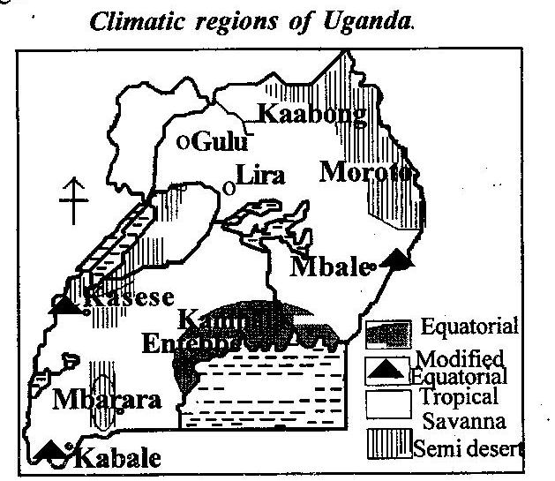

Equatorial climate
This is experienced around Victoria shores i.e. Kampala, Kalangara, Entebbe, etc. It has got the below characteristics;
- Heavy rainfall over 1250mm per annum. This rainfall is reliable and well distributed throughout the year because of breezes.
- Hot and humid temperatures ranging between 22⁰C-30⁰C due to thick cloud cover in the region
- High humidity throughout the year due to high evaporation rates in the region.
- Small annual temperature range between 0⁰C-3⁰C due to hot and humid temperatures received throughout the year.
- There is little or no dry season with one rainfall peak, although areas away from L. Victoria can experience two distinctive rainfall peaks, this is due to high humidity received throughout the year.
- The climate is warm and wet and leads to growth of equatorial rain forests of Mabira and Ssese.
Modified equatorial climate
This is experienced in West Nile, Kigezi highlands and some parts of central Uganda, with the below characteristics;
- Relatively heavy rainfall between 1000mm and 1500mm per annum mainly relief rainfall.
- There is alternating dry and wet seasons
- High humidity during the wet season and low humidity during dry season.
- High temperatures are experienced above 25⁰C throughout the year
- Rainfall received is of two rainfall peaks
- Mostly the climate leads to growth of savannah woodlands.
Tropical climate
This covers the most parts of Uganda more especially in the northern region with the following characteristics;
- It has a clear distinct wet and dry seasons
- Moderate rainfall is received between 750mm-1000mm per year due to moderate humidity received in the region.
- High temperatures are experienced ranging between 25⁰C-32⁰C throughout the year.
- High humidity during the wet season and low humidity during the dry season.
- The climate leads to growth of savannah vegetation dominated by grasslands.
Semi-desert
This is experienced in north eastern Uganda i.e. Moroto, Kotido, Kaabong and in Albert eastern shores i.e. Kabalega park and in Ankole-Masaka corridor. It has the following characteristics;
- Very low rainfall is received between 325mm-620mm per year due to low humidity in the region. It has one rainfall peak
- Very hot temperatures are experienced over 35⁰C due to cloudless skies.
- Very low humidity in such areas and the skies are cloudless thus hot days and clold nights.
- The climate leads to the growth of shrub and thickets due to low rainfall.
Factors which influence the climate of Uganda
Relief, highland areas like Mt. Rwenzori block moving moist air masses resulting into the formation of relief rainfall on the wind ward side of the mountain while little or no rain is received on the lee ward side due to descending dry winds as illustrated.
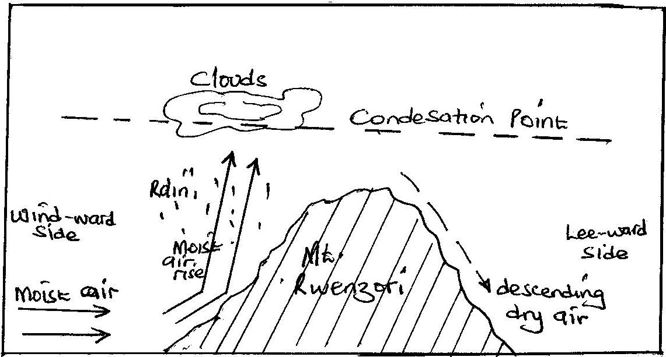
This explains why some parts of Kasese receive little rainfall well as Semulik valley receives heavy rainfall.
Flat areas like Karmoja receive little rainfall because of lack of obstacles to make the winds rise.
Altitude has an effect on temperature in Uganda. Places of high altitudes like Rwenzori peak, Elgon, experiences low temperatures while lower altitudes of Albert shores and rift valley areas experiences high temperature. This is because the higher you go upslope, the cooler it becomes.
Water body effect, large lakes such as Victoria and Kyoga are source of water vapour in atmosphere through the high rates of evaporation. This results into high humidity content in atmosphere thus convectional rainfall as illustrated.
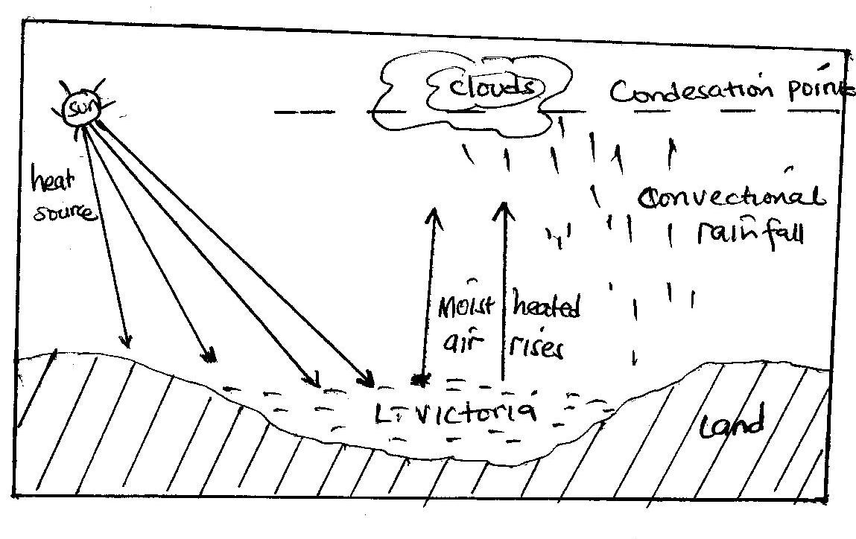
Such lakes also influence rainfall formation on their crescent due to land and sea breeze.
Latitudinal effect, Uganda is located astride the equator and this makes it to receive high temperature throughout the year. The high temperature received warm up air masses on the ground causing them to rise, condense and form convectional rainfall. This is experienced around l. Victoria, western and south western and northern parts of Uganda.
Nature of vegetation cover, areas covered by forests like Mabira, Kalinju influence convectional rainfall formation due to the process of evapo-transpiration. On the other hand areas with shrubs and thickets vegetation such as Karamoja and Ankole-Masaka dry corridor receive very low rainfall since such vegetation provide limited water vapour in the atmosphere for rain formation.
The prevailing wind system effect, Uganda is affected by two main wind systems i.e. the north east trade winds and the south east trade winds. These winds are caused by the apparent movement of the sun north and south of the equator.
When the sun moves to the tropic of Capricorn, the north east trades blow with a lot of emphasis over Karamoja and make it dry due to no obstacle to make them rise. They pick moist air from L. Kyoga and cause rainfall at the foothills of Mt. Rwenzori in Fort Portal.
As they reach the equator, are deflected to the left and help to dry up Ankole-Masaka corridor as it also lack physical obstacle to make them rise.
When the sun moves to the tropic of Cancer, the south east trades blow and pick moist air from Victoria and cause rainfall on the northern shores of L. Victoria. They also blow over Ankole-Masaka corridor and dry it further and cause rainfall in western Uganda.
As they reach the equator, are deflected to the right, moves through L. Kyoga and help to dry up Karamoja again.However a section of these winds bring about rainfall formation on Mt. Elgon and Moroto in eastern Uganda.
When the sun is on the equator, the winds i.e. NE and SE trades converge and cause cyclonic rainfall.
Map of Uganda showing wind systems.
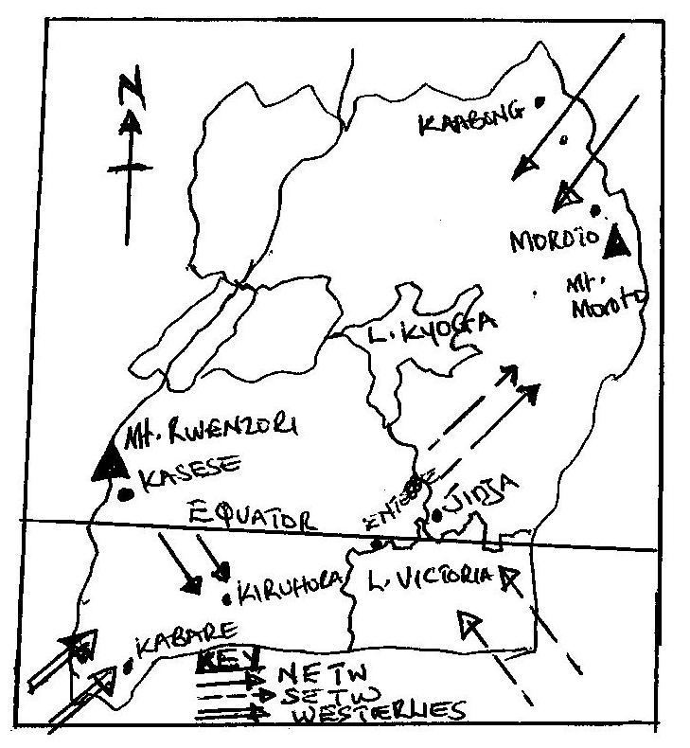

The effect of westerlies, these winds blow from Congo basin towards Kasese, Bundibugyo, Kabalore, Kisoro and Bushenyi. These warm and moist winds are blocked by the highlands of south western Uganda, rise, condense and form relief rainfall.
Position of the sun overhead, since Uganda is located astride the equator, it experiences the periods of equinoxes i.e. March and May and also September to October. Throughout these periods the country experiences heavy rainfall due to inter-tropical convergence zone (ITCZ).
Man’s activities, which effect climate positively and negatively i.e. activities such as deforestation, monoculture, swamp reclamation, settlement, overgrazing, tend to affect vegetation thus less water vapour in the atmosphere and less rainfall.
Man has tried to improve on the climate of the area by programs such as aforestation and reforestation as in Kabale, Ntugamo and Mbarara. This Increases the chances of rainfall formation and climatic modification.

Rainfall patterns in Uganda.
Rainfall refers to tiny droplets falling on the earth’s surface from the atmosphere under the influence of gravity. There are mainly two rainfall types received in Uganda i.e.
Relief or orographic rainfall characterized in mountainous or hilly areas of Uganda like Rwenzori.
Convectional rainfall commonly received in areas of water bodies of Victoria and Kyoga and dense forests like Mabira and Kalangala forests.
Rainfall distribution in Uganda
The rainfall received in Uganda is generally grouped as;
Rainfall above 2000mm experienced in equatorial climatic regions like on L. Victoria crescent.
Rainfall ranging between 1500mm-2000mm (heavy) experienced in modified climatic regions of Uganda.
Rainfall ranging from 1000mm-1500mm (medium) experienced in tropical climatic regions like in northern Uganda.
Rainfall ranging between 750mm-1000mm (low) experienced in semi-arid climatic regions like in Lyantonde, Kiruhura, Lwengo, etc.
Rainfall ranging below 750mm per annum experienced in dry climatic regions like in Karamoja districts of Kaabong, Kotido Kitgum, etc
The distribution of rainfall in Uganda
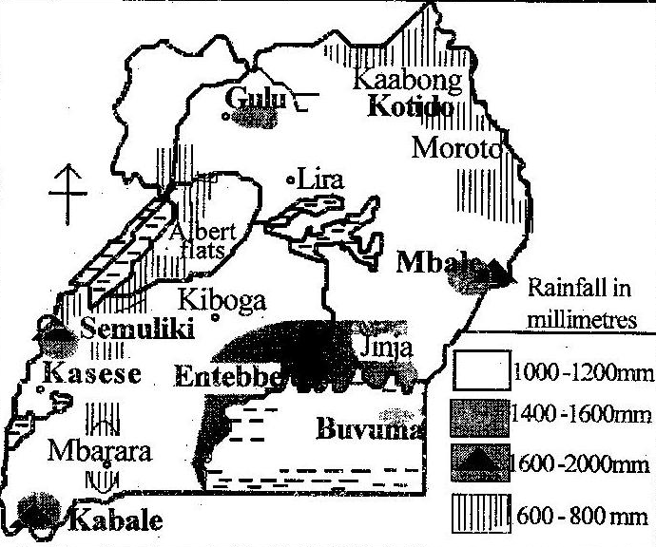

Factors for the variation in rainfall distribution in Uganda
- Relief, in mountainous areas like Rwennzori in Kabarole, Bundibugyo receive heavy rainfall of about 1500mm per annum. This is because mountains block moist winds on the wind ward sides which rise, condense and form rainfall.
- The areas with dense forests like Mabira in Buikwe receive heavy rainfall due to high evapotranspiration levels resulting into convectional rainfall.
- Areas near large water bodies like the shores of L. Victoria in Kampala, Wakiso, receive heavy rainfall over 1500mm per annum due to lake and land breezes.
- Latitudinal influence/I.T .C.Z, this is a low pressure belt where various winds meet resulting into heavey thunder stoms and rainfall around lake Victoria region in districts of kamuli, Iganga Kampala where heavy rainfall of about 1500mm p.a is received.
- Wind system, the northeast trade winds bring dry conditions because they originate from the dry desert. This has resulted into dry conditions (less than 750mm) in kotido and moroto. The south east trade winds from the Indian ocean carry moist winds which they drop on the slopes of mountain Elgon resulting into heavy rainfall(1500mm) in sironko and Manafwa.
- Destruction of vegetation cover, in areas where vegetation has been destroyed the rainfall amounts have reduced eg Nakasongola with less than 750mm pa.
- Afforestation and re-afforestation in areas where trees have been planted the rainfall amounts have been increased such as Kabale(mafuga forest), bugamba in Mbarara etc.
- Swamp drainage / reclamation in areas where swamps have been reclaimed.The rainfall amounts have been reduced because of evaporation e.g in Kumi, Soroti, Bugiri etc.
- Mam made lakes/ valleys dams/ ponds, when these are constructed they increase on evaporation levels and therefore results into increased rainfall amounts such as kibimba.
- Government policy of conservation
Vegetation of Ug anda.
Natural vegetation is the total sum of all plants that have grown naturally on the earth’s surface. The natural vegetation that grows in an area mainly depends on the climate of such a region.
Types of natural vegetation in Uganda.
- Equatorial rain forests/ tropical rain forests.
- Savannah vegetation
- Dry region vegetation
- Montane vegetation/ highland heath and moorland
- Swampy vegetation.
The distribution of natural vegetation in Uganda
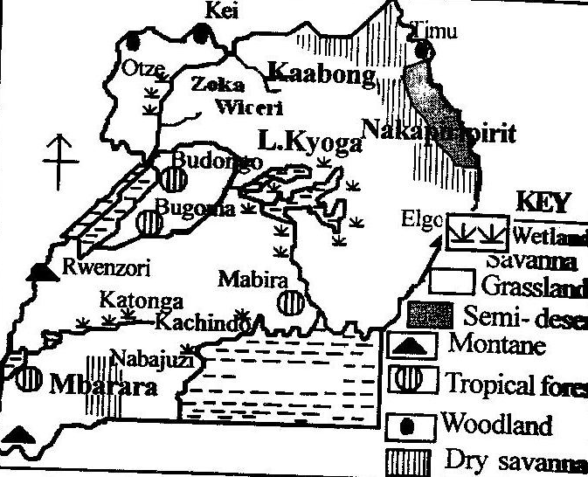
Tropical rain forests
This is found in Mabira-Mukono, Budongo-Masindi, Kalinju-Bushenyi, etc and has the following characteristics;
- The forest is thick and luxuriant with much foliage due to heavy and reliable rainfall received in the region throughout the year.
- The forest contains a variety of tree species like Mvule, Msizi, Mahogany, Ebony, etc. therefore do not grow in pure stand.
- Trees have got broad leaves and the forest is ever green because they receive reliable well distributed heavy rainfall throughout the year.
- Trees form canopies and have no under growth due to less lights penetrating through the forest because of the dense canopies.
- Trees have buttress roots to support the heavy tree stems and many climbers which move from one tree to another.
- Forests have hard wood trees with a long gestation period and such trees grow up to 50metres high due to competition for light and fertile soils in such regions.
NB. Lumbering, forest exploitation, growing of subsistence crops, wildlife conservation, tourism development, settlement, are the major land use types in tropical rain forests.

Problems of land use types in the tropical rain forests of Uganda.
- Heavy rains cause pest multiplication such as mosquitoes and tsetse flies which transmit human diseases. This affects settlement in areas of Mabira, Ssese, Etc.
- Impassable roads caused by heavy rains which destroy roads creating potholes. This affects lumbering like in Kibale forest since logs and timber transportation is limited.
- The humid conditions within the forests and dangerous animals such as snakes limit forest exploitation as it is in Budongo forest.
- Trees do not grow in pure stand which hinder their selection, felling and transportation of logs.
- These forests experience fire out breaks during dry seasons and uncontrolled farming has cleared much of the tropical rain forests.
- Animals from such forests like Ssese forests destroy crops grown near the forests thus hindering crop growing.

Savannah vegetation
Savannah covers much of Uganda’s total land area. It is divided into savannah grassland and woodland. Also dry savannah sometimes known as range lands.
Savannah woodlands
This is found mainly in Kei, Otze, Timu, in northern Uganda, West Nile and some parts of central region.
Savannah grasslands
These are well developed in the fringes of savannah woodlands. It exists in Nakasongola, Luwero, Hoima, Sembabule and in the rift valley areas of western Uganda.
The dry savannah or rangelands are found in Albert flats, Semulik zones, Kotido, Moroto, Kaabong and in Ankole Masaka dry corridor.

Savannah vegetation has got the following characteristics.
- Combination of trees and grasses but the trees are not so close like in forests.
- Trees are umbrella shaped and shed off their leaves during the dry season.
- The grasses are very tall up to 1metre like elephant grass due to moderate rains received in the area.
- It should be noted that different forms of savannah have got different characteristics.
NB. Crop growing, animal rearing, settlement, wildlife conservation in National Parks like Queen Elizabeth, Kabalega, wood collection, hunting are some of the land use types in savannah.
Rangelands / dry savannah
These are dry savannah rangelands which receive 750mm of rainfall and below. In Uganda they include;
- North eastern Uganda in Karamoja regon of Kaabong, Moroto, Kotido, etc.
- North Acholi in Maracha district
- Western rift valley in Albert flats
- Around L. Edward and L. George in Queen Elizabeth national park
- Ankole-Masaka dry corridor
- Bululi-Nakasonglo areas.

Distribution of dry savanna vegetation in Uganda
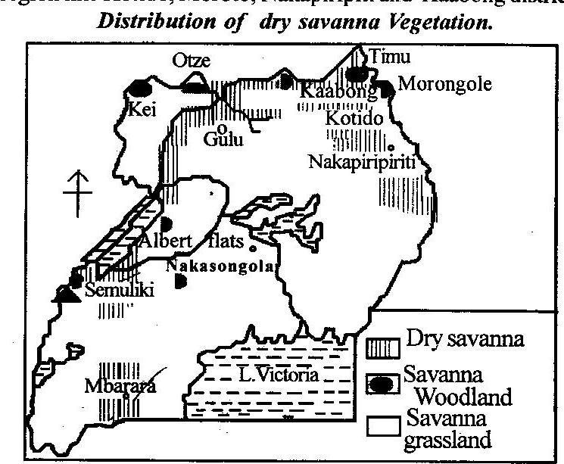

Characteristics of rangelands in Uganda
- Low and unreliable rainfall of less than 750mm per year which leads to growth of short grass, scrub and thorny thickets.
- High daily temperature throughout the year of over 30⁰C which has led to growth of thorny trees with thick barks and needle shaped leaves to store enough water for use during drought seasons.
- Low temperatures at night and high during day which has discouraged settlement in the region and the areas have been left for national parks like Kidepo in north east, Kabalega in Albert flats and Queen Elizabeth in western rift valley.
- There is low humidity, cloud less skies and rains received is erratic.
Conditions for the growth of dry savannah in Uganda
- High temperatures of over 26⁰C like in Nakapiripiriti have led to growth of dry savannah vegetation. This facilitates the growth of trees with small twisted leaves so as to avoid loss of moisture through rapid respiration and evaporation.
- Low humidity content in the atmosphere in the areas like Kotido leads to scarcity of luxurious vegetation except drought resistant vegetation such as thickets.
- Low and unreliable rainfall between 250-500mm favours growth of dry savannah vegetation in Moroto and Kaabong. This supports growth of acacia, baobab and cactus trees which are drought resistant.
- The low lying relief in the Albert flats and Kotido district experience high temperatures and low rainfall thus growth of drought resistant vegetation.
- On the lee-ward side of Mt. Rwenzori there is scarce rains due to descending dry winds thus dry savannah vegetation growth.
- Poor and sandy soils with limited retention capacity like in Kotido and Kaabong and Albert flats which can only support poor plant life growth thus dry savannah vegetation.
- Overgrazing like in Karamoja region and in Kiruhura in south western Uganda leads to depletion of vegetation thus encouraging dry savannah vegetation.
- Wildlife conservation in game parks of Kidepo, Queen Elizabeth and Murchison fall park with animals such as buffaloes, giraffe which eat up vegetation and create dry savannah vegetation.
- Bush fires by farmers like Basongola and Karamajong has led to growth of stunted grass with short trees which are scattered.
- Deforestation for farming, lumbering and tsetse fly control like as it was in Albert flats, led to growth of dry savannah vegetation.

Economic activities in rangelands
- Subsistence farming like nomadic pastoralism in Karamoja and Bululi, production of cereals like maize, millet and cotton like in Kasese.
- Wildlife conservation through gazettng national parks like Kidepo, L. Mburo, game reserves like Ajai in north western Uganda, etc.
- Ranglands provide vast land for settlement like in Hoima, Nakasongola, etc
- Mining like oil from Albertine shores, gold in Karamoja, etc.
- Rangelands provide a great potential for tourism due to fauna and flora in Kidepo, Queen Elizabeth, etc.
- Hunting like in Karamoja hunting zone, Bamunanika royal hunting zone in Luwero, etc.
- Local herbs collection and fruit gathering like in Lwera in Masaka and Nakasongola.
Problems faced in rangeland areas.
- Water shortage for watering animals and domestic use especially during drought seasons, this leads to death of animals like in Karamoja.
- Harsh climatic conditions of low rainfall totals and very high temperature during day and very low temperature at night has caused water shortage, famine, poor pasture, fire outbreaks, etc.
- Tropical pests and diseases which attack animals like nagana, crops and human beings like sleeping sickness hindering settlement and animal rearing.
- Limited important infrastructure of valley dams, veterinary services, market centres, health centres and roads like in Kaabong which has made the areas remote and inaccessible.
- Poor land tenure system of communal land ownership which has led to frequent degradation and abuse of rangelands.
- Unfavourable government policies of utilizing the rangelands like the government of Uganda has neglected such areas of Ankole-Masaka dry corridor and Bululi thus limited infrastructure.
- Sometimes floods caused by erratic rains in rangeland areas destroy crops and property and also claim human lives like as it was in Teso north eastern Uganda in 2007
- Some of the rangeland areas have got porous soils which do not favour crop growing. There is also the practice of poor farming methods like overgrazing which cause soil erosion.
Steps taken to over ride these problems
- Construction of boreholes and valley dam to fight the prolonged drought and water the animals in the region.
- Cultivation of profitable crops using scientific methods of planting of high breed seeds of cereals with short gestation periods. This has been done in Kitugm and Kotido.
- Farmers have been encouraged to apply fertilizers and organic manure where soils are poor. The use of irrigation like in Kibimba has increased on food production.
- Co-operative farming has been encouraged. Also cotton has been grown as a cash crop to increase on food supply like in Bululi and around L. Edward and George.
- There has been introduction of ranching schemes to provide veterinary services, scientific animal rearing methods, water sources mainly in Ankole-Masaka dry corridor and Bululi-Nakasongola.
- The government has set up milk collecting centres to enable marketing of cattle products of milk. Also beef markets have been established like in Sanga in Kiruhura district.
- Activities such as mining have been empowered like the extraction of oil at Albert, gold in Karamoja and tin in Ankole-Masaka corridor.
- There are aforestation programs to diversify the environment through formation rainfall and protection of land against erosion.
- Rangelands have been gazatted into national parks and game reserves like Kidepo and Ajai respectively. This has developed the tourist industry and helped to extend social infrastructure like heath services, roads and water to rangelands.
- The communal land ownership is being checked in favour of individual land ownership as the case in Ankole-Masaka corridor. Also paddocking of grazing land has been encouraged.
Montane vegetation
Vegetation on mountains varies according to the altitude. The higher the altitude, the cooler the temperature. Such temperature favour the growth of different vegetation types as illustrated below.
Vegetation zonation on Mt. Rwenzori

From the above vegetation zonation on Mt. Rwenzori, we realize that vegetation zones reflect changes in climatic conditions i.e.
- Savannah vegetation reflect tropical climate
- Tropical rain forest reflect equatorial climate
- Bamboo and alpine vegetation reflect temperate climate
- The moorland, heath and bare ice cap reflects polar climate.
NB. Different economic activities are carried out in different zones e.g.
- In savannah, crop cultivation, mining and quarrying like in Kilembe –Kasese, etc.
- In equatorial zone, perennial crops growing like tea and coffee in Bujjuku in Kasese, lumbering, etc.
- In bamboo, the tree poles are exported especially to Germany. There is also fishing from R. Sebwe and Mubuku, etc.
- The alpine pasture give potential ground for grazing animals especially exotic type.
- The moorland and ice cap are source of rivers like Mubuku and Nyamwamba. The region also attracts tourists thus foreign exchange.
Factors influencing vegetation cover in Uganda.
- Climatic factor of rainfall and temperature i.e. areas with abundant, heavy and reliable rainfall over 1500mm per annum have forest cover like Ssese in L. Victoria, well as areas with low and unreliable rainfall below 500mm per annum like Kaabong in Karamoja, there is dry savannah vegetation.
- Regions with high temperature experiences luxuriant forest growth like Mabira while those with low emperature like on the peak of Rwenzori in western Uganda, vegetation is reduced to alpine, moorland and sometimes bare rocks.
- The soil nutrients, texture, depth, moisture, content, acidity and alkalinity affect vegetation. Well drained moisture fertile soils leads to growth of dense forests well as poor soils lead to growth of grass vegetation.
- Altitude, as already illustrated, different altitude levels have different vegetation types. This is because different altitude levels have different temperature and this is clearly seen on Mt. Rwenzori in western Uganda.
- Latitude, dense vegetation cover like Mabira forest in Mukono grows along the equator due to availability of reliable rainfall, high humidity and hot temperature. With an increase in latitude, there is reduction in growth of vegetation in a dense form.
- Biotic factor i.e. Animals and birds act as seed carriers (dispersal) and lead to growth of vegetation in many areas. Pests like locusts on the other hand destroy vegetation.
- Presence of light, this is required for photosynthesis process. Where light is abundant like in Budongo, vegetation growth is luxuriant while limited light cause limited vegetation growth.
- Winds, these affect the rate of evaporation. Fairy strong winds increase the rate of transpiration resulting into strong growth of vegetation like in Bwindi southwestern Uganda.
- Human activities such as burning, overgrazing, deforestation, cultivation destroy the existing natural vegetation. However through afforestation and reforestation, reservation, etc, it leads to vegetation growth as it has been in Mbarara, Kabale, Ntungamo in south western Uganda.
- Government policy, through policies of forest reservation, wetland protection, etc there is vegetation growth. Wars and wildlife conservation leads to destruction of the available vegetation type turning it into another type. This explain why parts of Karamoja in Kidepo valley which were experiencing savannah vegetation has turned in semi-arid vegetation due to wildlife conservation by Ugandan government.

The forestry industry in Uganda
A forest is a close stand of trees that form a canopy or canopies on top.
Forestry refers to the management and harvesting of forest resource. The forests in Uganda play a major role in protecting the environment and in the economic development of the country.
Uganda has got two types of forests i.e. natural and artificial forests. The natural forests in Uganda are sub-divided into; tropical rainforests, mountain forests, woodlands and riverine forests.
The natural forests include; Mabira in Mukono district, Bugoma and Budongo in Masindi and Hoima, Kibale, Kalinju, Kitomi, Maramagambo, Mgahinga, Bwindi impenetrable, all in south and western Uganda, Zoka, Wiceri, Mt. Elgon forests, Mt. Rwenzori forests, etc.
Artificial forests include; Lendu in Nebbi, Kateera in Kiboga, Muko in Kabale, Ayere in Gulu, Rwomo in Ntugamo, Mafuga, Agwata, Abera, etc.
There also savannah woodlands especially in northern Uganda.
Distribution of forests in Uganda
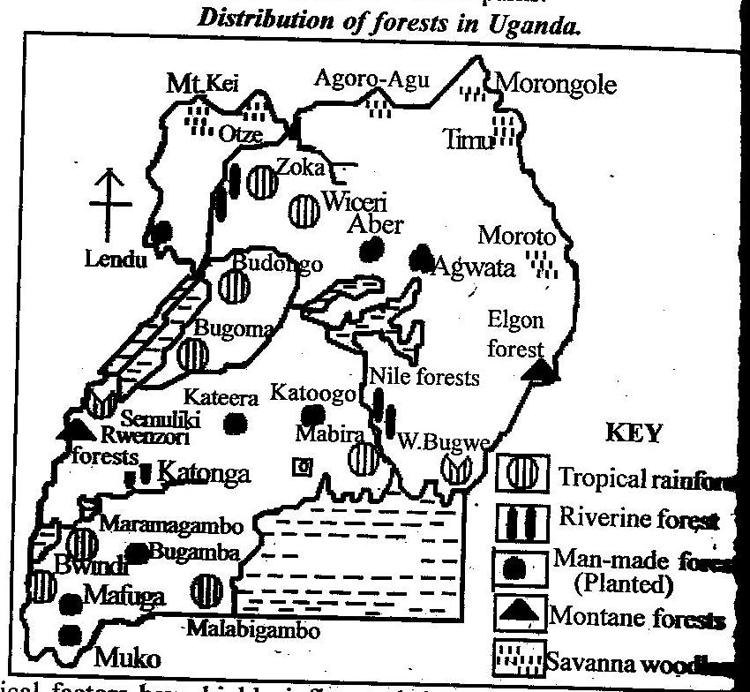
Status of the forestry industry
- Most of the country’s forest cover comprises natural forests.
- Savannah woodland forests are the most widespread forest types in the country.
- Most Uganda’s forests exist outside protected areas and on private land.
- There is high rate of deforestation of the natural forests like in Kyenjojo district.
- Some forests have been de-gazatted up to 23.6% like Namanve.
- The common planted tree species are pine and eucalyptus trees.
- All protected forests in the country are managed by National Forestry Authority (NFA) and Uganda Wildlife Authority (UWA).
- The most deforested areas are those which are heavily settled and cultivated.
- Uganda loses her forest cover at a rate of 1.8% per year.
- Much of the deforestation occur in well stocked high forests and woodland forests at a rate of 2% per annum.
- The country’s forest cover now covers 7.4 million hectares, down from 50 million hectares in 1900 only 9% down from 11% in 1995.
- Government encouraging afforestation under Agro-forestry.
Importance of forests in Uganda
The importance of forests in Uganda can be categorized into two i.e. productive importance and protective importance.
- Forests protect against erosion i.e. the leaves of the trees break the force of rain drops before they reach the ground. Also the fallen leaves help to mulch the soil hence protecting it from erosion like those on Elgon slopes.
- Tree roots bind the soil particles together making them less liable to erosion. Also tree branches act as wind breakers hence reduce the strength of wind that would have carried the top soil like on Mt. Rwenzori.
- Forests facilitate the formation of rainfall through the process of evapo-transpiration. This has led to rainfall in areas where forests are found like in Mabira-Mukono. Such rainfall has facilitated the growth of sugar canes at Lugazi sugar estate.
- Forests provide a habitat for wild animal and birds, protecting the rare species of animals such as gorillas in Bwindi that has boosted tourism industry for jobs to Ugandans.
- Forests help to prevent desertification through modification of the climate as they form rainfall in the process of evapo-transpiration like in Mabira-Mukono which in turn has favored tea growing at Kasaku.
- Trees provide oxygen in atmosphere and absorb carbon dioxide which reduces global warming. Forests like Mabira have absorbed pollutions from Namanve and Jinja industries.
- Forests like Budongo and Kalinju provide fuel in form of biomass in terms of fire wood and charcoal used for both industrial and domestic purpose. Industries like bakeries, brick laying factories like in Kajjansi use fire wood from Ssese forests.
- Timber derived from the forests such as Ssese and Mabira is used for a variety of purposes. Foristance making furniture, paper and pulp, matches, construction purpose, all of economic importance to Uganda through job provision and revenue to the government.
- Forests like Aber and Agwata provide poles for telephone and rural electrification. Eucalyptus tree poles are usually used, and also for construction purpose. This has led to increased industrialization in Uganda.
- Tropical rain forests of Mabira, Mgahinga and Bwindi act as tourist attraction potentials and this promotes the tourism industry thus earning foreign exchange for further development.
- Provision of employment opportunities as lumbermen in saw mills, forest rangers, officials in the tourist industry, furniture makers, etc. such Ugandans earn a lot of incomes improving on their standards of living.
- Forests contributes to the clean environment by reducing pollution of all types especially Mabira in Namanve industrial area i.e. absorbing carbon dioxide and producing oxygen. This increases the quality of life of Ugandans.
- Forests like mabira and Wiceri provide medicine in form of herbs that help to cure several diseases like moringa tree products, cinchona and aloe Vera which all cure diseases. This has improved on the life span of Ugandans.
- Forests like Kibale and Bugoma are source of food products such as fruits, honey, mashrooms, bee wax and gum. Also wild coffee is harvested mainly in Kibale forests and sold for cash. This improves on the incomes of Ugandans.
- Forests like Mabira and Ssese are used for research and study purpose by scholars of higher institutions. Foristance Makerere University uses forests for research.
- Forests are catchment areas for rivers as well as contributing rainfall into river channels. Forinstance Mt. Elgon forests Support River Manafa and Masaba. This helps to support aquatic life hence development of the fishing industry.
- Forests provide a good environment for recreation through picnics, hunting and beach games like at Botanical beach forests in Entebbe. This support tourism for foreign exchange.
- Forests are source of government revenue as well as foreign exchange from exportation of bamboo poles to Germany. The exchange is used for further development.
- Summary of positive importance i.e. Contributes gross domestic products, source of energy, provides valuable timber, yields valuable medicine, raw materials for art and craft industry, source of food (fruits), employment opportunities, income, revenue, urban growth around saw mills, promotes industrialization, foreign exchange, habitat for game/wildlife, tourist attraction, research promotion, catchment areas for rivers, positive modification of climate, protect soils from erosion, diversify the economy, promotes environmental purification, soil conservation through agro-forestry, act as wind breakers, promotes infrastructural development.
Short comings of forests include;
- Most forests like Malabigambo in southern Uganda do not appear in pure stand due to a variety of tree species they posses thus making their exploitation, felling and selection of logs difficult.
- Forests do habour dangerous pests and diseases like mosquitoes and tsetse flies. Also snakes and lions are a threat to forest exploitators.
- Thick forests like Bwindi impenetrable act as a barrier to communication especially in construction and maintenance of roads through the forest. This explains why some parts of Kisoro are remote.
- Summary: promotes remoteness, habit dangerous animals, habit pests and diseases, hide out for wrong doers, promotes drying of wetlands, hinder road construction, accidents are common during exploitation, etc.
Factors that have limited the exploitation of natural forests in Uganda
- Some forests like Marabigambo and Mafuga are located in remote and inaccessible areas especially during rainy seasons. This makes transportation and labor mobility for exploitation of the forest hard.
- The heavy rains received in such forests of Mabira and Budongo contribute to the outbreak of pests and diseases like mosquitoes and tsetse flies which are a threat to lumbermen.
- Tropical rain forests grow buttress roots which hinder effective felling of trees. Also trees are inter-connected by strong creepers and tree climbers. This makes tree felling difficult like in Ssese forests.
- The valuable tree species in forests like Maramagambo, Budongo and Mabira do not appear in pure stand. This makes it difficult in selection and felling of valuable tree species such as mahogany, ebony and mvule.
- Inefficient handling facilities after the logs have been felled. Lumbermen use manual rifting of logs to the nearest transportation centre like in Budongo forest.
- Shortage of capital to invest in the forestry industry for purchasing modern machines like electric saws, tractors to exploit big forests like Budongo and Bugoma. Few investors today have invested in the forestry industry since the business is less profitable.
- Limited market of Uganda’s timber since it is hard wood timber. These face a lot of competition from foreign countries with soft wood products.
- Inefficient transport networks to transport forestry products to market centres. Roads are destroyed by heavy rains within the forested areas.
- Shortage of skilled labour and managerial skills in the forestry industry to exploit forests like Kalinju and Bwindi. The unskilled labourers lead to felling of young trees.
- Floods especially during rainy seasons like by river Sezibwe in Mabira forest make its utilization difficult.
- The increasing population like in kibale has encroached on forest reserves for settlement and agricultural purpose. This is evident in kibale forest reserve.
- Political instabilities has affected exploitation of forests like the ADF affected Rwenzori forests and Mt. Kei and Otze in the north affected by LRA rebels.
- Steep slopes on mountains like Elgon and Rwenzori limit access to such forests for exploitation.also forests like maramagambo located in lowlands with soft soils limit transport facilities for exploitation.
- Inadequate research to identify and exploit trees of commercial value in Budongo, Bugoma and other forests. There is also limited modern technology to exploit forests and the use of primitive tools like axes cannot support commercial exploitation.

Deforestation in Uganda
Deforestation is the increased extinction of the forest resource. In Uganda the forests are on a decrease. About 100 years ago, the land of Uganda was having 12% covered by forests but now is estimated at 5%.
It should be noted that currently 21% of the original forests is remaining and 79% cleared. Most of the cleared forests are found in central region and in the west.
Map of Uganda showing mostly destructed forests.
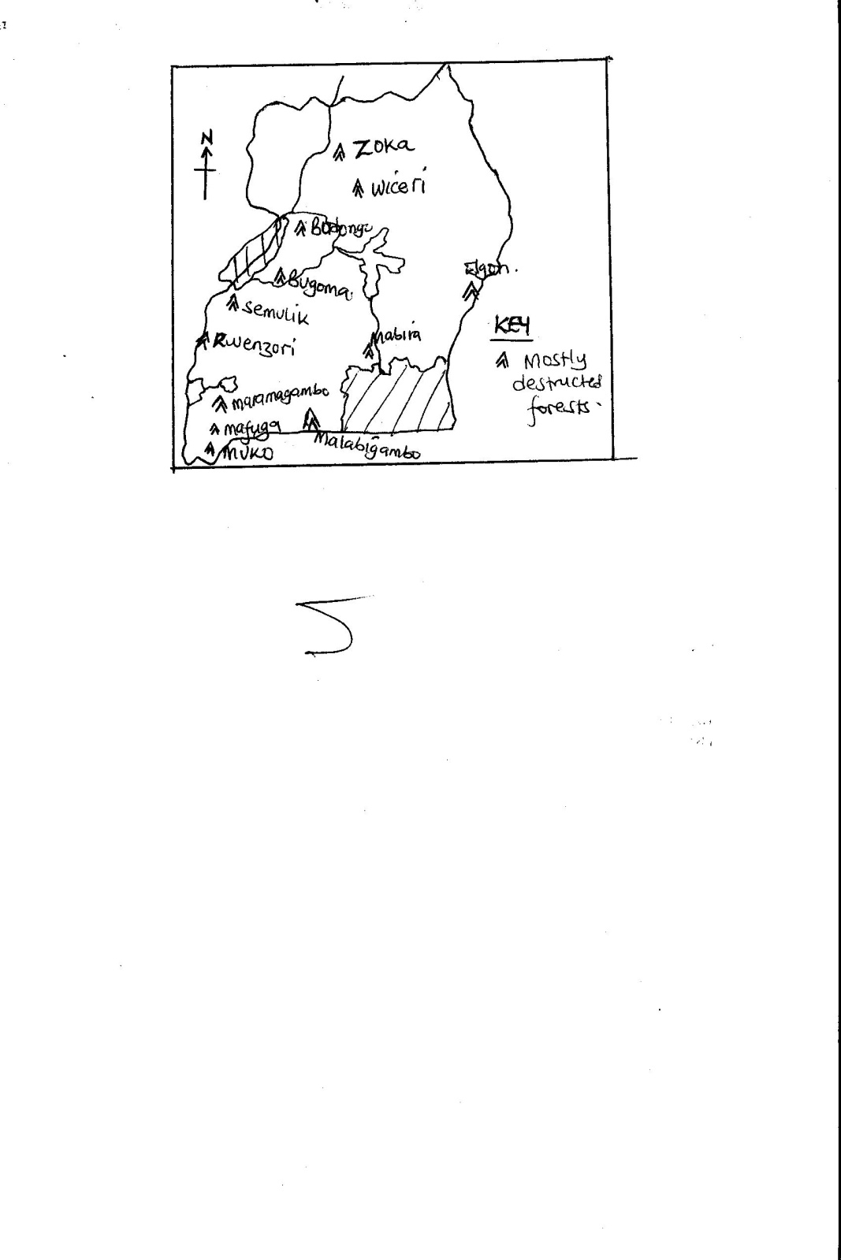

Factors/causes of deforestation in Uganda
- Rapid population growth, Uganda experiences a high population of 34.4 million people and the increasing population in areas such as kigezi, Mbale, Bugishu has led to high demand for land for settlement thus destroying forests like Mabira, Kibale, mt. Elgon forests, etc.
- Forests are major sources of biomass in form of fire wood and charcoal especially in rural areas. This has led to cutting down forests like Mabira, Bugongo and Maramagambo.
- The increasing demand for timber for furniture, building and construction has led to clearing parts of Kibale forest, Kalinju and Budongo which are accessible.
- Burning of forests especially by hunters, farmers and grazers has destroyed Mwenge forest reserve, mt. Rwenzori forests and Luwero forests. Also many hectares of forests of Aber and Opit in Gulu were burnt in 1982 by locals.
- Ignorance of the people especially in the rural areas like in Kibale and Kigezi, who have inadequate knowledge about the value of forests. Such simply destroy forests because they look at them as obstacles to more meaningful land use.
- Corruption in the forest department in form of bribes, illegal sale of timber, illegal lumbering, thus clearing mostly soft wood trees like Mafuga.
- Political insecurity where forests have been cleared to check on insecurity like in 1980s Luwero forests were cut down, Nyamityobora forest in Mbarara, etc for security reasons.
- Limited resources invested in the forest department leading to inefficient equipments used, limited rangers, wardens and other staff to monitor forests and reduce on encroachment on forests like Mabira, Budongo and others.
- Pests and diseases which have led to clearing forests to destroy tsetse flies like in southern Busoga, Bunya forest in Mayuge and kibale forests.
- Over grazing of both domestic and wild animals like kadama forest reserves, Timu and Morongole in Karamoja area. Also Aber and Agwata forests are facing illegal grazing by the Iteso pastoralists.
- The use of traditional and rudimentary tools in felling trees like axes and pangas has caused deforestation. Foristance Mafuga and Muko forest reserve have been destroyed by felling immature trees.
- The need for more land for cultivation like Bugala forest was cut down by BIDCO to plant palm oil trees, and Kakira and Lugazi sugar estates cleared part of Mabira forest for sugar cane plantations.
- Industrial establishment where forests are cut down to provide land for industrial set up like in Namanve and to get fire wood for tea processing in Ankole tea estate, firing bricks in Butende and Uganda clays in Kajjansi.
- Mining activities foristance gold mining in kitaka-kamwenge, Buhweju-Bushenyi has led to clearing of forests in such areas for the activity.
Effects of deforestation in Uganda
- Deforestation has led to the decreased amount of rainfall and also became unreliable. Foristance the area around Mt. Elgon have had their rain seasons changed simply because of forest destruction.
- It increases the amount of carbon dioxide in the atmosphere especially in urban centres of Kampala and Jinja and this is responsible for increased temperatures and global warming.
- Deforestation especially on steep slopes of Mt. Elgon and Kigezi hills has led to increased soil erosion and mass wasting. This has reduced soil productivity hence low crop yields.
- The uncontrolled cutting down of trees has led to scarcity of wood and its products in many parts of Uganda especially in Masaka, Bushenyi, and Kigezi south western Uganda.
- Forests act as habitats for wildlife therefore their destruction means destruction of wildlife. For example the white rhinos are now extinct just because its habitant was destroyed.
- Man depend on forest for survival directly or indirectly therefore forest destruction means that such people like lumbers and herbalists in Mukono and Ssese islands will lose a base for their livelihood.
- It has affected water supply in rivers and lakes since forest destruction lowers the water table and rainfall received in areas of kigezi, Hoima and Manafa.
Measures to conserve forests in Uganda
- The government of Uganda has established the ministry in charge of environment protection. This ministry has put special emphasis on the conservation of wildlife, wetlands and forests. There are now policies that are being followed by forest exploiters.
- The forest department has evicted many encroachers on the forest reserves like on Mabira and Kibale. Foristance the people who were occupaing 200ha had been evicted in Kibale.
- Education concerning the vitalness of forests has been carried out through mass media and other local authorities.
- Re-forestation programs are being carried out in various parts of the country. Foristance in Mbarara, Kabale, Arua, Mbale and Tororo.
- Afforestation programs are carried out, like planting of eucalyptus trees have been practiced in Ruhama, Mbarara, Ibuje in Apac, etc.
- Developments of other sources of energy like bio-gas, HEP, etc. in addition energy saving stoves which use less charcoal and fire wood have been introduced.
- The forest department through National Forestry Authority (NFA) has set up and maintained nursery beds to provide trees to farmers for planting and all this is intended to encourage people plant trees.
- Regular patrols by forest rangers to curb down illegal cutting of forests. This is limited in Uganda due to limited resources in the forest department.
- Forest boundaries have been planted with fire wood tree species in densely populated areas.
- Since 1986 the security situation in Uganda has been greatly improved. This improvement has helped to preserve the forests especially in eastern, central, western and southern Uganda.
- Family planning programs especially in rural areas have been encouraged to reduce on the rapid population growth rate which has cleared forests for other land use.
- Agro-forestry is being encouraged by farmers.

Population in Uganda
- Population refers to the total number of inhabitants in an area over a given period of time. Uganda’s population has been increasing over the years i.e.
- In 1959 Uganda had 6.5 million people, 1969 with 9.5 million people, 1980 with 12.6 million people, 1991 with 16.7 million people, 2002 with 24.6 million people and in 2015, 34.8 million people. The annual population growth rate is 3.4%and this rate varies from one district another.
- The densely populated districts of Uganda include Kampala, Jinja, Masaka, Wakiso, Mbale, Kabale, Kisoro, Tororo, Mpigi, Bushenyi, etc. The sparsely populated districts in Uganda include Moyo, Kitgum, Kotido, Kaabong, Masindi, Hoima, Kiruhura, etc. the districts with moderate population in Uganda include Luwero, Gulu, Arua, Iganga, Kumi, Kasese, Kabalore, etc.

Map of Uganda showing population distribution.

Factors responsible for the population distribution in Uganda
The distribution of population in Uganda vary from one district to another due to physically, economical, historical and environmental factors, these include;
- Climate, there is a close relationship between population distribution and climate. Areas which receive heavy and reliable rainfall support successful agriculture and therefore attract dense settlement like L. Victoria crescent, Bugishu highlands, etc.
On the other hand the little rains in N.Eastern Uganda of Moroto, Kaabong, Nakapiripiriti, discourages crop growing and settlement thus sparse population.
- Soils, areas with fertile soils which are well drained support flourishing cultivation like in Mt. Elgon slopes and the shores of L. Victoria support high population densities. On the other hand the poor soils in north eastern Uganda Copt with low rainfall received are responsible for the low population.
- Altitude, this control human settlement, usually settlement stops at 2000 meters above sea level and beyond this level there is severe soil erosion and reduced oxygen with increased coldness thus low population like on slopes of Mt. Rwenzori.
- Relief, the nature of land does influence population distribution in Uganda. The gentle slopping land is easily settled than steep slopes. For instance there more people on the gentle slopes of Mt. Elgon than on the steep slopes of Mt. Rwenzori. Flat lands and valleys usually floods during rainy seasons thus discourage settlements.
- Vegetation, the dense forested areas are difficult to clear for settlement and as a result they remain sparsely populated likewise the swampy areas are water logged therefore donot attract settlement. Populations tend to concentrate in areas which are easily cleared and well drained like in Luwero and Gulu.
- Pests and diseases, areas occupied by tsetse flies like parts of Busoga and western rift valley has got low population. In addition some parts of Bugerere remained un-occupied for some time just because of pests and diseases.
- Water resource, areas with permanent water source like Kampala encourages dense population well as Ankole-Masaka dry corridor and Karamoja with semi-permanent water have got low population.
- Mineral resource factor, mining of minerals like copper and cobalt in Kilembe-Kasese, cement at Tororo, has attracted dense population.
- Economic activities, man’s activities such as mining, industry and trade has contributed to the inflow of population from other areas to the central and eastern Uganda regions of Kampala, Jinja, Tororo, Mukono, Masaka, etc. on the other hand areas like Karamoja with little economic activities have attracted less population.
- Cultural factor, the pastoral economy of cattle keeping among the Karamajongs and Hima of Ankole demand large areas of land where this activity can be carried out (transhumance). This explains why such areas are sparsely populated.
- The no man’s land created by worrying tribes in the past like between Iteso and Japadhola, Baganda and Banyoro, japadhola and Banyole, until now have low population although it is relatively increasing.
- Tribal location, areas where traditional leaders head quarters where, tend to attract a lot of population and still has maintained such high population density like Mengo in Kampala.
- Political climate, in stable areas there is population increase well as unstable political climate in an area like as it was in Gulu which encouraged out migration which resulted into low populations.
- Urbanization, towns tend to attract settlement due to better living standards of better schools, health centers, electricity, etc. This explains why Kampala, Jinja, Masaka are densely settled.
Population growth and structure
- Population growth refers to the increase in number of people of a given area while population structure refers to the characteristics of the population. The structure is in terms of sex, age, education, etc.
- Both population growth and structure affect economic activities of Uganda. Uganda experiences a high population growth rate of an average of about 3.4% per annum.
- Infant mortality is defined as the death of children less than one year of age per 1000 live birth during the same year.
- Birth rate refers to the annual number of children born per 1000 people of the population of the country.
- Death rate refers to the annual number of people who die per 1000 of the total population of a country.
- Population growth rate refers to the percentage ratio of birth rate to death rate per 1000 people.

Causes of high population growth rate in Uganda.
- Very high birth rate which exceeds the death rate. The death rate is declining today because of improved medical services which has reduced infant mortality rate.
- The high infant mortality rate often forces people to frequently produces to ensure survival of at least a few, therefore there is a close relationship between survival and high birth rate.
- Values attached to children in many societies of Uganda. Parents look at children as source of labor in Kiga, wealth in Banyankole, security during old age in Baganda thus favour large families.
- Polygamy which is the act of a man marrying many wives which results into large families. This is seen mainly in Busoga, it is also reported that 33% of women in Uganda report that their husbands have got other wives.
- Early marriages, about 54% of women in Uganda marry before the age of 18 years they therefore have a long production period in which they bare many children like in Kabale.
- Education levels, there is a relationship between education and family size. The more advanced the level of education, the fewer children a couple is likely to have and vice verser.
- Income levels, poor people with less ambitions and property normally have many children well as the rich with a lot of over whelming ambitions to acquire more wealth attach little value to have children.
- Religion, some religions like Catholics encourages family development and opposes birth controls and abortion. Likewise the Muslims have a religious dogma of marrying many wives, such beliefs are characterized with many children.
- Limited family planning education and facilities especially in rural areas. Ignorance in some areas makes people to look at family planning contraceptives with a lot of fear that can prevent them from having children in future, thus more birth rates.
Problems resulting from high population growth rate
- Un-employment especially in urban areas which leads to out crop of high crime rate due to poverty, such crimes includes robbery, prostitution and theft.
- It contributes to the youthful structure of Uganda’s population. For instance the proportion of children aged from 0-17 years is estimated at 54% and this implies that there is high dependency syndrome.
- It exerts pressure on provision of basic facilities such as housing in urban centres, health, education, social transport facilities, etc and this costs a lot of money to the government.
- It results into little land per person hence land fragmentation. This results in over utilization of land leading to soil erosion and exhaustion. The low productivity of land results into absolute poverty like in Kigezi.
- Land fragmentation due to increasing population limits mechanization, reduces opportunities for employments in addition to famine.
- The increased pressure to feed the increasing population has resulted in settlement of people in marginal land, wildlife reserves and forested areas. Forests such as Mabira, Elgon forests have been encroached on leading to erosion, landslides, reduced rainfall and the general environmental degradation.
- It has resulted into rural urban migration especially by the landless and youth. This has led to rapid growth of urban centres with their associated problems such as slum growth, high crime rate, limited social services, etc.
Measures to control population growth rate
These measures are designed to control birth rate and those designed to manage the high number of people.
Birth rate measures
- Education through UPE and USE is emphasized to increase literacy especially among women. This is to break customs and traditions that favour large families. Also educated families tend to have fewer children than the un-educated.
- Encouraging of education among women and awareness in men as away of encouraging the use of modern methods of family planning birth control like use of condoms, pills, etc.
- Improvement in general standards of living by raising people out of poverty so as the use of children as an asset is stopped. It should be noted that poor people has a lot of time to produce.
Measures to manage high population
- Setting up settlement schemes, this involves the transfer of people from densely populated areas to un-settled areas like as it was in resettlement of Bakiga to Kibale.
- Eradicating of tsetse flies in some areas which are infested such that people are encouraged to go and settle there like it was in Bugerere and Busoga in eastern Uganda.
- Reduction on rural urban migration to reduce on rapid population growth especially in major towns of Kampala, Masaka and Mbarara. This can be done by providing related service of urban to rural areas.
- Developing other sectors such as industry, mining, tourism, which can absorb excess population on land
- Land reclamation especially swamps so as to create room for settlement; however this should be done with care so as to avoid environmental degradation.
Merits of high population
- It creates high potential for labour both skilled and un-skilled which can be used for economic growth.
- It stimulates industrial and agricultural development through increased labor supply and demand for goods and services.
- It leads to utilization of idle resources since there is plenty of labour.
- It makes it economical to produce power, health, water supply, education and other social facilities.
- It increases the tax base of a country used for further economic development through construction of important infrastructure.
- It provides a lot of potential for defense and security of a country.
Demerits of having low population
- It leads to under utilization of resources like land, water, minerals, forestry, etc.
- It limits the supply of labour force necessary for economic development.
- It results into market shortage and this does not provide incentives for invention and innovation.
- It results into limited development of social services like health, education, water supply, since it becomes un-economical to provide them in low population areas.
- It leads to low tax base thus less capital available for development.
- The area remains remote and inaccessible and this is a disincentive for agricultural and industrial development.
- Social and economic dependency on other countries for market, labour and other essential supplies.
- The country is liable to insecurity since the population provide less labour in the security department.
Population migration
This refers to the movement of people from one region to another. Migration can be internal or international.
- Internal migration refers to the frequent movement of people from one area to another within the same country. This is categorized as;
- Rural urban migration, this involves the movement of people from villages to towns. Like from rural areas of Rakai to Masaka town.
- Rural-rural migration, this involves the movement of people from one village area to another village area usually from densely populated areas to sparsely populated. Like Bakiga from Kabale to Kibale.
- Urban-urban migration, this involves the movement of people from one town to another town like from Masaka to Kampala.
- Urban-rural migration, this involves the movement of people from towns to villages like from Masaka to Rakai.
- International migration is the movement of people from one country to another. This is sub divided as;
- Immigration, this refers to the act of people entering a country from other countries. These can be refugees, tourists, officials, etc. like people from S. Sudan to Uganda. Such people are called immigrants.
- Emigration, this refers to the movement of people out of the country. Such people are called emigrants
Map of Uganda showing population migration.

Rural urban migration
This is the most common migration in Uganda and the major destinations of migrants is Kampala, Mbarara, Jinja, Gulu, Mbale, Kasese, Kabale, Masaka, etc.
The migrants come from villages of Moroto, Kitgum, Kaabong, Nakapiripiriti to Gulu, Bundibugyo, Sheema to Kasese, Rakai, Kalungu, Kalangala to Masaka, Bududa, Bulambuli, Bukedia, Budaka to Mbale, etc.

Map of Uganda showing rural urban migration.

Causes of rural urban migrations
There are both ‘pull’ and ‘push’ factors responsible for the movement of people from rural areas to urban areas. Pull factors are the attractive conditions in urban areas well as push factors are the un suitable conditions in rural areas from which people want to run-out or away. These include;
- Limited employment opportunities in rural areas, administrative, commercial and industrial activities are found in Kampala, Masaka, etc therefore attracting the youth for jobs
- Urban areas have better education, health, and other social facilities which pull people into towns like Mbarara and Mbale to enjoy a better life.
- Political security in towns like Gulu town which attracted many people affected by Kony war in the region.
- Most youth from Kisoro are attracted to Kabale town due to urban excitements of cinema, films, recreation like Bunyonyi sites, etc.
- Social amenities in Kampala such as electricity, communication, entertainment of radio Simba and capital, T.vs like Ntv, all attract majorly the youth from Kiboga, Buikwe, etc.
- The development of mining activity in an area provides a pull factor in relation to population migration into such area. For instance in 1960s many migrant workers used to move from Kigezi region to Kasese where copper mining was being carried out seeking for jobs.
- Some people move to urban areas like Jinja after committing crimes in rural areas such as rape and defilement, child sacrifice, etc.
- The landless people in rural areas move to town to seek for alternative way of settlement. This explains why towns like Kasese, Kabale and Mbale are densely populated.
- Natural factors such as drought, epidemic diseases which are harmful to human beings force people to leave rural areas to towns. Recently people have been forced to move out of Rakai and Lyantonde due to aids epidemic.
- Social factors such as male circumcision in Bugishu and female mutilation in Sebai cause the youth to run away to Jinja, Mbale, Gulu and Kampala.
- Excessive population in rural areas like in Kisoro, Sironko, Kabale, Mbale, has led to population explosion on land causing the disadvantaged to migrate to towns.
Effects/consequences of rural urban migration
Rural urban migration has got both positive and negative effects on both rural areas and urban areas. These include;
- It has resulted into depopulation of rural areas of Kiboga, Sembabule causing a negative effect on agricultural development since movement includes escaping of energetic men and women.
- It has resulted into rapid growth of urban areas; however this has got problems such as slum growth, un-employment, high crime rate, poor sanitation like in Kampala suburbs of Katanga, Kisenyi, Kamwokya, etc.
- It has resulted into racial ethnicity diversity which leads to racial conflicts and tension like in central region. This is because movement involves all kinds of citizens.
- It has resulted into intermarriages between tribes which has led to loss of traditional values and culture. This has increased on immoralities and sexual abuse like in Wakiso and Kampala.
- Since rural urban migration increases population in towns, this puts government to task to provide social infrastructure like water, health, education, security, which may drain government budget.
- Rural urban migration may lead to famine due to the decline in agriculture since the energetic men and women who would have facilitated agricultural development in rural areas moved to towns.
- It increases encroachment on wetlands and swamps in cities like Kampala in search for land for settlement. This later result into floods and disease outbreak like in Bwaise, Lubigi, Lugogo, etc.
- Rural urban migration leads to traffic and human congestion in urban areas of Kampala, Jinja and this causes delays especially during rush hours and easy disease spread.
- Positively, rural urban migration is an important source of labour especially unskilled in urban centres. Such labour is used for industrial development like in Mbale and Jinja.
- Rural urban migration leads to land consolidation in rural areas and useful utilization of the available resources by the remaining people in villages.
Solution to rural urban migration
- Addressing the issue of regional economic imbalance through creating employment opportunities and industries in rural areas.
- Agricultural modernization to help to increase on the rate of employment generation in rural areas.
- Controlling the rate of population growth so as to match the number of people to the available resources through family planning.
- Encouraging rural to rural migrations through allowing voluntary migrations from densely populated areas of rural to sparsely populated rural areas.
- Establishing large scale resettlement schemes to help check on this negative phenomena.
- Setting up of social amenities in rural areas like health, education, water, recreation, electricity, etc.
- Fighting against such cultural and traditional practices like forced marriages, circumcision, mutilation, polygamy, etc.

Agriculture in Uganda
Agriculture is the growing of crops and rearing of animals. Crop growing can be termed as arable farming well as animal rearing, animal husbandry or livestock farming.
- It should be noted that over 90% of the total population of Uganda depends on agriculture and 80% of Uganda’s exports are dominated by agricultural products.
- Different parts of Uganda practice different farming systems i.e. pastoralism in Karamoja, Nakasongola and Ankole-Masaka corridor, and cultivation of different types of crops of banana, cereals, tobacco, coffee, cotton, etc in the rest of Uganda.
- The sector employs over 70-80% of Uganda’s labour force and contributes 40-45%of the country’s GDP.
- Livestock farming has grown especially cattle, goat and pig rearing
- The range of commercial crops is growing from traditional cash crops of coffee and cotton to vanilla, aloe Vera, tea, rice, etc.
This difference is accounted for below;
- The type of climate experienced in the region, especially rainfall totals, reliability and distribution and temperature patterns. Areas which receive heavy reliable and well distributed rainfall like L. Victoria shores practice crop growing and vice verser.
- Also the temperatures are influential i.e. higher temperatures between 27⁰c – 30⁰c favour perennial crops of cotton, coffee in mukono, palm in kalangala, etc. well as low temperature of kabala and kisoro favour the growth of vegetables and apples.
- Soils, areas with well drained fertile soils like Mt. Elgon slopes favour arable farming well as Karamoja areas with infertile and porous soils favour pasture growth for animal rearing. Also acidic soils of Toro and Kasaku in Mukono support tea growth.
- Relief, relatively flat and gently sloping land in Buganda region of Wakiso, Mukono, favour mechanization thus arable farming, while steep slopes of Mt. Rwenzori attract animal rearing. Also tea and Arabic coffee grows well on higher altitude like in Toro and Mbale while masaka low altitudes facilitate Robusta coffee.
- Culture, the Karamajong and Hima rear animals because it is of their cultural attribute thus pastral system, the Baganda, Basoga, Kiga, etc practice arable farming growing crops such as banana, coffee potatoes thus banana coffee system .
- Land tenure system i.e. communal land ownership encourages nomadism like in Karamoja well as individual land ownership calls for crop growing like in Kigezi-Kabale areas.
- The level of economic development, usually in relatively developed areas of Uganda like Wakiso and Mukono there is practice of modern farming methods of vegetable-flower growing unlike under developed areas of Kaabong and Kotido where there is pastoral system.
- The influence of colonialists who developed cash crop farming in areas of west Nile, Busoga, L. Victoria shores leaving other parts of Uganda practicing nomadism and food crop growing.
- Government policy of emphasizing the growing of cash crops to boost the export sector. This has put a lot of land mainly in central Uganda to plantation agriculture like tea at Kasaku-Mukono, sugar at Lugazi, compared to animal rearing.also schemes facilitated by government like Doho, Kibimba and Mubuku.
- Nature of population found in an area, usually sparse population encourages transhumance like in Kiruhura and Kaabong thus pastoral system, well as dense population calls for intensive farming like in Entebbe.
- Biotic factors,
- Transport,
- market potential,
- Privatization and
- Education levels should also be considered in the discussion of the differences in farming practices.

Contribution of the agricultural sector to the development of Uganda
- The agricultural sector employs a lot of people in Uganda estimated at over 90% of Uganda’s population. Farmers, extension officers, veterinary officers, exporters earn a lot of incomes thus increased standards of living.
- It earns the country foreign exchange since it contributes 80% estimated exports. Coffee, flowers, vegetables, fruits, etc are some of the exported products. The forex is used to set up important infrastructure like schools, health units, thus development.
- Agriculture provide market to industrial products such as fertilizer making, hoe making, animal feeds by NUVITA, etc. this has led to industrial growth thus source of jobs and development.
- The government earns a lot of revenue from the agricultural sector through taxing agricultural enterprises such as Kakira and Lugazi sugar estates in Mukono and Jinja respectively. This revenue is used to set up important infrastructure such as roads.
- It has led to infrastructural development such as feeder roads, heath units, schools, valley dams, research centers, etc. these facilitate Uganda’s development.
- There is created international relationship through exportation of flowers, vegetables and fruits to Europe, food stuffs to S. Sudan and Kenya, etc. this has helped to keep Uganda secure.
- Is source of food to Ugandans like banana in Mbarara and Masaka, millet in Lira and Soroti, milk from Sembabule and Mbarara, etc. this has led to improvement in people’s health.
- Agriculture has led to the growth of agro-based industries through provision of raw-materials like Kasaku tea estate for Kasaku tea factory, kakira sugar estate for Kakira sugar factory. Such industries are a source of government revenue.
- Promotes economic diversification, power source, promotes research and tourism.

Problems facing agricultural sector in Uganda
These vary from one farming system to another, the below limit agricultural modernization.
- Climatic changes which have caused little rains in some parts of the country like in Karamoja region. This has led to shortage of water and pasture for livestock farming. Also in 2007 in Teso region floods destroyed crop farms. The practice of irrigation farming is also very expensive in arid areas of Kotido, Kitgum, Kiruhura, etc.
- Some areas in Uganda have got porous soils which are un suitable for irrigation like in Kitgum yet the area is semi-arid. The volcanic soils of Mt. Elgon get exhausted very quickly and the practice of monoculture by estates like Kasaku tea estate in Mukono exhaust soils and yet fertilizers are very expensive.
- The steep slopes of Mt. Rwenzori, Kisoro hills, Bundibujjo and other parts of the country limit the use of machines thus small scale farms. Also fewer farmers can access machines due to limited capital.
- Crop pests and animal diseases which make them stunted in growth like cassava mosaic, banana and coffee wilt especially in Masaka, Luwero, nagana, east coast fever and foot and mouth animal diseases in Sembabule, Kiruhura, affect agriculture leading to losses.
- Limited capital resource to finance research activities, set up large scale plantations, buy fertilizers and farm implements. This explains why farming in Kisoro, Nakapiripiriti is on small holder.
- Shortage of skilled labour to operate machinery and carryout research in the agricultural sector especially in Soroti and Lira. This calls for importation of skilled labour which is expensive.
- Political instabilities since 1970s to date in Luwero, Lira, Kasese, Gulu, Pader, has continued to scare away investors in the sector, destroy plantations and factories and also drained government treasury thus under funding of the agricultural sector.
- Corruption among the government officials in the agricultural sector, for instance a lot of funds were embezzled during the NAADS program, construction of valley dams, which was made to improve on the agricultural sector in Uganda.
- Inefficient transport network of roads to transport agricultural products to market centers like from Kiboga, Nebbi, Nabirongo and Mbale. It should be noted that most of the agricultural products are perishable like fruits, vegetables, flowers, animal products, etc,
- Inefficient and limited storage facilities, it is true to state that a lot of agricultural products are destroyed by weevils due to poor storage facilities. Also milk from Soroti, and Moroto, banana from Mbarara and Mbale is lost due to this factor.
- There is competition for market with outside countries which produce similar agricultural products such as Kenya and Tanzania. This causes price fluctuation.
- Others include low technology, cattle rustling, and low yielding crop and animal varieties, high population growth rate, poor land tenure system, natural hazards like hail stones and landslides, etc.
Farming systems in Uganda
There are several farming systems in Uganda which include;
- Small holder farming
- Subsistence animal keeping
- Cash crop growing/plantation farming
- Irrigation farming
- Co-operative farming
- Livestock ranching
Map of Uganda showing farming systems.
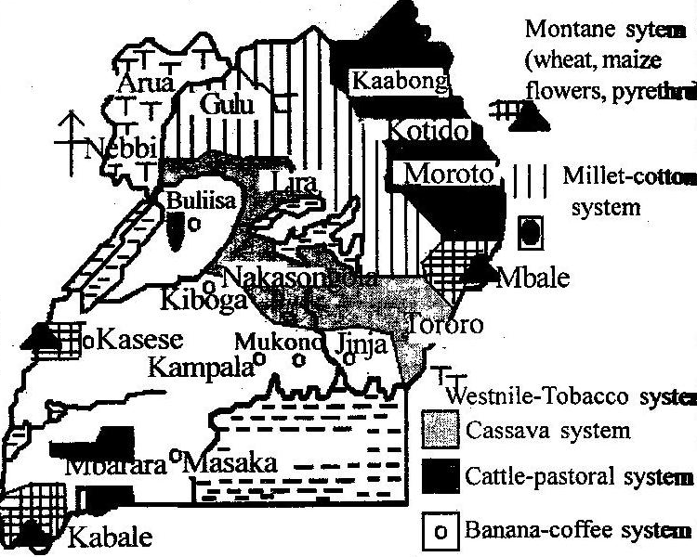
Small holder/ peasant farming
This is the growing of food and cash crops as well as animal rearing on small scale. It is the most dominant in Uganda. Food crops such as cassava, potatoes, millet, maize, beans, etc. cash crops like coffee, cotton, vanilla are grown. Pigs, cattle, goats, sheep, donkeys and poultry are reared.
X-tics of small holder farming
- Land units are very small in size but intensively worked since peasant farming is carried out in densely populated areas such as in Buganda.
- Individual land ownership.
- Farmers practice inter-cropping on their small portions of land i.e. production of cash and food crops.
- Elementary tools/traditional tools are used by farmers; these include hoes, digging sticks, etc.
- Little attention is given to crops while growing i.e. less or no scientific methods of crop growing applied.
- Use of family labour on farms.
- Some few animals and poultry are kept alongside crop growing on the farms.
N.B small holder farming is found in regions of Buganda where banana, coffee and other crops grown, Teso region where maize, cassava, simsim and cattle rearing, Kigezi where sorghum, vegetables, Irish potatoes, carrots are grown, Ntungamo district where coffee, millet, sorghum, cassava, sweet potatoes and cattle rearing.
Problems facing small holder farming in Uganda
- Limited land and therefore such areas face a problem of land fragmentation like in Kabale, Kisoro, Mbale, and Kapchorwa.
- There is a problem of high population growth rate which creates population explosion on land like in Kabale.
- Environmental degradation in form of severe soil erosion, deforestation and land degradation.
- The peasant farmers practice poor farming methods, such methods facilitates low crop yields, low agricultural output and stagnation in agriculture.
- The low productivity in agricultural sector make farmers to be un employed and have low standards of living.
- Limited market for the produce from the small holder farms, and this demoralizes such peasant farmers in relation to expanding their farming units.
- Shortage of capital/funds to purchase farm implements such as hoes which are becoming costly to such peasant farmers to buy.
- Peasant farmers lack technical advice from agricultural extension workers, they therefore end up practicing poor farming methods which lead to agricultural stagnation.
- Inefficient transport network of impassable roads during rainy seasons and this limit the produce to reach market centers in time and yet agricultural products are perishable.
- Un predictable climatic changes causing drought and floods which destroy crops. For instance in 1994 eastern Uganda experienced a long period of drought and in 2007 the same region was hit by floods which led to crop failure.
- Since peasant farming is characterized by small plots, such plots are repeatedly cultivated causing soil exhaustion thus low crop yields.
- Heavy taxes imposed on farmers’ produce while being taken to market centers.
- Small holder farming is practiced in densely populated areas of Uganda of Buganda, Kigezi, Mbale, and others. Due to the dense population, the population has led to land fragmentation.

Land fragmentation
Is an agricultural phenomenon which involves dividing and re-dividing of the land.
Land fragmentation in Uganda has majorly affected Kabale and Kisoro in South Western Uganda, Mbale and Kapchorwa in eastern Uganda, Bushenyi and Rukungiri, Kasese and Kabarole, etc.
Major areas affected by land fragmentation in Uganda.
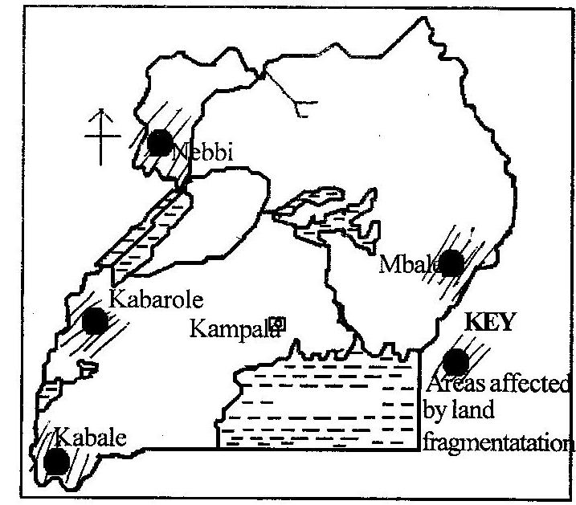
Causes of land fragmentation
- A high population growth rate in Mbale, Kabale, and Buganda which creates a problem of population explosion on land for settlement and agricultural activities thus division into small plots.
- The socio-cultural practices such as polygamy and land inheritance from ones parents and grandparents especially in Bugishu, Kigezi and Buganda. This means dividing the initial land into small plots to cater for the different wives.
- A high rate of un employment and general poverty, the two forces people to carryout installment selling and buying of land like in Kabarole and Wakiso.
- Many people believe in large families with many children and avoid family planning facilities thus increasing population and land fragmentation like in Mbale and Bugishu.
Effects of land fragmentation
- It discourages mechanization thus low farm production especially in Mbale.
- Since the plots are small, they are ever used thus soil exhaustion and low yields like in Kabalore.
- It accelerates land conflicts especially individual land owners and families sharing land boundaries like in some parts of Mpigi and Kisoro.
- Land fragmentation facilitates the occurrence of environmental degradation in form of severe soil erosion, deforestation and soil degradation like in Kabale and Kisoro.
- Small plots may fail to produce adequate food stuffs to feed the available population thus famine and malnutrition like in Kabale.
- It doesn’t encourage the growing of cash crops since farmers concentrates on growing food crops to feed their families. This is true in Mbale and Manafa districts.
- The crops may easily be damaged by wild animals and birds and their protection may be difficult in case the plots are located far away from one another like in Mbale.
- Crops may be damaged by crop pests and diseases from the neighboring plots.
- Land fragmentation leads to stagnation of agricultural sector thus leading to un employment since agriculture employ about 80% of Uganda’s population which is evident in Kisoro.
- Farmers are likely to use poor farming methods since they are peasants like in Mbale and Kabale, this leads to soil erosion, exhaustion and reduced crop yields.
Solution to above problems
- Family planning programs like in Kigezi and Mbale so as to control rapid growing population which causes such explosion on land.
- Resettlement of the excessive population where possible.
- Intensive methods of farming taught to affected people, here farming becomes more productive.
- Establishment of resettlement schemes where such excessive population can be resettled.
- Land consolidation so as to favor mechanization which improves on farming practice. This has started in Mbale and Kigezi with the help of agricultural extension workers.
- Teaching local people how to use modern methods of farming like mulching, fertilizer application, hybrid seeds and other intensive farming practices and this is supported by land consolidation.
- Starting up cash crop production alongside food crop growing due to consolidated land.
- Developing other sectors to increase on employments and reduce pressure on agricultural sector. This includes tourism in national parks like Bwindi in Kisoro, mining in Kamwengye district, transportation in Kabale, etc.
      - It should be noted that land consolidation solves the problems caused by land fragmentation; however it also causes other problems such as creation of landless people and displacement of people.
Subsistence animal rearing/nomadic pastoralism
This involves rearing of animals with a sole aim of producing what to satisfy home needs such as bride price, food, clothing, etc.
In Uganda, nomadic pastoral tribes include Bahima in districts of Mbarara, Ntungamo, Isingiro, Kiruhura, Rakai, Mubende, Sembabule, and Rukungiri, Karamajong in districts of Kotido, Nakapiripirti, Kaabong and Moroto. And some parts of Nakasongola-Bululi.

Pastoral areas in Uganda.
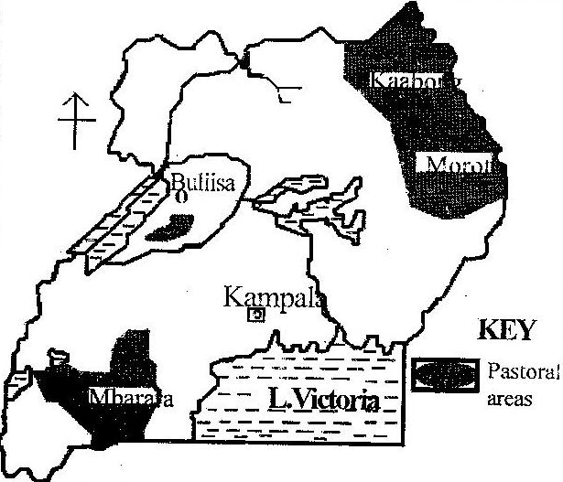
X-tics of nomadism
- Animal grazing is carried out on a subsistence level with no modern method of animal keeping used.
- Animals are grazed on natural pasture and nomads practice transhumance i.e. moving from area to anther looking for water and pasture for their animals.
- Pastoralist keep local/traditional breeds of animal species like Zebu of Karamajong and Ankole long horned cattle for Bahima. Other animals kept include goats, sheep, donkeys and camels.
- Pastoralists keep large herds of cattle for security and social reasons such as bride price, when some die during drought others survive, etc.
- There is communal grazing and land ownership in such areas.
- There is no permanent settlement of nomads, they keep on moving.
Problems facing nomadic pastoralists in Uganda
- Prolonged drought conditions which results into limited pasture and water, this makes nomads to keep on moving from one place to another.
- Nomads face a problem of famine and malnutrition since they normally neglect crop growing due to the prolonged drought.
- Over stocking has led to disappearance of vegetation cover which has resulted into environment degradation and soil erosion in particular, this is common in Karamoja north eastern Uganda.
- Tropical pests which attack animals and reduce their quality. These pests include ticks, tsetse flies, etc.
- The occurrence of such pests has resulted into animal diseases like nagana, foot and mouth, rinder pest and east coast fever.
- The act of communal grazing causes rapid spread of pests and diseases which attack their animals. Also tsetse flies cause sleeping sickness to nomads.
- There are conflicts over grazing grounds by families which results into death, for instance Karamajong and Acholi, Langi and Iteso, etc.
- Inefficient transport net work and general remoteness of the area, feeder roads are poor and become impassable during rainy seasons which leave the nomadic areas inaccessible.
Measures taken to solve the above problems
    - The land tenure system has been changed from communal to individual land ownership in Iteso and this has helped to curb down deforestation and soil erosion.
    - Demonstration farms have been established in Karamoja with an aim of teaching pastoralists modern and scientific methods of animal rearing.
    - Valley dams and bore holes have been established in Nakasongola and Bululi to provide permanent source of water to create a permanent settled way of life of nomads.
    - Education has been encouraged especially in Mubende and Rakai so as nomads break their traditional conservativeness and backwardness which makes them to over stock and graze.
    - Important infrastructure such as roads, health units, education, veterinary, clean water and good housing have been set up in Karamoja north eastern Uganda to break the remoteness of the area.
    - Introduction of crop growing to nomads alongside animal rearing which has reduced on famine and malnutrition among children in Nakasongola and Bululi.
    - Modern livestock ranches have been introduced in Kiruhura and Lyantonde to provide to nomads better and modern methods of cattle rearing.
Livestock farming in Uganda
This involves the rearing of animals on a large scale purposely for commercial reasons using scientific methods. This is sometimes referred to as ranching.
In Uganda, ranches have been introduced in districts of Nakasongola, Luwero, Mbarara, Ntungamo, Rukungiri, Rakai, Sembabule, Mubende and some parts of Karamoja, etc.
The ranches in Uganda include Ankole Masaka ranching scheme, Aswa ranching scheme in Kitgum, Maruzi ranching scheme in lango, Bunyoro ranches in Masindi, Buluri ranches in Nakasongola, Jesa ranch in Busunju, Batuma ranch in Kabale, Kyaka ranch in Kabalore, Kilyandongo ranch in Masindi, Agago ranch in Kitgum, Singo ranch in Luwero, Usuk ranch in Soroti, etc.

Map of Uganda showing areas of livestock ranches
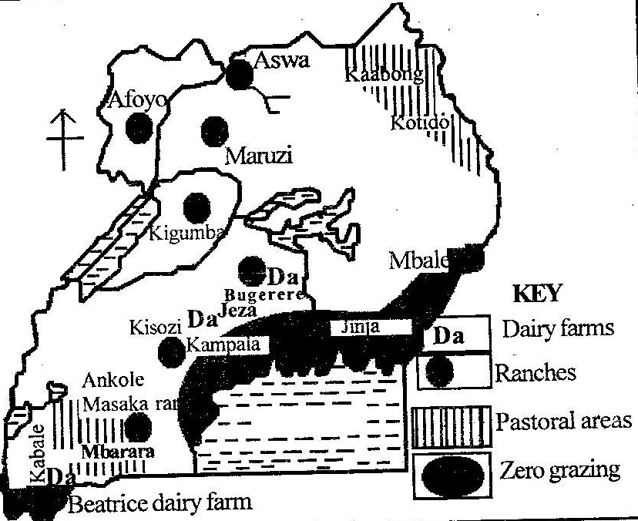
Status of ranching in Uganda
- Most ranches are characterized by low quality animal breads mainly zebu and long horned cattle.
- Exotic breeds of animals are increasingly being introduced like Frisians, jersey and Angus.
- Ranches are mainly in rural r remote areas with vast land.
- Scientific methods of animal rearing have been used like extension of veterinary services, use of artificial insemination, etc.
- Machines are used for milking like in Jesa diaries.

X-tics of livestock farming
- Animals are kept for commercial purpose.
- It involves keeping cattle, goats, sheep, pigs, poultry, donkeys and camels.
- Application of highly scientific methods of animal rearing such as sprays and dipping, cross breeding, etc.
- Permanent water sources like bore holes and valley tanks are provided on farm.
It should be noted that livestock farming in Uganda is limited and this is due to;
    - Shortage of capital and farming skills required in the management of modern and extensive cattle ranch.
    - Limited market for dairy and beef products since most people live below the poverty line.
    - Tropical diseases and pests such as tsetse flies which cause nagana, also other diseases such as rinder pest, foot and mouth scare away the establishment of ranches.
    - Limited research centers and this has failed the introduction of high breed animals to farmers in ranches, farmers in ranches still keep local breeds of cattle.
    - Prolonged drought conditions in many parts of Uganda which cause water and pasture shortage which makes pastoralists in ranches to practice transhumance.
    - Un supportive government policy of protectionism i.e. there is importation of cheap cattle products like milk from Kenya which out compete cattle products from ranches. Also limited loans have been given to pastoralists to set up ranches.
    - Land tenure system of communal land ownership which limit ranch establishment. Also individual land ownership has caused land fragmentation which affect ranch establishment.
    - Political instabilities which has destroyed important infrastructure such as roads and research centers. It has also drained government treasury thus less funds invested in the agricultural sector.
    - Limited land for expansion of ranches like in jesa ranch in Mpigi and in Mbarara.
    - Limited power supply to preserve animal products such as in milk cooling machines, and beef fridges.
    - Competition for market of livestock products with other producers like from Denmark, Netherlands and Britain.
    - Inefficient transport network especially during wet seasons to transport the perishable milk and beef to market centres.
Importance of ranches in Uganda
- Ranches have improved on breeds of cattle and goats through research in animal husbandry. This has improved on output in the livestock industry.
- Acquisition of skills by farmers such as spray, dipping, cross breeding, paddocking, insermination, etc
- There has been a check on occurrence of tsetse flies which used to cause nagana in animals and sleeping sickness in people.
- Ranches have increased on employment opportunities i.e. cattle keepers, veterinary officers, animal husbandry officials, etc. these earn incomes thus improved standards of living.
- It has led to improved infrastructure such as rehabilitation of feeder roads, construction of valley dams and bore holes, establishment of markets for animal products like Sanga in Kiruhura.
- Ranches have also led to establishment of small scale industries of milk cooling factories, meat packers, etc. these contribute revenue to Uganda.
- Ranches have broken the remoteness of the once nomadic pastoralist areas of Ankole-Masaka and Karamoja.
NB. Ankole-Masaka ranching scheme is the largest in Uganda.
Dairy farming is also practiced in Uganda i.e. the rearing of cattle purposely to obtain milk for commercial reasons. Mbarara, Masaka, Mukono, Kabalore, Bushenyi, Wakiso, Mpigi, Rakai, Kasese, Luwero, etc are some of the districts where dairy farming is practiced in Uganda.
Research must be done by the student on;
- Ankole Masaka ranch.
- Dairy farming in Uganda.
Cash crop growing and plantation farming
Uganda today has emphasized plantation farming since the economy is dominantly depending on agriculture. Some of the cash crops grown include coffee, cotton, tea, sugarcane, tobacco and vanilla.
It should be noted that plantation farming in Uganda has been favoured by both environmental and human factors
Coffee growing
This is the mostly grown cash crop in Uganda on plantation and small holder farming. The main coffee growing areas in Uganda include Buganda region, Ankole region of Rukungiri and kanungu, Sebei region of Kapchorwa, Busoga region of Iganga and Kamuli, west Nile of Nebbi district.
Factors which favour coffee grown in Uganda
- The local environmental conditions are favourable to coffee growing in many parts of Uganda i.e. heavy, reliable and well distributed rainfall throughout the year. Also the temperature range of between 14⁰C and 26⁰C favour coffee growth.
- The individual ownership of land in the growing areas favours coffee growing. Farmers own large tracts of land on which they have been able to grow coffee.
- Availability of large market for coffee domestically and foreign, Uganda’s coffee is of high quality and highly demanded in Western Europe and Asian countries.
- The effect of colonial legacy i.e. it made it compulsory for households to grow coffee in order to improve on their income.
- Presence of cheap labour recruited from household family members and neighbouring densely populated region.
- Improved transport network based on road which has favoured easy transportation of coffee to market centre.
- Favourable government policy of encouraging people to grow coffee, providing loans, coffee seedlings, etc, to farmers
Conditions required for coffee growing.
- Moderate rainfall of between 1000mm-1500mm per annum and temperatures ranging from 14⁰C to 26⁰C.
- Need protection from strong winds i.e. planting coffee trees alongside banana plants, tree species for protection.
- Coffee trees can tolerate any type of relief and altitude, forinstance Arabica coffee does well in mountainous and hilly relief while Robusta coffee does well in low lying areas.
- Large supply of cheap labour especially the harvesting period.
- It requires sufficient capital supply to purchase all the necessary farming inputs such as insecticide, pay labourers, etc.
- It requires improved transport network to transport coffee beans to the processing plants and subsequently to consumers.
It should be noted that coffee farmers face problems such as
- Coffee wilt disease and other pests.
- Price fluctuations due to over production.
- Weather vagaries of prolonged drought and strong winds.
- Soil exhaustion due to mono-cropping.
- Limited cheap labour during harvesting period
- Shortage of funds to invest in large scale coffee production.

Cotton growing in Uganda
Cotton growing started far back in 1903 and came to its peak in 1960s, however the frequent political instabilities made cotton growing decline throughout years.
In Uganda today, cotton growing districts include Kamuli, Iganga, Tororo, Pallisa, Soroti, Kapchorwa, Gulu, Kitugum, Moyo, Arua, Kasese, Masindi, Kumi, Lira, and Apac.
Conditions required for cotton growing
- Needs a warm climate with moderate rainfall ranging between 510mm and 1100mm per annum.
- It requires high temperatures of about 25⁰C and above.
- It requires a medium loam soil and application of fertilizers for continuous cotton growing.
- It requires cheap supply of labour especially during planting, weeding, fertilizer application and cotton picking.
Factors which have favoured the growing of cotton in Uganda
- There was a ready market for cotton mainly in Britain where it was highly demanded for her domestic textile industries.
- The Asians and Indians provided market of cotton and helped in cotton processing before its exportation.
- Favourable climatic conditions of moderate rainfall with high temperature for the growth of cotton and cotton bolls.
- Presence of medium loam soils coupled with application of fertilizers and organic manure which favoured cotton growth.
- Availability of cheap transport network of roads and a railway line from Mombasa to Kampala-Jinja and then to west Nile. This eased cotton transportation to market centers of Europe.
- Supportive government policies of increasing the export base of Uganda through encouraging cotton growing by improving transport network and provision of other services to cotton growers.
- The availability of cheap labour mostly family labour and from neighbouring un employed labour mainly offered by women and children.
Problems facing cotton growing
- The elnino weather phenomenon which affects the quality of cotton especially in Eastern Uganda as it was in 2007.
- Political instabilities like in Kasese ADF invasions, Kony wars which affected west Nile cotton producers.
- Amin’s expulsion of Indians and Asians in 1970s which hindered cotton processing.
- Occurrence of prolonged drought in major cotton growing districts of Uganda affects cotton growth.
- Limited farming implements and inputs such as hoes, ox-ploughs and improved seed varieties.
- Inefficient transport network since most cotton growers are located in remote areas which are inaccessible limiting cotton transportation to processing plants and market.
- Pests and diseases like boll weavils and cotton strainer bugs which destroy the quality of cotton.
- Monoculture which has led to soil exhaustion and low yields.
- Competition from other cotton producing countries like USA’s south, for market
- There is a general shortage of funds by the government of Uganda and this has limited research to produce good cotton varieties which are more valuable.

Tea growing in Uganda
Tea is one of the important cash crops grown in Uganda. It is grown on plantation as well as out growers.
Tea is majorly in Uganda grown in districts such as Mukono at Kasaku, Kabalore, Kyenjojo, Mubende, Bushenyi at kyamuhunga ang Igara, Kanungu, etc. tea growers are mainly foreign investors especially Asians.
The tea estates in Uganda include Kasaku in Mukono managed by Mehta group of companies, Kijura tea estate in Kabalore, Kyamuhunga tea estate, etc.
Conditions required for cotton growing.
- Tea requires deep fertile and acidic soils which is well drained and aerated for its growth.
- It requires a fairy heavy rainfall of about 1500mm per annum and well distributed and reliable.
- Tea requires a warm temperature ranging between 10⁰C to 20⁰C.
- It requires a large supply of cheap labour for planting, weeding, pruning and tea picking or plucking.
- It requires cheap transport means connecting tea growing areas to market centers.
- It needs reliable market for the processed tea leaves
It should be noted that the above conditions exist in areas where tea is grown and a reason why tea is grown in such areas.
Other factors favouring tea growing in Uganda include.
- Availability of fair prices for tea on international markets
- Improved extension services which were provided to the tea out growers.
- The process of privatization of tea growing in Uganda which has invested more capital into tea estates.
Problems facing tea growers in Uganda
- Limited capital and skilled man power to invest into tea growing.
- Political instabilities since 1960s and the 1970s Indian expulsion which scared away investors in tea growing like Mitchel cots.
- Shortage of cheap labour required in the growing of tea, few people are willing to offer their labour since low wages are paid in the estates.
- Inefficient transport networks like in south western Uganda on Buhwenju and Kabalore. This means that the processing, transporting and marketing of tea in such areas becomes hard especially during rainy seasons.
- Monoculture has led to soil exhaustion and application of fertilizers is costly thus the production of poor quality tea leaves.
- Harsh climatic conditions like the occurrence of prolonged drought conditions which interfere with tea growth.
- Inefficient funding and corruption within the government thus tea rehabilitation programmes get stunted and research is slowed.
Sugar cane growing
Sugar cane is grown as a cash crop as well as a food crop. The most growing estates in Uganda include Lugazi or SCOUL in Mukono, Kakira sugar cane estate in Jinja and kinyara in Masindi.
Conditions required for sugar cane growing.
- Sugar cane needs at least rainfall of well over 1500mm although it can do well with the use of irrigation methods.
- It requires a low temperature of about 20⁰C.
- Sugar requires a low-lying relief with mainly alluvial soil type.
- It requires a well drained fertile soil
- Sugar growing requires cheap labour mainly for planting and harvesting.
- It requires large sums of money for the establishment of the plantation, pay labourers and buy farm implements.
Some of the problems facing sugar cane estates.
- Competition for market from imported sugar.
- Limited capital to invest in sugar cane growing.
- Fluctuation in HEP supply which affect sugar processing process.
- Shortage of cheap labour to work on the sugar estate.
- Insufficient transport network and increased transport costs due to increase in petroleum products.
- Fire out breaks especially during dry season which destroy large acres of sugar cane.
- Pests and diseases like sugar wilt which destroy the quality of sugar cane.
Tobacco growing in Uganda
Tobacco growing in Uganda was introduced in 1920s, the crop is grown in many parts of Uganda such as West Nile, Bunyoro, Kigezi, Gulu, Kitgum, Pader, Masindi and Mubende.
Conditions required for Tobacco growing.
- Moderate rainfall between 750 to 1100mm per annum.
- It requires temperatures of about 18⁰C and above.
- Tobacco requires a well drained and fertile soil for its growth.
- It requires cheap supply of labour for planting, weeding and harvesting.
- It needs ready storage facilities.
- It requires ready market, capital and efficient transport network.

Problems facing Tobacco growers
- Prolonged drought conditions have interfered with the growth of tobacco in many parts of Uganda like in Kitgum and Mubende.
- Limited market for tobacco and this has discouraged farmers to grow more tobacco.
- Shortage of capital to invest in the growing of tobacco through setting up plantations and buying farm implements.
- Wide spread tobacco fungal disease which spoils tobacco leaves while growing there by reducing its quality.
- Labour shortage to work in the tobacco farms due to low wages.
- Monoculture which has led to soil exhaustion and reduced productivity of land.
- Inefficient transport net works to access market centers especially feeder roads become slippery during rainy seasons.
- The wide spread campaign by WHO against tobacco consumption has reduced market for tobacco.
- Political instabilities especially in the west Nile and northern Uganda at large which destroy tobacco gardens.

In Uganda today there are crops which were non-traditional export crops which are grown and exported as well.
These include banana grown mainly in central and south western Uganda, maize, beans, ground nuts, simsim, and soya beans, spice crops like vanilla, chiles, ginger, garlic, black pepper, flowers of various types, fruits such as pineapple, passion fruit, avocado, cashew nuts, vegetables like cabbage, green pepper, cow peas, okra, etc.

Vanilla growing in Uganda
This is one of the introduced crops in Uganda recently with an aim of crop diversification. It is grown in Mukono, Kasese, Bunibugyo, Mpigi, Masaka and Bushenyi.
Conditions for vanilla growing
- Plenty supply of heavy rainfall of over 1500mm per annum well distributed and reliable.
- It requires high temperature of above 25⁰C.
- It requires well drained fertile soils.
- The plants require protection from strong sunshine and strong winds
- Since it is a creeping plant, it requires other tree like plants to creep on.
- It requires a large supply of cheap labour during planting, pollination and harvesting periods.
- Like other crops, vanilla faces problems such as price fluctuations, limited capital, labour shortage especially during pollination and its too labourious during pollination.
Horticulture and Floriculture in Uganda
Horticulture/market gardening is the growing of vegetables, fruits and flowers purposely for commercial gain. In Uganda the practice is well developed in the L. Victoria shore districts of Kampala, Wakiso, Mpigi, Mukono and other districts of Mbale, Tororo, Mbarara, Kasese, Kabale and Fort Portal.
Characteristics of market gardening
- Small farms which are intensively cultivated to maximize profits.
- It is both capital and labour intensive.
- There is use of scientific methods of crop growing like sprays, fertilizer application, etc.
- Individual ownership of land.
- Farms are located near urban centers for ready market.
- The crops are sold while still fresh since they are highly perishable.
Factors which have favoured horticulture in Uganda
- Presence of improved transport and communication network of roads linking urban centers and air transport like Entebbe linking international markets of Europe.
- Availability of heavy and reliable well distributed rainfall throughout the year for crop growth.
- Presence of fertile soils which are well drained for fruit, vegetables and flower growth.
- Availability of cheap supply of labour both skilled and semi-skilled to work in the gardens.
- Presence of adequate capital to invest in the horticulture.
- Supportive government policy of liberalization of agriculture sector allowing foreign investors into market gardening especially in floriculture.
Floriculture involves the growing of flowers for commercial purpose. Today in Uganda floriculture has increased greatly on the exports of the country, majorly carried out in Wakiso, Mpigi, and Mukono.
Factors favouring floriculture in Uganda
- Presence of a cool and warm tropical climate which allows growing of various flower types mainly Rose type.
- An increased demand for flowers from Uganda by western European countries.
- Availability of cheap labour to work in the flower fields.
- Presence of cheap water supply for irrigation of flower fields.
- Improved transport and communication network especially Entebbe international airport which has played a vital role in promoting flower growing in Uganda.
- Presence of adequate financial assistance especially by foreign investors and organizations such as USAID.
- Supportive government policies of liberalization of agriculture thus encouraging foreign investors in floriculture.
Problems facing flower growers in Uganda
- Un-predictable weather conditions especially strong winds and too much rainfall.
- Inefficient transport network and yet flowers are perishable which needs to reach market immediately.
- Limited storage cold rooms for the cut flowers and this make flowers wither and a general loss.
- Competition for market with other flower producing countries such as Kenya and Zambia.
- The cost of irrigation of flower gardens is high limiting floriculture expansion.
- Shortage of labour to work in flower gardens due to little wages paid. Also farmers have limited skills in growing flowers.
General contribution of plantation farming in Uganda
Cash crop growing has got both positive and negative contribution towards the development of Uganda. These include;
- Provision of employment opportunities to Ugandans like engineers in kakira sugar processing factory, tea pluckers in Ankole tea estate, etc. this has earned farmers income and thus improved standards of living.
- Cash crops have increased on Uganda’s exports especially coffee and horticulture products. Uganda exports maize, sugar, banana to south Sudan, flowers to Europe earning foreign exchange which has helped to set up important infrastructure like roads.
- Through exportation of cotton tea and coffee, Uganda has improved on her international relations with countries like Britain, Kenya, etc. this has helped Uganda to become politically stable.
- Plantation farming has led to development of important infrastructure like schools, health units and roads. The availability of SCOUL in lugazi led to set up of Lugazi primary school.
- The government of Uganda has earned great revenue from licenses given to plantations such as Kakira sugar estate in Jinja, Igara tea factory of Bushenyi, and taxing plantation workers. Such revenue has been used to set up schools and hospitals.
- Plantation farming has led to growth of industries in Uganda like BAT due to tobacco from west Nile, freedum/Nytil in Jinja due to cotton growing, BIDCO due to palm growing in Kalangala, etc. such industries have provided jobs to Ugandans, source of revenue, etc.
Irrigation farming in Uganda
Irrigation refers to a process of application of water to the growing of crops. It is most suitable in the areas which receive little and un-reliable rainfall.
The major irrigation schemes in Uganda include; Doho irrigation scheme, kibimba rice scheme and mubuku irrigation scheme. Otherareas where irrigation take place are Kakira, Lugazi sugar estates and in flower farms.
Reasons for irrigation farming in Uganda
- Some areas in Uganda like western rift valley areas in Kasese receive little and un-reliable rainfall and this cannot support crop growing thus a call for irrigation farming.
- The need to increase on food production to feed the increasing population mainly in drier areas of Uganda.
- In some areas of Uganda like in Kasese there is high rate of evaporation and this water loss is replaced by irrigation farming.
- Irrigation farming helps to maintain water in soil which keeps it fertile and less degraded by soil erosion.
- Some crops while growing require much water and this can be supported through irrigation means.
Doho irrigation scheme
Doho is located on R. Manafa in Tororo district eastern Uganda. The main crop grown is rice and other food crops. Also cotton is grown as a cash crop.
Benefits of Doho irrigation scheme
- It has increased on rice production and other food crops are available for consumption to the local people and this has reduced on famine.
- The scheme has availed the locals with employment opportunities as farmers, transporters of rice, etc. this has earned them incomes thus improved standards of living.
- Farmers have acquired better farming skills from the scheme and this has increased on out growers output
- The scheme has provided settlement opportunities for the local people and about 1500 local farmers are settled around the scheme.
- The scheme has provided rice for export which has earned Uganda foreign exchange used for further development.
- It has increased on government revenue through taxing the scheme farmers; the revenue has been used for setting up infrastructure like roads and health units.
The main problems facing the scheme
- There birds which destroy the growing rice
- Use of poor farming methods outside the stipulated guidelines.
- Sometime R. Manafa over floods its valley during rainy seasons resulting in destruction of rice fields.
- Bilharzia is a common disease on the scheme which attacks the local farmers.
- Competition for market with other foreign countries which produce and import rice into Uganda like Pakistan.
- Price fluctuation for rice both domestic and on international scene and this leads to losses.
- Limited capital to invest in growing of rice and carrying out irrigation.
- The canals usually silt which block water transfer system.
Kibimba rice scheme
This was started by the government of Uganda and Peoples Republic of China in 1965. It is located on river Kibimba in Bugiri eastern Uganda. The scheme is well known for rice production.

Factors which favoured the establishment of Kibimba rice scheme
- The area experiences heavy rain fall between 1300mm-1500mm per annum which favour rice growth.
- The temperature in the area is relatively high throughout the year up to 32⁰C between December to February.
- The soils are relatively fertile which support rice growth.
- The availability of an extensive swampy land and gently sloping slopes suitable for rice growing.
- Availability of cheap supply of labour from the nearby densely populated Samia region.
- Presence of ready market both domestic and foreign. Locally rice is highly demanded by the dense population in Uganda’s districts like Kampala, Mbarara, Jinja, etc.
- Presence of adequate capital and managerial skilled labour provided by the Chinese workers and local population.
- Supportive government policy of encouraging and allowing foreign investors to invest in the agricultural sector.
- Improved transport and communication network of roads like Tororor to Jinja and railway line which help to transport rice to market centers.
Problems facing the scheme
- There is still a problem of expensive farming equipments used in irrigation and farming.
- Pests and diseases which affect the growing rice thus low quality rice
- Labour shortage due to low wages given to workers.
- Harsh climatic conditions of prolonged drought which leads to rice stunted growth.
- Low production compared to the scheme targeted levels and this makes the scheme appear less economic in terms of modern standards.
- Siltation of canals used to transport irrigation water,
Mubuku irrigation scheme
The scheme is located in Kasese district on the foothills of the Rwenzori Mountains. The scheme is located along Kasese-Fort portal road on R. Sebwe a tributary of R. Mubuku. It is well known to grow food crops like maize, onions, vegetables, sweet potatoes, etc.
There is also introduction of animal keeping especially the milk yielding types.
Factors which favoured the establishment of Mubuku scheme
- The presence of R. Sebwe a tributary of R. Mubuku which provides water for irrigation on the scheme.
- Supportive government policy, the scheme was set up to accommodate and train all the farmers selected in all the districts of Uganda in modern farming methods.
- The region contains fertile soils which support food crop growing.
- Presence of relatively flat land at the foothills of Mt. Rwenzori which allowed the use of machines.
- Easy access of the region since it is located along Kasese-Fort portal road thus quick transportation of crops produced to market centers.
- Availability of ready market for the produced food crops in the urban centers of Kampala, Kasese, Mbarara, Masaka, and Fort portal.
- Presence of an extensive land provided by the government of Uganda as well as capital to set up the scheme.
- Availability of cheap labour provided by the dense population of Bakonjo and Bamba in the Rwenzori Mountains.
Co-operative farming in Uganda
This involves pooling together of resurces by individual farmers in order to overcome some scarcity of such resources.
Uganda had co-operatives before their collapse due to political instabilities which included;
- Toloyang co-operative farming society in Acholi.
- West Nile master growers tobacco scheme in West Nile
- Kigezi vegetable grower’s co-operative union in Kigezi.
- East Mengo co-operative growers union in Buganda.
- Nyakatonzi co-operative society in Kasese.
- Masaka grower’s co-operative union in Masaka.
- Banyakole kweterana grower’s co-operative union in Mbarara.
- Bugishu grower’s co-operative union in Mbale.
Benefits of co-operative farming
- It gives farmers power to bargain for loans, market accessibility and putting in place the necessary farming infrastructure.
- Co-operatives train farmers in modern and scientific methods of farming which increases total yields from the farms.
- It becomes easy for farmers to purchase machinery, improved seed varieties, animal feeds, drugs and fertilizers as a group.
- Co-operatives can export their produce which increases their incomes thus high standards of living.
- Co-operative farming creates employment opportunities to their members and other local people and this improve on people’s standards of living.
- Co-operatives facilitate the carrying out of research which helps to modernize the agricultural sector.
- Co-operatives involve in the process of soil conservation and general environmental management.
Problems associated with the development of co-operative farming in Uganda
- The vagaries of weather foristance the occurrence of prolonged drought conditions and strong winds coupled with hailstorms which destroy the growing plants thus losses.
- Tropical pests and diseases like banana wilt, coffee wilt which attack and destroy crops and animals on farm.
- Price fluctuation especially for crops on international market which affect farmers planning and implementation of farming programs.
- Corruption among co-operative society officials especially in managerial positions and this drag the society down.
- Political instabilities since 1970s in Uganda which destroyed farms and loss of cattle. Eventually political chaos in Uganda by 1970s, co-operative society collapse.
- The soils in Uganda get exhausted quickly which calls for application of fertilizers which are expensive.
- Shortage of water resource for animals and irrigation especially in dry climatic regions of Kaabong and lyantonde.
- Limited capital to invest in the farming activities of co-operatives.
- Unsupportive government policies in relation to promotion of co-operative farming societies.

Fishing in Uganda
Fishing refers to all aspects of man’s pursuit of the aquatic animals from lakes, rivers, swamps and ponds.
Uganda’s fishing industry is based on the fresh water fishing grounds of lakes such as Victoria, Kyoga, Edward and George, rivers such as Katonga, Kafu, Nile, and Kagera and Kazinga channel. Also in swamps like Rubigi, Nabajjuzi and Mpologoma and in ponds such as Nkoma ponds in Mbale, Kajjansi ponds in Wakiso, etc.

Major fishing grounds of Uganda
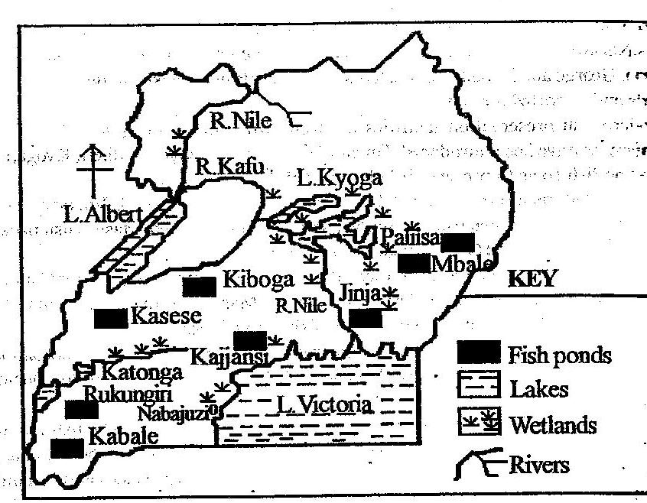
A sketch map showing L. Victoria, L. Albert and L. Kyoga fishing ground
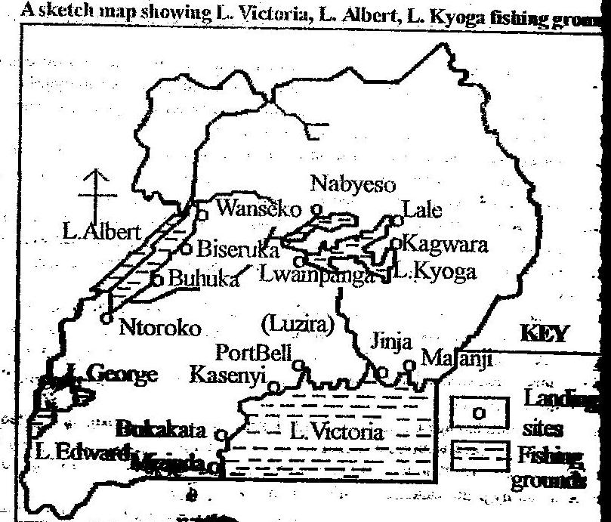
Status of Uganda’s fishing industry
- Majorly fish in Uganda is caught from L. Victoria contributing 58% of the total catch
- There is an increase in exported fish, fish processing factories and fish exporting companies. Fish is majorly exported to USA and Middle East countries.
- Fish processing and exporting companies include Hwang Sung, Ngenge Limited, Green fields, Four Square, Uganda Marine products, etc.
- The fishing sector has employed many people especially the un-educated.
- 60% of the total fish catch is sold fresh while 40% is processed.
- Traditional methods of fish processing like sun drying and smoking account for 20% though smoking is now illegal.
- Fish caught is transported to market centers through road, water and air depending on the destination.
- Common fish caught include tilapia and Nile perch

Major fish species of Uganda
Nile perch (mputa), Tilapia (ngege), lung fish (mamba), halochromics (nkejje), silver fish (mukene), clarias (male), mud fish (nsonzi), Bagrus (semutundu), cat fish, moon fish, yellow fish, etc. most of the above however are of less economic value except tilapia and Nile perch.
Methods used to catch fish in Uganda
- Baskets and troughs; this is normally used in the shallow water of rivers, swamps and lagoons. Baits such as worms, termites and meat are put in the basket to attract the fish. Also fishermen fence off an area and fish is then caught using baskets.
- The line method; in this method hooks are used, a rope is used with hooks tied on and baits on hooks to attract fish. Once fish is trapped the fishermen pull out the rope and it usually catches large fish like Nile perch.
- Gill netting; this is the most commonly used method where the net is suspended into water floated by floats and weights at the bottom. Here fish is caught by gills.
- Purse-seine; these are used together with boat engines which are driven on the water and fish is trapped into the net. A bag like net is tied on the boat and suspended into water as the boat is driven in the water, fish is trapped.
NB. Draw the required diagrams to describe the above methods
Major fish preservation methods used in Uganda
- Smoking method; this involves the use of fire to smoke the fish after it has been splint open and placed on the rack.
- Salting method; this involves the splinting open fish and then smear salt on it and put it in the sun shine to dry.
- Freezing method/refrigeration; this is the most modern method used, large refrigerated trucks are filled with fish and transported to the fish processing factories or market centers. Sometimes fish mongers carry with them ice blocks which they place in their containers with fish in it.
- Fish canning/tinning; here fish is processed and put into tins or cans, this is specifically used by large fish factories such as Hwang sung fish processing plants.
Factors that have favoured and contributed to rapid development of the fishing industry in Uganda
- Presence of moderate temperature and rainfall which support fish growth and breeding. This has increased on multiplication of fish within the fishing grounds of Uganda like in L. kyoga.
- The fishing grounds of Uganda receive a lot of light and the waters are oxygenated in L. Victoria, such is required for fish growth and multiplication.
- The presence of abundant planktons in the fishing grounds of Edward and George due to alkaline level of the water. Planktons are fish feed thus fish growth.
- Availability of several fishing grounds in Uganda such as Lake Victoria, river katonga, Lumbuye swamp and ponds. All these become source of fish.
- Presence of well sheltered bays on the shoreline of L. Victoria and Kyoga, these are suitable for the development of the fishing activities and setting up of landing sites such as Lambu and Kasenyi on L. Victoria.
- Presence of valuable fish species of Nile perch and Tilapia from Kyoga and Victoria. These are highly demanded by the local population as well as foreign markets. Also silver fish is highly demanded for making animal feeds.
- Supportive government policy of encouraging and accepting of foreign investors to invest in the fishing industry, companies like Hwang Sung have improved on Uganda’s fishing industry
- The government has also given loans to fishermen and mongers so as to buy modern fishing equipment. It has tried to protect the fishing grounds like Victoria against over fishing and the use of traditional fishing method.
- The rich continental shelf of L. Kyoga and L. Victoria which ease the use of gill netting and fishing gears thus a lot of catch.
- The presence of numerous islands like Ssese, Bubeke, Buvuma in L. Victoria which act as landing sites thus more fish catch.
- Availability of dense forests such as Bugala and kalangala along L. Victoria which has boosted boat construction used in fishing. Also Budongo forest has been a source of wood for smoking fish at Butiaba and Wanseko on L. Albert.
- Improved transport network which access the main fishing grounds of L. Victoria and Kyoga. This has eased fish transportation to market centers like a road from Lambu to Masaka town.
- Improved market potential for fish both internally in Kampala, Jinja, Masaka and externally in USA and Middle East countries, the market returns have been used to develop the industry.
- The availability of cheap labour largely from the dense population concentrations within the Victoria-Kyoga basin of Wakiso, Mukono, Jinja, etc to work in the industry.
- The use of modern fish preservation methods of freeing and canning by fishing companies of Hwang Sung, has improved on the quality of fish thus development of the fishing industry.
- The increasingly use of gill netting and purse- seining especially on L. Albert, Kyoga and Victoria, has led to improved fish catch which has fetched more incomes.
Roles played by the fishing industry in the development of Uganda.
- Fish is source of food as animal and human proteins. Silver fish from L. George and Albert is used as poultry feed and this has supported poultry farming thus more incomes to farmers.
- It earns Uganda foreign exchange through the exportation of fish and fish products especially Nile perch from L. Victoria to EU countries and Middle East countries. Such income is used to establish important infrastructure like roads and health units.
- The industry provides employment opportunities for the local people especially to un-educated youth like at Kasensero and Lwampanga fish landing sites. These are boat makers, fishermen, mongers and exporters as well as processors like in Ngege limited thus improved standards of living.
- Fish provide valuable products such as cooking oil, fertilizers, cosmetics which leads to industrial development. Companies like Hwang Sung, Uganda Marine products exist due to the fishing sector. Such companies are source of jobs and incomes thus high standards of living to Ugandans
- The industry facilitates the development of important infrastructure such as roads like a road from Lambu in Bukakata to transport fish to Masaka town, health units like Kasenyi health centre on L. Victoria, and these have improved on people’s living standards.
- It has led to diversification of the economy of Uganda from over depending on agriculture. Many Ugandans especially un-educated have been employed like at Buvuma, Katunguru, Masese, reducing pressure on land as well as incomes and foreign exchange from fish exports.
- It has led to establishment and development of ports on the fishing grounds; these include Lwampanga on L. Kyoga, Butiaba and Wanseko on L. Albert, and others on L. Victoria. Such ports have been used to develop trade and international relationship.
- Through licenses given to fishing companies like Ngenge Limited, Green fields, Four Square, taxes from fishermen and mongers, Uganda government has earned lot of revenue and used it to set up important infrastructure like roads, health units, etc.
Negative contribution of fishing to Uganda’s development includes
- Fishing requires boats and canoes and these claim a lot of forest cover for timber. Forests like Ssese and Mabira are getting depleted leading to reduced rainfall and soil erosion. Also on Lake Albert a lot of fire wood is used to smoke fish causing deforestation of Budongo and Bugoma as well as air pollution.
- Fishing is risky since it involves drowning, foristance about 20 fishermen drown into Lake Albert per year. Also dangerous animals like crocodiles especially in L. Kyoga have claimed a lot of people loosing labour force which would have been used for economic development.
- Fishing leads to growth of landing sites like Lambu and Kasenyi on L. Victoria and these are associated with a lot of evils such as prostitution, immorality, robbery, etc. also the activity has encouraged illiteracy since very few people go to school and others drop out of school on landing sites affecting economic development.
- Most of the fish processing and exporting factories like Green field at Entebbe Hwang sung in Ntinda are foreign owned repatriating all the profits got from the industry leading to low development of Uganda.
Problems facing the fishing industry in Uganda
- Limited valuable fish species in Uganda’s fishing grounds. Many fish species like mud fish, cat fish from L. Albert are less valuable and cannot compete favourably on the international scene.
- The major fishing grounds of Victoria-Kyoga basin have been invaded by a water weed known as water hyacinth which has endangered the life of fish. The weed block oxygen and light penetration into water which is necessary for planktons and fish growth. It also blocks fishing boats and habours snakes which attack fishermen.
- Pollution especially around L. Victoria which emanates from various industries in Jinja and Kampala like Nile breweries and Uganda breweries respectively pour wastes into the lake claiming many fish.
- There is a problem of over fishing by greedy fishermen by using under nets and beach seining on Golo and Buikwe on L. Victoria and Kyoga fishing grounds. This has reduced on fish.
- Prolonged drought condition especially affecting the north, eastern and western Uganda’s fishing grounds like L. Albert, George, and Edward. Drought reduces water levels, increase water temperature which leads fish death.
- Fish predators like Nile perch which eat other species, crocodiles, snakes and birds on L. Victoria which gradually reduce on fish numbers.
- Limited capital by fishermen to buy modern fishing gears of moto-boats, purse seining nets and preservation facilities which has led to continuous use of traditional methods of poison, beach seining like at Masese and Katunguru on L. Victoria and George respectively thus under exploitation of the fish resource.
- There is limited market for fish and fish products and this is mainly due to competition from international market with other fish producing countries like Peru and Norway. Also local market is affected by poverty in districts of Nakasongola, Moroto and some tribes which take fish as a taboo like the Hima.
- Limited handling facilities both at landing sites like Lambu and Masese on L. Victoria, market levels and storage of fish. This leads to losses since fish is perishable.
- Inefficient transport network especially during rainy seasons where roads like Masaka-Lambu is impassable, and also some fishing grounds like Rwenshama, are located in remote areas which delays perishable fish to reach the market centers thus losses.
- Political instabilities in some fishing grounds like L. Albert and Edward i.e. Kony and ADF wars respectively which limited full exploitation of the fishing grounds. Also wars in Uganda since 1960s have continuously drained government treasury thus low government funding of the industry.
- Water borne diseases like bilharzia which affect the fishermen leading to low exploitation of fish.
- Others include floating vegetation, ragged relief, irregular shorelines, moon light, waterfalls, water currents accidents, limited government support, use of poor fishing methods, remoteness of fishing grounds, reclamation of swamps, corruption, siltation of fishing grounds and limited research.

Measures to curb down the above problems
- Fishermen are encouraged to form co-operatives so as to bargain for loans from financial institution of FINCA, SERUDEF, and purchase preservation facilities and get managerial skills. Such institutions have provided loans to women groups at Lambu, Bukakata and Kasenyi for buying modern fishng gears.
- There has been a search for fish market from abroad and fish processing factories like Hwang Sung have increased on the quality of fish and fish products hence can compete favourably on the world market.
- There has been improvement on both preservation and transport facilities like refrigerated trucks of Ngege limited have helped to reach fish on market and for processing while still fresh. Also roads like Kampala-Ggaba, Kampala-Nakasongola-Lwampanga were tarmaced to access fisheries on L. Victoria and Kyoga.
- The government has tried to carryout training and research into the fisheries so as to maximize on fish production and reduce over fishing. This has been done on fish landing sites of L. Victoria like Lambu, Masese and Kasenyi which has reduced on overfishing.
- There is still a need to restock the over fished grounds like L. Albert and Kyoga by introducing new valuable fish species and protecting them from fish predators. This was done on L. Victoria where Nile perch was introduced.
- Strict laws have been put in place to check on indiscriminate fishing using beach seining and poisoning especially on L. Victoria fishing sites of Golo, Nakiwogo, etc.
- There has been treatment of industrial wastes before dumping into lakes to check on pollution which endangers fish life. Here the government has ensured that Nile breweries in Jinja and Uganda breweries in Luzira treat their wastes before dumping into L. Victoria.
- There has been a fight against the water hyacinth by individual fishermen and companies such as Uganda fishing co-operative union limited (UFCU) using machnes. This has helped to increase on oxygen and light in waters of L. Kyoga thus fish growth.
- Standard gill net size of 125mm has been recommended for use in most fishing grounds in Uganda especially at lwampanga and Nabyeso on L. Kyoga and Gaba and Majanji on L. Victoria. Also regular patrols are under taken on the same lakes by BMU to control pirates, under nets and fish poisoning.
- Creating of conducive political atmosphere by UPDF and peace talks. This has improved on fishing activities on L. Albert and Edward.
- Fish farming has been started in Uganda especially in Mukono and Kajjansi-Wakiso which has increased on fish production.

Note
- L. Victoria is the largest fishing ground in Uganda with several landing sites of Katebo, Ssese, Bukakata, Kasensero, Entebbe, Jinja, Bugadi, Kasenyi, Masese, Ggaba, Majanji, Kigungu, Lamu, Katosi, Sugu, etc.
- Lake Kyoga is the second largest with landing sites of Lwampanga, Mulondo, Nabyeso, Kigingi, etc. This is followed by L. Albert with landing sites of Butiaba, Wanseko, Bulisa, Buhuka, Ntoroko, Kibira, etc
- L. Edward and George are important fishing grounds with landing sites of Rwenshama, Kisenyi, Katwe, Kayanja and Kazinga. Kahendo, Katunguru, Kasenyi and Mahara of L. George.
- Fishing also takes place in rivers and swampy banks of rivers of Uganda mostly catching mud fish using traditional methods of fishing. Such rivers include Mpologoma, Katonga, Sezibwa, Nile, etc.
Fish farming in Uganda
Aquaculture refers to ‘growing’ of fish within the fish ponds and in Uganda it is stationed in Arua, Mukono, Bushenyi, Gulu, Kitanga-Kabale, Kamenyamigo-Masaka, Kisiizi-Rukungiri, Mbale, Kajjansi-Wakiso, etc.
The main species stocked in the ponds include Tilapia, clarias, bagrus, etc.
Factors that have favoured fish farming in Uganda
- Improvement in research on fisheries which provided the need to establish ponds where the studies are carried out like in Kajjansi-Wakiso.
- Supportive government policy of financing fish farming which came up after realizing that the natural fishing grounds like L. Victoria are getting depleted.
- Availability of ready fish market both local in urban areas of Jinja, Kampala, Masaka and foreign in Middle East countries which encouraged farmers to practice fish farming so as to earn a living.
- The presence of cool temperature and reliable rain fall which support the existence of fish and fish growth like in Wakiso and Mukono.
- Availability of various fish species to stock the ponds such as Tilapia, Bagrus and clarias.
- Presence of skilled labour provided by graduates from Makerere University and semi-skilled labour by the locals in populated districts of Mukono, Buikwe, Kamuli, and Mpigi to facilitate the establishment and management of ponds.
- Plenty of fish feeds produced locally by Uganda like maize brand and burnt bread, this support fish growth and multiplication.
Importance of fish farming
- Fish farmers have been provided by food in form of proteins and incomes from fish sales. This has ensured improved standards of living to farmers like in Kamenyamigo-Masaka.
- Skills acquisition by local farmers on how to manage ponds and fish farming at large. Organizations like CARE, NARO, IUCN has trained fish farmers in Arua, Kitgum, Kapchorwa, etc, thus more fish production and improved incomes.
- Fish exports like to South Sudan and USA fetch a lot of foreign exchange to Uganda which is used to set up important infrastructure like roads and health units.
- Fish farming has provided employment opportunities to many Ugandans who would have been un-employed especially in rural areas of Buikwe and Bushenyi. These have earned incomes like Nakapinyi fish farmers group members in Mukono, thus improved living standards.
- It has led to improvement in infrastructure such as research centers, roads and fish processing factories.
Problems facing fish farmers in Uganda
- Limited fish fry to the majority of fish farmers. This makes it expensive to buy fish feeds.
- High cost of pond construction on the part of local fish farmers, this is caused by a lot of poverty in Uganda and high fuel costs.
- Shortage of fish farming inputs like fertilizers and fish feeds as well as seine nets which limit the growth of aquaculture in Uganda.
- Limited capital to invest in fish farming for buying feeds, set up ponds, etc.
- Un controlled fish breeding which results into overcrowding in the ponds. This reduces fish quality.
- Harsh climatic conditions especially prolonged drought conditions which cause water shortage in ponds and sometimes dry up of ponds like in Kapchorwa.
- Fish predators like snakes, birds and other animals which attack the fish ponds and eat up fish. Also fish theft by the local people.
Solutions to above problems
- The government through FIRI (Fisheries Research Institute) under NARO with collaboration with Aquaculture Research and Development Centre at Kajjansi, has taught fish farmers better farming techniques.
- There are established demonstration fish farms at Kajjansi where fish farmers have acquired more skills.
- There are commercialization of fish farming and fry production by the Aquaculture Research and Development Centre at Kajjansi-Wakiso.
- CARE an NGO is training farmers in the districts of Arua and Kitgum. It has also stocked fish ponds to increase on their productivity.
- IUCN is rehabilitating fry centers in Mbale and Kapchorwa and also training fish farmers in Lira and Soroti in fry production and pond management.
- ODA (Over Seas Development Agency) supporting hatcheries in the production of mirror carp fry in various districts of Uganda to improve on fish farming.
- World Bank Unified Agriculture Extension Program has continued to support fish farmers through training, rehabilitation of fry centers, breeding trial demonstration farms, all done to improve fish farming in Uganda.

Tourism and wildlife resources
Tourism is the practice of travelling for purpose of either pleasure or curiosity. Tourism involves movement from one area to another within or outside the country.
Uganda’s tourist potentials
The potentials for Uganda’s tourism industry are categorized as;
- Mountain and drainage scenery (landscape). This include physical features of Uganda such as;
- Great rift valley/western rift valley and its associated features of escarpments like Butiaba and kicwamba, Rwenzori horst, rivers like Mubuku, lakes like George and Edward. These attract tourists to western Uganda.
- Volcanic features of Mt. Muhavura, Elgon, and Moroto, Napak caldera, explosive craters of Nyungu, Katwe, hot springs of Kitagata and geysers.
- Glacial features of Pyramidal peaks like Margarita, arêtes, glacial troughs like Lac du Speke, Lac Catherine, all on Mt. Rwenzori with activities of ice skating and mountain climbing.
- Coastal features such as spits, cliffs and caves like on Kasenyi landing site on L. Victoria, beaches such as Lutembe, Lido, Aero and Botanic, on L. Victoria.
- Blue water lakes of Victoria and Kyoga where swimming activities take place, game fishing, boat rides, etc.
- Rivers such as Nile, Katonga, Aswa with spectacular attractive waterfalls of Owen falls, Karuma and Bujagali on R. Nile, Sezibwa falls, Siipi falls Kisiizi falls, etc.
- Wildlife (fauna and flora). These include;
- Fauna, Uganda has a variety of wild animals which are gazetted into National parks and game reserves. Such parks include Mt. Rwenzori N.P, Queen Elizabeth N.P, Kidepo N.P, L. Mburo N.P, Mgahinga N.P, Bwindi Impenetrable N.P, Semuliki N.P, Kibale N.P and Toro N.P.
The game reserves include Pain-upe, Bukora, Karuma, Matheniko, Bugungu, Kigezi, etc. there are also sanctuaries in Uganda such as Jinja sanctuary for hippopotami, Entebbe sanctuary, Bwindi impenetrable forest for Mt. golliras, Mt. kei in Arau for white Rhinos. Also zoos like Entebbe Wildlife Education Centre.
Uganda has got avi-tourism i.e. bird watching with various bird species along Kazinga channel, Queen Elizabeth N.P, Semulik N.P, etc.
- Flora, Uganda has got an impressive vegetation cover which attracts tourists from abroad. These include the dense tropical rain forests like Mabira in Mukono, Budongo, Kalinju, etc,
Also the swampy vegetation along rivers like Mpologoma and Katonga, the dry savannah of Kitgum, Kaabong, Moroto and savannah grass land in the western rift valley all attract tourists.
- Climate, the tropical climate of Uganda in districts of Kampala, Wakiso, Mpigi has attracted tourists from abroad for sun bathing activities on beaches of Nabinonya, Aero on L. Victoria. Also tourists during November-February come for ‘refugee’ in Uganda due to the winter season thus benefiting from Uganda’s tropical climate.
- Culture potential, Uganda is rich in cultural heritage of traditional dances of Baganda, dressing style of Banyankole, traditional dishes like ‘Oluwombo’, burial grounds like Kasubi tombs of Buganda kingdom which all attract both local and foreign tourists.
Other heritages include Namugongo martyrs shrines in Wakiso, Nyero rock paintings in Kumi, artifacts, wood carvings and hand crafts all attract tourists.
- Historical attractions, these include Uganda museum in Kampala, Sango bay, Oruchinga valley, Bigobyamugenyi and Kagadi in Mubende, Lugard’s fort at Old Kampala all attract tourists.
- The equator, many local tourists and foreign visit areas in Uganda where the equator crosses for photographs and feel of the equator thus important tourist potential.
Map of Uganda showing its tourist potentials.
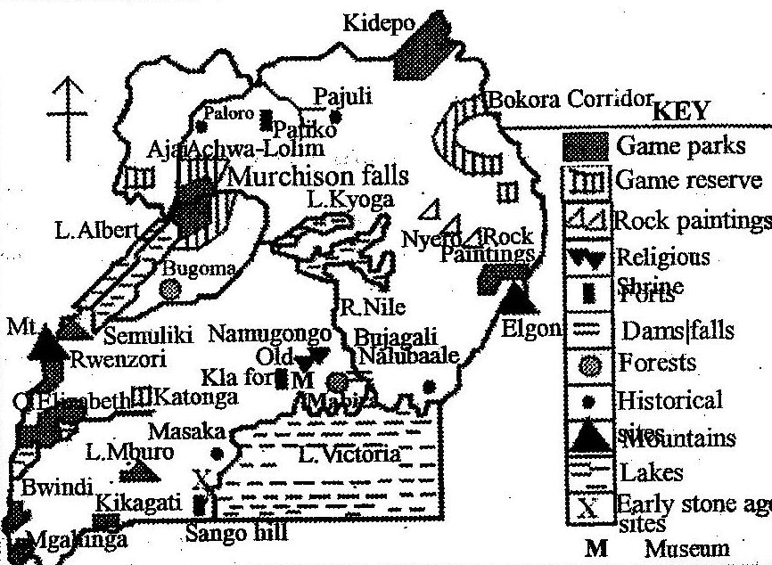
Map of Uganda showing her national parks,
game reserve historical site and resorts.
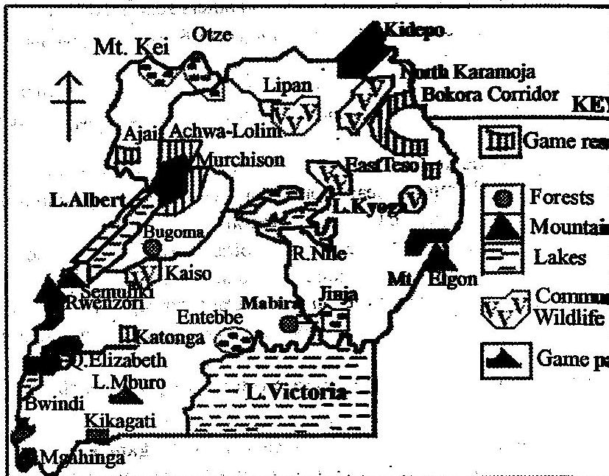
Status of Uganda’s tourist industry
- The sector majorly depends on wildlife of fauna and flora.
- More game parks and reserves have been gazetted up to over 22 in total.
- The sector contributes 25% of Uganda’s export earnings per year and the number of tourists is constantly increasing per year.
- The sector has employed many people over 70,000.

Factors that have favoured the development of Uganda’s tourism sector
- Presence of a wide range of tourist attractions which ranges from physical to human aspects. These include land forms such as spectacular lakes and rivers like Victoria with beaches like Lido, Botanical, and water falls on river Nile such as Karuma, Murchison, etc, all attract tourists.
- The presence of fauna and flora within the forest reserves and natural forests like Mabira, national parks like Kidepo with different animal species such as giraffes, lions, zebras attract tourists thus development of the industry.
- Historical sites of Uganda museum in Kampala, kasubi tombs in Mengo, martyrs shrines in Wakiso, Kinyankole dressing style, Baganda dances, all attract tourists to Uganda leading to development of the industry.
- The climate of Uganda being warm and wet tend to attract people especially from European countries during winter seasons between November and February each year contributing a lot of income for the development of the industry.
- Improved transport network of roads like from Kampala to Kasese, air transport of Entebbe international air port to Kotido air strip help to transport tourists to tourist potentials.
- Well developed and maintained hotels and lodges like Mweya Safari lodge in Rwenzori N.P, hotels in Kampala like Africana, Sheraton, Equatorial, etc, which provide accommodation services to the tourists.
- A wide capital base provided by the government of Uganda and foreign investors for establishment and maintenance of modern tourist facilities like accommodation, advertisement and transport facilities.
- Well established advertisement network over local TVs like Bukedde TV, radios like Simba, news papers like Monitor and in magazines so as to inform tourists of what Uganda can offer.
- Hospitality of local people to foreign tourists who come into Uganda for tourism purpose. The Baganda and Basoga are hospitable which encourage tourist to visit Uganda again and again.
- The prevailing peaceful political atmosphere especially in central, East and southern Uganda which has attracted tourists from abroad and within to visit all tourist potentials throughout the whole country.
- Availability of skilled labour produced by Makerere and other Universities and semi-skilled labour in the tourism industry to work in the hotels like Africana, game guides like in Kabalega N.P, transport tourist, etc.
Importance of the tourist industry to the economy of Uganda
- Uganda has earned foreign exchange in form of invisible export from thousands of tourists who visit the country from Europe, Asia and from other continents due to her tourist potentials. Such income has been used to rehabilitate roads, set up heath units, etc.
- The industry has provided employment opportunities to many Ugandans such as those working in Hotel like Serena, tour and travel agencies, game guides like in Queen Elizabeth N.P. This has earned income to workers and thus improved standards of living.
- It has led to conservation of wildlife of flora and fauna through gazetting and restricting of areas such as Bwindi impenetrable, Semulik N.P, forest reserves, etc. this has helped to modify Uganda’s climate by forests and protecting her heritage for future generation.
- Tourism facilitate the development of important infrastructure such as air fields like Kasese air field to link Queen Elizabeth N.P, roads like Kampala-Gulu-Kitgum to access Kidepo N.P, health units, lodges like Mweya Safari lodge in Semulik N.P for tourist accommodation. These have led to the development of Uganda.
- It has promoted and reflected the cultural heritage of Uganda i.e. historical sites like Bigobyamugenyi, museums like Uganda museum in Kamwokya-Kampala, cultural sites like Kasubi tombs, all protect Uganda’s image abroad.
- Tourism has led to development of the craft industry and agricultural sector through providing market to the products of such sectors like at the source of the Nile. This means provision of more jobs and income from craft industry thus improved living standards of Ugandans.
- Tourism has led to diversification of Uganda’s economy from over dependence on the agricultural sector. This has resulted into increased foreign exchange used to set up schools and health centers thus Uganda’s development.
- It has improved on international relationship between Uganda and the countries like Norway, Germany and Britain, where tourists come from. This has helped Uganda to become politically stable.
- Training of skilled man power like hotel attendants, game guides, etc.
- Government revenue through taxing tourist transport companies, tourists hotels, etc.
- Growth of urban centers like Kasese town
- Promoted environmental conservation through forest reserves, gazzetting of national parks like Kidepo.
- It has promoted education and research in botany and zoology.
Negative importance includes;
- Foreign tourists bring in Uganda social evils like homosexuality, promotes prostitution in small towns like Kayabwe and Nakasero which hinder Uganda’s cultural heritage.
- Tourism promotes terrorism as such people pretend to be a tourist leading to death of people as it was at Lugogo bombings.
- Profit repatriation caused by foreigners like Madhvan group who invest in Mweya Safari lodge
- Displacement of people to reserve parks and forests like in Kiruhura due to L. Mburo
- The wildlife in parks destroys people’s property and leads to loss of lives.
- Conserved areas for tourism habour and multiplies tsetse flies like in Queen Elizabeth Park.
- The overgrazing in parks has led to environmental degradation
- Encourages smuggling out of rare animal species and birds like parrots and monkeys from Bwindi
Problems facing the tourist industry in Uganda
- Political instabilities experienced in Uganda for a very long time. Foristance the LRA and ADF scared away tourist from visiting Kabalega N.P and Queen Elizabeth N.P respectively. This also reduced on the total number of tourists in Uganda since they were scared of visiting the country.
- Increased poaching in national parks and game reserves like Kibale N.P and L. Mburo N.P which has led to reduction and depletion of some animal species like white rhinos, elephants and hippos.
- Population encroachment like in Masindi and Luwero on Kabalega N.P. the cattle keepers like in Kiruhura has encroached on L. Mburo N.P in search for water and pasture for their animals especially during dry seasons. All this affect the well being of wildlife and yet it’s the major tourist attraction of Uganda.
- Inefficient transport network especially air and road transport, roads during rain seasons are impassable like a road linking to Kidepo N.P in north eastern Uganda, the air strips like Kasese have limited handling facilities thus affecting the industry.
- Insufficient accommodation facilities of hotels, lodges and the well established ones like Sheraton and Serena are located far away from major tourist attraction. The available resorts are also too expensive discouraging local tourists.
- Inadequate advertisement to outside world of the tourist potentials available in Uganda for visiting. Also there is inefficient local advertisement rate thus many people are green about the tourist potentials in the country.
- Insufficient support from the government of Uganda to the Uganda Tourism Board (UTB) which is responsible for advertisement of Uganda’s tourist potentials both to local and abroad, which explain the low development of the tourist industry.
- Low domestic tourism due to poverty and ignorance of the locals, this has left tourism in Uganda dominated by foreign visitors like British, Germans, thus its low development.
- Hostility of some tribes in Uganda like the Karamajongs who are un friendly to Whites and this has continued to scare away visitors to Kidepo N.P making the industry to lose.
- Competition for foreign tourists with other African countries which has relatively similar tourist potentials like those of Uganda like Kenya has got relatively similar fauna, flora and climate. This claims a lot of tourists.
Measures to curb down the above problems
- Re-equipping and rehabilitation of existing tourist lodges such as Mweya, Chobe and Paraa. Other resort centers should be constructed with modern facilities to attract more tourists into Uganda.
- More training of labourers employed in the industry such as game wardens to fight poaching, hotel attendants to offer excellent service to tourists, so as to attract more tourists.
- Extensive advertisement to the international world about the existing tourist potentials with an aim of making the outside people aware of such existing potentials. This will fetch a lot of visitors into Uganda.
- The government has encouraged the development of the private local tour operations so as to provide efficient and modern reliable facilities in transportation.
- Massive campaign and education has been launched targeting local people especially encroachers and poachers to avoid their acts and protect wildlife resource.
- Privatization has resulted into an increased capital flow resource into the tourist industry. Also private Tours and travel agencies have helped to improve on the industry.
- There has been a check on political instabilities in Uganda. Today the LRA and ADF rebel groups no longer exist and now tourists access the once affected areas of North West and western Uganda parks like Mt. Rwenzori N.P.
- Anti-poaching units in the major parks in Uganda have been established like in L. Mburo N.P, and also strict laws dealing with encroachers on existing gazette areas have been enacted.
- Population pressure which has caused encroachers on fauna and flora has been checked through family planning awareness especially to local rural people and also resettlement of people from densely populated areas to sparsely populated areas.

Mining in Uganda
- Mining refers to all the processes through which both metallic and non-metallic materials are extracted from the earth’s crust. A mineral is any naturally formed element or composition.
- Metallic ores in Uganda include copper, lead, silver, tin, cobalt, wolfram, iron ore, etc.
- Non-metallic ores include phosphates, limestone, mica, salt, sand, asbestos, clay, gypsum, oil, potash and zinc.
- The major minerals in Uganda include limestone, asbestos and phosphates at Hima and Tororo, copper and cobalt in Kasese, iron ore, tin and wolfram in Kabale and Kigezi areas, salt in Katwe, sand and clay along L. Victoria shores, petroleum, natural gas and Kaolin in Albertine region, vermiculite and gold in noth east and eastern Uganda, mica and gold in Mubende, etc.
Map of Uganda locating major mineral deposits.
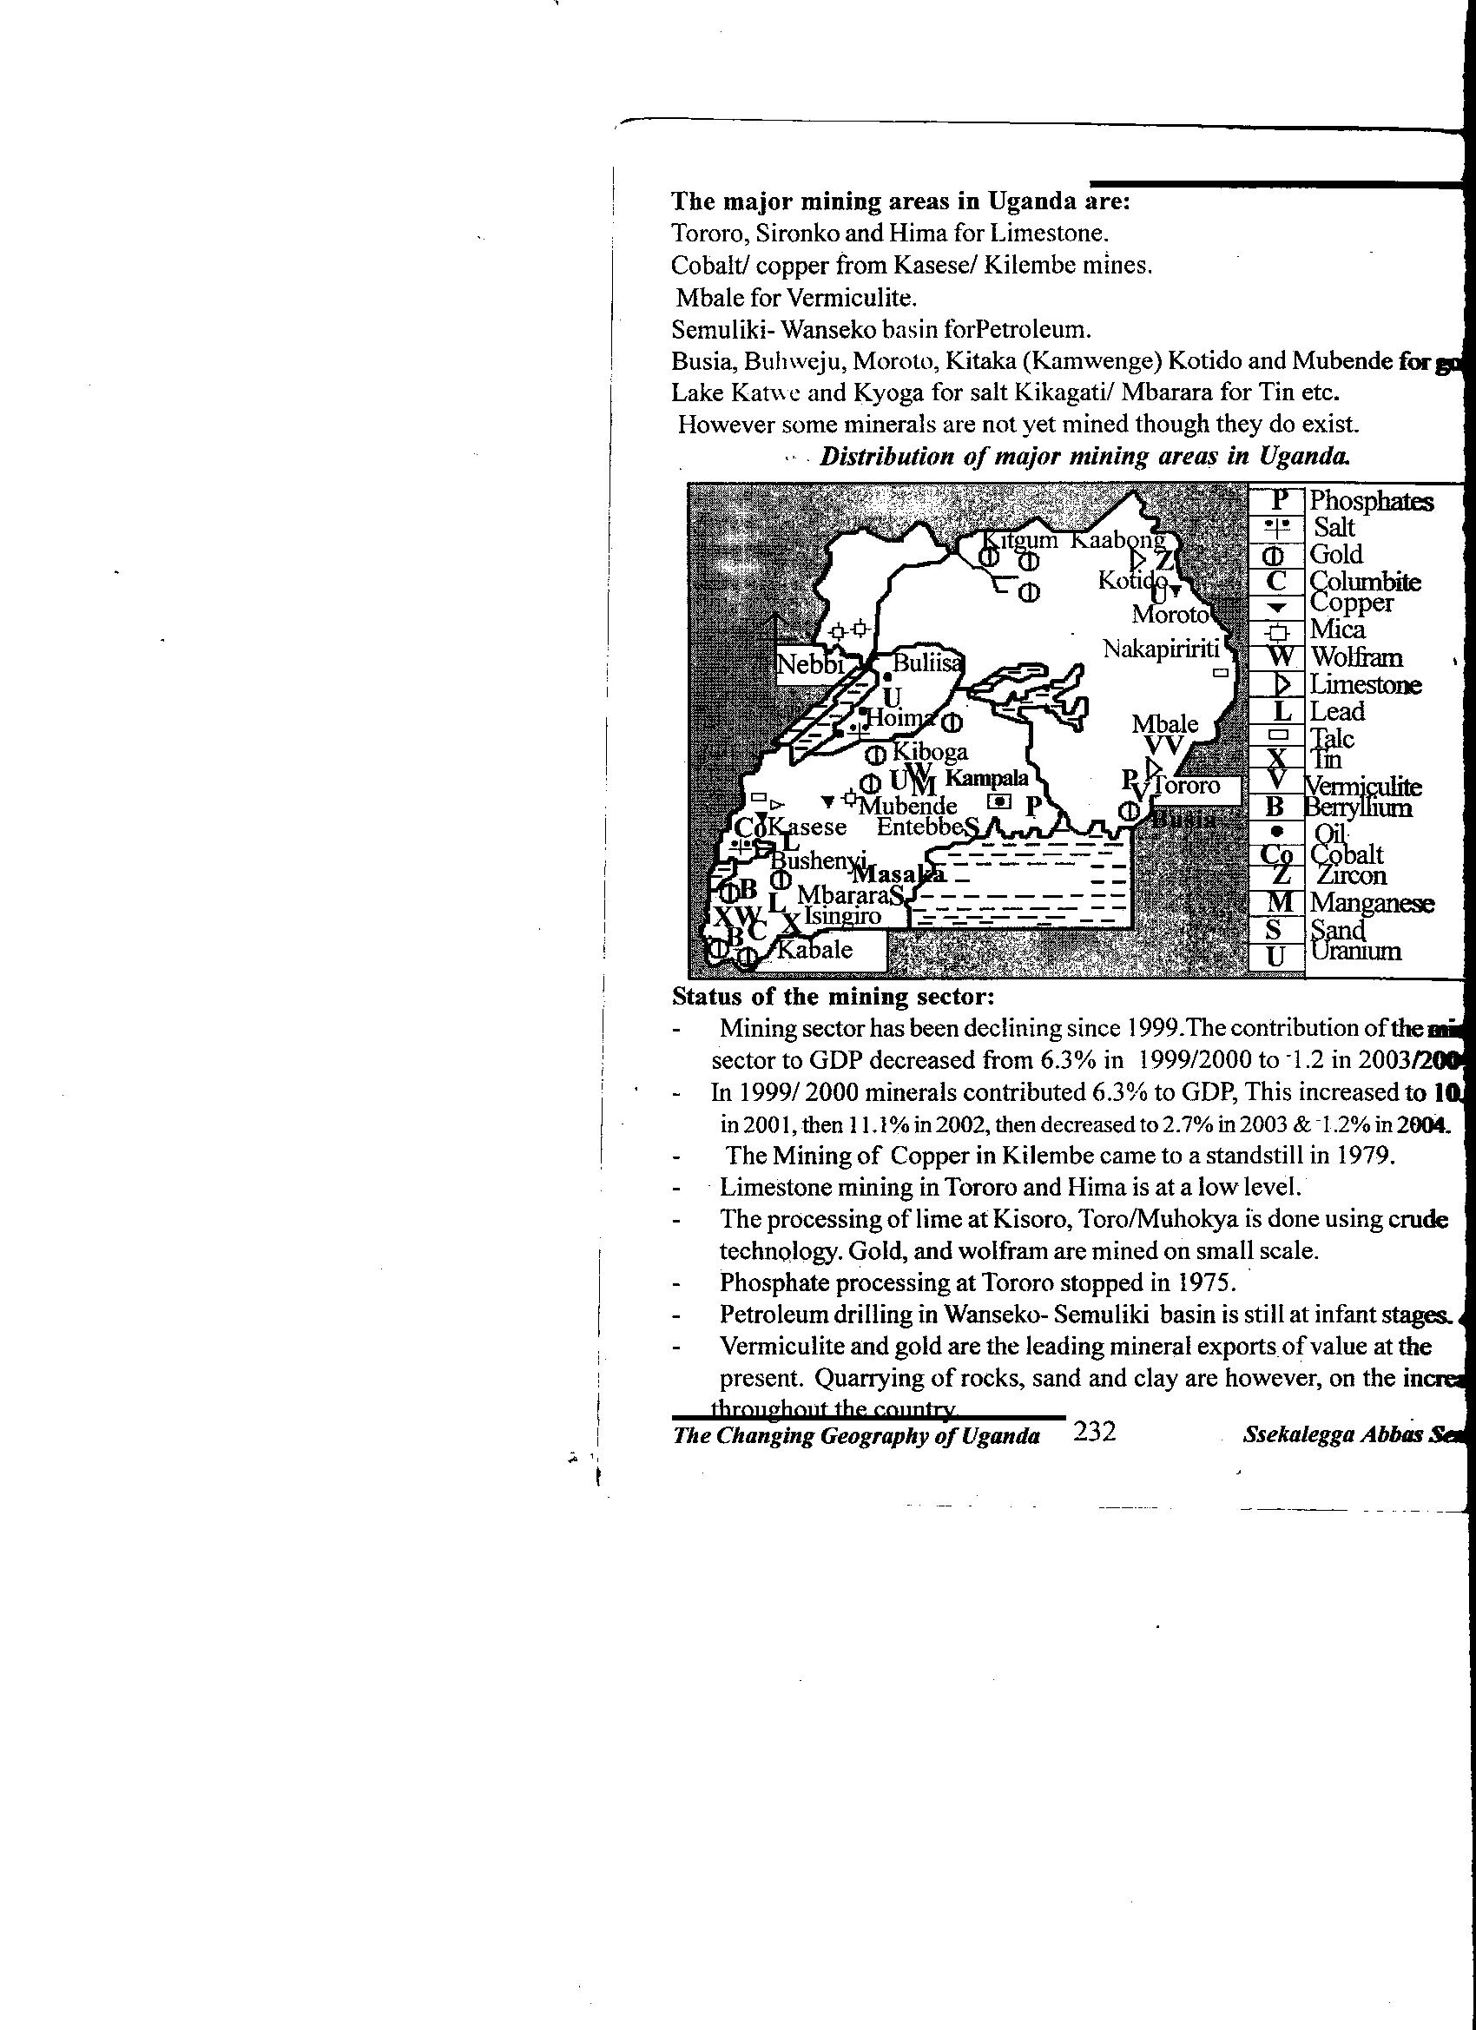

The status of Uganda’s mining sector.
- Mining in Uganda is mainly carried out on small scale using rudimentary tools especially iron ore and tin in Kabale-Kisoro, sand and clay in L. Victoria shores.
- Vermiculite and gold are now the leading mineral exports and mining companies are foreign owned.
- Oil drilling in Albertine graben is at infant stage and limestone at Hima and Tororo, copper in Kasese is declining.
- Quarrying of stones, sand and clay is dominant.

Methods used in mining
There are mainly three methods used to extract minerals in Uganda and these include;
- Open cast method which is used to extract minerals buried near the surface like limestone at Tororo and Hima, sand and clay at Kajjansi and Butende and stone quarrying in Ntugamo.
- Tunnel or adit method, this is used to mine minerals buried deep in the earth crust. It involves the construction of tunnels to reach the mineral bearing rocks like copper and cobalt mining in Kilembe-Kasese.
- Alluvial mining method, this is used for mining minerals like gold as it is in Buhwenju-Bushenyi and Karamoja region.
Factors which influenced the development of mining in Uganda
- Availability of large capital base to invest in the mining sector provided by the Ugandan government and foreign investors.
- Presence of a high level of skilled labour force in form of technicians, engineers and mineral explorers within Uganda and others imported from abroad.
- Presence of large semi-skilled labour supply especially from the densely populated areas. These provide support in sand, clay, stone quarrying, limestone and copper mining in different areas of mining in Uganda.
- Ready market for mineral products within Uganda like market of minerals such as sand, clay products, limestone (cement) and foreign market for gold, cobalt, vermiculite, copper, etc.
- Some minerals in Uganda such as limestone, sand, clay appear in large quantities and of high grade which becomes economical for their exploitation. This explains why there is prospering limestone mining in Tororo and Hima.
- Improved transport network of roads, water, air and mainly railway line which has helped to transport bulky copper and cobalt of Kilembe-Kasese, cement, etc.
- Some minerals in Uganda appear near the surface like limestone at Hima, stones in Kabale, clay and sand in Lweza-Wakiso, which has encouraged their exploitation since it becomes cheaper to mine them.
- The presence of a peaceful political climate since 2007 when the ADF and LRA were finally defeated. This has attracted foreign investor in the mining sector.
Factors hindering effective exploitation of mineral resource in Uganda
- Low levels of technology know-how which has led to limited research and exploration of mineral resource thus inadequate knowledge of mineral resources.
- Limited capital to invest in the mining industry since it requires a lot of capital for mineral extraction and paying of labourers.
- Shortage of skilled labour force required in the mining industry such as engineers, miners and other semi- skilled labour to support the industry is limited.
- Most of the mineral resources in Uganda appear in small quantities and are of low quality and this make them un-economical for mining.
- Most minerals like copper at Kilembe-Kasese are buried deep underground and it becomes expensive to extract them since it requires the use of tunnel or adit mining.
- The minerals in Uganda are located in remote and inaccessible areas, of seasonal roads like tin and iron ore in Kisoro, which makes their exploitation un-economical.
- Price fluctuations of mineral products on world market because most minerals are of low grade and this discourage their mining like copper in Kasese.
- Political instabilities of ADF and LRA which disturbed Uganda for a long time scared foreign investors in the mining industry. This also led to break down of infrastructure and drained government treasury thus low development of the mining industry.
- Minerals like gold in Mubende occur in small quantity such that it is un-economical to mine.
- Smuggling of minerals across boarders like gold which is usually smuggled to Kenya leading to loss of revenue.
- Un-healthy mining conditions due to fumes and poor ventilation with in mines like limestone at Hima. This affects workers in the mines leading to loss on lives.
- Hostile tribes like the Karamajong people who have limited exploitation of gold in the region.
- Corruption and embezzlement of funds by the government officials like as it was in Kilembe where copper pyrites were embezzled.
- Profit repartriation by foreign mining companies such as larfage of Hima cement and Kirembe mines thus low development.

Importance of the mining sector to Uganda’s development
- It has earned Uganda foreign exchange through exportation of minerals like copper by 2003/2004. The exchange earned has been used to for further development.
- The mining industry has provided employment opportunities to Ugandans. Today the industry is estimated to employ more than 15,000 people and by 1970s Kirembe copper mine were employing thousands of Bakiga and Bakonjo, thus earning income for better standards of living.
- Mining facilitates urbanization in Uganda, foristance Kasese, Kirembe and Katwe towns grew up as a result of copper and salt mining. Also Tororo and Hima towns from limestone mining and prospects of Masindi and Hoima to develop due to oil exploitation.
- The industry leads to development of important infrastructure of roads, railway, electricity, education and health facilities. Foristance Kirembe mines Secondary School in Kasese, Jinja-Kampala-Kasese railway line to transport copper, all these leads to further development of Uganda.
- Mining industry provides market to agricultural products of food to feed the workers in the mines; this explains why the mubuku irrigation scheme was set up in Kasese to produce constant food supply to workers in Kirembe mines.
- It has helped to diversify Uganda’s economy and has avoided over dependency on agricultural sector. This means there is increased foreign exchange, income and general development of the country.
- It has improved on Uganda’s international relationship with mineral importers such as China and USA. This has lead to political stabilities and encouraged international trade.
- The mining industry has fetched a lot of revenue to the government treasury through licenses given to mining companies and taxing miners. The revenue has been used to set up schools and health units.
- It has led to industrialization in Uganda with industries like Hima and Tororo cement industries which use limestone mineral.
- Mining has boosted the tourism sector through attracting foreign tourists for copper, iron ore, salt, etc thus earning Uganda foreign exchange.
Negative importance of mining in Uganda includes;
- Mineral extraction machines and process emit fumes which pollute the atmospheric air. This explains why Kasese, Hima and Tororo experience a dirty contaminated air.
- Mining disturbs the soil structure by digging it which destroy the land. Open cast pits normally encourage the occurrence of severe soil erosion as it is in Tororo.
- The soil erosion which has occurred due to mining activities has led to siltation of river valleys causing floods which has resulted into water borne diseases like bilharzias, typhoid and cholera.
- The open cast pits left behind and filled with water have become breeding grounds for dangerous pests like mosquitoes which cause malaria and this has been witnessed in Rukungiri gold mines.
- Clay and sand mining mainly in Kajjansi has reclaimed wetlands which has endangered animals which have their habitats in swampy areas.
- During the establishment of mines, large portions of forests have been cleared. It is estimated that Kirembe mines cleared a lot of forest cover on the foot of Mt. Rwenzoi.
- It has increased on population within the mining areas which has led to urbanization of such regions. However the population pressure in such areas has got negative effects like robbery and theft, slum growth and prostitution, increasing cost of living and yet there high rates of unemployment
Copper mining in Kilembe-Kasese
Copper mining in Uganda started by 1957 and reached its peak by 1965. However copper in Kirembe went on declining through years. Today the once Kirembe copper mines are turned into cobalt mines.
Factors that favoured cupper mining in Uganda
- Cupper existed in large quantities estimated at 12.7 million tones and of high grade i.e. 2.2% pure copper which made it economical to be mined.
- Availability of plenty of water supply for copper processing from rivers such as Mubuku, Nyamwamba, etc which originated from Mt. Rwenzori melting snow.
- Presence of cheap HEP supply generated from Owen falls dam in Jinja and this was supplemented on by Mubuku power station constructed on R. Mubuku which helped in mining activities.
- Availability of adequate capital provided by the Canadian Frobisher company and the UDC on behalf of the Ugandan government to invest in copper mining.
- The Canadian Frobisher company provided skilled personals as well as large supply of semi-skilled labour was recruited from Kigezi region to work in Kirembe mines.
- The presence of improved transport network based on Kasese-Kampala-Jinja railway and a tarmac road. It should be noted that the railway was extended to Kasese by 1966 to serve copper mines in Kirembe.
- Adequate supply of food supply to copper mines and this is because the area is an agriculturally rich referred to as the food basket for Uganda.
- Supportive government policy at the time of setting up of Kirembe copper mines. The government was looking forward to diversifying Uganda’s economy and avoids dependency on agricultural sector.
Problems facing Kirembe copper mines
- Limited capital and skilled labour force which forced Uganda to import capital and skilled labour and this later led to profit repatriation.
- There is a high rate of rotting and decaying of the physical infrastructure on the site at Kirembe due to complete copper mining. Also the flooding of R. Nyamwamba recently as led to destruction of important infrastructure.
- Price fluctuation for copper on the international market which discouraged further copper mining at Kirembe.
- There was a problem of increasing difficulties in the mining conditions which led to increased production cost and this was because recruiting cheap labour was no longer easy.
- There was copper ore exhaustion within the established areas of mining. This required more exploration for more copper reserves which was more costly.
- Copper ores constituted only 1.9% pure copper and the 98.1% was waste. This became un economical to continue with copper mining activities.

Industrialization in Uganda
Uganda traditionally is an agricultural economy; however there have been some efforts to achieve large scale industrial growth. Uganda’s industrial sector started way back in 1950s assisted by the UDC (Uganda Development Corporation). Uganda’s major industries include;
Raw-material oriented, transport oriented, market oriented, power oriented and labour oriented. These are paper and printing, clothing and foot ware, cement, beverages, chemicals, pulp and paper, meat processing, motor vehicle assembling, metal works, cigarrate making, paint and mattress making, etc.
The major Uganda’s industrial towns include Jinja, Kampala, Tororo, Mbale, Kasese, Masindi, Lira, Mbarara, Masaka, Mukono, Bushenyi, Gulu, etc.
Major industries and industrial towns
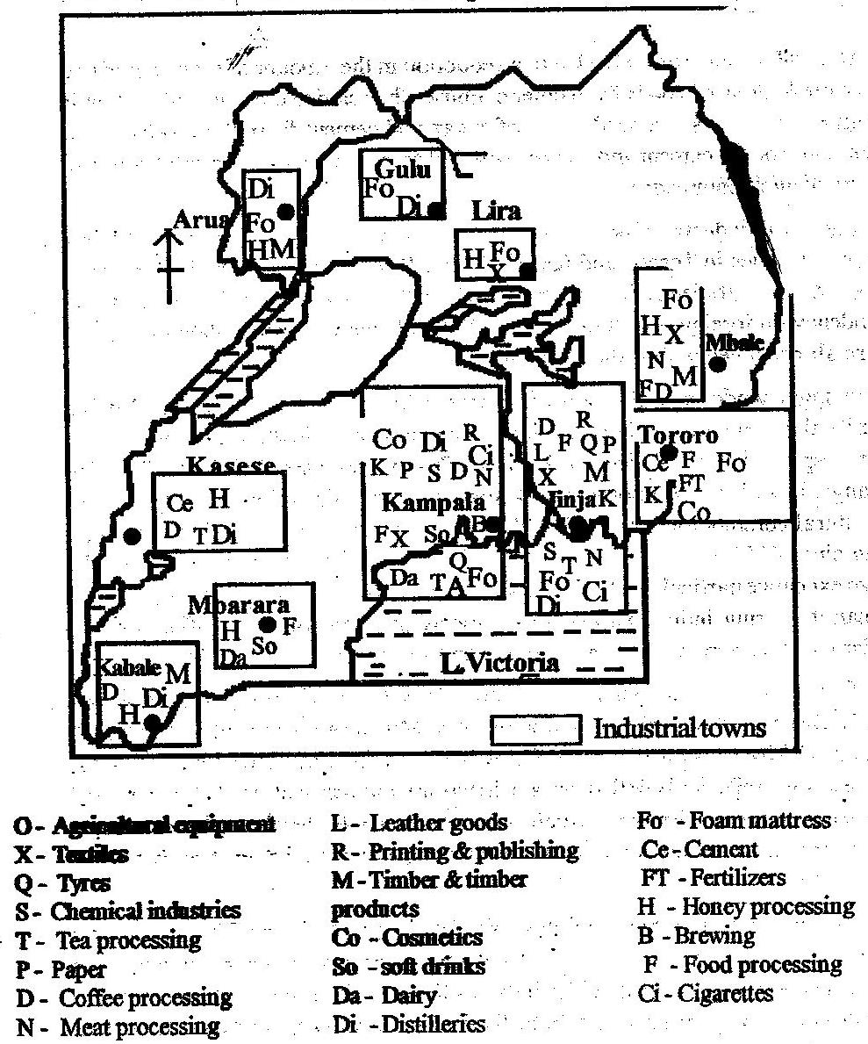
It should be noted that;
- By independence Uganda was producing consumer goods like salt and imported others.
- By 1972 the industrial sector suffered from Asian expulsion by Amin Dada and also in 1980s it suffered from political instabilities.
- The return of Indians saved the sector and its basically dominated by foreign investors.
- By 1991 the UIA (Uganda investment authority) was established to improve on the sector and by 2003-2004 the manufacturing sector was estimated to increase by 4.0% from the initial.
Factors which have influenced industrial growth in Uganda
The factors that favoured the development of the industrial sector in Uganda can be categorized into physical, human and historical factors.
- Availability of adequate mineral resource such as copper in Kirembe, limestone and phosphates at Tororo and Hima, clay at Kajjansi-Wakiso thus leading to the growth of cement industries, ceramics, etc
- Presence of adequate supply of raw-materials especially agricultural products used in agro-based industries like cattle and goat meat for meat packers, cotton used in textiles like in nytil Jinja, sugar cane in Lugazi and Kakira sugar refinaries, milk in Gesa, etc.
- Availability of adequate and reliable supply of water from lakes and rivers in Uganda. This is used as raw-material in beverage making like in Nile breweries in Jinja and as a coolant in iron and steel rolling industries like in Mukono.
- The relatively flat and gentle land of Uganda which have favoured the establishment of industrial plants like the flat lands of Kasese and Hima for cement industry, Namanve-Mukono, etc.
- Availability of extensive land for the setting up and expansion of the industries like in Mbale, Tororo and Mukono for Lugazi sugar plant.
- Presence of adequate and reliable supply of power especially HEP from Owen falls and Bujagali in Jinja and Mubuku power station in Kasese. The power is used to run machines in the industries such as cement in Hima, steel rolling in Mbarara, etc. Biomass energy has also supported bakery, ceramics at Butende and Lweza.
- Availability of ready and reliable market of manufactured products from the large population of the country and from foreign markets of DRC, Kenya, Rwanda and South Sudan where Uganda export her products.
- Presence of adequate capital to invest in the industries which is contributed by the government of Uganda through UIA and Asians who were the pioneers in the industrial sector. Such capital has been used to set up industries, buy machines, pay laboureres, etc.
- Availability of cheap and constant supply of labour both skilled and semi-skilled from the densely populated districts of Uganda like Kabale, Mpigi, and most skilled labour has been provided by foreign expatriates who work in the industries.
- The relatively stable political climate of Uganda which has encouraged foreign investments in the industrial sector. This allows the expansion of industries and explains why Kampala, Tororo and Jinja are booming in industrial establishment.
- Supportive government policies of protecting local industries against foreign competition, giving loans, look for market for manufactured goods, levying less tax on industries which has allowed industrial growth and expansion.
- Improved transport network of roads, water, air and railway in some areas to transport raw-materials to industries and manufactured goods to market centers like the Kampala-westnile railway which transports tobacco to BAT in Kampala.
Economic importance of industrial sector to Uganda
- Industrial growth in Uganda leads to an increase in the manufacture of goods for exports. This leads to earning of foreign exchange through exports like sugar to South Sudan; coffee to USA, etc. this exchange has been used for further development.
- It has led to exploitation of local resources such as soil for farming, minerals like limestone in Tororo, forests, water, etc. this has contributed more jobs to Ugandans, forex and a general development.
- The sector facilitates the growth of modern infrastructure such as roads, railway, health and education facilities, these indirectly benefits all the people in Uganda.
- The government of Uganda generates revenue from taxes and licenses imposed on industries. Such revenue from BAT, Nile Breweries, Hima and Tororo cement has been used to set up infrastructures and support other sectors.
- Manufacturing industries provide market to the raw-materials produced in the agricultural and other sectors like cotton for textile by freedom, tobacco for BAT, clay for tiles by Uganda clays. Thus development of such sectors.
- It generates employment opportunities to various categories of Ugandans such as engineers, chemists, managers, transporters, etc. it should be noted that many people are employed in Kakira sugar, Nile breweries, Hima cement, earning a lot of incomes thus improved living standards.
- Industrial concentration has resulted into growth of urban centers like Kampala and Jinja. The two towns partly developed due to concentration of industries like Uganda breweries in Luzira, TUMPECO in Ntinda, BIDCO in Jinja, etc.
- Industries have contributed to acquisition of skills mainly formal and job training. Such skills are used for further industrial development as it has been in Kakira sugar, Hwang sung fish factory, etc.
- It has attracted both local and foreign tourists for leisure and study purposes. Coca cola and pepsi plants in Namanve and Mbarara are destination for secondary and primaryschools. Tourists bring in foreign exchange which is used for infrastructural development.
However manufacturing industries in Uganda have got negative contributions which include;
- Industries lead to pollution of air, water and land. Nile and Uganda breweries foristance dump their waste products into Lake Victoria killing thousands of fish and contaminating water supply for towns such as Kampala.
- The bakery and ceramics industries have cut down forests for bio-mass power. Also industrial expansions like in Namanve, Mbale and Tororo forests have been cleared.
- Industrial expansion has reclaimed the swamps in many parts of the country like in Nakawa, Ntinda and Kyambogo for Oscar and Spear Motors, Nalukolongo valley for Ssembule steel mills and this has caused environmental degradation.
- Industries have led to urbanization and RUM associated problems. RUM has decreased labour for agriculture in rural areas, un employment, street beggers, high crime, slums, prostitutions like in many parts of Kampala of Kisenyi, Katanga, Kivulu, etc.
- Many industries in Uganda are foreign owned leading to constant profit repatriation like century bottling company, uniliver Uganda limited, etc. this leads to under development of Uganda.
Problems limiting industrial development in Uganda
Uganda has a steadily expanding manufacturing sector with Kampala, Jinja, Tororo, Mbale, Mbarara, Arua industrial towns.
The sector has contributed much of the country’s GDP increasing from 6.5% to 15% majorly depending on agro-based industries of breweries; cigarettes (BAT) grain milling, textile, bakery, tea factories like Igara, etc.
It should be noted that these industries are small and produce less output and this is due to the following problems
- Limited capital to invest in the sector and there is limited access to credit facilities which becomes a setback to expansion and establishment of new investments in Uganda.
- Inadequate skilled labour force to operate industrial activities like in Kakira and Lugazi sugar industries, cobalt mining industry in Kasese, etc. most of Uganda’s industries rely on foreign expensive expatriates which increase production costs and prices of manufactured goods limiting their competition for market.
- Fluctuating and expensive power supply to industries which affect industrial production. Power load-shedding has limited development of heavy industries like steel rolling in Mukono, Uganda Bati, Mukwano group of companies, etc. the limited power calls for use of diesel generators increasing the cost of production.
- Political instabilities in Uganda since 1970s in addition to 1972 economic war have scared foreign and local investments in the sector. Wars have also destroyed supporting infrastructure and drained government budget thus limited funding to the sector.
- Shortage of market of manufactured goods mainly due to poverty among locals and competition from imported products which are cheaper than the locally produced, foristance Kakira sugar, textiles from southern range Nyanza have faced a lot of competition and limited market.
- Inefficient transport facilities especially the railway network and water which limit raw-material, labour and goods mobility thus industrial stagnation. Some roads are impassable during rainy seasons leading to high transport costs.
- There is a problem of dumping manufactured goods by industrialized countries of China and Europe, such commodities are cheaper and out compete local products limiting industrial development.
- High taxes imposed especially on imported raw-materials and manufactured goods. Industries like steel rolling in Mbarara and Mukono which imported raw-materials have faced this problem, increasing production costs and manufactured goods prices.
- There is severe smuggling of manufactured goods in Uganda especially around boarders of Busia from Kenya and this undermines the market for locally manufactured goods.
- High costs of production emanating from high cost of utility facilities such as electricity, water, communication, high taxes, imported skilled labour, etc. these makes manufactured goods prices high thus less market demand.
- Un supportive government policies in relation to protection and promotion of local industries against foreign competition. This has increased dumping and smuggling. The privatization verses nationalization also scare local investments.
- Corruption by ministry officials has led to failure of national industries such as Tri-star Apparel garments in Bugolobi, Tororo fertilizer industry all collapsed due to corruption.
- Inadequate raw-materials like iron ore, copper and other chemicals to use in the industries foristance Roofing steel rolling mills depends on imported raw-materials which is very expensive to produce iron sheets. Also agro-based industries are affected by climatic changes like Southern Range (textile) which use cotton and BAT which use tobacco.
- Inadequate modern technology necessary for industrial development. It should be noted that the imported technology is very expensive and this led to closure of a salt plant at Katwe and a fertilizer factory in Tororo.
Measures to curb down the above problems
Qn Examine the steps being taken to encourage industrial development in Uganda.
Approach
- Define manufacturing industries i.e. the transforming or changing of organic or inorganic substances into new products i.e. chemically by hands or by use of machines.
- Identify the types of industries in Uganda as well as industrial towns and draw a map to locate them.
- Give the status of the industrial sector in Uganda.
- In one paragraph state the problems facing manufacturing industries.
- Explain the measures being taken, NB. Don’t use words like should, can and may.
- Uganda has encouraged foreign investments by investors from China, India, Japan, Europe, USA, etc. These come with capital, technology and skilled labour for industrial development like Uniliver Uganda limited, coca cola, BIDICO, etc.
- Privatization which has led to better financial performance, increased production and profits. Foristance Uganda grain milling company, Tororo cement industry, Uganda clays limited, and Nile breweries were privatized.
- There is training of man power in universities like Makerere and Kyambogo producing engineers, tailors, technicians, etc, to work in industries like Sembule steel mills, TUMPECO, BETA Uganda, Phonics logistics, etc. The ministry of trade and industry has created institutions like Uganda Investment Authourity (UIA), Uganda Manufacturing Association (UMA) which attract local and foreign investors, organize trade shows and fairs thus industrial growth and development.
- The government of Uganda is protecting local industries through levying high taxes on imported goods similar to those produced in Uganda like Nile breweries, BAT have benefited from this protection.
- The government has also banned some commodities imported to out compete local industries, to allow them grow to a large scale. This has helped coca cola, pepsi cola and picfare to flourish.
- In Uganda peace and stability has continued to prevail especially in Kampala, Jinja attracting more investment in the sector. This explains why Kampala has got many industries such as Mega form, New Vision printing and publishing; Hwang sung fish factory, etc.
- The UMA has broadened the market for industries in Uganda by organizing annual trade fare at Lugogo in Kampala which has attracted millions of buyers. Madhivan, Hima and Tororo cement are popular exhibitor.
- The East African community, COMESA, WTO, AGOA, have been joined by Uganda in order to expand market for their manufactured goods for industrial growth and development.
- The upgrading of Owenfalls dam and construction of Bujagali power station, thermal generator installation, etc have increased on power supply for manufacturing industries especially Roofing, iron and steel rolling, etc.
- The government has given tax holidays; decrease the taxes on imported raw-materials which have attracted local and foreign investors to invest in the industrial sector of Uganda. BIDICO in Jinja has been attracted by this.
- Research has been under taken in the sector by Uganda Industrial Research Institute to improve capacity and competence of local industries like Lweza clays, Kampala pharmaceuticals industry, Wavah and Rwenzori water producing industries, etc.
- Improvement in transport and communication has greatly helped in acquisition of raw-materials and industrial products distribution, foristance the Kampala-Arua road to transport tobacco from West Nile to BAT in Kampala.
Qn. ‘agriculture is the back born of industrial development in Uganda’ Discuss.
Qn. To what extent has transport influence the location of manufacturing industries in Uganda?
Qn. To what extent have raw-materials influenced the location of manufacturing industries in Uganda?

Transport sector in Uganda
- The term transport refers to the process whereby passengers are moved from one place to another. Transport aids trade and industrial production.
- The types of transport in Uganda include land transport i.e. human portage, animal, road, railway and pipeline transport, water transport and air transport.
- It should be noted that Uganda is majorly relying on road transport consisting of track and feeder roads which run throughout the country. However, air transport with Entebbe international airport, Kasese, Arua, Gulu, Tororo, Jinja, etc airstrips are also important.
Location of Uganda’s transport routes
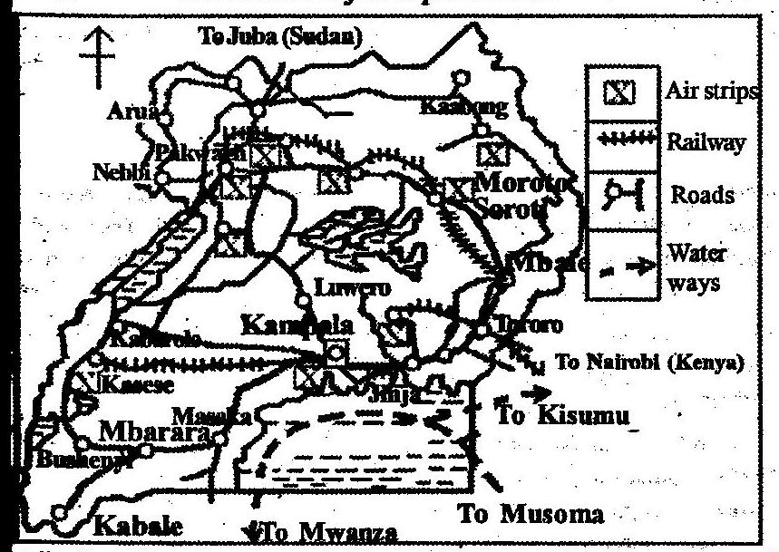

Factors which influence the development of the transport sector in Uganda
Looking at the transport network distribution in Uganda, the southern half has more developed transport routes than the northern part; this is due to historical, physical and economical factors.
- The location of major economic resource like agricultural regions, mining centers, forestry, fishing, etc. foristance transport routes have been constructed to link areas with tourist attractions like water transport to Ssese islands, air transport to Kasese near Queen Elizabeth and Kampala-Mbarara road.
- Transport routes have been constructed to link industrial areas for raw-materials, labour and manufactured goods transportation like roads linking Kampala’s Bugolobi, Kawempe and Nakawa industrial areas.
- The railway route was extended to northern Uganda to facilitate the marketing of cotton, tobacco, maize, millet, simsim, etc.
- Roads and railway have been constructed to link areas with mineral resource like a railway line to Kasese to serve copper mines at Kirembe, road transport to Kabale for tin and wolfram mining, etc.
- Timber from Ssese islands have been transported by water to the main land via Bukakata. Roads have also transported timber and wood fuel from Mabira, Budongo, etc.
- The levels of technological resource i.e. the availability of skilled labour to extract the available resources like engineers have helped to extend Uganda’s transport system.
- The nature of relief i.e. mountainous areas tend to remain remote like in Kisoro and Bundibugyo because it becomes difficult to construct transport routes and in flat and gentle relief like in Mpigi, Wakiso, Kampala, Jinja there are developed transport networks.
- Large water bodies like Victoria has facilitated water transport development through ports like Port Bell, Bukakata, Jinja, etc. however waterfalls and rapids like on R. Nile have blocked water transport.
- Influence of climate i.e. areas in Uganda which receive heavy rainfall make it hard to construct and maintain roads like in Mukono and Kapchworwa.
- Industrialization and urbanization leads to development of efficient, reliable, modern and well maintained transport network. This explains why Kampala city has got the best transport system in Uganda.
- Government policy encourages or discourages transport network extension. Today the government of Uganda is emphasizing the development of water transport to reduce on transport costs. Also the government puts a lot of money in the ministry of works to establish transport routes though it’s affected by corruption.
- Availability of a large capital base to invest in the development of modern transport network. It should be noted that construction of transport routes is very expensive.
- Historical factor of early colonialists who constructed many roads in the central region for administration and a railway line to link raw-material collecting centers like Jinja-Kasese railway line to collect copper ores.
- The Arabs and Missionaries also helped in the construction of roads in parts of Buganda, Busoga, and Bunyoro to help them spread their religion.
- Political instability
Contribution of the transport sector to the development of Uganda
The transport sector in Uganda has got both negative and positive contribution to Uganda’s development which include;
- It facilitates the development of internal trade through movement of goods from areas of production to consumers like roads transport milk, cattle, banana from Mbarara to Kampala, millet, simsim, sorghum from Lira and Gulu to Jinja and Kampala.
- It facilitates the development of international trade. Roads transport coffee to Mombasa for export, flowers and fish are transported to USA and Europe by Entebbe international airport and the railway imports commodities from Busia boarder through Jinja to Kampala.
- Transport facilitates labour mobility especially road transport which transports workers to different industries and businesses in Kampala from their residents in Mukono, Wakiso, Luwero, Mpigi, etc.
- It facilitates industrial development through movement of raw-materials and industrial goods like fish from Ssese islands is transported by water to Masese and Ggaba for processing, cement is transported from Hima and Tororo industries to main markets of Kampala, Jinja by roads.
- Transport facilitates the development of tourist industry through linking tourists to tourist potentials like Kampala-Kasese road and Entebbe international airport to Kasese airstrip move tourists to Queen Elizabeth National Park.
- Transport has generated employment opportunities to many Ugandans. Such are employed as drivers, conductors, guides, mechanics, engineers, traffic officers, controllers in Multi-plex, UTODA, UBOA, etc.
- It has generated government revenue through taxes and licenses to transport companies i.e. Multi-plex and taxis pay a lot of money to KCCA, URA also gets a lot of revenue from vehicles imported, insurance companies like NIC, etc.
- Transport has facilitated the development of the mining industry since it helps to transport machinery, labour and minerals to processing centers like Kasese-Jinja railway line was to transport copper from Kirembe, roads to Tororo and Hima to transport cement from limestone minerals, etc.
- It has helped to promote the fishing industry through transportation of fish to fish markets in Jinja, Kampala, Masaka and processing as well as exportation. Many feeder roads link landing sites like Masese, Katotsi and Lambu to market centers has helped to develop fishing.
- Transport facilitates the development of the agriculture sector through movement of farm inputs like seeds, fertilizers and outputs like milk, cotton to market and processing centers. Like Kampala-Jinja road links Lugazi sugar plantation and Kasaku tea estate in Mukono, Kampala-Arua road which link WestNile to BAT factory in Kampala for tobacco processing, etc.
- It facilitates political governance through fast movement by both local and central government officials in all parts of Uganda. E.g. roads link villages of Kaliiro, Kibisi and Kinuuka, Kashagama sub-counties to Lyantonde district administrative offices.
- It promotes co-operation between Uganda and her neighbours e.g. roads like Busia-Kampala-Kabale, Busia-Kampala-Kasese and Tororo-Soroti-Moyo transport goods to Rwanda, DRC and South Sudan respectively through Uganda.
It should be noted that transport sector has got negative contributions to Uganda’s development. These include;
- It pollutes air, water and land through fumes by vehicles, trains, ships and other water vessels pollute water from oil spills which endangers aquatic life and water quality.
- Many accidents occur on roads such as Kampala-Masaka, Kampala-Jinja, on L. Albert and Victoria killing many important people and loss of property. Such human resource would have been used for Uganda’s development.
- During the construction of transport routes many people are displaced loosing property and investments e.g. the construction of the Northern-by-pass around Kampala and the 1998 expansion of Entebbe road displaced many people in Namasuba, Nalya, Bwaise, Namuwongo, etc.
- Forests have been cleared in the process of constructing roads and railway lines, airstrips, etc. parts of Mabira in Mukono were cleared to construct Kampala-Jinja road.
- The construction of transport routes and their maintenance is costly. This necessitates Uganda to depend on neo-colonialists since the billions required are provided by the World Bank and the other bodies with a lot of interests.
- Floods have resulted into spread of diseases like bilharzias, cholera and dysentery which result from construction of roads like the Northern-by-pass in Bwaise and Namugoona.
- Other negative contributions are regional imbalances created, smuggling especially by water transport, and profit repatriation by the foreign companies which construct and maintain the transport routes.

Problems facing the development of transport sector in Uganda
- Inadequate capital for both constraction and maitainance of transport routes eg kampala-Masaka, Masaka-Mbarara and Kabale-kisoro roads have been costly in their up-grading.
- Low levels of technology required in the construction and maintainance of transport routes. The imported technology is very expensive as evidenced from foreign firms constracting and up-grading roads such as Kampala northern by pass by salin, Jinja-Bugiri by Reyonod, Busunju-Hoima by sterling etc.
- Political instabilities especially in northern parts of Uganda a twenty year war by LRA disraputed road construction like Gulu-Peder road and Gulu to Kitigumu road. Cattle rustling in Karamoja also hindered road construction in the area.
- There is a problem of vandalism of the railway line especially in Busoga, Mbale, Soroti and Gulu and this has hindered railway transport network.
- Heavy rains in some areas of Uganda affect transport routes e.g floods in north eastern Uganda caused by kirik and Aswar rivers after heavy rains wash away roads and bridges making roads becoming quagmires of mud and therefore impassable during wet seasons.
- Extensive profit repatriation by the foreign firms dealing in construction and maintainance of transport routes e.g Salini constructions which constructed the northern-by-pass in Kampala.
- Mountainous and hilly areas of Bundibugyo, Kabale, Kapchorwa make road construction difficult and expensive. Also landslide does happen in these hilly areas of Bududa, Bundibugyo and Manafa areas covering roads.
- The nature of rocks in the area sometimes hinder transport routes establishment. The harder rock surface along Sironko-Kapchworwa road and soft rocks in the lower vallies like in Rubigi-Kampala where the Northern-by-pass crossed made construction difficult and expensive.
- Drainage system makes road construction difficult and expensive. Fast flowing rivers of Mubuku requires construction of bridges and culverts and swampy areas like along L. Kyoga need land fills thus becoming expensive to link landing sites of Lwampanga and Namabale.
- Waterfalls and rapids, shallow and narrow river channels and seasonal water fluctuations make navigation on most rivers of Uganda a futile like Bujagali, Kagoma and Murchison falls limit navigation along river Nile.
- Thick vegetation cover hinder road and railway line construction. Forests such as Mabira, Budongo and Kitomi clearing the vegetation during construction are difficult and maitainance of roads is irregular due to wet and moist conditions, e.g. Kampala-Jinja road across Mabira forest.
- Water hyacinth over lakes such as Victoria hinders navigation especially by small boats and canoes. There is also floating vegetation in form of sudd on Lake Kyoga which all disrupts, delays and raises operation costs in the transport sector.
- Corruption in the transport sector i.e. diverting funds made for transport routes construction for private gains. Thereis a lot of shoddy work which all hinder the sector e.g. Mukono-Katosi road saga.
- Negative attitude towards self help projects such as construction and maintainance of feeder roads in rural areas of Pallisa, Kamuli, Kaberamaido, etc.
- Some means of transport like air transport are too expensive and cannot be afforded by the majority Ugandans thus making it limited in specific areas like towns of Kasese, Kampala, Arua and Entebbe.
- The collapse of the East African Railway Corporation in which Uganda had benefited by amalgamation of the system of the territories. This decreased Uganda’s ability to finance the railway network.
- The sector is affected by traffic congestion in busy towns of Kampala, Jinja and Mbarara and this normally affects road transport causing delays. This is partly due to poor planning of the towns and cities.
Measures to the above problems
- There is rehabilitation of roads like Kampala-Entebbe, Iganga-Mbale, Kampala-Masaka, Kabale-Kisoro, etc.
- The Entebbe airport has also been modernized to reach the world standards.
- World Bank, European Union and other friendly countries have given Uganda grants, loans and aid to finance the construction and maintainance of transport routes foristance the European Union funded the construction of the northern-by-pass in Kampala.
- There are efforts to develop local transport construction companies like Zimwe, Multi-plex which will decrease on over dependency of foreign companies which repatriate profits.
- Many foreign construction companies have been attracted to Uganda to take over construction and maintainance work like Sterling from Italy rehabilitated Busunju-Hoima road, SBI international holdings from Switzerland rehabilitated Kampala-Mbarara-Kabale road.
- Makerere and Kyambogo University are training technical personels in the transport sector. Other workers are gaining skills from on-job training like those who constructed Jinja-Bugiri road. This has availed skills to Ugandans to support the sector.
- The UPDF embarked on stablising Uganda and the areas of northern Uganda are now stable. Vandalising the railway line in Busoga and other areas have been checked.
- Various skills have been used in the construction of roads in hilly areas of Kabale, Kisoro, Ntungamo, e.g. wind along slopes to solve the problem of steep slopes.
- Ferry services have been provided by the ministry of works and transport across parts of rivers and lakes like from Bukakata in Masaka to Ssese islands.
- The IGG, police and parliament have embarked on fighting corruption to check on shoddy works and save millions of shillings to develop the transport sector as it was on Katosi-Mukono road.
- Sign posts warning drivers and motorists of black spots along roads so as to reduce the rate of road accidents have been provided by the ministry of works and transport like on Kampala-Bugiri road. Also more traffic officers have been employed on roads to check on indisciplined drivers.
- The local governments have got road construction and maintainance equipments and this is aimed at constructing and up-grading of roads like Kaliro-Katovu in Lyantonde, Wakiso-Matuga in Wakiso, etc.
- Major mobilization by local leaders especially L.C I chairpersons has helped in changing the negative attitude of people towards self-help projects. This has helped to construct and maintain roads in Butareja and Budaka.
QN. To what extent is the road and railway network in Uganda are a reflection of occurrence of resources.
Approach
- Definition of transport
- Show roads and railway networks in Uganda
- Draw a sketch map to locate the above
- Give the status of road and railway network
- Explain the resource factors and how they have favoured the existence of roads and railway while giving example.
- Explain other factors which have favoured road and railway transport.
QN. Assess the role of in-land water transport to the economic development of Uganda.
Water transport
Status
- Most of the water transport occurs on lakes
- Few rivers are used for transport due to rapids and water falls
- Few modern ships are in operation
- Much of the water transport sector is privately owned
- Ferry services on major lakes and R. Albert-Nile are on an increase.
Water transport routes
- Portbell-Kisumu, Portbell-Jinja-Buvuma, Jinja-Mwanza, Portbell-Bukoba, Bukakata-Bugoma/Ssese island, Nakiwogo-Entebbe-Kalangala, etc on L. Victoria
- Luwero-kamuli, Apac-Lira, Kayunga-Soroti through Lwampanga-Nabyeso, Kagwara-Lwampanga, etc on L.Kyoga
- L. George-Edward system through Kazinga channel to Katwe.
- Butiaba-Bugungu-Congo, Arua-Bulisa, Muhangi-Butiaba-Ntoroko on L.Albert.
- Masindi port to Kasenyi, Muhangi-Pakwach-Nimule, Lalopi-Nimule on R. Nile.
Problems limiting water transport
- Presence of water falls and rapids like Karuma on R. Nile
- Presence of wter weed/hythnith like on L. Kyoga and Victoria
- Existence of swamp vegetation on the fringes of lakes and rivers like Mpologoma, L. Kyoga, etc.
- Shallowness of some rivers like Katonga and Kagera
- Steep gradient/escarpment like on L. Albert.
- Narrowness of some rivers like Kafu and Sezibwa
- Reduction in water levels during drought seasons like on L. George.
- Strong winds/storms on lakes like Victoria
- Strong currents/tidal range which cause accidents like on L. Albert.
- Presence of dangerous wild animals like crocodiles at Kazinga channel.
- Presence of rock out crop in lakes like L. Victoria
- Floods due to heavy rains destroying ports like Bukakata on L. Victoria.
- Suds/floating islands on l. Wamala and Kyoga.
- Poorly developed transport network linking to ports like Nyendo-Bukakata road.
- Remoteness of some water bodies like Edward
- Limited capital to purchase modern vessels like on R. Nile
- Inadequate skilled labour to handle the sector on L. Victoria ports like Port Bell
- Limited government support
- Low levels of technology in ship building and maintenance.
- Competition for cargo and passengers from other forms of transport.
- Poorly developed port handling facilities.
- Political instabilities and piratess
NB.
Land transport is the mostly used transport in Uganda and it includes human portrage, animal, road, railway and pipe line transport.

Urbanization in Uganda
Urbanization refers to the process of town growth in an area. It may also refer to the process whereby an increasingly proportion of the total population of a country becomes concentrated in towns.
According to 2015 population census, only 14% of the population of Uganda live in urban areas in Uganda. The major urban areas of Uganda include Kampala city, Masaka, Mukono, Wakiso, Arua, Lira, Bushenyi, Mbarara, Kasese, Apac, Kotido, Tororo, Mbale, Pallisa, Kamuli, Iganga, Mubende and Luwero.
The major urban areas of Uganda
It should be noted that there are several criteria which are used to determine an area as urban i.e.
- Population size
- Population density
- Functions of the urban center
- Legal and administrative consideration
- Social and economic consideration
- Etc.
Factors which influence growth of urban centers
- The effect of economic factors such as mining and industrial growth, foristance Kilembe in Kasese grew up as a result of copper mining, Katwe town as a result of salt mining, Tororo and Hima as a result of limestone mining.
- Historical factors such as head quarters of cultural leaders like Mengo of Buganda kingdom in Kampala and also British Colonial masters chose Kampala as an administrative center thus its growth.
- Defensive reasons, foristance Gulu town which is experiencing a high rate of urban growth because many people move town for security reasons. On the other hand Kampala city was set up on hill tops in order to defend it against any external threats.
- Availability of fertile soils which favour the development of farming that attracts a large population to settle into the area. Towns such as Masaka, Kabale, and Mbale grew up from trading centers of agricultural products to towns.
- Availability of water resource for constant water supply to the people. This attracts many people to settle and lead to growth of such an area. Foristance Entebbe, Jinja, Kampala, Mukono grew due to the Lake Victoria fresh water body presence.
- The availability of improved transport especially where roads or transport routes converge and then radiates to various directions, foristance in Kampala city and Gulu town. Such transport routes favour trade transaction thus urban growth.
- Availability of reliable HEP like Jinja municipality grew up largely as a result of HEP generation from Owen falls dam on R. Nile. HEP attracts industrial growth, population settlement and urban growth.
- Effects of government policy where the government can decide the growth of an area due to its convenience, social, political and economic reasons, foristance Kampala city was favoured due to this reason.
- Rural urban migration especially to areas with social service and amenities such as education, health, clean water, electricity and recreational facilities. These services attract population to settle in such areas thus urban growth.
- Favourable climatic conditions which attract settlement.
- Hard basement rocks for the construction of strong buildings
- Rich hinterland to provide raw materials for industries
- Large tracts of land for expansion
- Numerous industries that attract large population
- Low incidences of pests and diseases
- Advanced technology for urban development
- Adequate power supply
- Skilled and semi skilled labour
- Favourable political climate
- Large market potential which attract many people for investment
- Adequate capital for contruction of urban centers
- s
It should be noted that the growth of towns in Uganda are related to increased population in trading centers which leads to urbanization.
The increase in the population in urban centers has been caused by rural urban migration. R.U.M has been caused by factors such as high population growth rate, decline in agriculture sector, political insecurity, forced marriages, circumcision and mutilation, etc.
Functions of towns in Uganda
- Commercial function i.e. towns contain shopping centers which help the people to carryout trade, such towns include Kampala, Jinja, Mbale, Tororo, Gulu, Kasese, etc.
- Residential function i.e. most towns have areas which are exclusively gazette for residential purposes like in Kampala National Housing Construction Corporation owns several housing units in places like Bugolobi, Bukoto and Ntinda.
- Administrative function i.e. towns serve as district head quarters, possesses ministerial offices and offices of NGOs. Foristance Kampala, Mbale, Iganga, Jinja, etc.
- Industrial function i.e. towns contains industries foristance Kampala Tororo, Masaka, Mbarara, Jinja, etc. such industries have provided employment opportunities to many Ugandans.
- Educational function i.e. many towns have got educational institutions of schools, colleges and universities. Foristance Kampala has got schools like Mengo S.S, Makerere and Kyambogo universities, etc.
- Transport and communication function i.e. most towns in Uganda contains transport routes and communication networks. Foristance Entebbe has got the international airport, Kampala has headquarters of Uganda Railway Corporation, Taxi parks, MTN, Airtel, etc.
- Cultural functions i.e. most towns in Uganda contain cultural sites of museums, worshiping centers, etc. foristance Kampala city has got Uganda museum, Kasubi tombs, Namirembe and Rubaga cathedrals, Bahai temple, etc.
- Recreational function i.e. towns in Uganda contains recreational facilities in form of theatres, stadiums, halls, etc. Kampala foristance has got Nakivubo and Namboole stadiums where people go for sports, beaches in Entebbe like Lido, Aero, etc.
Effects of urbanization in Uganda
These effects are both positive and majorly negative as explained below.
- There is a problem of inadequate housing facilities in many towns in Uganda, this has led to growth of slums like in Kampala there is Katanga, kamwokya, Kisenyi, etc.
- There is un-employment in many towns in Uganda like in Mbarara and Kasese due to high rates of rural urban migration causing high population densities.
- There is high rate of rural urban migration in Uganda which has resulted into social problems such as alcoholism, prostitution, rapid spread of diseases, poor sanitation, youth moral decay, etc, in Jinja, Kasese and Masaka.
- Shortage of social services such as health and education, water, etc. this is caused by high population in urban areas which later leads to high cost of living like in Tororo, Gulu and Mukono.
- Some urban centers like Kampala experiences floods due to encroachment on swamps and wetlands. Such floods have led to death of people and property destruction like in Bwaise and Karerwe in Kampala.
- There is land, air and water pollution in urban areas caused by garbage, uncontrolled sewerage, industrial and vehicle fumes and wastes. This has caused environmental degradation in Jinja, Kampala and Kasese.
- Urban centers like Kampala and Jinja face a problem of traffic congestion which cause a lot of delays and inconvenience especially during rush hours. This affect business and production as well as administration duties.
- Limited land for expansion which has today led to encroachment on swamps and wetlands thus floods like in Kawara, Namugoona and Bwaise in Kampala.
- Towns like Entebbe, Mukono and Wakiso experiences high costs of living and high crime rate. This is causes by un-employment as a result of rural urban migration.
NB. The positive effects of urbanization are the functions of towns as earlier discussed.
Kampala city
This is the largest urban center in Uganda located on several hills of Old Kampala, Namirembe, Rubaga, Naguru, Kololo, Nsambya, Mbuya, Kireka, Makerere, Mulago, Mutungo, Kyambogo, etc.
It is boarded by Lake Victoria and Wakiso district
Functions of Kampala city
- It is an administrative center with many ministerial offices, Uganda’s parliament, international conference centers and NGOs offices, KCCA hall, etc
- Kampala is a commercial center with major central business centers based largely on Nakasero hill and others in Katwe, Kawempe, Nakawa, etc.
- It is a financial center with the Bank of Uganda, stanbic bank, centenary bank, etc. the city has also got several insurance companies like NICO, SWICO, as well as forex beuro.
- Kampala is a residential center with several areas gazette for residential housing development in Bugolobi, Bukoto flats, Muyenga, Nsambya, etc.
- It is an industrial center with several industrial areas like Nakawa, Bugolobi, Kawempe, etc, such industries have attracted many people for jobs.
- Kampala city is an education center with several educational institutions based on nursery schools, primary like Buganda road p/s, secondary schools like Old Kampala SS, colleges like Multec and universities like Makerere University.
- Kampala is a cultural center with Uganda museum in Kamwokya, Kasubi tombs in Mengo, worshiping places of cathedrals of Rubaga and Namirembe, Gadafi Mosque and Bahai temple in Kanyanya.
- Kampala is a transport and communication center with several transport terminals for buses and taxis, URC head quarters, Kololo airstrip, posta Uganda, MTN and Airtel head quarters.
- It is a tourist center with several hotels and lodges which provide excellent accommodation facilities to foreign tourists. Such hotels include Sheraton, Serena, Speke tourist hotel, Africana, etc.
- Kampala city is a recreation center with sports stadiums like Nakivubo, beaches like Ggaba beach, theatres like La Bonita, cinema halls like Cineplex, etc.
Factors which favoured the growth of Kampala city
- The location of Kampala on the shores of Victoria with fertile soils and reliable rainfall which support farming for constant supply of food stuffs to the people in the city.
- Presence of plenty of water supply from L. Victoria to the city for domestic and industrial use which has supported human settlement.
- The relatively flat and gently sloping relief of Kampala favoured the construction of important infrastructure in the city such as roads, health centers, education centers, etc.
- The Baganda factor i.e. Mengo the head quarters of Buganda kingdom influenced the establishment of Kampala as a city by colonial master and this led to its rapid expansion and growth.
- The generation of hydro-electric power from Owen falls dam accelerated the growth of Kampala city. The power has been used in shops, homes, offices and industries.
- The coming and subsequent settlement of Asian Traders (Indians) in Kampala made it to develop very fast. The Indians invested heavily in commercial, residential and industrial ventures.
- Kampala is served by a well developed transport networks. Roads radiate almost in all directions from the center, it possesses a railway network and an airstrip at Kalolo is near to Entebbe international airport.
- The city contains modern hotels and other social facilities which attract many people into it. Such hotels include Sheraton, Equatorial, Africana, stadiums like Nakivubo, theatres like LaBonita, etc.
- Kampala city has got an excellent communication network dominated by MTN, Airtel and Utl, this has eased communication and increased on employment opportunities which attract many people into the city.
- The city is a commercial center, located in a densely populated area and very productive which empower its local people for its growth and development.
- The mobilization of resources both internally and externally after Kampala being made a city led to its growth and development.
Problems facing Kampala city
- There is a problem of slum (ghetto) development in the suburbs of Kampala city in places like Kivulu, Katanga, Katwe, Kisenyi, Namuwongo, Kamwokya, etc. these have social problems like prostitution, poor housing, moral decay, alcoholism, rapid disease spread, etc.
- There is improper garbage disposal which has led to land degradation and poor sanitation in the city. Garbage sometimes causes floods as it blocks water channels, garbage also attract flies, dogs and birds which lead to easy spread of diseases such as cholera and dysentery.
- There is high rate of un-employment by the city dwellers in Kampala city which has resulted into lumpens and pick pocketers on Kampala streets of Ben Kiwanuka, Luwum and in the taxis parks.
- There is inadequate supply of the essential social service and amenities such as health and education services, clean water, housing, etc. this problem emanates from population explosion in the city straining the existing infrastructure.
- There is congestion and traffic jam especially during rush hours, the two taxi parks cannot accommodate the taxis that ply various routes within the city. This cause more traffic jam.
- Currently Kampala city is experiencing corruption by KCCA officials which has resulted into poor planning, uncollected garbage and general un-hygienic conditions.
- The city is experiencing a high rate of rural urban migration from almost all parts of the country especially from the north eastern Uganda. Rural urban migration has aggregated into growth of slums, un-employment, theft, prostitution, etc.
- Due to swamp reclamation areas such as Bwaise, Ndeebe, Natete, Kinawataka, industrial areas experience floods during rainy seasons. This causes loss of lives, property destruction and road network cut-off, disease outbreak like cholera, malaria, etc.
- The cost of living is very high in Kampala i.e. housing, food stuffs, etc, are costly. This has caused insecurity in the city in search for a living.
- Limited space for further city expansion which has made people to encroach on the existing wetlands which in turn lead to environmental degradation and floods.
- The increasing industrial growth in Nakawa, Bugolobi, Kawempe in Kampala has resulted into air pollution. Also dense populations of vehicle in the city pollute the atmospheric air.
- There are street children on many streets and roads of Kampala such as kampala road, Namirembe road, etc. such helpless children have increased on city insecurity.
Solution to the problems facing Kampala city
- Rural urban migration should be controlled through addressing the issue of regional economic imbalance. This can be done through improving on agricultural sector especially in rural areas. Also provision of social services such as education, health, electricity, clean water in rural areas will help to reduce the problem.
- Construction of estates and better housing facilities in areas where slums have grown can help to address this problem; however such estates should be cheaper to accommodate low income earners.
- The government has encouraged the growth of industries in the city, it has also persuaded foreign investors like MTN, Airtel, Shoprite, Stanbic to bring in capital so as to create more employment opportunities for the city dwellers.
- The construction of the northern-by-pass and widening and rehabilitating of roads, the use of fly-overs like at Katwe and Nakawa is aimed at reducing on traffic jam and congestion.
- The KCCA is today encouraging vertical expansion of the city rather than horizontal to get more space for further expansion.
- There is widening of Nakivubo channel to accommodate more water when it rains and also protecting wetlands in Bugolobi and Namuwongo to overcome floods.
- There is strengthening of the police and use of special police constables to curb down theft, robbery and other crimes within the city.
NB. Students should make research on Jinja Municipality.
QN. Examine the factors which influence the growth and development of towns in Uganda,
QN. Explain the effects of urbanization to the immediate environment in Uganda.

Energy resources in Uganda
Energy resources are resources which can be used to provide heat, light and motion power. Uganda has got a variety of energy resources and these include;
- Electricity (HEP) from Owen falls dam in Jinja, Bujagali, Mubuku, etc.
- Petroleum products i.e. petrol, kerosene and oil, imported and at Albertan graben
- Solar mostly used in rural areas of Lyantonde, Mpigi, etc.
- Thermal power at Lugogo
- Biomass or wood fuel i.e. firewood and charcoal
- Biogas
It should be noted that according to 2004 population and housing, estimates 88% where using biomass, 1% electricity, 11% others as energy
Location of energy resources in Uganda
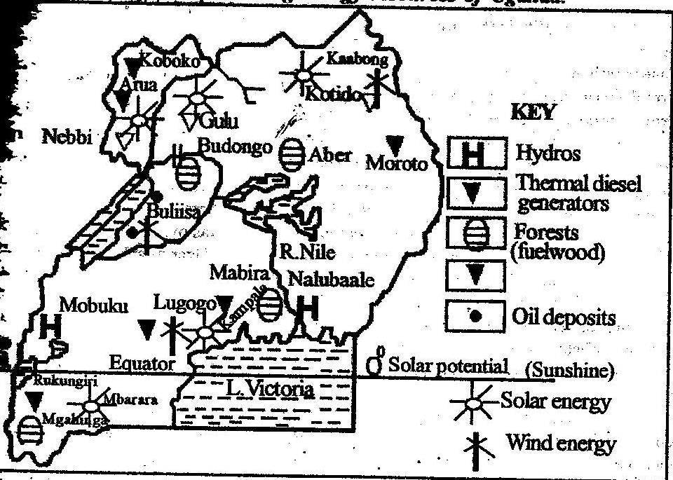
Status of energy sector
- Biomass widely used i.e. 39% followed by 5% petroleum and 5% of HEP.
- Solar and biomass widely promoted to save forests.
- Frequent load shedding of HEP
- Petroleum is imported and expensive however oil mining in Albertine graben is to commence soon.
- New HEP plants have been constructed like Bujagali, Nyagak to increase power.
- Plans are under way to produce geo-thermal energy in the western rift valley region.
- Thermal energy at Lugogo.
It should be noted that power generated at Owen falls dam in Jinja is transmitted using power lines to different areas in Uganda i.e. To Kasese-Fort portal, Bushenyi-Rukungiri-Kabale, Mbarara-Masaka-Mpigi and Kampala. Also Luwero-Hoima-Masindi-Apac-Gulu, Lira-Soroti-MbaleTororo-Iganga and Kamuli and other parts of thse country.
Factors that have favoured the development of the energy sector in Uganda
Problems facing the energy sector in Uganda
- Limited skilled llabour to tap the existing power and energy potential.
- Limited research in the energy sector
- Competition from other land use for labour, capital, etc.
- Depletion of forest resources like Namanve forest.
- Limited capital to purchase machines.
- Poorly developed transport network.
- Corruption and embezzlement of funds meant for the development of power and energy sector
- Scattered settlement pattern affected distribution of power
- High level bureaucracy in the development of power projects
- Fluctuations in power supply due too natural disasitors like cloudy skies in case of solar power
- Physical barriers like steep slopes in mountainous areas which limit transmission of HEP
- Profit repartriation
- High wastage and loss of power caused by illegal connections
- Less demand for energy and power due to poverty
- Remoteness of some areas with power potential
- Political instability
- High rates/cost of HEP discouraging consumers
- Decreasing levels of water in L. Victoria and rivers.

Benefits of the energy sector
Nb. Make research on the above
Measures to the above problems
- The government of Uganda is aiming at improving the quality and quantity of energy supplies at least cost to the national economy. It has set up a hydro-power development master plan (HDMP) to achieve its aim.
- There is rehabilitation and development of mini power stations such as Bujagali on R. Nile, Maziba on R. Maziba in Kabale, Mubuku on R.Mubuku, etc.
- Today there is rural electrification program which has helped several rural areas to posses electricity like in Kabatema-Nsika in Lyanntonde.

Environmental degradation
Environmental degradation is the deterioration of the available renewable and non renewable resources. It is the decline of the productive value of man's environment.
- The degraded resources in Uganda include water, atmospheric air, soils/land, vegetation and forests, swamps/wetlands, minerals, etc.
- The degradation in Uganda is in form of water pollution, deforestation, mineral exhuastion, soil erosion and exhuastion, swamp reclamation, air pollution, etc.
- It should be noted that by 2001, 4-12 of Uganda's GDP was lost due to environmental degradation
- By 2004, 10-11% of the biodiversity was lost.
Map of Uganda showing areas of environmental degradation
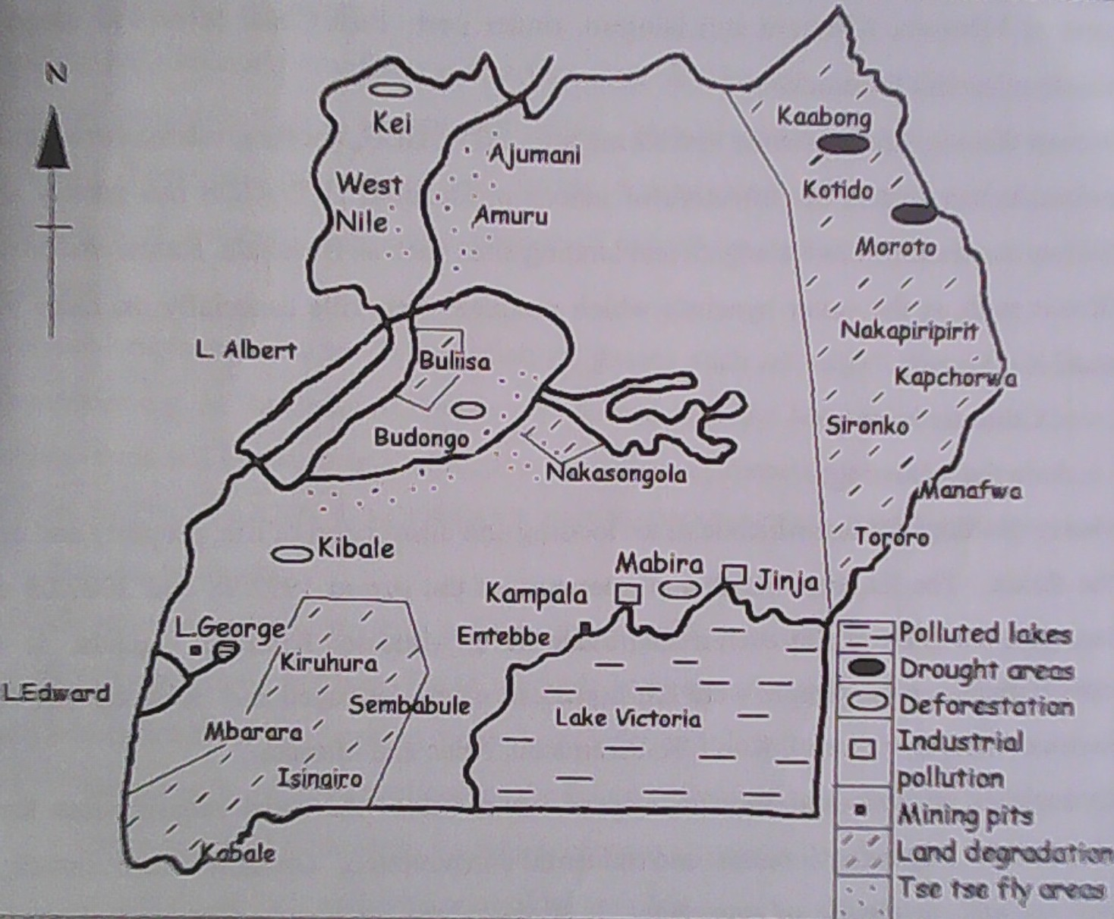

Causes of environmental degradation in Uganda
Environmental degradation in Uganda has been a result of both human and physical factors explained below.
- Over grazing due to overstocking by pastoral tribes like Karamajong in Kaabong, Kotido, Moroto and Hima of Kiruhura, Sembabule, Mbarara, etc. This has led to devegetation exposing land to soil erosion and loss of fertility thus land degradation.
- High population pressure in areas of Kisoro, Kabale, Mbale which has led to land fragemantation thus over cultivation of land leading to reduced soil productivity causing land degradation.
- Extensive swamp reclamation like in Nabajjuzi wetland in masaka for settlement, Mpologoma and lumbuye wetlands for cultivation, this has led to loss of birds and animal habitats, drying up of streams, reduced land productivity and arid conditions.
- Monoculture has led to depletion of soil nutrients and a general loss of soil productivity. Coffee and banana growing areas of Mukono, Masaka, Mbale, tea growing at Kyamuhunga in Bushenyi, sugar cane growing at Lugazi season by season has all led to land degradation.
- Deforestation for purposes of wood fuel and timber in Mabira, Budongo, mt. Elgon forests has led to loss of forests. The continued loss of forests has led to soil erosion and degradation and low and unreliable rainfall in such areas.
- Bush burning by pastoral tribes of Hima in Isingiro, Kiruhura, Karamajongs in Kaabong, Kotido, has led to loss of vegetation leading to soil erosion and degradation.
- The use of pesticides and over use of fertilizers in rice growing at Doho, kasaku tea in Mukono, coffee growers in Masaka and Mpigi all at the end leads to pollute soils, leads to death of soil living organisms which are responsible for soil formation thus land degradation.
- Industrialization has led to water and air pollution especially in industrial cities and towns of Jinja, Kampala, Kasese, Tororo, etc. This emanates from industrial fumes and wastes like Uganda breweries at Luzira pollutes lake Victoria leading to death of aquatic life thus degradation.
- The effect of poor disposal of industrial products like plastic bottles, polythene bags, which takes long to decay causing soil deterioration. Companies such as coca cola, Nile house of plastics are responsible for accumulation of plastic products into soils thus land degradation.
- Mining of minerals like copper at Kilembe-Kasese has led to mineral exhuastion and land deformation, clay at Kajjansi-Wakiso has deteriorated swamps affecting rain formation and ecosystem thus swam reclamation.
- The continued road construction which involves excavating of the landscape leading to soil erosion and landslides. Roads like Kampala-Kabale, Kampala-Gulu, Northern-by pass, Entebbe express high way, have reclaimed swamps, deformed land and cleared forests.
- Political instabilities in Uganda since 1970s, With 1980s Luwero triangle war, the 20 year LRA Kony war in Gulu, ADF-Kasese threats, Kampala city demonstrations all leads to loss of lives, vegetation and land degradation. Also the tear gas affect man, animals and insects as well as the ozone layer.
- The practice of indiscriminate fishing and use of poison during fishing has affected the aquatic life leading to exhuastion. On lakes such as Victoria, Kyoga, Albert, fish has reduced and water contaminated by poison affecting human life .
- Increasing use of second hand motor vehicles, computers and other machinery which emits nitrogen-oxide and other fumes leading to air pollution. In congested towns such as Kampala, Jinja, human life is affected by such fumes causing cancer, acidic rains received and global warming.
- Floods due to heavy rains have destroyed agricultural land, crops and settlements. Elnino rains of 1997-98 in Uganda led to floods which caused diseases like cholera in Kampala, killed people in Bwaise and kalerwe, destroyed crops in soroti, caused erosion in Kisoro thus land degradation.
- Mass wasting inform of landslides in Bududa and Bulambuli have burried and destroyed a variety of fauna and Flora. Such slides have caused devegetation, deformation of landscape and death of people.
- Weeds such as water hyacinth on lake Kyoga and Victoria has affected fish existance since it absorb oxygen gas from water thus fish death. The weeds also affect boat movement and the general fishing industry.
- Crop pests like locusts, cartapillas, and diseases such as coffee wilt, banana wilt, all attack and destroy Flora in form of crops and trees in Mabira, Mpigi, Luwero, etc. This reduces crop productivity and changes natural vegetation.
- In addition to above are animal pests like ticks, tsetse flies, which attack and reduce the quality of animals both domestic in Kaabong, Kiruhura, mbarara and also diseases such as foot and mouth, East coast fever killing animals in Queen Elizabeth and Kidepo national Park. This lowers the productivity of fauna in Uganda.
- Drought ie prolonged sun shine in karamoja areas of Moroto, Kaabong, western rift valley of Kasese, has caused land degradation. Drought leads to wind erosion, reduced vegetation cover and affects the water table thus degradation.
- Heavy rains characterized by hailstorms have destroyed crops and killed animals in Isingiro, Iganga, Kamuli, Kayunga, etc. Such strong winds have reduced productivity in crops, led to famine and general effect to wildlife.
Effects of environmental degradation
- These effects are majorly negative and they include
- Siltation of rivers and streams due to soil erosion ran off into streams like Birira, Ishasha and lakes such as Bunyonyi andvMutanda. This eventually leads to death of aquatic life and water contamination.
- Lowering of the water table due to destruction of wetlands of Lumbuye, kirihiri, Mutai, leading to drying up of streams like in Kabale. This reduces water for domestic purpose, affects aquatic life and leads to unreliable rainfall.
- Degradation leads to desertification since forests, wetlands and atmospheric air is endangered through blocking the process of evapo- transpiration and evaporation. This reduces rainfall received and it's reliability in areas like Kaabong, Sembabule, Kiruhura, etc.
- Reduction in soil productivity due to soil erosion in Mbale, soil exhuastion at Kasaku in Mukono and overgrazing in Kiruhura. This leads to reduced crop and animal yields thus famine in Kabale, Mubende, etc.
- Reduction in fish from water bodies like Victoria and Kyoga due to increased water pollution and indiscriminate fishing. This has affected local incomes at Kasenyi, Uganda's GDP due to reduced fish exports and reduce animal proteins from fish.
- Increased health harzards such as heart diseases, high blood pressure, cancer due to pollutant gasses from industries, vehicles in Kampala, Jinja, etc. This has led to death of many Ugandans.
- There is reduction in wildlife in Kisoro, Kasese, Hoima where Lions, gorillas, chimpanzee, since it's habitats are destroyed due to deforestation.
- Landslides have blocked roads like in Bundibugyo, Bududa, Bulambuli, etc. These impassable roads like Kabale-Kisoro have hindered trade and communication in Uganda.
Measures to overcome environmental degradation and it's effects
- Afforestation and reforestation programs have been under taken in areas of Mbarara, Kabale, Ntungamo which have controlled soil erosion.
- Terracing is widely practiced in Kigezi highlands of Kisoro, Rukungiri which has reduced on soil erosion and thus controlled soil exhuation.
- Crop rotation has been under taken in Kumi, Pallisa where farmers grow maize, beans, cotton, cassava, etc. this has enriched the soils.
- There has been controlled grazing through establishing of ranches in Mbarara, Nakasongola, Kiruhura, etc. This has reduced on vegetation destruction and soil erosion.
- Agro-forestry is going on in Kabale, Kabanyoro in Wakiso, Bushenyi, etc. This practice of growing crops with in trees has modified climate and controlled erosion.
- Production of more power through dams of Bujagali in Jinja, Karuma, Bugoye, has helped to conserve forests. Also energy saving stoves has saved trees thus controlling soil erosion and modification of the climate.
- Massive education is being done in order to create awareness on the dangers of environmental degradation and how to combat it . This has helped to conserve forests and wetlands in Manafa,Bukwa and Kabale
- Regional co-operation between Uganda and her neighbours of Kenya and Tanzania over protection of L. Victoria fisheries (LVEMP) L. Victoria Environmental Management Programme. This has ensured sustainability of L. Victoria fisheries.
- There has been enacting of laws to protect the environment. It is not allowed to settle in wetlands and NEMA was set up to enforce such laws which protect swamps of Lubigi in Wakiso, Nabajjuzi in Masaka, etc.
- The government of Uganda has set up NEMA and NFA to manage wetlands and forests respectively. NEMA has already evicted wetland encroachers in LubigiWakiso, Bugolobi and Ntinda in Kampala, etc.
- There have been population control measures to reduce on population pressure on land, forests and other resources. The introduction of UPE and USE, use of condoms, pills in Kamuli, Kalangala, etc has indirectly conserved the environment.
- Improved security through the use of Uganda police and UPDF. The disarming of the Karamajong pastorists in Kaabong and Moroto as well as peace in Gulu and west Nile has reduced on environmental degradation caused by insecurity.
- Spraying uusing chemicals of pesticides and insecticide to locusts in Amudat, Nakapiripiriti, etc, to tsetse flies in Mayuge, Nakasongola and Kiruhura, which has controlled death of wildlife as well as destruction of vegetation.
- There has been discouraging of bush burning in many parts of Uganda like in Lwera, Moroto, Mbarara in order to protect the soils against soil erosion.
- Recycling of scrap products especially steel to avoid dumping and land pollution. Industries like Shumuk in Kampala and Rwenzori beverages as well as nice house of plastics have recycled plastic bottles and polythene bags thus preserving environment.
- Application of fertilizers, organic manure and mulching has helped to enriched the soils in many parts of Uganda. The use of artificial fertilizers at Kakira sugar estate in Jinja has reduced on soil exhaustion and erosion.

Field work
Is the practical collection of geographical information about the natural physical phenomena, social establishments, peoples’ opinions and feelings, etc.
It is the art of using local ground/field for investigating geographical phenomenon or happenings. Field work is a laboratory for testing geographical facts.
Terms used in fieldwork
- Field excursion/tour/trip; this refers to an off-school campus approved and planned activity that relates to the school’s curriculum.
- Field work study; is the scientific study of the natural and social environment in which features or subjects are observed in their natural state.
- Field research; is the collection of information from the study place/field. It involves collection of information, analyzing it and making a report. This requires a lot of time and resources.
- Population; this refers to total units of interest. The units can be people, towns, shops, markets, animals, crop fields, etc. from the population a sample is always taken to represent the bigger population.
- Study problem/phenomenon; this is the geographical issue that is not known and therefore requires investigation.
- Respondent; is a person who is interviewed or give information in the field during a fieldwork study.
- Interviewer; is a person who asks questions to the respondent during data collection.
- Data; this is the information collected while in the field. This is primary or first-hand-data (data collected while in the field) and secondary data (data collected from read documents.
Phases of field work
Fieldwork has got basically three phases i.e.
- Preparation and planning
- Data collection
- Follow-up activities
- Preparation and planning
To have a successful fieldwork study, a plan should be made which involves;
- Deciding on the broad theme like fishing, farming, forestry, etc
- Selecting a particular geographical area to visit where the theme is practiced.
- Carrying out a pilot study.
- Formulating the topic of study
- Stating the objectives of the study.
- Deciding on the methods of data collection.
- Deciding on the tools and equipments to use.
- Making administrative arrangements and seeking for permission from concerned persons.
- Preparing transport, food, drinks, etc if necessary.
- Carrying out a briefing in case of a group field work study.

Formulating of a topic
A fieldwork topic is a geographical statement of what is to be investigated/studied in the field. The topic should be;
- Distinct and comprehensive with quality of clarity.
- Original and fresh on fresh geographical issues.
- Concise but covering geographical meaning i.e. on geographical topics like mining, farming, etc.
- Researchable and achievable in the available field time.
- Specific and revealing the area studied
E.g.
- A study of the relationship between relief and mixed farming on Mulungi farm in Kaliiro parish, Kaliiro sub-county in Lyantonde district.
- The effect of relief on the growth of Lambu fishing village on the western shores of L. Victoria in Bukibongo parish, Bukakata sub-county in Masaka district.
- The role played by wolfram mining in the socio-economic development of the residents of Buyaga parish, Mpumudde sub-county in Lyantonde district.
- The growth and development of Mbarara coca cola plant and its effects on the surrounding people in Makanke parish, Mbarara municipal in Mbarara district.
Inter-relationship of phenomena in field work study
This is all about how geographical features i.e. physical may influence the existence of another geographical feature i.e. human.
These physical features may include mountains, hills, plains, basins, lakes, rivers and streams, vegetation, etc. All these influence the type of human activities to develop in an area.
The human activities include farming of all types, settlement, industrial development, mining activities, transport network development, fishing, forestry, urbanization, etc.
Formulating field work objectives
An objective is an intended outcome whose attainment can be observed or measured. It is a short term goal to be achieved at the end of the fieldwork activities.
Fieldwork objectives should be;
- Specific on the stated topic, distinct, precise and definite.
- Measurable i.e. possible to determine or estimate the outcome either quantitative or qualitative.
- Achievable in the available time frame of the study.
- Realistic i.e. sensible with in practical limits.
NB. While stating objectives of the study, one should avoid phrases like to know, get interested, to see, to tour, to love, but rather use to find out, to discover, to assess, to examine, etc
Given a topic: The effect of relief on the growth of Lambu fishing village on the north western shores of L. Victoria in Bukibongo parish, Bukakata sub-county in Masaka district.
Objective may include;
- To find out the location and historical back ground of Lambu fishing village.
- To discover the landscape covered by lambu fishing village.
- To find out the land uses at Lambu fishing village.
- To find out the types of fish, methods of fishing, preservation and marketing of fish at Lambu fishing village.
- To assess the benefits of fishing at Lambu fishing village to the surrounding areas.
- To find out the problems facing the Lambu fishing village and how they are being solved.
- To find out the future prospects for Lambu fishing village.

- Data collection
This is the second phrase of fieldwork, it involves collecting and recording of data on the set topic and objectives. Here methods/techniques are used to collect information which include;
- Observation method
- Interview method
- Measurement method
- Pacing method
- Sampling method
- Recording method/documentation method
- Questionnaire method
- Map orientation method
- Literature review
- Sketching method

- Observation method; this is a method of data collection which involves the use of naked eyes to see geographical features in their natural state.
Advantages of observation
- It approaches reality in its natural environment and obtains first hand information.
- It allows collection of a wide range of information.
- It offers data even when respondents are either un able or un willing to give information.
- It is less complicated and less time consuming compared to other methods.
- It isn’t affected by language barrier.
- It is cheaper and sometimes cost free.
Disadvantage
- It fails to gather information about the past like historical events.
- It fails to study a person’s attitude and opinions.
- It covers a small sample which makes it inappropriate for making generalizations about a bigger population.
- The effect of interaction of the phenomena may not easily be got by mere observation
- Some information such as numerical data cannot be obtained like incomes, number of workers, etc.
- In case of difficulty in gaining entry in an area of security concerns, no data will be obtained by observation method.

- Interview method; this involves asking of questions by an interviewer to the respondent who answers them there and then in a face-to-face conversation. Interview can be informal (oral questions) or formal (structure specific questions for the respondent).
Advantages of interview
- It is helpful in a situation where it is impossible to observe geographical phenomena directly.
- It becomes easy to obtain historical and statistical information about the phenomenon under study.
- It enables the collection of data about a person’s feelings, attitude and opinions.
- It obtains more and relevant information.
- The interview method can facilitate development of cordial relationship between the interviewer and respondent.
Disadvantage of interview
- It is costly and time consuming in case of making appointments, travel cost, etc.
- The respondent may decide to be hostile and give false information.
- It is affected by language barrier and the respondent may speak too fast to record the information.
- Suspicions may develop incase of research on incomes, prostitution, slums and respondents give false information.

- Questionnaire method; this is the method of data collection which involves writing down questions and send them to the respondent(s) for answering who after send them back to the researcher.
Advantages of questionnaire method
- Relevant information is likely to be obtained since the respondent is given ample time to fill-in the questionnaire.
- It minimizes on bias since many respondents are used.
- It becomes useful in a situation where there is less time and money to organize a fieldwork study
- It tends to be a consistent and uniform way of collecting data thus no variation.
Disadvantage
- Sometimes different respondents interpret questions differently hence give varying answers.
- It restricts the number of respondents since mailed questionnaires are used only for literate people.
- Sometimes the return rate of questionnaires is low and some may not be returned to the researcher.
- Many questions in the questionnaire may not be answered which hinder the research carried out.
- It becomes costly especially when many questionnaires have to be printed and posted.
- It is time consuming in case the respondents delay to return the questionnaires.
- Measurements; this involves determining the size, height, distance, weight, value, quantity of features while in the field. Here tools like weighing scale, tape measure, meter ruler, etc are used.
Advantages of measurement method
- First-hand information is obtained.
- Clear information is obtained without any bias.
Disadvantages
- The method is tiresome when being used in the field.
- The absence of relevant measuring equipments leads to biased information
- It requires a lot of techniques which may be limited to the researcher.

- Sampling; this is the method of data collection which involves the use of part of a whole to represent the whole phenomenon.
- First-hand information is obtained.
- Clear information is obtained without any bias.
Disadvantages
- There is bias on who and what to sample and this can lead to obtaining wrong information.
- There is likely to be a problem of limited tools for carrying out some samples like on soil samples.
- There is likely to be a problem of limited representative samples.
- Information got by sampling may not be the actual information of ground.

- Map orientation; this is the determination of the position of a particular place or any geographical phenomenon in relation to compass direction. Here a map or written information can be used to identify the feature on ground.
- Pacing; this is the method used to determine the distance of a specific geographical feature using strides. Here one can determine the distance from the main road to the factory.
- Literature review; this is where written geographical information is visited to gather information about the topic of study. Such data can be got from text books, news papers, magazines, etc.
- Recording method; this is the noting down of information collected using other methods while in the field. Here pen, pencil, note books are used.
- Sketching method; this is a method of data collection which involves the drawing of maps, panoramas, cross-sections, etc, while in the field.

- Follow-up or post field work activities

These are activities done immediately after a field work study. It is done in class and it involves;
- Interpreting of data into meaningful geographical information.
- Polishing and improving on diagrams and maps drawn in the field.
- Arranging and analyzing the raw data.
- Drawing meaningful conclusions following the objectives of study.
- Making recommendations from the data collected.
- Writing a report of the findings based on the objectives of the study.
Nb. Arrange a field work study and answer the following questions.
- (i) State the topic of study
(ii) Outline the objectives of the study.
- Describe the methods/techniques you used to collect data. Or how did you carryout the fieldwork.
- Explain the problems you faced during the collection of data.
- How was your fieldwork geographical? Or what were your fieldwork findings? Or explain the relationship between physical and human aspects of the area of study. Or how did the fieldwork help you to understand the geography of the area? Or how was your fieldwork realistic?
- What were your follow up activities or post fieldwork activities.
- Drw a cross section/transect or a sketch map or a panorama/landscape sketch showing physical and human features.
- Explain the preparations/pre-fieldwork activities you carriedout.
- Explain the effect of the land use activities on the environment in the area of study.
- What were the recommendations you made after the study.
- Which conclusions did you make after the study?
- Explain the skills you gained from the field work study.

